Q1. Advanced Employee Dashboard (JavaScript / React)

Problem Statement
A company wants to build an interactive Employee Dashboard to analyze and visualize employee salary data.
Design and implement the system using either JavaScript (with DOM manipulation) or React.
Hint: For the bar chart, Chart.js is provided in the folder.

Functional Requirements
The application should support the following features:
- Add Employee
  - Accept employee details:
    - Name
    - Salary
    - Department (minimum 3: IT, HR, Finance)
  - Dynamically update the dashboard after adding an employee
- Compute Statistics
  - Calculate and display:
    - Average Salary
    - Salary Grade based on average:
      - < 40000 → E
      - < 45000 → D
      - < 50000 → C
      - < 60000 → B
      - ≥ 60000 → A
- Employee List
  - Display all employees with:
    - Name
    - Department
    - Salary
- Sorting
  - Provide an option to sort employees in descending order of salary
- Department-wise Analysis
  - Compute and display average salary for each department
- Data Visualization
  - Display a bar chart showing salary comparison of employees

Implementation Options

✅ Option 1: JavaScript
- Use:
  - Arrays of objects for storing employees
  - DOM manipulation (createElement, innerHTML)
- Implement functions:
  - addEmployee()
  - computeAverageSalary()
  - getSalaryGrade()
  - sortEmployees()
  - calculateDepartmentAverage()
- Use either:
  - Chart.js (offline/local file), OR
  - Pure HTML + CSS graph

✅ Option 2: React
- Create a component (e.g., EmployeeDashboard)
- Use:
  - useState() for managing employees
  - map() for rendering lists
  - filter() / reduce() for calculations
- Display:
  - Dynamic employee list
  - Statistics cards
  - Chart visualization

Expected Output Interface
The application should display:
- Dashboard Title
- Input Form (Add Employee)
- Average Salary and Grade (in card format)
- Sort Button
- Employee List (with department and salary)
- Department-wise Average Salary
- Bar Chart for Salary Comparison

The Output is as follows:-

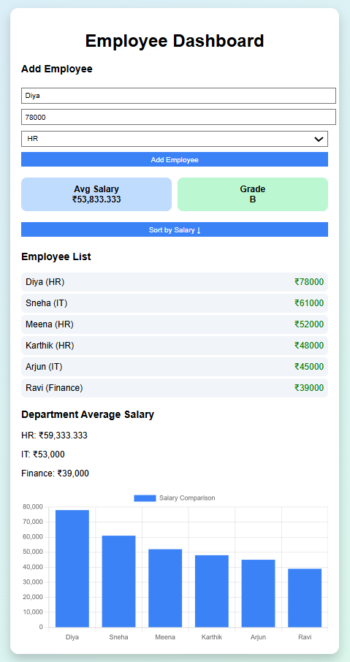

Q2. Profile Card UI using React (Flexbox)
Problem Statement
Design and implement a Profile Card User Interface using React.
The card should visually represent a user’s profile with an image, name, and a short description, similar to the layout shown.
Hint: Try with multiple Profile cards that belong to multiple users.
Requirements
Your application should include:
- Profile Image
  - Display a circular image at the top
  - Image should be centered
- User Name
  - Display the name prominently (bold and larger font)
- Description
  - Display a short paragraph describing the user
  - Text should be centered

UI Design Requirements
- The card should:
  - Be centered on the screen
  - Have a rounded border (border-radius)
  - Include shadow effects for a modern look
  - Maintain proper spacing between elements
- Use Flexbox to:
  - Align items vertically
  - Center content horizontally

Implementation Instructions
✅ Use:
- React (functional component)
- CSS for styling
❌ Do NOT use:
- External UI libraries
- Internet-based image links

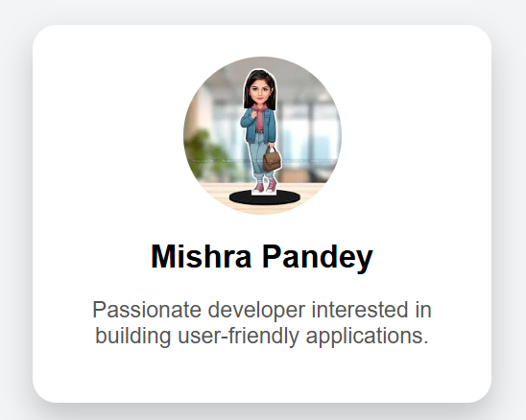
Expected Output:

Step 1: Create React App
npx create-react-app profile-card
cd profile-card
npm start

Step 2: Clean the Project
Open App.js and remove default content.

Step 3: Write React Component
App.js
import React from "react";
import "./App.css";
import profile from "./profile.jpeg"; // ✅ local image, store it inside “src” folder

function App() {
return (
<div className="container">

<div className="card">

<img
src={profile}
alt="Profile"
className="image"
/>

<h2 className="name">Mishra Pandey</h2>

<p className="desc">
Passionate developer interested in building user-friendly applications.
</p>

</div>

</div>
);
}
export default App;

Step 4: Add CSS (Flexbox Styling) just below the existing code
App.css

body {
margin: 0;
font-family: Arial, sans-serif;
}

/* Center the card */
.container {
display: flex;
justify-content: center; /* horizontal */
align-items: center; /* vertical */
height: 100vh;
background: #f3f4f6;
}

/* Card styling */
.card {
display: flex;
flex-direction: column;
align-items: center;
background: white;
padding: 20px;
width: 250px;
border-radius: 15px;
box-shadow: 0 10px 20px rgba(0,0,0,0.2);
}

/* Image */
.image {
width: 100px;
height: 100px;
border-radius: 50%;
margin-bottom: 15px;
}

/* Name */
.name {
margin: 0;
font-size: 20px;
}

/* Description */
.desc {
text-align: center;
color: #555;
font-size: 14px;
}

Step 5: Run the App
npm start

Q3: Interactive Conference Speaker Dashboard (JavaScript / React)

Problem Statement
An organizing committee is developing an interactive web application for an International Conference on Web Technology to efficiently manage and showcase invited speakers. The application should display speaker details in the form of profile cards and allow users to dynamically interact with the data.
Each speaker’s information is stored in an array of objects, and the application must generate the UI by transforming this data into multiple profile cards using a mapping function. In addition to displaying the speaker information, the system should provide interactive features such as searching, filtering, highlighting special speakers, and dynamically adding new entries.
Design and implement the application using either JavaScript (with DOM manipulation) or React, ensuring a clean, responsive, and user-friendly interface. The application must function completely offline.
Hint: Use a mapping function: array.map((item) => UI element)
Concept: Mapping array of objects to <li>
When you are mapping an array of data to convert it into an array of HTML, you have to specify a "mapping function" that will receive each item from the original array, transform it and insert it into the new array.

Dataset
Use the following sample data:
const speakers = [
{ id: 1, name: "Dr. Alice Johnson", domain: "Web Development", org: "MIT" },
{ id: 2, name: "Mr. Rahul Sharma", domain: "Cybersecurity", org: "IIT Delhi" },
{ id: 3, name: "Ms. Sara Lee", domain: "AI & ML", org: "Stanford" }
];

Functional Requirements

1. Display Speaker Cards
- Use a mapping function (map()) to:
  - Transform the speaker data into profile cards
- Each card should display:
  - Speaker Name
  - Domain
  - Organization

2. Search Functionality
- Provide a search input field
- Dynamically filter speakers based on name

3. Domain Filter
- Provide a dropdown menu to:
  - Filter speakers by domain

4. Add Speaker
- Allow users to dynamically add a new speaker by entering:
  - Name
  - Domain
  - Organization
- The UI should update immediately after adding

5. Highlight Featured (Keynote) Speaker
- Identify and highlight at least one keynote speaker
- Use a distinct visual style (e.g., border, badge, or label)

6. Display Speaker Count
- Display the total number of speakers currently visible
- The count should update dynamically based on search/filter results

Implementation Options

Option 1: JavaScript
- Use:
  - Array of objects for storing speaker data
  - map() for generating HTML
  - DOM manipulation (innerHTML, createElement)

Option 2: React
- Use:
  - Functional components
  - map() to render speaker cards
  - useState() for dynamic updates
  - filter() for search functionality

Expected Output: