**Jenkins** is an automation tool, which is used to implement Continuous Integration/Continuous Delivery

It is java based tool

Jenkins is a compatible tool with diff s/w packages with the plugins

**CI/CD** is a method to frequently deliver apps to customers by introducing automation into the stages of app development.

CI vs CD vs CD:

**CI:** The developer's changes are validated by creating a build and running automated tests against the build. By doing so, you avoid integration challenges that can happen when waiting for release day to merge changes into the release branch.

**CD:** [Continuous delivery](https://www.atlassian.com/continuous-delivery) is an extension of continuous integration since it automatically deploys all code changes to a testing and/or production environment after the build stage.

**CD:** Continuous deployment goes one step further than continuous delivery. With this practice, every change that passes all stages of your production pipeline is released to your customers. There's no human intervention

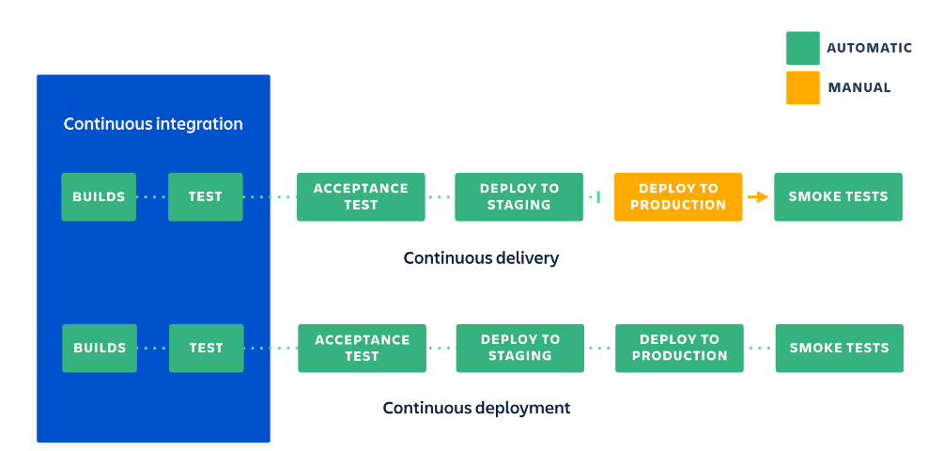

**Jenkins Prerequsites:**

JDK 8.0 and Above

**How to start Jenkins:**

Download Jenkins war file with wget

Java –jar Jenkins.war

**Get Jenkins admin password:**

/home/ubuntu/.jenkins/secrets/initialAdminPassword

Ansible Syntax:

Ansible all/group_name/ip address -i path of inventory –m module_name –a ‘ arguments ‘