Contents
Visualization 2
Pandas 3
Dataframe 3
Series 4
Pandas and Visualization 4
Matplotlib 6
Line Charts 6
Scatter Charts 8
Bar Charts 9
Pie Charts 10
Histogram 11
PLOTLY 12
Line chart 13
Bubble Plot 14
Box plot 15
Violin plot 16
Contour Plots 17
Heatmaps 19
3D Scatter Plot 20
Plotly VS Matplotlib 21
Reference 23

Visualization
Data visualization is the process of representing data in graphical or pictorial formats such as charts, graphs, and diagrams to clearly communicate insights. It helps users easily understand trends, patterns, outliers, and relationships within data that may not be obvious from raw numbers.
Visualization supports better and faster decision-making by presenting complex information in an accessible and meaningful way, especially for non-technical audiences.
In today’s world of big data, visualization tools are essential for analysing large datasets and transforming them into actionable insights.
Using Python libraries such as Pandas for data handling and Matplotlib and Plotly for plotting, programmers can explore distributions, averages, correlations, and variations in data, making analysis both insightful and visually intuitive.

Pandas
Pandas is an open-source Python library used for data manipulation and data analysis. It provides fast, flexible, and easy-to-use data structures that help in working with structured data efficiently. Pandas is widely used in data analysis, data cleaning, and data visualization workflows.
Pandas was created in 2008 by Wes McKinney, a software developer and data scientist, while he was working at AQR Capital Management, a finance company.
The name Pandas comes from a combination of “Panel Data” and “Python Data Analysis”, reflecting its purpose of handling structured data in an easy and effective way.
It provides powerful data structures such as Series and DataFrame, which allow data to be stored and handled in a tabular format similar to spreadsheets or databases.
To use Pandas in Python, it is first imported as shown below. The name pd is an alias that makes the library easier and faster to use in code.
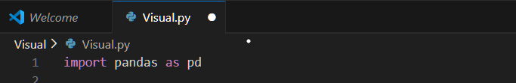

Dataframe
A DataFrame is a two-dimensional data structure in Pandas that stores data in the form of rows and columns, similar to a table or spreadsheet. Each column in a DataFrame can contain different types of data.
DataFrames are commonly used for:
- Data cleaning
- Removing duplicate values
- Handling missing (null) values
- Filling missing values using mean, median, or mode
- Performing statistical operations and analysis
Because of its tabular structure and powerful functions, the DataFrame is the most frequently used data structure in Pandas.
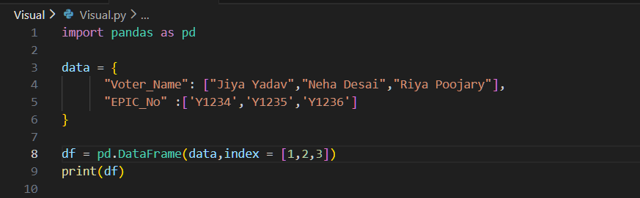

Series
A Series is a one-dimensional data structure in Pandas that holds a single column of data. It can be considered as a single column of a DataFrame. Each Series has values along with an index.
Series are useful for:
- Working with individual columns
- Performing mathematical and statistical operations
- Creating DataFrames

Pandas and Visualization
Pandas also provides built-in plotting functions that allow users to visualize data directly from Series or DataFrames. These plotting functions make it easy to create graphs using simple commands such as
df.plot().
However, Pandas does not draw graphs by itself. Instead, it uses Matplotlib as its backend to render the plots. This means Pandas simplifies the visualization process, while Matplotlib handles the actual creation and display of graphs.
Because of this integration, Pandas is widely used for quick and efficient data visualization, especially during exploratory data analysis.
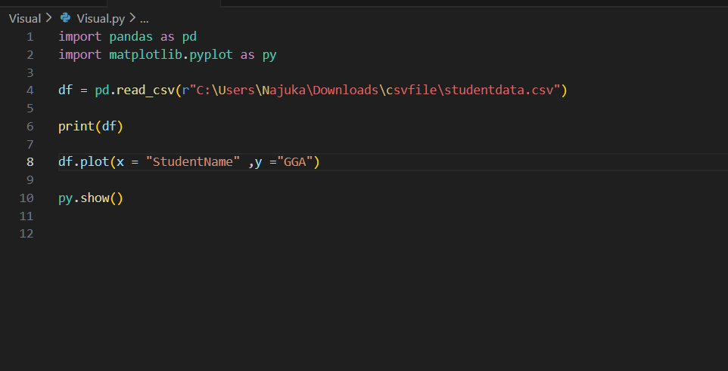
OUTPUT -
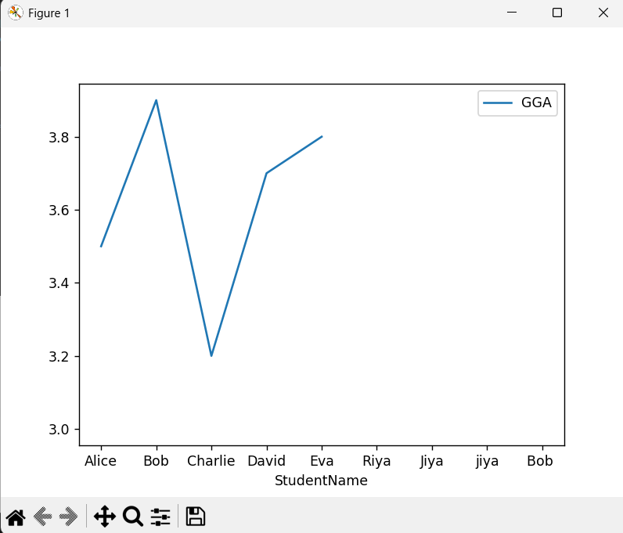

Matplotlib
Matplotlib is a comprehensive library for creating static, animated, and interactive visualizations in Python. Matplotlib makes easy things easy and hard things possible.
Matplotlib was created by John D. Hunter in 2002 and is one of the most widely used visualization libraries in the Python ecosystem.
To use Matplotlib, the pyplot module is commonly imported. The name plt is an alias that allows easier access to plotting functions.
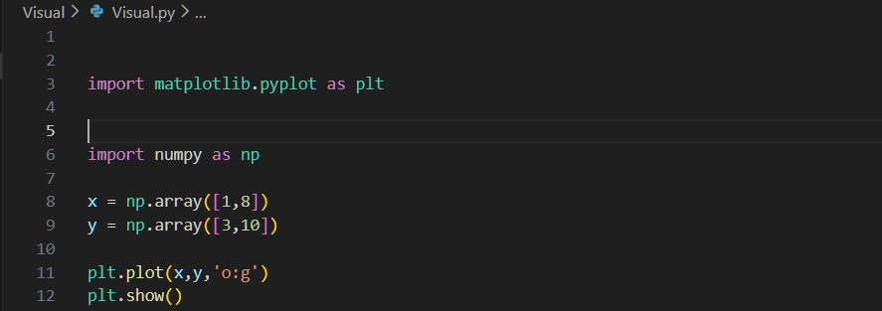
Matplotlib supports many types of plots such as:
- Line Charts
- Scatter Charts
- Bar Charts
- Pie Charts
- Histogram

Line Charts
A line chart is used to display data points connected by a continuous line.
It is mainly used to observe trends or changes over time.
A line chart can be plotted using the plt.plot() function.
Uses of Line Chart:
- Trend analysis
- Continuous data visualization

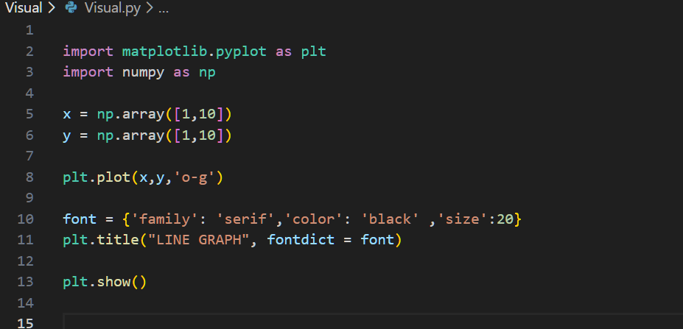
OUTPUT -
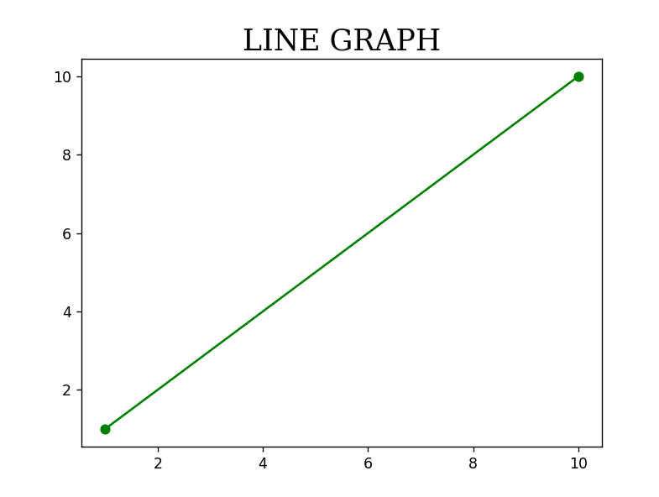

Scatter Charts
A scatter chart uses dots to represent individual data points. It is used to understand the relationship between two numerical variables.
Scatter plots are commonly used to identify correlations or patterns in data.

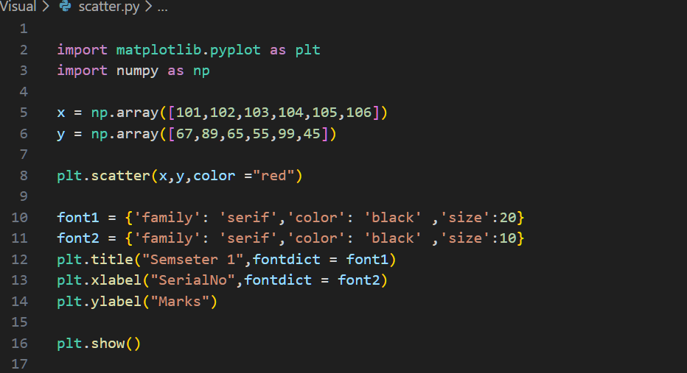
OUTPUT -
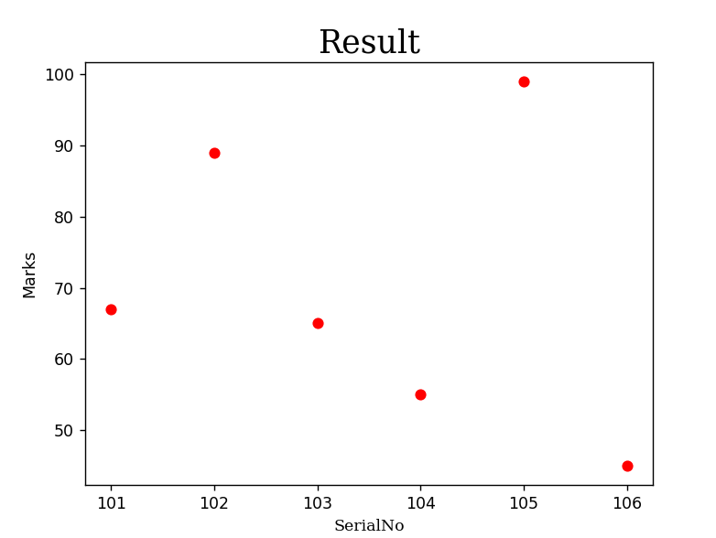

Bar Charts
A bar chart represents data using rectangular bars, where the height or length of the bar indicates the value of the data.
Bar charts are mainly used to compare values across different categories.
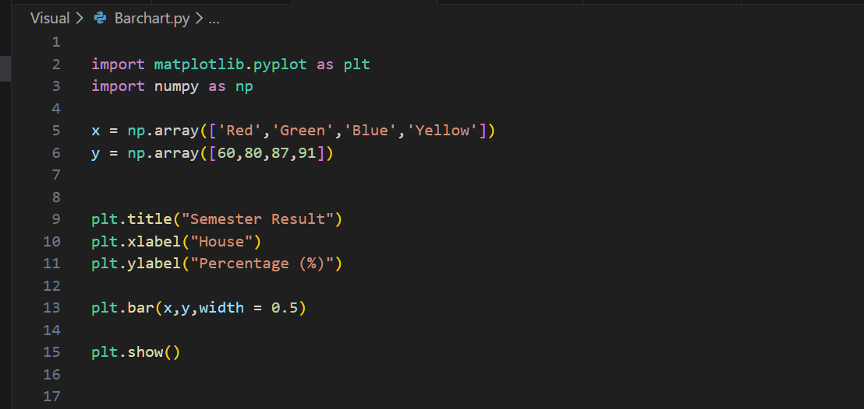
OUTPUT -
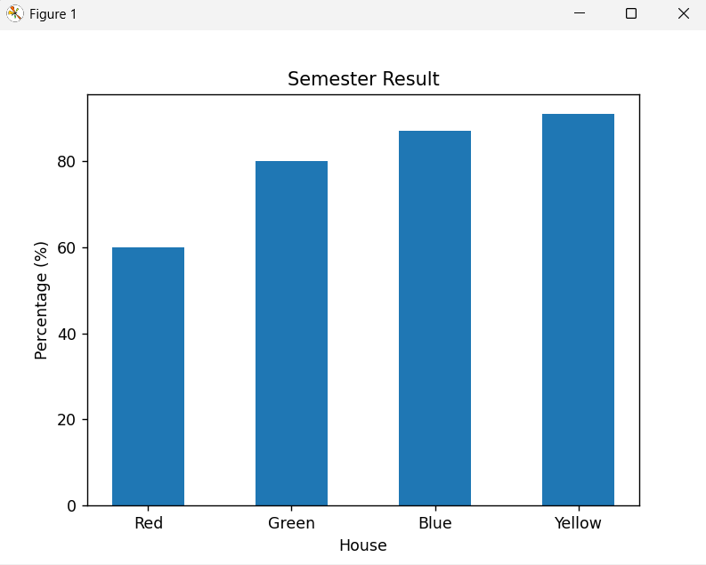

Pie Charts
A pie chart represents data as slices of a circle, where each slice shows the proportion or percentage of a category relative to the whole.
Pie charts are useful when comparing parts of a single dataset.
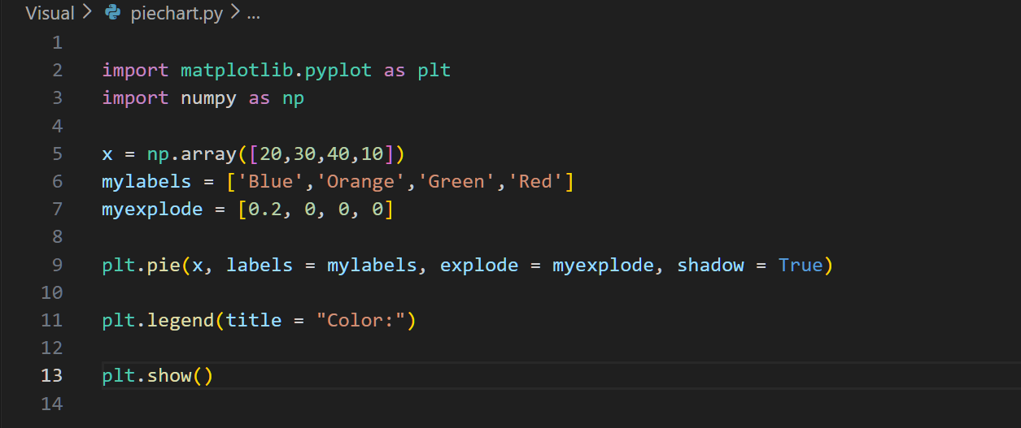
OUTPUT -

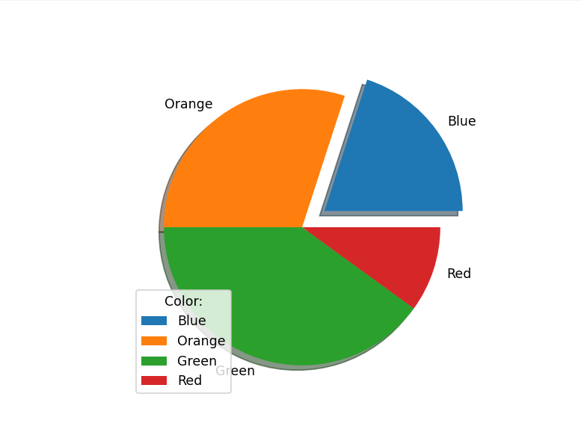

Histogram
A histogram is used to represent the distribution of numerical data. It groups data into ranges called bins and shows the frequency of data values within each range.
Histograms are commonly used to analyze the spread and concentration of data.
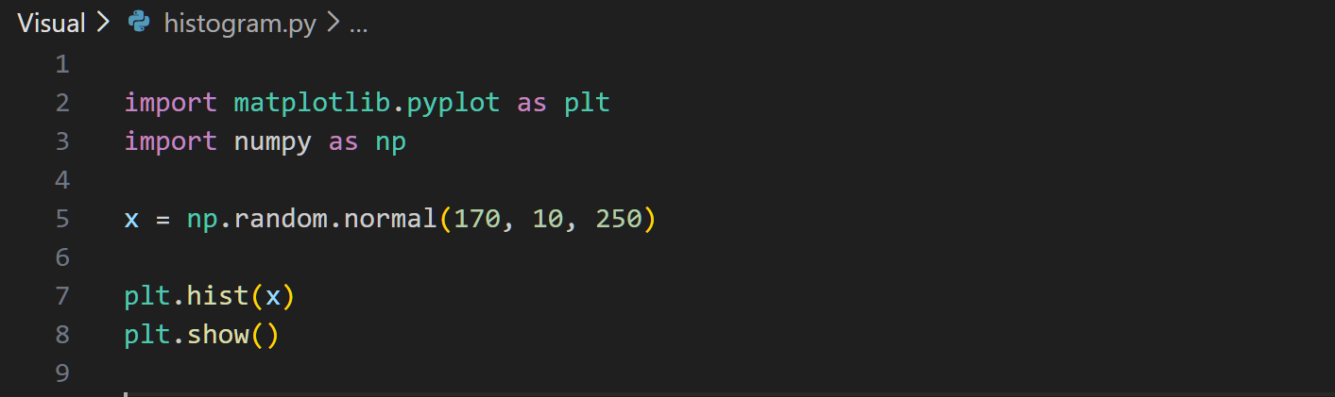
OUTPUT -
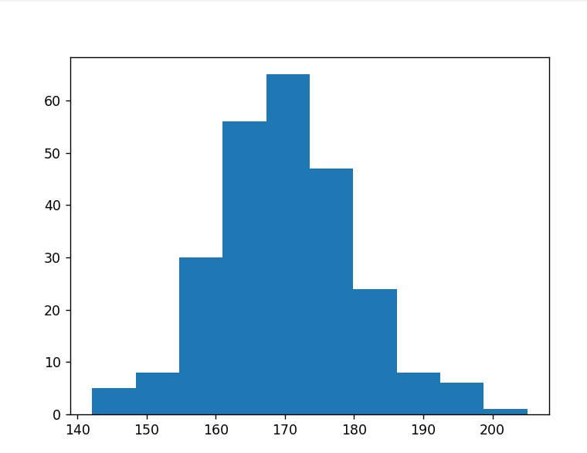

PLOTLY
Plotly is a popular open-source Python library used for creating interactive and publication-quality visualizations. It is widely used in data science, analytics, and machine learning to present data insights in a visual and interactive way. Plotly supports a wide variety of charts, including line charts, scatter plots, bar charts, pie charts, heatmaps, contour plots, box plots, violin plots, and Gantt charts.
Package Structure of Plotly
There are two main modules in Plotly used for creating visualizations:
- plotly.graph_objects
It is a low-level module used when we need full control over the plot.
It is mainly used for deatailed customization, complex plots and professional dashboards
This module work using three main compoments:
- Figure: The figure id the main container that hold everything related to the plot.
- Traces(data): Traces represent the actual plotted data.
- Layout: Layout control the appearance of the plot.
- Frames: It is used for animations

- plotly.express
This is a high-level module used to quickly generate complete figures. It mainly used for dast plotting, simple code and beginners.
It integrates well with Jupyter Notebooks, Dash, and web applications, making it ideal for interactive dashboards and web-based visualizations.
PLOTLY supports many types of plots such as:
- Line Charts
- Scatter Charts
- Bar Charts
- Pie Charts
- Bubble Chart
- Box plot
- Violin plot
- Contour graph
- Heatmap graph
- 3D Scatter plot
We can see line, scatter, bar, and pie charts in both Matplotlib and Plotly. However, Matplotlib graphs are mostly static and cannot be zoomed, while Plotly graphs are interactive and allow zooming. That is why I did not repeat the same graph and instead showed another graph.

Line chart
A line chart displays data points connected by a continuous line. It is used to analyze trends over time. Plotly line charts are interactive, allowing users to zoom, hover, and explore data points.
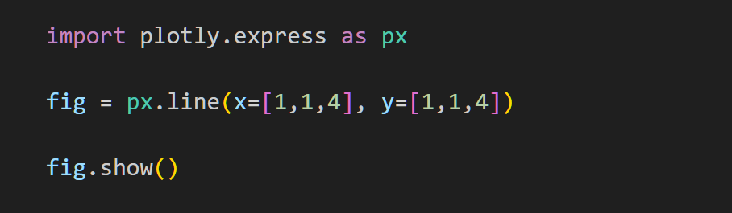

OUTPUT -
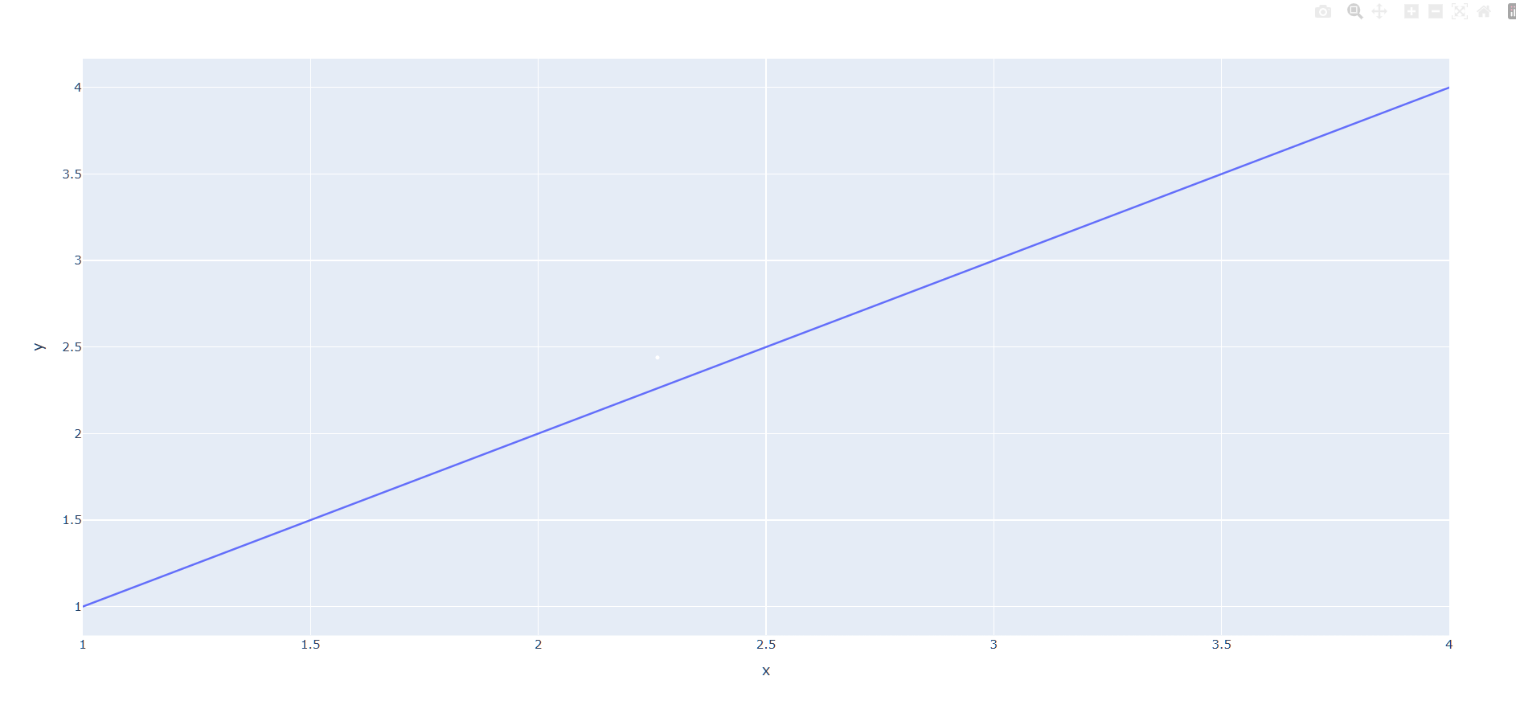

Bubble Plot
A bubble plot is a type of scatter plot where each point is displayed as a circle (bubble).
The position shows two variables (X and Y), and the bubble size represents a third variable.
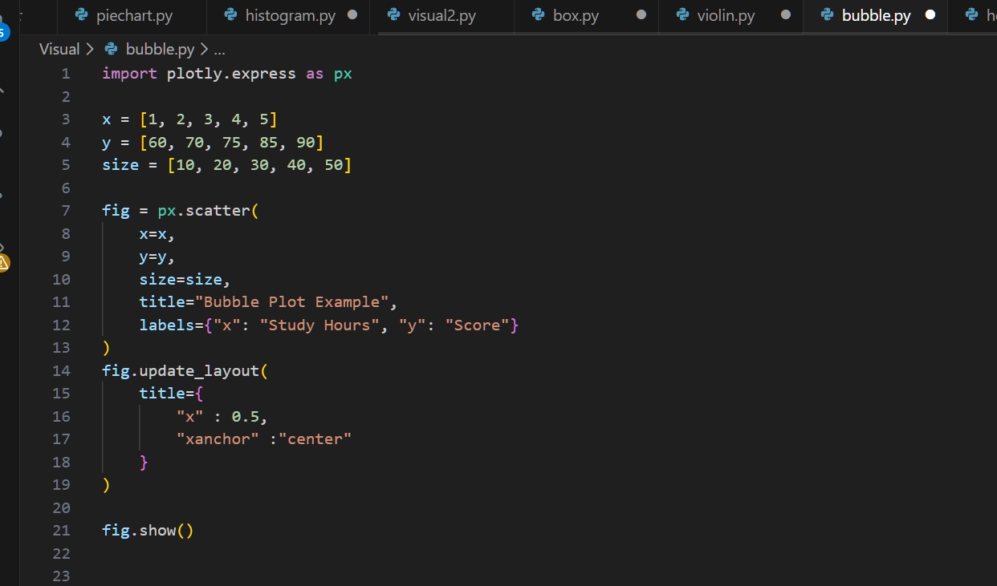
OUTPUT -

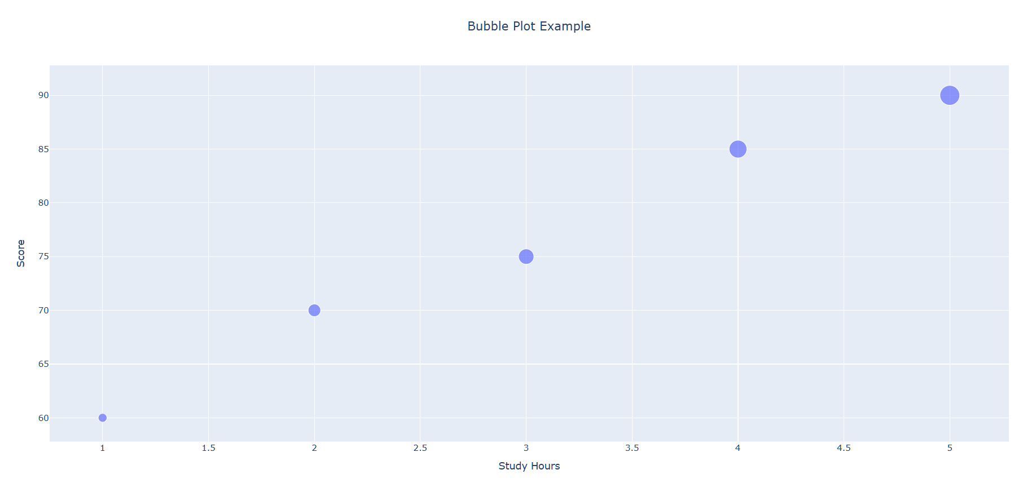

Box plot
A box plot shows the distribution of numerical data using quartiles. It highlights the median, spread, and outliers in the dataset.
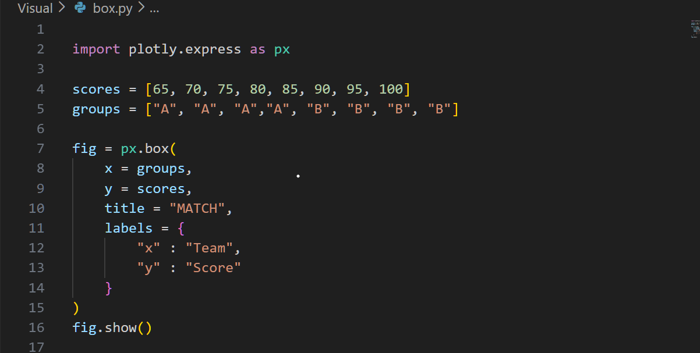

OUTPUT -
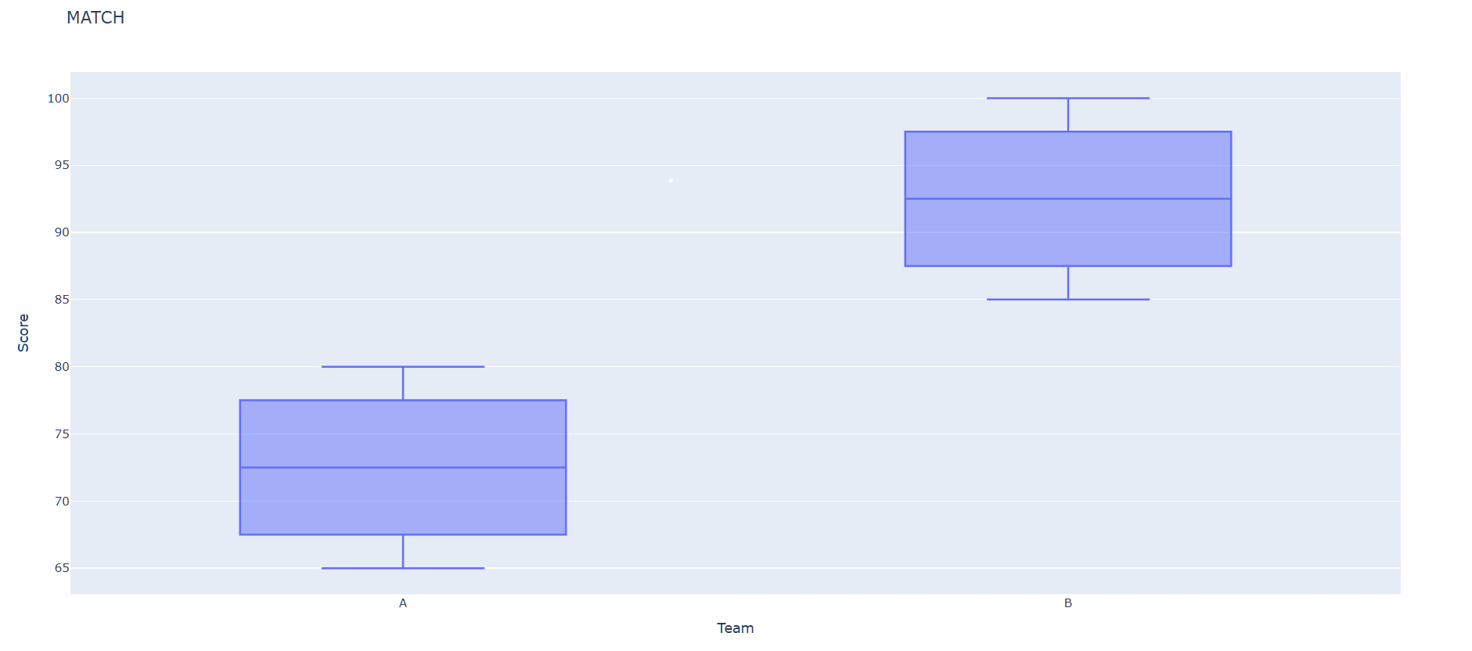

Violin plot
A violin plot combines a box plot and a kernel density plot. It shows the distribution shape of the data along with summary statistics.
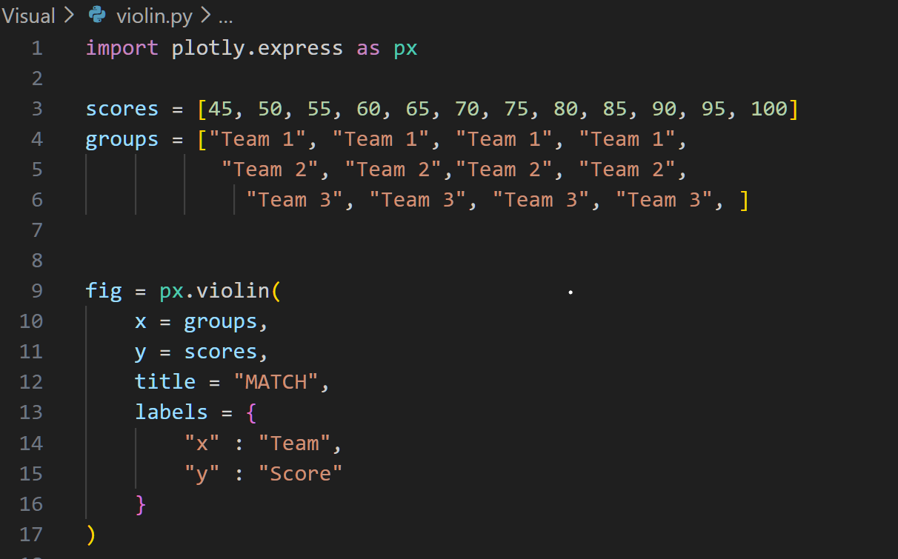
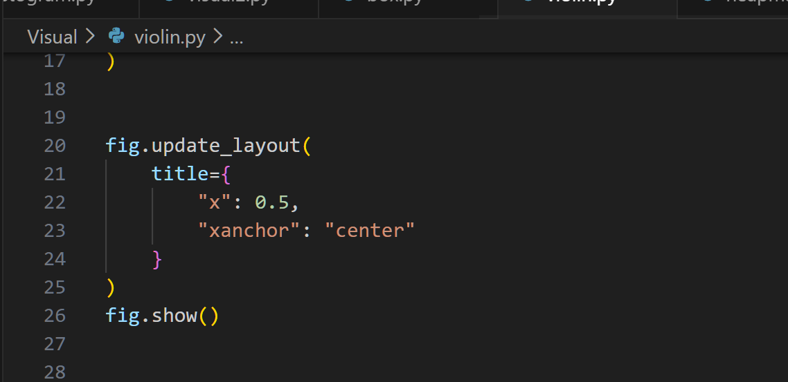

OUTPUT -
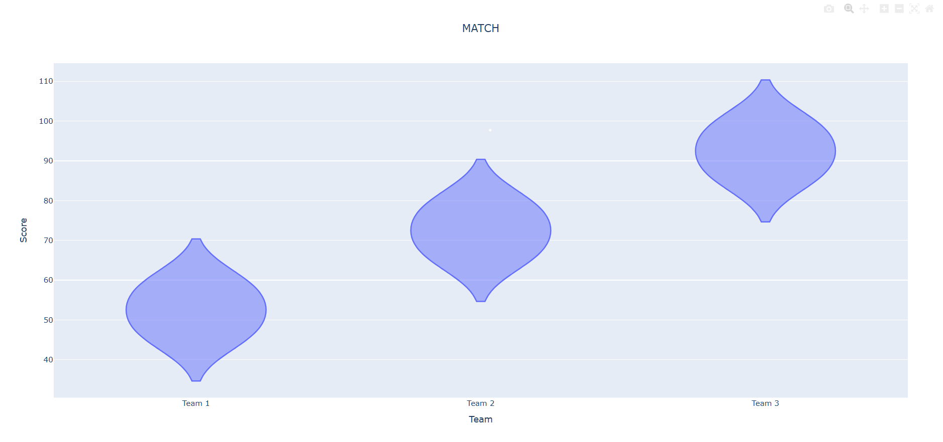

Contour Plots
It is a type of graph that shows a 3D data on 2D surface using lines or colors and curved lines are called as contour lines.
It used a plotly.graph library module
It is like a map that is flat (2D) of the world (3D)
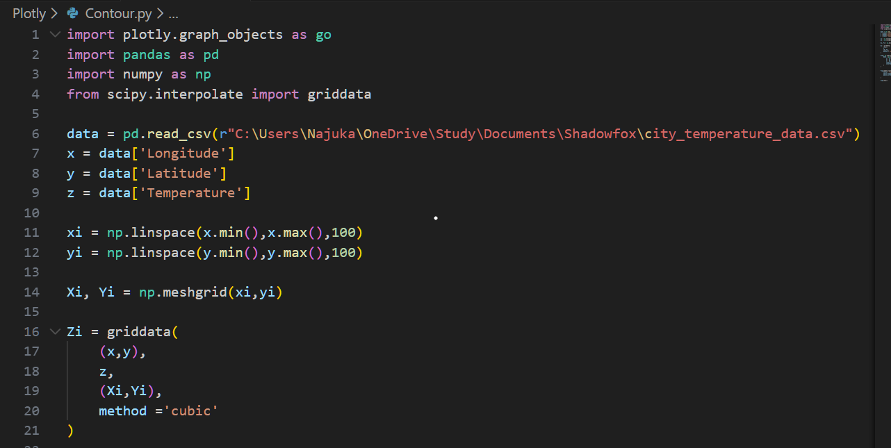
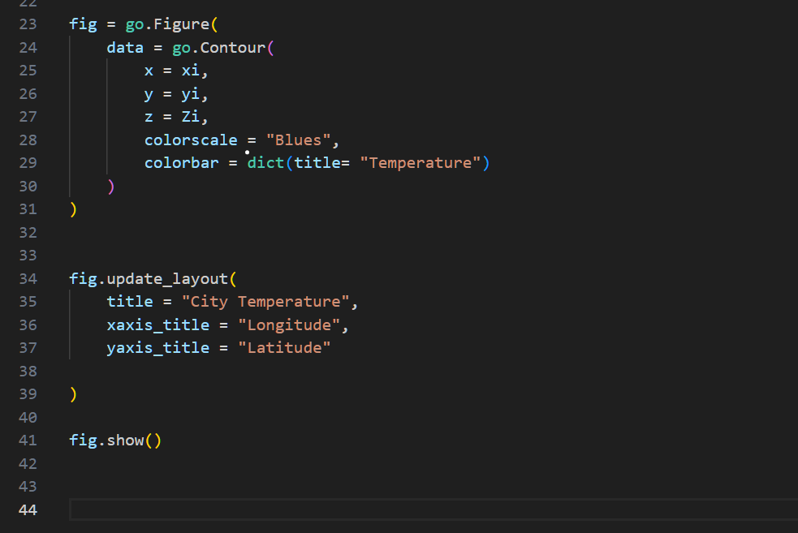
OUTPUT
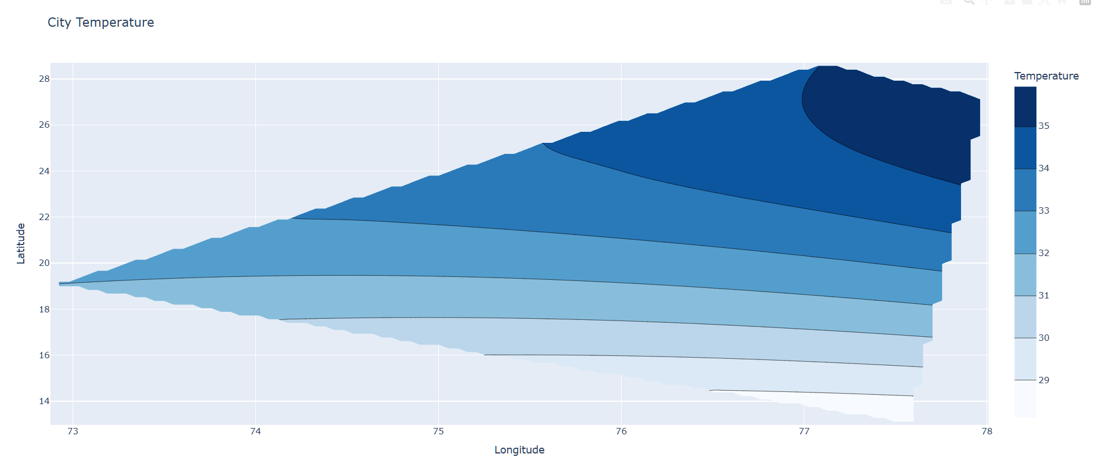

Heatmaps
Heatmap is a graphical representation of data using colors to visualize the the claue otf the matrix.
It also defined by the name of the shading matrix
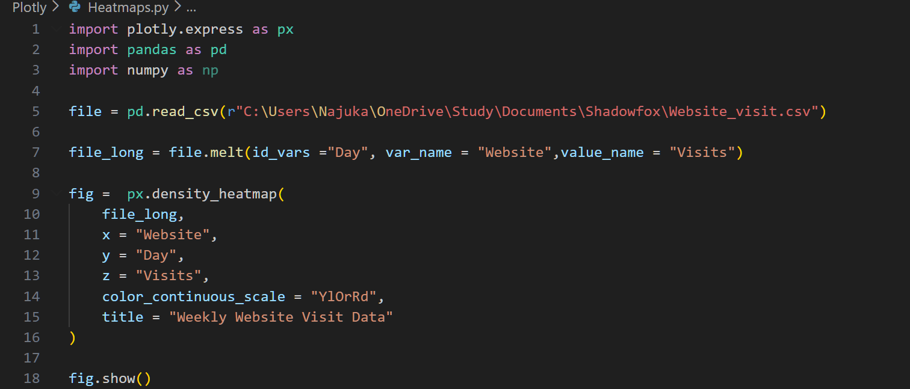
OUTPUT
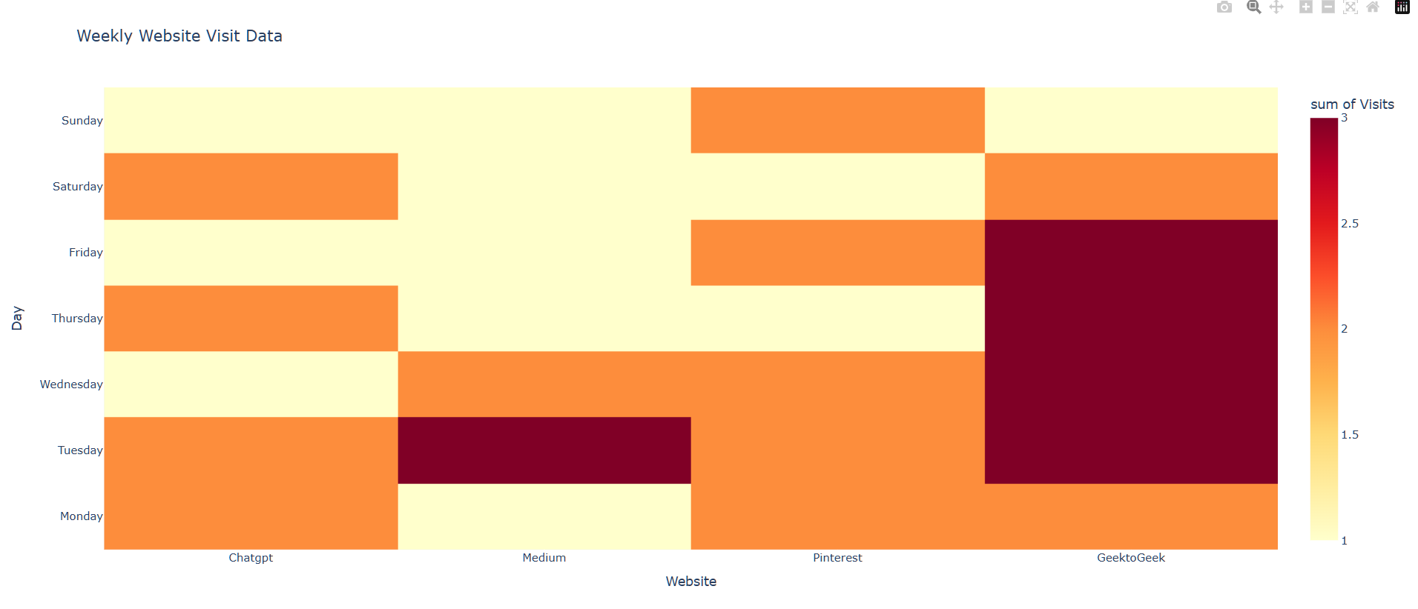

3D Scatter Plot
A 3D scatter plot displays data points using three numerical variables on the X, Y, and Z axes.
Each point represents one observation in three-dimensional space.
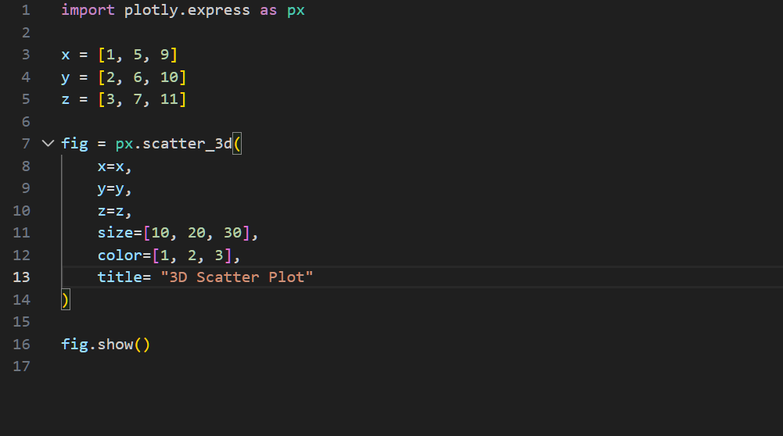
OUTPUT -
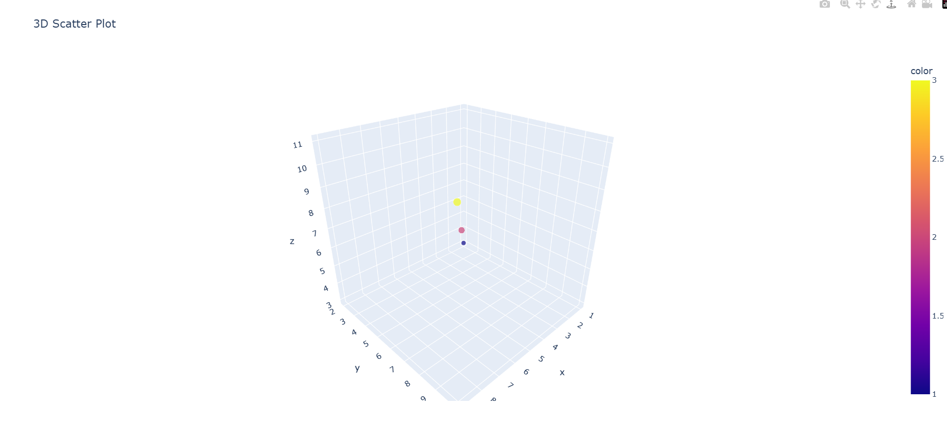

Plotly VS Matplotlib
Matplotlib
Core Library: Matplotlib is the original Python plotting library. It provides a low-level interface for creating static, academic-style plots with fine-grained control over every element of the figure.
Flexibility: Matplotlib supports a wide variety of plot types, including line plots, scatter plots, bar plots, histograms, and 3D plots. Almost any aspect of a plot can be customized, from fonts and margins to axis scales.
Mature Ecosystem: Matplotlib has been around for a long time and is widely used in academia. Many other libraries, such as Seaborn, pandas plotting, and scikit-learn visualizations, are built on top of Matplotlib.
Integration: Matplotlib works seamlessly with other Python libraries like NumPy, Pandas, and SciPy, making it a versatile choice for academic, research, and analytical projects.
Usage Context: Typically used for static or embedded charts, such as in PDFs, reports, or presentations. It is ideal for situations requiring highly precise control over figure formatting, such as publishing scientific papers or textbooks.
Performance: Matplotlib is generally performant for static plots, though extremely large datasets (e.g., millions of points) may slow down rendering.
Weakness:
- It is static plot, we can’t zoom, hover or interact easily.
- It not interactive, not ideal for dashboard or web apps

Plotly
Interactive Graphics: Plotly is designed for interactive, web-ready visualizations. It allows zooming, hovering, and rotating 3D graphs, enabling users to explore data in detail.
Ease of Use: Plotly produces visually appealing charts out of the box and is perfect for creating dashboards, apps, or interactive visualizations without extensive manual styling.
Integration and Ecosystem: Plotly integrates with web frameworks and platforms such as Dash and Fabi.ai. Its ecosystem includes plotly.js for JavaScript, Dash for Python web apps, and chart-studio for sharing.
Customization: While Plotly is highly customizable, its strength lies in interactivity and web-based visuals. Users can create 3D surfaces, geographic maps, and complex charts with relative ease.
Usage Context: Plotly is especially popular in corporate or industry settings, where interactive dashboards allow stakeholders to explore and filter data in real-time.
Performance: Plotly handles medium to large datasets well, but very large datasets with hundreds of thousands of points can slow down browser-based interactivity. Optimization techniques exist to improve performance.
Weakness:
- It can be slower with large datasets
- Less control over fine grading styling compered to Matplolib

Overall, choice of library is depends on the type of visualization needed. Matplotlib is best suited for static, academic-style visualizations. It is ideal when precise control over figure details is required for papers, reports, or textbooks, and works well for teaching, research, or any scenario where interactivity is not necessary.
On the other hand, Plotly is best suited for interactive, web-based visualizations. It is ideal for dashboards, presentations, or business analytics, where stakeholders can zoom, hover, filter, and explore data dynamically. While Plotly’s performance is optimized for interactivity, extremely large datasets may slow down rendering in the browser.

Reference
- https://www.sisense.com/blog/10-useful-ways-visualize-data-examples/
- https://www.w3schools.com/python/pandas/default.asp
- https://www.geeksforgeeks.org/python/python-plotly-tutorial/
- https://www.fabi.ai/blog/plotly-vs-matplotlib-a-quick-comparison-with-visual-guides

