Comeback Momentum, Chart Re-Entry, and Fandom Intensity Analysis of South Korea Top 50 Playlist
Exploratory Data Analysis (EDA) Report
Source basis: Atlantic South Korea cleaned playlist data, re-entry event data, fandom leaderboard data, the supplied Google Colab notebook, and the supplied Power BI report structure.

1. Executive Summary
The project analyzes 27,750 cleaned Top 50 playlist observations across 555 observed dates, spanning 18 May 2024 to 27 Nov 2025. The cleaned panel contains 537 unique song-artist combinations and 194 artists.
The re-entry event table contains 835 comeback events across 224 songs. The median absence before re-entry is 2 days, while the median post-comeback retention is 2 days. This indicates that many returns are brief bursts rather than long uninterrupted runs.
Average Momentum Spike Score is 48.10. 41.0% of re-entry events improve the prior run's ending rank, while 12.5% are unchanged. The mean rank jump is -0.37, with a median of 0.
The fandom leaderboard contains 134 songs and is a behavioral proxy based on re-entry frequency, rank recovery, recovery speed and retention. The top proxy scores should be interpreted as repeated chart-reactivation signals rather than direct measurements of fandom size.

2. Data Structure and Data Quality
Dataset | Rows | Primary purpose
Cleaned | 27,750 | Daily Top 50 observations and content attributes
Reentry | 835 | Chart-run comeback events and momentum metrics
Fandom | 134 | Song-level fandom intensity proxy leaderboard
Daily validation is strong in the cleaned dataset: all 555 observed dates contain exactly 50 records. The original notebook records 27,800 raw rows and one date with a 100-row overlapping snapshot; the cleaned dataset provided with this report is already normalized to 27,750 rows and 50 rows per observed day.
The cleaned data has no missing values in the supplied 14 columns. It contains 537 unique song-artist identifiers and 194 artists.
Content mix in the cleaned panel is approximately 64.6% single, 35.4% album, and 9.6% explicit. The remaining album_type values are negligible in the cleaned panel.

3. Exploratory Dataset Profile
Metric | Value
Observed date range | 18 May 2024 - 27 Nov 2025
Observed dates | 555
Cleaned playlist rows | 27,750
Unique songs | 537
Unique artists | 194
Mean popularity | 76.92
Median popularity | 79
Mean song duration | 3.20 min
Median song duration | 3.14 min
Explicit share | 9.55%
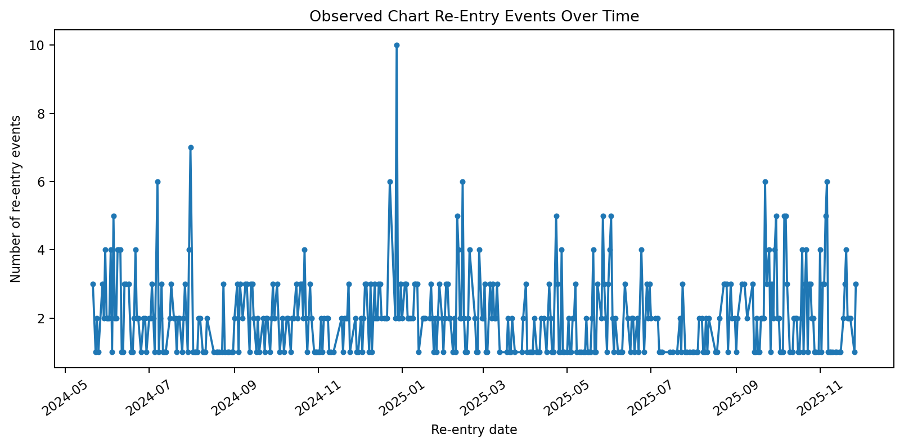
Figure 1. Re-entry events by start date.

4. Chart Re-Entry Analysis
There are 835 re-entry events across 224 unique songs. The median re-entry gap is 2 days and the 75th percentile is 5 days. Mean gap is 6.52 days, showing a right-skew created by a smaller number of long absences.
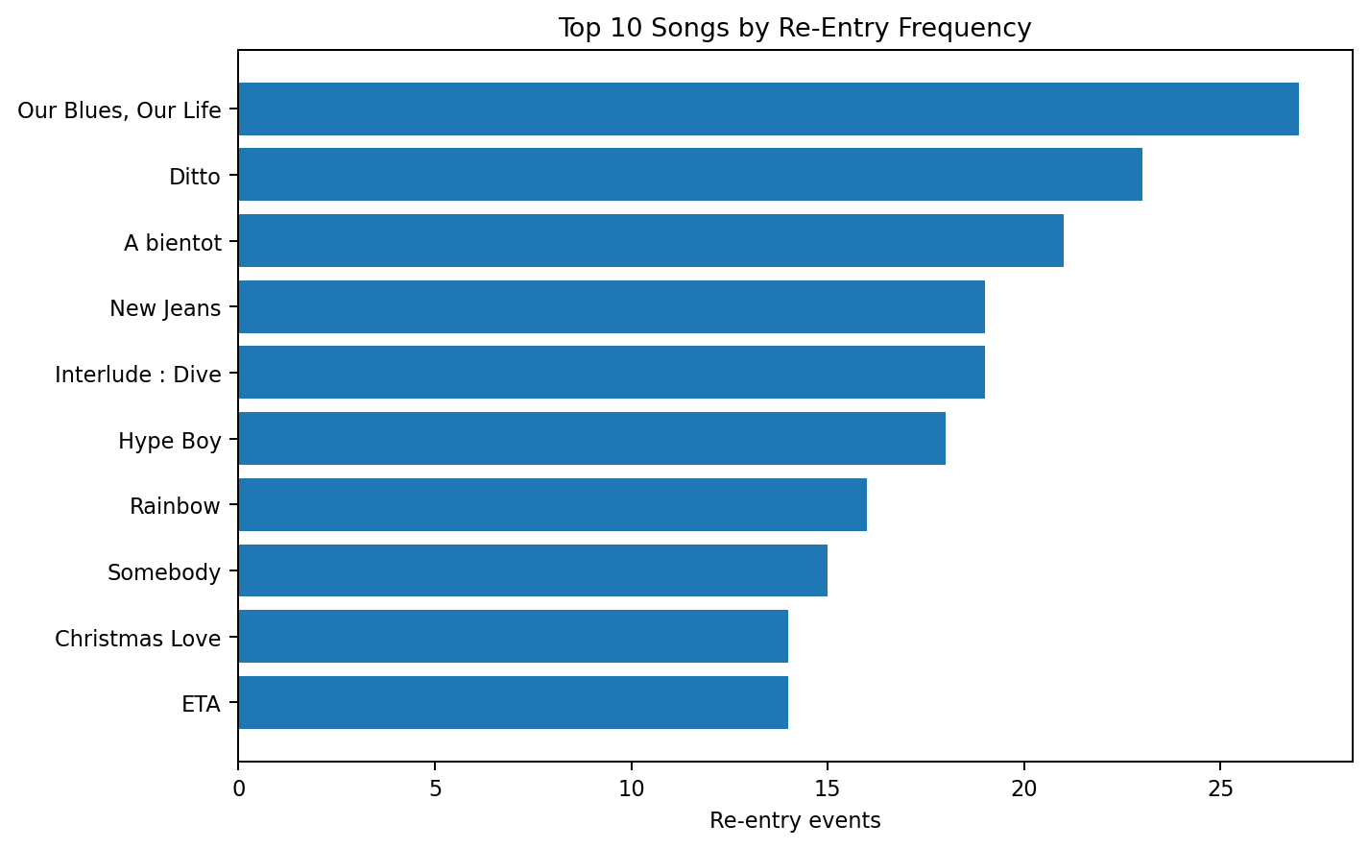
Figure 2. Songs with the highest number of observed re-entry events.
Top recurring songs:
Song | Artist | Re-entry events
Our Blues, Our Life | Lim Young Woong | 27
Ditto | NewJeans | 23
A bientot | Lim Young Woong | 21
Interlude : Dive | Jimin | 19
New Jeans | NewJeans | 19
Hype Boy | NewJeans | 18
Rainbow | Lim Young Woong | 16
Somebody | Jung Kook | 15
Christmas Love | Jimin | 14
ETA | NewJeans | 14

Key insight - Re-entry concentration
The five artists with the most re-entry events are Lim Young Woong (157), Jimin (117), NewJeans (103), Jung Kook (62) and DAY6 (31). Together they account for 56.3% of all observed re-entry events, showing that comeback behavior is concentrated among a relatively small set of highly recurring artists.

5. Momentum Spike Analysis
The project notebook defines Momentum Spike Score as a weighted composite of normalized rank jump (40%), popularity change (20%), recovery speed (20%) and retention (20%). In the supplied re-entry event table, the mean score is 48.10 and the median is 48.09.
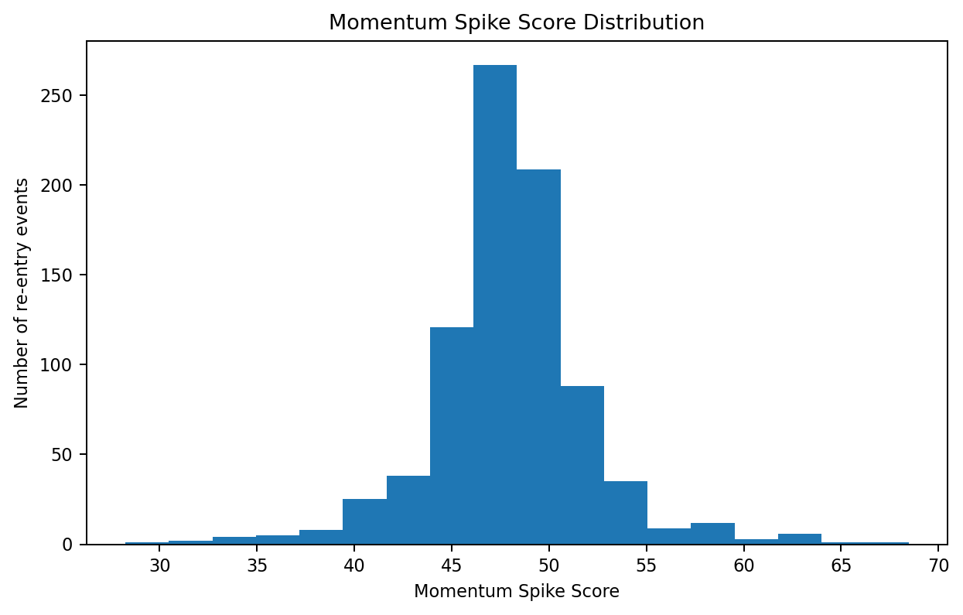
Figure 3. Distribution of Momentum Spike Scores.
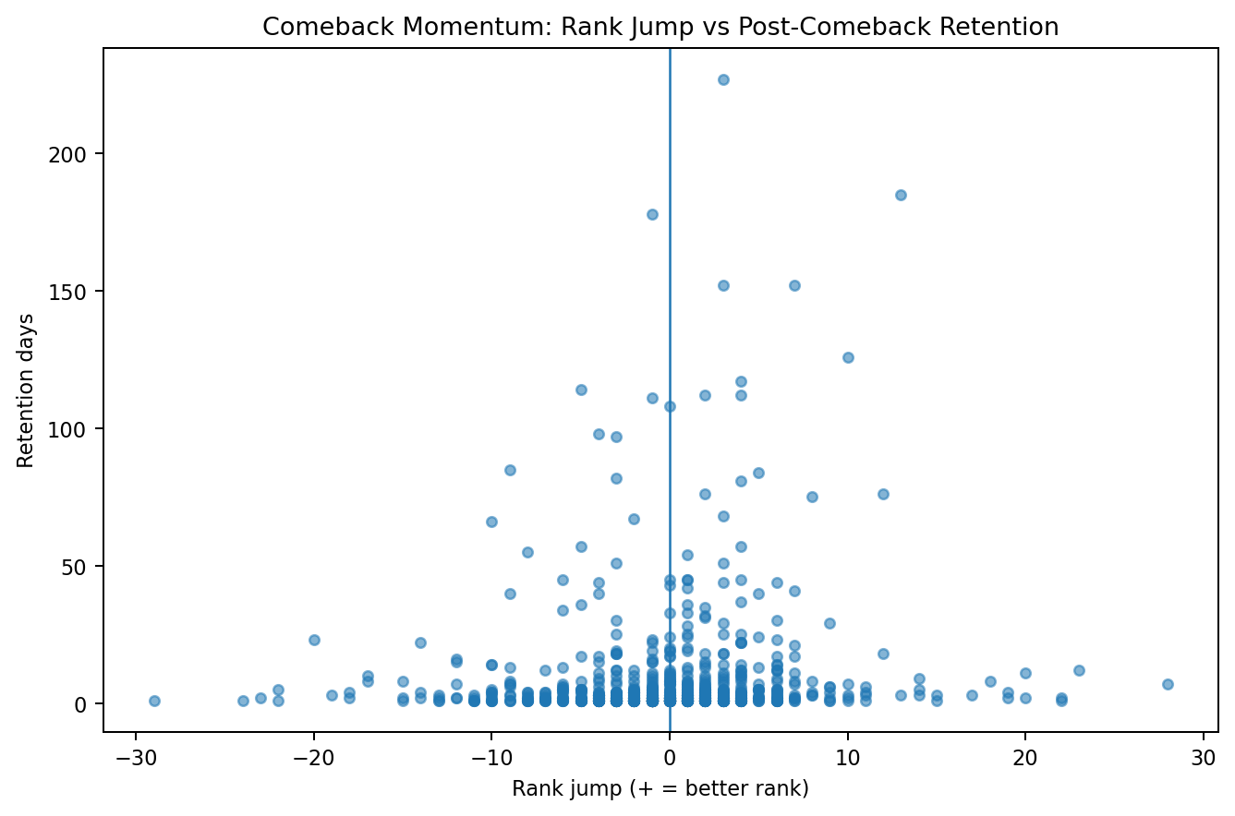
Figure 4. Rank jump versus post-comeback retention.
An important analytical observation is that Momentum Spike Score is strongly aligned with rank jump in the supplied model (correlation ≈ 0.96). This is expected because rank jump receives the largest 40% weight. Therefore, rank recovery and momentum are closely related in the dashboard and should not be interpreted as fully independent dimensions.
Top average momentum songs include Jealousyvalhalla (YANGHONGWON, 68.46), Lost and Found (KingLee & Lil' Flip, 63.84), and All I Want for Christmas Is You (Mariah Carey, 61.79).

6. Momentum Sustainability and Recovery
Post-comeback retention is highly skewed: the median is 2 days, the mean is 8.54 days, and the 75th percentile is 6 days. The difference between mean and median indicates a small number of unusually long comeback runs.
Average time to best rank after re-entry is 2.82 days, with a median of 0 days. This supports an operational focus on the first few days after a comeback event, while also monitoring outlier songs that sustain longer.

7. Content Attribute Analysis

Single vs Album
Single re-entry events: 476; average momentum 48.05; average retention 7.53 days; average recovery time 2.18 days; average re-entry gap 6.95 days.
Album re-entry events: 359; average momentum 48.16; average retention 9.87 days; average recovery time 3.65 days; average re-entry gap 5.96 days.
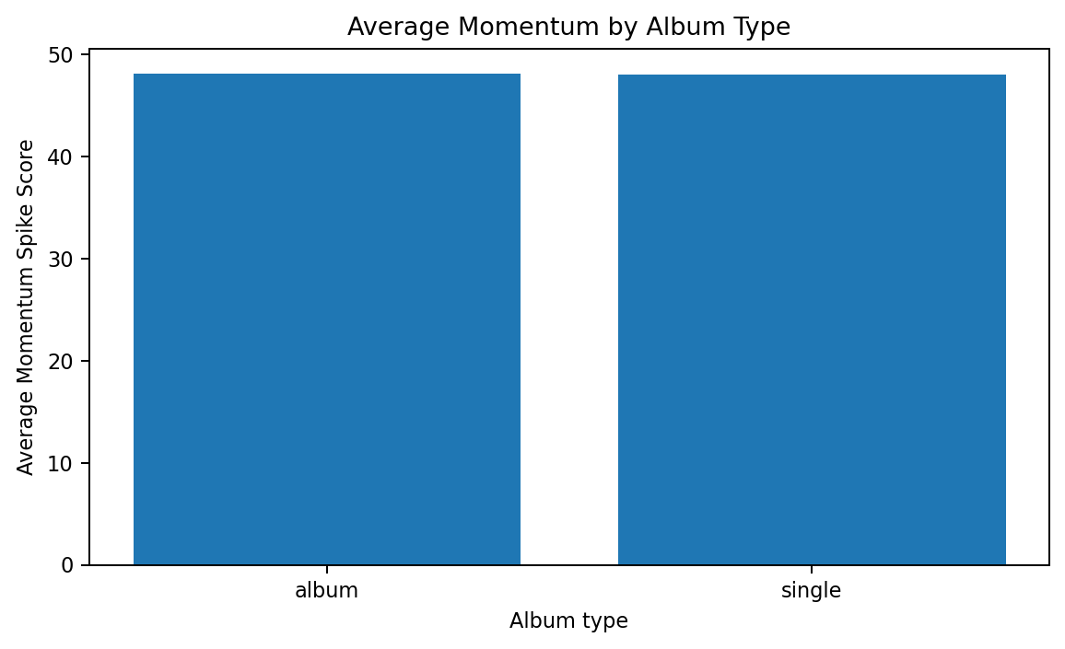
Figure 5. Average Momentum by Album Type.

Key insight - Format differences
Singles and album tracks have nearly identical average Momentum Spike Scores in this dataset. However, album tracks show longer average recovery times and slightly longer average retention, while singles show faster recovery but a slightly longer average absence before re-entry. The evidence therefore supports different comeback mechanics rather than a single format universally outperforming the other.

Explicit vs Clean
Clean re-entry events: 796, average momentum 48.08, average recovery 2.89 days. Explicit re-entry events: 39, average momentum 48.53, average recovery 1.28 days.
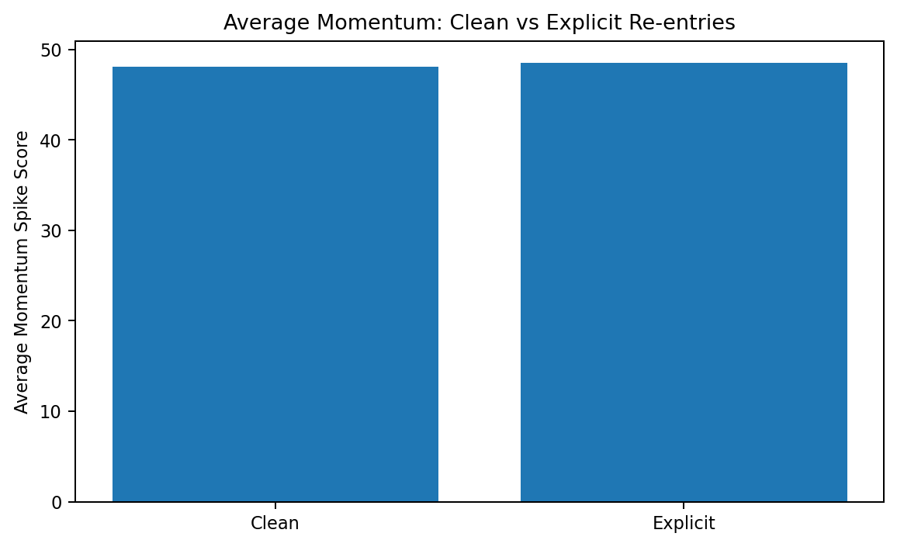
Figure 6. Average Momentum by Explicit Status.
Explicit content shows a slightly higher average momentum and faster recovery in the event table, but explicit events are only 39 of 835 events (4.7%). This small base means the difference should be treated as a directional observation, not evidence that explicit content causes stronger fandom response.

Album Size vs Momentum
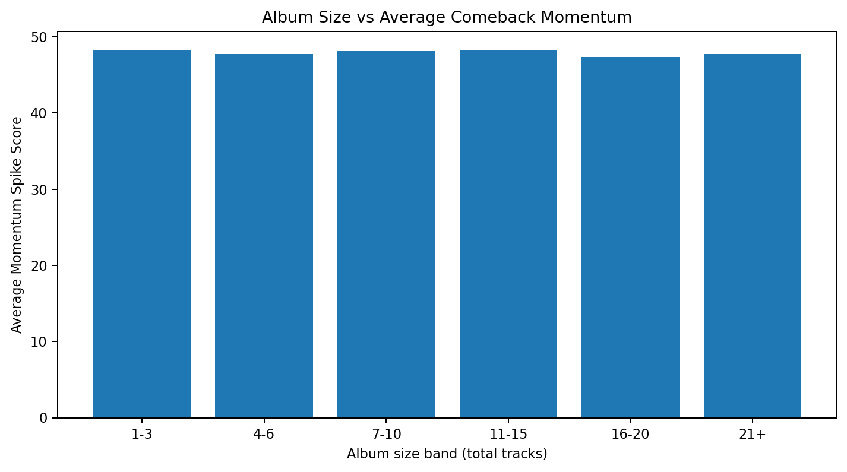
Figure 7. Average comeback momentum across album-size bands.
The linear correlation between total_tracks and Momentum Spike Score is approximately -0.006, which is effectively close to zero in this sample. Album size therefore does not appear to be a strong standalone predictor of comeback momentum.

Song Duration vs Momentum
After joining duration from the cleaned playlist table to the re-entry events by song_id, the correlation between song duration and Momentum Spike Score is approximately 0.014, also close to zero. This suggests that song length alone has little linear relationship with comeback intensity in the supplied data.

8. Fandom Intensity Proxy Analysis
The supplied Fandom leaderboard ranks songs using a proxy built from re-entry frequency, rank recovery, recovery speed and retention. This should be described as a chart-behavior signal, not direct fan measurement.
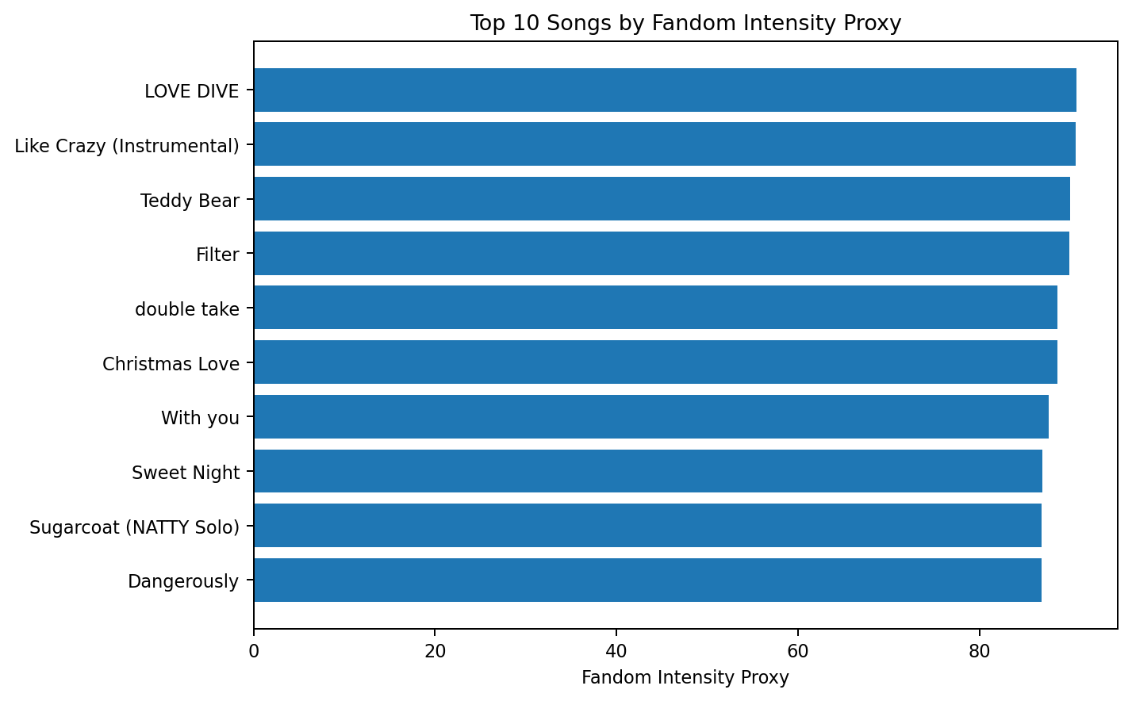
Figure 8. Top 10 songs by Fandom Intensity Proxy.
Song | Artist | Re-entries | Avg Rank Jump | Proxy Score
LOVE DIVE | IVE | 3 | 0.33 | 90.72
Like Crazy (Instrumental) | Jimin | 2 | 2.50 | 90.61
Teddy Bear | STAYC | 4 | 1.00 | 89.97
Filter | BTS | 2 | 0.50 | 89.87
double take | Dhruv | 6 | 4.33 | 88.63
Christmas Love | Jimin | 14 | 0.29 | 88.57
With you | Jimin & HA SUNG WOON | 4 | 5.25 | 87.67
Sweet Night | V | 2 | 2.00 | 86.96
Sugarcoat (NATTY Solo) | KISS OF LIFE | 3 | 2.33 | 86.85
Dangerously | Charlie Puth | 4 | 2.00 | 86.82
The highest-scoring song in the supplied leaderboard is LOVE DIVE (IVE) with a proxy score of 90.72. The leaderboard also contains songs with very different raw re-entry frequencies, demonstrating that the proxy is a composite ranking rather than a simple count of comebacks.

9. Key Insights for Power BI Storytelling
- Re-entry is recurring but concentrated: 835 events are spread across 224 songs, and the top five artists account for 56.3% of all re-entry events.
- Comeback spikes are usually short: median retention is 2 days compared with a mean of 8.54 days.
- Rank recovery is mixed: only 41.0% of re-entry events improve the prior run's ending rank; the median rank jump is 0.
- Single and album momentum is nearly at parity (48.05 vs 48.16), but recovery mechanics differ.
- Album size and song duration show almost no linear association with momentum (correlations ≈ -0.006 and 0.014, respectively).
- The Fandom Intensity Proxy is useful for prioritization and hypothesis generation, but should not be presented as actual fan count, fan sentiment or proof of coordinated streaming.
- Momentum Score and rank jump are closely linked because rank jump is the largest component of the score; these should be interpreted as related rather than independent KPIs.

10. Recommendations
- Treat a re-entry as a separate campaign state. Build a re-entry alert in Power BI that flags a song when it returns after at least one day outside the Top 50.
- Prioritize the immediate post-re-entry window. Because the median retention is only two days, promotion and monitoring should be concentrated early.
- Separate comeback intensity from persistence. Use Momentum Spike Score, Rank Jump, Days to Best Rank and Retention Days as complementary KPIs.
- Use artist-level concentration for resource allocation. The concentration of re-entry events suggests that a small number of artists can account for a large share of comeback activity.
- Use content attributes as descriptive segments, not causal drivers. The current data does not explain why a song re-entered.
- Add campaign and event metadata in future collection: release dates, performances, award shows, anniversaries, viral challenges, playlist placements and social activity. This would allow the observed re-entry patterns to be connected to likely drivers.

11. Limitations
- The source is a Top 50 playlist snapshot and does not directly contain streams, listeners, sales or fan counts.
- The Fandom Intensity Proxy is inferred from chart behavior and is not a direct fandom measurement.
- Momentum Spike Score is a constructed index; alternative weights could change rankings.
- The notebook's re-entry methodology treats consecutive observed dates as a continuous run; calendar gaps in the broader date range should be handled cautiously when interpreting edge cases.
- Explicit-content analysis is based on a small number of re-entry events compared with clean events.
- The data supports association and prioritization, not causal conclusions about promotion, fandom or event effects.

12. Alignment With the Supplied Power BI Report
The supplied Power BI file contains a Home page plus five analytical pages: Executive Overview, Re-entry Analysis, Momentum Analysis, Content Analysis, and Fandom Intensity Leaderboard. The EDA in this report is designed to support those exact page themes.
Power BI page | Primary dataset | EDA questions supported
Executive Overview | Cleaned + Reentry | Scale, activity trend, top re-entries, album mix
Re-entry Analysis | Reentry | Frequency, gaps, event-level comeback details
Momentum Analysis | Reentry | Rank jump, retention, recovery, momentum distribution
Content Analysis | Reentry + Cleaned | Album type, explicit status, album size, duration
Fandom Intensity Leaderboard | Fandom + Reentry | Proxy score, re-entry frequency, recovery behavior

13. Conclusion
The supplied South Korea Top 50 data shows a market pattern characterized by repeated, often short-lived chart reactivation. With 835 observed re-entry events, a median two-day retention, and meaningful concentration among a small set of artists, the dashboard's emphasis on comeback momentum is justified. Content attributes such as album size and song duration appear to be weak standalone explanations, while the strongest observable signals are repeated re-entry, rank recovery and short-horizon persistence. The resulting Power BI dashboard is therefore most useful as a monitoring and prioritization tool, with future event and campaign metadata needed to move from descriptive chart intelligence toward causal marketing intelligence.

