Fear and Loathing in the Global Middle Class

Raj M. Desai

By 2020, members of the global middle class will outnumber either the rich or the poor around the world. This middle-class prosperity promises to unleash opportunity, innovation, and broader economic growth in the developing world. But without a functioning system of social protection on which middle class individuals can rely, the growth in their numbers also carries significant risks of democratic retreat, conflict, and instability.

According to research from the Brookings Institution, more than half of the planet can now be considered “middle class” or “rich.” It is estimated that some 48 percent of the world’s population earns between $11 and $110 per day in PPP-adjusted dollars—a standard definition of the middle class using absolute (rather than relative) cut-offs—while another 2 percent earns more than $110 per day. According to projections and measures, the middle class will reach 4 billion people worldwide by the end of 2020, and 5.3 billion by 2030. This expansion has been driven by two phenomena: a steep decline in poverty around the world since the 1980s and rising household incomes in Asia.

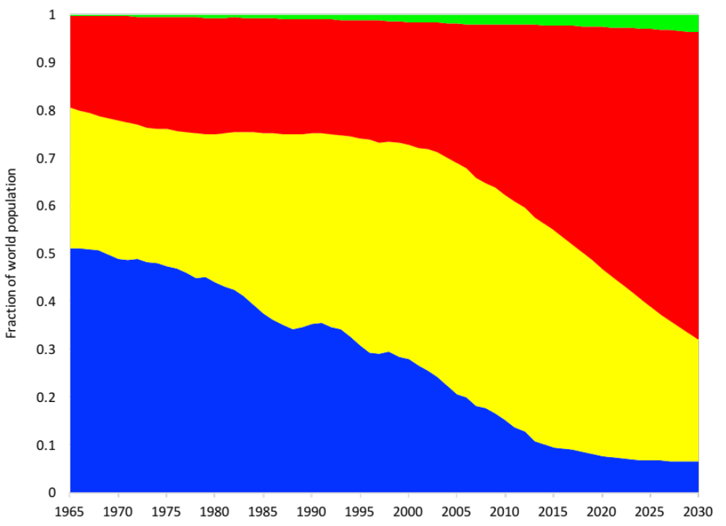
The middle class
The rich
The vulnerable
The extreme poor
Source: Data courtesy of Homi Kharas and Lorenz Noe, The Brookings Institution
Notes: Income categories, using PPP-adjusted (2011) dollars, are: extreme poor < $1.90/day; vulnerable = $1.90 to $11/day; middle class = $11 to 110/day; rich > $110/day.

The graph shows the sharp fall in poverty as well as the steady growth of the middle class since 1965, with projections to 2030. Between 1990 and 2015, the share of the population considered by the World Bank among the “extreme poor” (less than $1.90 per day) fell by almost 75 percent, surpassing the first goal of the UN Millennium Development Goals to slash extreme poverty by half. At the same time, the bulk of middle-class growth occurred in the Asia-Pacific region, driven by China and India, along with Indonesia, the Philippines, and Thailand. By 2030, nearly 9 out of 10 new middle-class consumers will be living in East, South, and Southeast Asia.

There should be reasons to cheer this global “tipping” point. For the first time in recorded history, the majority of the world’s population will not consist of impoverished peasants or workers, but of wage-earners who can afford to buy cell phones, washing machines, and televisions, to go out to restaurants and theaters, and to take vacations with their families.

A growing middle class is supposed to be good for society. Their consumerism is supposed to boost global production of durable goods and make businesses more efficient and innovative in targeting these new customers. The global middle class is also committed to the education of their children. The middle class is more entrepreneurial than either the rich or the poor, and demands more transparency from policymakers and tolerates less corruption. Because the middle class does not owe its wealth to privileges granted by the state, its members are more likely to support protections for property rights, as well as greater access and representation in decision-making. The middle class is more politically engaged than either the rich or poor. A middle class is, therefore, a requirement for stable democracy; one of the most famous phrases in social science history is “no bourgeoisie, no democracy” written in 1966 by the political sociologist Barrington Moore, Jr., arguing that the only democratic route to modernity was through the middle class.

For all these benefits, the world has also observed a recent dark side to the growing global middle class. While middle-class individuals may be more entrepreneurial and civic-minded, they also appear to be more prone to support radicalism, authoritarianism, and political violence. Although the middle class played a major role in democratic transitions in Latin America and East Asia in the 1980s, they have also supported military interventions against democratically-elected leaders in Thailand (2006, 2014), Honduras (2009), and Egypt (2013). In Pakistan, Indonesia, Colombia, and several Arab states, the middle classes appear to support political violence to a greater extent than the rich or poor.

How do we reconcile these two views of the global middle class? One possibility is that rising affluence is producing rising expectations. Individuals with more purchasing power, education, and information can place tremendous pressure on governments that may lack the capacity to meet those expectations. And when rising expectations go unfulfilled, the result can be backlash, declining trust in institutions, and conflicts with other groups.

Another explanation has to do with a slow, widening disconnect between middle-class citizens and their governments.

Take a look at the graph again. Notice that, while the fraction of extreme poor has been falling towards 10 percent, the “vulnerable poor” (those earning above $1.90 per day but less than $11 per day) has been relatively constant over that same period. In fact, since the 1990s, it has actually grown! This shows that the dramatic rise in the middle class is because of “churning” among this vulnerable group. Most of the extreme poor have seen their incomes rise, and over time they have become vulnerable—that is, no longer poor, but still not able to join the ranks of the middle class. Meanwhile, some of those that were considered vulnerable have joined the middle class—but not nearly as many as those members of the extreme poor that have become vulnerably poor. Meanwhile, some who have risen from vulnerable to the middle class may have fallen back into vulnerability.

In other words, being a new member of the global middle class is a precarious thing. An illness, a recession, an ecological or natural disaster can all plunge new middle-class members back into poverty.

In the West, the growth in the middle class occurred alongside an expansion in a universal social safety net. Social “protection”—the collection of policies designed to reduce poverty and vulnerability by limiting people's exposure to risk—was used to tamp down radicalization and social upheaval among the industrial workforce and its accompanying political movements—socialist parties and revolutionary communes. In the 1880s, with the support of “bourgeois parties” against social democrats, Bismarck’s government crafted the elements of the modern welfare state: healthcare, disability, and pensions. Similarly, France established free medical assistance and assistance programs for workers in the 1890s. Facing trade union mobilization and electoral threats from the newly-formed Labour Party, the governing Liberals in Britain established worker pensions, unemployment, and health insurance between 1906 and 1911.

By contrast, in most developing nations, social protection tends to be fragmented, temporary, or highly targeted towards specific groups of individuals (mostly the extreme poor), and financed from general budget revenues rather than contributions. As a consequence, the growing middle class has little stake in a system of social assistance from which they have been typically excluded. Brazil’s Bolsa Familia program, which provided small cash transfers to poor families, is widely credited with lifting millions out of poverty in that country. But for the tax-paying middle classes, Bolsa Familia provided no cushion against economic shocks (in fact, the current far-right presidential candidate Jair Bolsonaro once declared Bolsa Familia to be a “crime” against the Brazilian people for how it redistributes money to the underprivileged). Meanwhile rich Brazilians have access to pensions and other programs for salaried professionals.

What this comes down to is that, in many countries, the middle class are left out, despite the fact that many individuals in the middle class are one shock away from becoming poor again.

There is evidence that social protection in today’s developing countries is more limited when compared to today’s advanced economies when they were at similar levels of wealth. There are a number of reasons for this. Greater integration into the global economy has caused developing countries to reduce taxes in order to attract highly-mobile foreign capital. Large portions of the labor force in today’s developing countries work in the informal sector. Labor unions in many developing countries lack the political clout they had in richer countries in the late-19th and early-20th centuries.

According to the International Labour Organization, 80 percent of the developing world’s population has no access to social protection. Little wonder then that, across the developing world, the new middle classes send their children to private schools, use private healthcare, dig their own boreholes for water, and buy their own generators. This middle-class “exit” means there are few demands by the middle classes to improve the public provision of services or the functioning of their government.

A new social contract that connects the emerging middle class to their own governments, as well as to the global economy, will be needed to avoid exacerbating tensions between social classes and to remove barriers to social mobility, while preserving the benefits afforded by globalization and technological change.

Part of this new social contract requires resisting the default preference for targeted benefits. In the 1980s and 1990s, many developing countries shifted away from broad social policies that emphasized universal benefits toward an approach that concentrated public resources on the poorest segments of the population, but which gradually alienated the non-poor in these countries. Abetting this transformation in social policy has been a host of multilateral and bilateral donors that emphasized short-term cost-effectiveness over political support from broader segments of citizens in those countries.

Crafting a social contract for the middle class in developing countries when support for globalization is under stress in advanced economies presents an additional challenge. Without efforts by richer nations to extend the benefits of the global economy to poorer countries, there is a strong risk that politicians in both places will stoke conflict between the middle class and the poor, or between the middle class in emerging economies and those in advanced economies.

The United States and Western Europe have seen some of the consequences of a middle-class revolt against political systems that were perceived to be under-delivering. Whether rising incomes in the developing world creates global opportunities for shared economic growth, or unleashes new forces of division and disorder will depend critically on policies that can gain acceptance and buy-in from the middle class.

