# Bone Fracture Classification Report:

### Data Exploration and Preprocessing

* The dataset contained 10 types of bone fractures with folders for training and testing.
* Each image was loaded, resized to 224x224 pixels, and normalized.
* A label mapping dictionary was created to encode fracture types from strings to numbers.
* Basic visualizations were used to confirm dataset balance and view representative images per class.

### Model Development

* I used **MobileNetV2**, a lightweight pre-trained CNN from Keras.
* Layers were frozen initially to leverage transfer learning.
* The classifier was built with:
  + GlobalAveragePooling2D
  + Dense(128, relu)
  + Dense(10, softmax) for classification.

### Model Evaluation and Improvement

* **Initial results without augmentation**:
  + Accuracy: ~37%
  + Loss: ~2.05
* **With Data Augmentation**:
  + Applied: Rotation, Flip, Zoom, Shift
  + Final validation accuracy: **50.7%**
  + Test accuracy: **~44%**
* **Fine-tuning** (unfreezing last 50 layers):
  + Accuracy didn’t improve further. Test accuracy plateaued around 47%.
* **Conclusion**: MobileNetV2 with data augmentation gave the best balance of performance and training efficiency.

### Streamlit App Interface

* Built a simple app using Streamlit that:
  + Let’s users upload an X-ray image (.jpg/.png).
  + Displays predicted fracture type and class confidence.
* Model used: mobilenet_fracture_model_da.keras
* 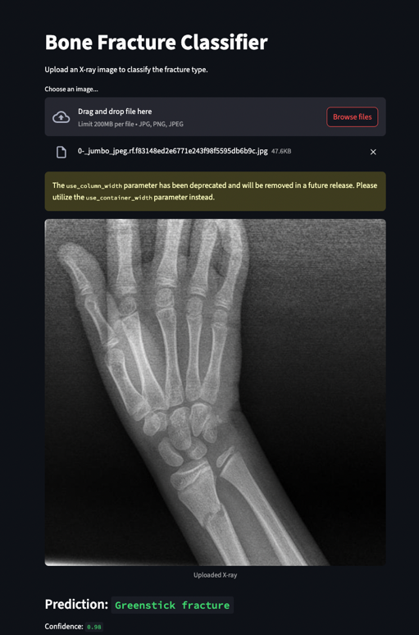Screenshots:

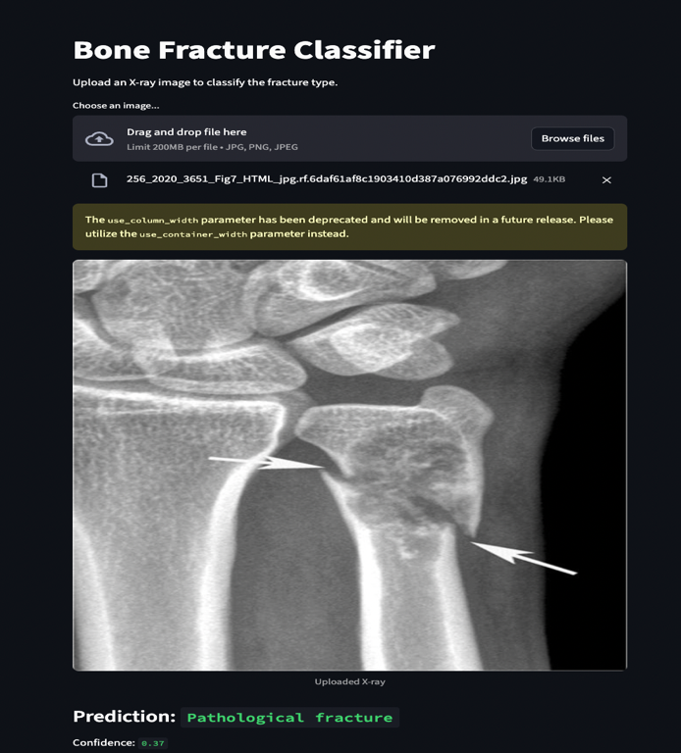

This project shows how deep learning models can assist doctors in classifying bone fractures automatically. While not a replacement for expert diagnosis, it can:

* Help in triaging large volumes of X-rays.
* Provide a second opinion to reduce human error.
* Be used in low-resource clinics where radiologists are not always available.