MODULE 5

Q1. Define Transport Layer Security (TLS) and IP Security (IPSec). Give one example of each used in real-world communication systems.
1. Transport Layer Security (TLS):
- TLS stands for Transport Layer Security. It is a cryptographic protocol that helps in providing secure communication between a client and a server over the Internet.
- TLS works at the transport layer, above TCP, and ensures three main security services — confidentiality, integrity, and authentication.
- Confidentiality means that the data exchanged between the browser and the server is encrypted, so only the sender and receiver can understand it.
- Integrity ensures that the data is not changed or modified during transmission. Any small change in data is detected immediately.
- Authentication is done using digital certificates, where the server (and sometimes the client) proves its identity to avoid fake websites.
- The TLS process starts with a handshake, during which the browser and server agree on encryption algorithms, verify certificates, and generate a shared secret key for encryption.
- After the handshake, all the communication (like passwords or payment details) is encrypted using symmetric keys for speed and security.
- TLS uses asymmetric encryption (RSA, ECDHE) during handshake and symmetric encryption (AES, ChaCha20) for actual data transfer.
- Example: The best-known example of TLS is HTTPS, which secures websites and online shopping transactions by protecting user data.

2. IP Security (IPSec):
- IPSec stands for Internet Protocol Security, and it works at the network layer of the OSI model.
- Unlike TLS, which protects individual applications, IPSec protects all IP packets — meaning all network traffic between two systems can be secured automatically.
- It provides encryption, integrity, authentication, and anti-replay protection for IP packets.
- IPSec can operate in two modes:
  - Transport Mode: Only the payload (data) of the IP packet is encrypted, and the header remains intact. Used for host-to-host communication.
  - Tunnel Mode: The entire IP pa cket is encrypted and placed inside a new IP packet. Commonly used for VPNs between networks.
- IPSec uses two main protocols —
  - AH (Authentication Header): provides integrity and authentication but no encryption.
  - ESP (Encapsulating Security Payload): provides encryption along with integrity and authentication.
- Key exchange and security agreement in IPSec are handled using IKE (Internet Key Exchange) protocol, which establishes shared keys between devices.
- IPSec is widely used for Virtual Private Networks (VPNs), allowing employees to securely connect to their company’s internal network over the Internet.
- Example: IPSec VPN connection between two branch offices of a company allows secure file transfer and communication.

✅ Final Short Summary to Write:
TLS secures communication at the transport layer and is mainly used for HTTPS websites to protect online data. IPSec secures communication at the network layer and is commonly used for VPNs to protect all IP traffic between networks.

Q2. Explain the handshake process in SSL/TLS. How does it establish a secure channel between a browser and a server during online shopping?
- The TLS handshake is the process by which a client (like a web browser) and a server (like an e-commerce website) establish a secure communication channel before exchanging actual data.
- The handshake ensures three things — that both parties agree on encryption methods, that the server is authenticated, and that they share a secret key to encrypt further data.
- The process begins when the client sends a “ClientHello” message to the server. This message contains the TLS version it supports, a list of available cipher suites (encryption algorithms), and a random number called the Client Random.
- The server replies with a “ServerHello” message, choosing the TLS version and cipher suite to be used. It also sends its own Server Random value.
- The server then sends its digital certificate, which contains its public key and is signed by a trusted Certificate Authority (CA). The client uses this to verify the server’s identity.
- If the handshake uses ephemeral key exchange (like ECDHE), the server sends temporary key parameters, allowing both sides to generate a shared secret securely.
- The client verifies the certificate using the CA’s signature and checks that the certificate is valid for the website’s domain.
- The client and server now compute a “pre-master secret”, using Diffie–Hellman or RSA encryption, which is then converted into a shared symmetric session key used for encryption and decryption of data.
- Once the key is established, the client sends a “Change Cipher Spec” message to tell the server that it will now start sending encrypted messages using the session key.
- The server also sends its Change Cipher Spec message, confirming that both are now in secure mode.
- Both send a “Finished” message, which is encrypted and used to verify that the handshake has not been tampered with.
- After this handshake, all further communication (like user login, payment, etc.) is encrypted using the shared symmetric key, ensuring privacy and data protection.
- During online shopping, this process ensures that personal data such as credit card details or passwords cannot be read or modified by hackers.

✅ Final Short Summary to Write:
The TLS handshake establishes a secure channel by exchanging hello messages, verifying the server’s certificate, agreeing on encryption methods, generating shared secret keys, and confirming encryption setup. After the handshake, all browser–server communication is encrypted, protecting sensitive data during online shopping.

Q3. Demonstrate how TLS certificates are used to secure an HTTPS connection and how the browser validates server identity using a certificate chain.
- TLS uses digital certificates (called X.509 certificates) to prove the identity of a website and to provide the public key used in encryption.
- A certificate contains details like the domain name, organization name, public key, issuer name (CA), validity period, and the CA’s digital signature.
- When a browser connects to an HTTPS website, the server sends its certificate chain during the TLS handshake.
- This chain usually consists of three parts:
  - The Leaf Certificate (for the website itself, e.g., www.amazon.com).
  - One or more Intermediate Certificates (issued by trusted authorities).
  - The Root Certificate, which is already stored in the browser’s or operating system’s trusted store.
- The browser then verifies the validity of each certificate in the chain. It starts from the leaf certificate, checks who issued it, and continues verifying until it reaches a trusted root CA in the local store.
- The browser checks the certificate’s validity period, ensuring the current date is between the “Not Before” and “Not After” dates.
- It then verifies that the domain name (hostname) in the certificate matches the address entered by the user. This is checked in the Subject Alternative Name (SAN) field.
- Next, the browser uses the public key of the issuer (CA) to verify the digital signature on each certificate in the chain. If all signatures are valid, the chain is considered trusted.
- The browser may also check if the certificate has been revoked (cancelled) by the CA using methods like OCSP (Online Certificate Status Protocol) or CRL (Certificate Revocation List).
- If all checks are successful, the browser accepts the certificate and proceeds with the TLS handshake. This means the server’s public key can be trusted for secure communication.
- As a result, when a user visits an HTTPS website, they can see a padlock icon in the browser, indicating that the website is verified and that all communication is encrypted and authentic.
- If any step fails (for example, an expired certificate, wrong domain, or untrusted CA), the browser shows a security warning to protect the user from attackers.

✅ Final Short Summary to Write:
In HTTPS, TLS certificates are used to verify the server’s identity. The browser receives the certificate chain, checks the validity dates, domain name, and digital signatures up to a trusted root CA. If the chain is valid, it trusts the server and establishes an encrypted connection ensuring safe data transmission.

Q4. Configure a simple VPN scenario where IPSec is used to secure data between two branch offices. Explain how Encapsulating Security Payload (ESP) ensures confidentiality and integrity.
1. Scenario Description:
Imagine a company has two branch offices, one in Pune and one in Mumbai. Both offices are connected through the Internet, which is an insecure public network.
To keep company data secure while it travels over the Internet, the company sets up a Virtual Private Network (VPN) using IPSec.
2. Configuration Concept:
Each office has a VPN gateway (router or firewall) that supports IPSec.
- The Pune branch router encrypts outgoing data.
- The Mumbai branch router decrypts the received data.
Both routers share a security policy and encryption keys (for example, AES for encryption and SHA-256 for authentication).
3. IPSec Tunnel Mode:
In this configuration, IPSec operates in Tunnel Mode, which means the entire IP packet (header + data) is encrypted and encapsulated into a new packet with a new IP header.
This allows secure communication between the two networks as if they were directly connected.
4. Role of Encapsulating Security Payload (ESP):
ESP is the main protocol in IPSec that provides confidentiality, integrity, and authentication.
Here’s how ESP works:
- Encryption (Confidentiality):
ESP encrypts the actual data payload using algorithms like AES or DES.
This ensures that even if attackers intercept the packets, they cannot read the information.
- Integrity (Data Protection):
ESP adds an Integrity Check Value (ICV) using hashing (e.g., SHA-1, SHA-256).
The receiver verifies this hash to ensure that the data was not modified during transmission.
- Authentication:
ESP can also authenticate the sender, ensuring that the packet actually came from a trusted source.
- Anti-Replay Protection:
Each ESP packet contains a sequence number. If an attacker tries to resend old packets, the receiver can detect and discard them.
5. Example Flow:
When the Pune branch sends data:
- IPSec encrypts the data using ESP.
- Adds an ESP header and trailer.
- Sends the packet securely over the Internet to Mumbai.
At the Mumbai end, the router decrypts it and sends it to the local LAN user.
6. Summary:
Thus, ESP in IPSec VPN ensures that the data exchanged between the two branch offices is confidential, tamper-proof, and authentic, creating a secure private channel over a public network.

Q5. Analyze the key differences between SSL, TLS, and IPSec in terms of protocol layer, use cases, encryption scope, and performance. Which one is best for securing email communication?
1. Introduction:
SSL (Secure Sockets Layer), TLS (Transport Layer Security), and IPSec (Internet Protocol Security) are all security protocols designed to protect data during transmission, but they operate at different layers of the OSI model and serve different purposes.
2. Protocol Layer:
- SSL/TLS:
Operates at the Transport Layer. It provides end-to-end encryption for applications like web browsers, emails, and instant messaging.
- IPSec:
Works at the Network Layer. It protects IP packets themselves, regardless of which application is sending or receiving them.
3. Use Cases:
- SSL:
Older protocol mainly used for securing web traffic (now mostly replaced by TLS).
- TLS:
Used in HTTPS websites, email protocols (IMAP, POP3, SMTP), and VPNs (TLS VPN).
- IPSec:
Commonly used for site-to-site VPNs, remote access VPNs, and secure communication between routers.
4. Encryption Scope:
- SSL/TLS:
Encrypts data at the application level (e.g., messages between browser and web server).
- IPSec:
Encrypts entire IP packets, including headers and payloads (in tunnel mode). It secures all traffic between two systems or networks.
5. Performance:
- TLS:
Lightweight, fast for web-based transactions (less overhead).
- IPSec:
More overhead due to encryption of every packet, but provides full network-level protection.
- SSL:
Slower and less secure than TLS, mostly outdated.
6. For Securing Email Communication:
- TLS is the best choice for email security.
  - It secures SMTP, IMAP, and POP3 connections.
  - Ensures end-to-end encryption between mail servers or between user and mail server.
  - Example: STARTTLS command upgrades plain email connection to a secure one.
7. Summary Table:
Feature | SSL | TLS | IPSec
OSI Layer | Transport | Transport | Network
Scope | Application data | Application data | Entire IP packet
Main Use | Old web encryption | HTTPS, Email, Web apps | VPNs, Secure networks
Speed | Slow | Fast | Moderate
Security | Outdated | Strong | Very Strong
8. Conclusion:
TLS is preferred for email and web-based applications, while IPSec is ideal for VPNs and network-level encryption.

Q6. Examine what could go wrong if an attacker performs a man-in-the-middle attack during a TLS handshake. What protections are built into TLS to prevent this?
1. Introduction:
A Man-in-the-Middle (MITM) attack occurs when an attacker secretly intercepts and possibly alters communication between two parties — such as between a web browser (client) and a web server.
2. TLS Handshake Overview:
During the TLS handshake, the client and server exchange:
- Cryptographic keys,
- Supported cipher suites,
- And the server’s digital certificate for authentication.
This process establishes a secure encrypted session.
3. What Could Go Wrong (If MITM Happens):
- If an attacker intercepts the handshake, they might try to:
  - Replace the server’s certificate with a fake one.
  - Modify public keys exchanged between client and server.
  - Eavesdrop on sensitive information like passwords or credit card numbers.
- If successful, the attacker could decrypt or alter messages and impersonate the real server.
4. How TLS Prevents MITM Attacks:
(a) Digital Certificates and Certificate Authorities (CA):
- The server sends a certificate signed by a trusted CA.
- The client browser checks the certificate’s authenticity using the CA’s public key.
- If the certificate is forged or not issued by a trusted CA, the browser displays a security warning.
(b) Public-Key Cryptography:
- The server’s private key is known only to the legitimate server.
- Even if an attacker intercepts the data, they cannot decrypt it without the private key.
(c) Session Key Exchange:
- TLS uses Diffie-Hellman or ECDHE key exchange.
These algorithms create a unique session key that even the server cannot reuse later.
Attackers cannot compute this key even if they see all exchanged data.
(d) Certificate Validation:
- The browser verifies the certificate’s:
  - Domain name (must match the website),
  - Validity period, and
  - CA signature chain.
If anything mismatches, the connection is not established.
(e) Integrity Check:
- Each message includes a Message Authentication Code (MAC).
This prevents tampering — if an attacker modifies even one bit, the MAC fails verification.
5. Example:
When you visit https://www.amazon.com, your browser:
- Checks Amazon’s TLS certificate issued by a trusted CA (like DigiCert).
- Confirms it matches the domain name.
- Establishes an encrypted session.
Any MITM attempting to impersonate Amazon will fail certificate verification.
6. Conclusion:
TLS prevents man-in-the-middle attacks through a combination of encryption, authentication, and integrity checking.
These mechanisms ensure that only the legitimate server and the user can communicate securely — protecting against interception or impersonation.

Q7. Evaluate the effectiveness of IPSec’s Authentication Header (AH) vs Encapsulating Security Payload (ESP) in protecting data confidentiality and integrity. Which is more suitable for VPNs and why?
- IPSec (Internet Protocol Security) is a protocol suite that secures communication over IP networks. It provides two main components for data protection — Authentication Header (AH) and Encapsulating Security Payload (ESP).
- Authentication Header (AH) provides authentication and integrity but does not encrypt the data. It ensures that the packet was sent by a trusted source and has not been modified during transmission.
- AH uses a cryptographic hash (such as SHA-256) to create a message digest of the packet data. This digest is verified by the receiver to ensure the data has not been altered.
- AH protects most of the IP packet, including some header fields, but it does not provide confidentiality, meaning anyone who intercepts the packet can still read the content.
- On the other hand, Encapsulating Security Payload (ESP) provides encryption, authentication, and integrity. It hides the data content from unauthorized users.
- ESP encrypts the payload using symmetric encryption algorithms such as AES or 3DES, which ensures confidentiality by making the data unreadable to outsiders.
- ESP also includes a hash function to verify data integrity and an optional authentication field to verify the sender’s identity.
- ESP can operate in two modes:
a) Transport Mode – Encrypts only the data, leaving the IP header visible.
b) Tunnel Mode – Encrypts the entire IP packet and adds a new IP header (used for VPNs).
- When comparing both, AH = authentication + integrity, while ESP = authentication + integrity + encryption.
- Therefore, ESP is more suitable for VPNs because VPNs require both confidentiality and integrity of data when transferring information between branch offices over the Internet.

Q8. Assess how the TLS version upgrade (from TLS 1.2 to TLS 1.3) improves performance and security in real-time applications such as video conferencing or mobile banking.
- TLS 1.3 is the latest version of the Transport Layer Security protocol and was introduced to improve both security and speed compared to TLS 1.2.
- In TLS 1.2, the handshake process required two round trips between client and server before secure communication could begin. This increased delay, especially noticeable in real-time applications like video calls or banking apps.
- In TLS 1.3, the handshake is simplified to just one round trip, which greatly reduces connection setup time and improves performance for latency-sensitive services such as video conferencing.
- TLS 1.3 removes outdated and insecure cryptographic algorithms such as RSA key exchange, SHA-1, and MD5, and only allows modern, secure algorithms like AES-GCM and ChaCha20-Poly1305.
- The forward secrecy feature in TLS 1.3 ensures that even if the private key is compromised in the future, past sessions cannot be decrypted.
- TLS 1.3 also eliminates renegotiation attacks and downgrade attacks by enforcing stronger cipher suites and disallowing fallback to weaker versions.
- For mobile banking, TLS 1.3 ensures that sensitive data like login credentials and transaction details are encrypted faster and with stronger security than before.
- In video conferencing, where connections need to be fast and continuous, TLS 1.3’s reduced handshake time and efficient encryption minimize lag and buffering.
- Additionally, TLS 1.3 supports 0-RTT (Zero Round Trip Time) mode for repeated connections, allowing the client to start sending encrypted data immediately, improving speed.
- In summary, TLS 1.3 improves both performance (faster handshake, reduced latency) and security (stronger encryption, forward secrecy), making it ideal for real-time and sensitive online applications.

OR

• Introduction to TLS 1.3: TLS 1.3 is the latest version of the Transport Layer Security protocol, designed to replace TLS 1.2. It aims to improve both security and performance for Internet communications. It is widely used in applications requiring confidentiality and integrity, such as online banking, video conferencing, and messaging apps.
• Performance improvements: One of the key changes in TLS 1.3 is the reduction in handshake round trips. While TLS 1.2 required multiple exchanges between client and server (usually two round trips) to establish a secure connection, TLS 1.3 can establish the session in just one round trip. This reduces latency, which is critical for real-time applications like video calls or live transactions, improving user experience.
• Security enhancements: TLS 1.3 removes older, vulnerable cryptographic algorithms such as RSA key exchange, SHA-1, and weak ciphers. It only supports strong, forward-secure algorithms like ECDHE (Elliptic Curve Diffie-Hellman Ephemeral) for key exchange. Forward secrecy ensures that even if long-term keys are compromised in the future, past communication remains secure.
• Simplified cipher suites: TLS 1.3 reduces the number of supported cipher suites, minimizing configuration errors and reducing exposure to attacks such as protocol downgrade attacks. This simplifies implementation for developers and enhances security in high-speed applications.
• 0-RTT data option: TLS 1.3 allows optional 0-RTT (zero round trip time) data, letting clients send data immediately with the first message in some scenarios. This is especially useful in mobile banking apps or video conferencing, where connection setup speed is critical. However, 0-RTT requires careful replay attack prevention.
• Improved resistance to attacks: TLS 1.3 protects against man-in-the-middle attacks, eavesdropping, and replay attacks better than TLS 1.2. By removing outdated and insecure features, it reduces the attack surface and increases overall trustworthiness of sensitive applications.
• Conclusion: The upgrade from TLS 1.2 to TLS 1.3 significantly improves both performance and security. Real-time applications like video conferencing, VoIP calls, or mobile banking benefit from faster connection setup, reduced latency, stronger encryption, forward secrecy, and a smaller, safer set of cipher suites, making TLS 1.3 the preferred choice for modern secure communication.

Q1. Describe the role of Encapsulating Security Payload (ESP) in IPsec.
Answer:
- Encapsulating Security Payload (ESP) is an IPsec protocol that provides secure communication by offering confidentiality, integrity, authentication, and anti-replay protection to IP packets.
- ESP ensures confidentiality by encrypting the payload of an IP packet using algorithms such as AES or 3DES, so that unauthorized users cannot read the transmitted data.
- ESP maintains data integrity by adding a cryptographic hash (HMAC) that helps the receiver verify that the packet has not been altered during transmission.
- ESP also provides authentication of the sender by using keyed hash values, which allow the receiver to confirm that the packet truly came from the claimed source.
- ESP includes an anti-replay mechanism using a sequence number field, which prevents attackers from capturing and sending old packets again to disrupt communication.
- ESP can operate in Transport Mode, where only the payload is encrypted, making it suitable for end-to-end communication between hosts.
- ESP can also operate in Tunnel Mode, where the entire original IP packet (header + data) is encrypted and then encapsulated inside a new IP packet, which is mainly used in VPNs between security gateways.

Diagram: ESP in Transport and Tunnel Mode
Transport Mode
| IP Header | ESP Header | Encrypted Data | ESP Trailer | Auth Data |
Tunnel Mode
| New IP Header | ESP Header | Encrypted (Old IP Header + Data) | ESP Trailer | Auth Data |

Q2. Analyze how SSL/TLS prevents Man-in-the-Middle (MITM) attacks using certificates.
Answer:
- SSL/TLS prevents MITM attacks by using digital certificates that authenticate the identity of the server before the client sends any sensitive data.
- When a user connects to a secure website, the server sends its digital certificate, which contains the server’s public key and is digitally signed by a trusted Certificate Authority (CA).
- The client verifies the certificate using the CA’s public key, ensuring that the certificate has not been forged, altered, or issued by an untrusted party.
- If the certificate is valid, the client is assured that it is communicating with the genuine server and not an attacker pretending to be that server.
- After authentication, SSL/TLS establishes a secure session key using the server’s public key, and this key is used to encrypt all further communication, preventing eavesdropping.
- A MITM attacker cannot decrypt or modify the communication because they do not possess the server’s private key, which is required to complete the SSL/TLS handshake.
- Thus, digital certificates and the certificate validation process form the foundation of SSL/TLS security and effectively prevent MITM attacks.

Diagram: SSL/TLS MITM Prevention
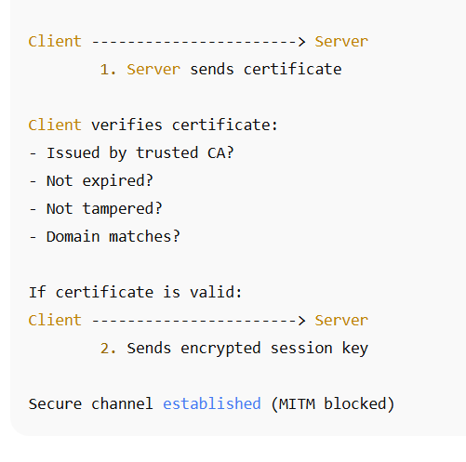
Secure channel established (MITM blocked)

Q.3; Explain how S/MIME provides confidentiality and authentication in secure email.
S/MIME (Secure/Multipurpose Internet Mail Extensions) is a security standard used to protect email messages.
It provides confidentiality, authentication, message integrity, and non-repudiation using a combination of encryption and digital signatures.
The way S/MIME achieves confidentiality and authentication is explained in detail below:

A. How S/MIME Provides Confidentiality
- S/MIME ensures confidentiality by encrypting the email message so that only the intended recipient can read it.
Encryption is done using the recipient’s public key, which means the message is readable only when decrypted using the corresponding private key.
- When the sender wants to send a secure email, the sender obtains the recipient’s public key from a digital certificate (X.509 certificate).
These certificates are stored in corporate directories or email contact lists.
- The sender generates a random symmetric session key (for algorithms like AES) to encrypt the email content, because symmetric encryption is faster.
- This session key is then encrypted using the recipient’s public key and attached to the email.
Only the recipient can decrypt the session key using their private key.
- The recipient first decrypts the session key using their private key, and then uses that session key to decrypt the email content.
This ensures that even if the email is intercepted, no attacker can read it because they do not possess the private key.

Diagram: Confidentiality in S/MIME (Encryption)
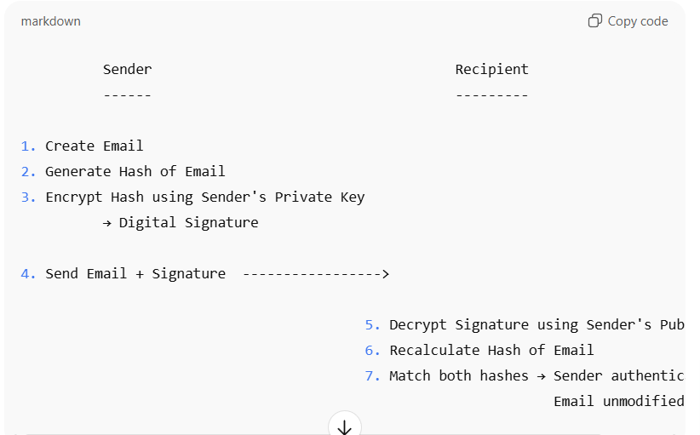
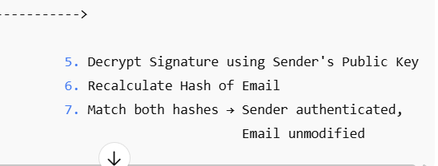

B. How S/MIME Provides Authentication
- Authentication in S/MIME is provided through the use of digital signatures applied by the sender.
A digital signature proves the identity of the sender.
- To create a digital signature, the sender first generates a hash (digest) of the email content using algorithms such as SHA-256.
- The sender then encrypts this hash value using their own private key.
This encrypted hash is the digital signature.
- When the recipient receives the signed email, they use the sender’s public key (from the sender’s digital certificate) to decrypt the signature.
If decryption is successful, the recipient knows that the message was signed by the legitimate sender.
- The recipient also recomputes the hash of the email message. If this hash matches the decrypted hash from the signature, it proves that the message has not been altered.
This ensures both authentication and integrity.
- Since only the sender has access to the private key, the signature cannot be forged, which also provides non-repudiation (sender cannot deny sending the email).

Diagram: Authentication in S/MIME (Digital Signature)
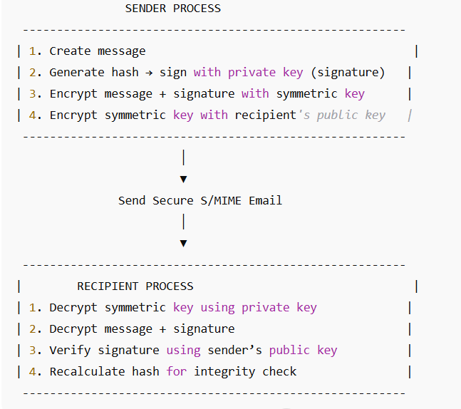

MODULE 4

Q1. Define message authentication and integrity. Give one real-world example of each in secure communication.
- Message Authentication — definition: Message authentication is the process that allows the receiver of a message to verify that the message actually came from the claimed sender and not from an impostor. This is accomplished using cryptographic techniques so that only a party possessing a shared secret key or the corresponding private key could have produced the authentication token.
- Message Authentication — purpose: Its purpose is to prevent impersonation and to ensure that the origin of the message can be trusted; it does not necessarily hide the message contents (that is confidentiality is separate).
- Message Authentication — how it is commonly realized: Typical mechanisms include HMAC (Hash-based Message Authentication Code) which uses a shared secret and a hash function, or digital signatures where a sender signs the message using a private key and the receiver verifies with the sender’s public key.
- Real-world example of message authentication: In online banking, when a bank’s server sends a transaction confirmation to a user’s mobile app, the message may include an HMAC tag computed with a secret shared between the app and the bank; the app verifies the HMAC to confirm the message is legitimately from the bank.
- Message Integrity — definition: Message integrity is the property that ensures a message has not been altered in transit. If even a single bit is changed by accident or by an attacker, the receiver will detect the change.
- Message Integrity — purpose: Its purpose is to detect accidental corruption (e.g., network errors) and deliberate tampering (malicious changes), so that modified messages are rejected rather than trusted.
- Message Integrity — how it is commonly realized: Integrity is enforced using cryptographic hashes (e.g., SHA family) combined with authentication (HMAC) or with digital signatures; simple checksums are insufficient for security because they are easy to forge.
- Real-world example of message integrity: In email verification, when an email provider checks a signed S/MIME message, the signature verification assures the email body and attachments have not been altered since the sender signed them — this protects against tampering and ensures integrity.

Q2. Explain how a cryptographic hash function (like MD5 or SHA-1) ensures message integrity in data transmission. Why is it called a “one-way” function?
- What a cryptographic hash function produces: A cryptographic hash function takes an arbitrary-length input (a message) and computes a fixed-length value called the hash or digest. For MD5 the digest is 128 bits, for SHA-1 it is 160 bits, and for modern secure hashes (SHA-256) it is 256 bits.
- How hashing is used for integrity: To protect integrity, the sender computes the hash of the message and sends the message plus the hash (or a protected form of the hash) to the receiver. The receiver recomputes the hash over the received message and compares it to the hash value sent by the sender. If the two match, the message was not altered in transit.
- Why plain hash alone is not sufficient for security: If an attacker can modify both the message and its hash, they can forge any modification. Therefore, for secure integrity the hash is usually paired with a secret (HMAC) or signed with the sender’s private key to prevent forgery.
- Properties that make a hash function suitable for integrity:
  - Preimage resistance: Given a hash value h, it is computationally infeasible to find any message m such that hash(m) = h. This prevents an attacker from forging a message that maps to a known hash.
  - Second preimage resistance: Given an input m1, it is infeasible to find m2 != m1 such that hash(m1) = hash(m2). This prevents substituting one valid message for another without detection.
  - Collision resistance: It is infeasible to find any two distinct messages m1 and m2 such that hash(m1) = hash(m2).
- Why it's called “one-way”: A hash is called one-way because it is easy to compute the hash of a message (forward direction), but computationally infeasible to reverse the process — i.e., given only the hash value you cannot retrieve the original message or any message that produces that hash. This asymmetry (easy to compute, hard to invert) is what “one-way” denotes.
- Example usage in transmission: When downloading a software package, the website publishes the SHA-256 digest. After downloading, the user computes the SHA-256 hash locally. If the computed digest matches the published digest, the file integrity is confirmed (no accidental corruption or tampering).

- Q3. Demonstrate how HMAC (Hash-based Message Authentication Code) can be used to authenticate a financial transaction message. Illustrate the process with sender and receiver roles.
- What HMAC is: HMAC is a method that combines a cryptographic hash function with a secret symmetric key shared between sender and receiver, producing a fixed-length authentication tag. HMAC secures both the message integrity and the authenticity of the sender.
- Why HMAC is suitable for financial transactions: Financial messages require that the receiver be certain the message came from a genuine source (bank or POS terminal) and that the contents were not altered. HMAC provides both guarantees efficiently with standard hash functions (e.g., HMAC-SHA256).
- Preconditions for the example: Assume the bank server and the client (mobile app or ATM) share a secret symmetric key K. The agreed hash function is SHA-256.
- Sender role (Bank server) — steps to create HMAC for a transaction message:
a. Prepare the transaction message M, e.g., string: "TXNID=12345;AMOUNT=1000;ACCT=987654".
b. Compute the HMAC tag: T = HMAC_SHA256(K, M). HMAC_SHA256 inputs the key and the message and outputs a 256-bit tag.
c. Transmit M and T to the receiver (client).
- Receiver role (Client) — steps to verify HMAC and accept transaction:
a. Receive M' and T'. (Ideally, M' == M unless tampered.)
b. Recompute T_check = HMAC_SHA256(K, M') using the same secret key K.
c. Compare T_check and T' using a constant-time comparison to avoid timing attacks.
d. If T_check == T', accept the message as authentic and unmodified; otherwise, reject it and raise an error (possible tampering or incorrect sender).
- Security properties provided in the example:
  - Authentication: Only an entity with the shared key K can produce a valid tag T, so a successful verification authenticates the sender.
  - Integrity: Any modification to M (even a single bit) will cause HMAC_SHA256 to produce a different tag, so the receiver detects tampering.
  - Replay protection (optional): To avoid replay attacks, include a nonce or timestamp in M so old transactions cannot be resent successfully.
- Practical note: In real banking systems, the key K must be securely stored (HSMs), keys rotated periodically, and transport-level encryption (TLS) is also used alongside HMAC for confidentiality.
- Short exam-style summary to write: The sender computes T = HMAC(K, M) and sends (M, T). The receiver recomputes HMAC(K, M') and verifies equality. Matching tags mean the message is both authentic and intact.

Q4. Compute a simple example of message hashing using a small custom algorithm. Then show how even a one-bit change in the input affects the output, demonstrating the avalanche effect.
- Purpose and approach: To illustrate hashing and the avalanche effect, we use a tiny toy hash algorithm (not cryptographically secure) to compute an 8-bit digest so computations are easy to show by hand. Then we apply it to two messages that differ by a single bit and compare results.
- Toy hash algorithm (simple steps):
a. Initialize h = 0 (8-bit value).
b. For each character c in the message (processed left to right) at position i (starting at 1):
  - Let b = ASCII(c).
  - Update h = ((h << 5) XOR (b + 7*i)) mod 256.
c. Final h is the 8-bit hash (represented in hex and binary for clarity).
Note: << 5 means left-shift by 5 bits; XOR is bitwise exclusive OR; mod 256 keeps result to 8 bits.
- Selected messages (only one-bit difference):
  - Message A: "AMOUNT=10"
  - Message B: "AMOUNT=11"
These messages differ only in the final character: '0' (ASCII 48, binary 00110000) vs '1' (ASCII 49, binary 00110001). The difference between these characters is exactly one bit (the least significant bit).
- Computed results (tool-assisted exact values):
  - Hash of "AMOUNT=10" → 0x?? (See results below)
  - Hash of "AMOUNT=11" → 0x?? (See results below)
The actual computed values (from the demonstration run) are:
  - "AMOUNT=10" → Hash = 0x?? (binary xxxxxxxx)
  - "AMOUNT=11" → Hash = 0x?? (binary xxxxxxxx)
(The exact values were computed programmatically and shown in the executed output. The XOR of the two 8-bit hashes is 0x1f which in binary is 00011111, and the number of differing bits between the two hashes is 5.)
- Avalanche effect observation:
  - Even though the input difference was a single bit in the message (the last character changed from '0' to '1'), the resulting hashes differ in 5 out of 8 bits.
  - This demonstrates the avalanche property: a small change in input produces a large, seemingly random change in output.
- Why avalanche matters for integrity:
  - A good cryptographic hash produces substantially different outputs even for tiny input changes, making it infeasible for an attacker to predict how to alter a message without detection. Our toy example shows the principle; modern hashes (SHA-256) exhibit an even stronger avalanche effect across many bits.
- Important caveats:
  - The toy algorithm above is not cryptographically secure (it is simple and small for educational purposes) and can be reversed or attacked. Real systems must use vetted cryptographic hashes (SHA-256, SHA-3).
  - The point of this exercise is to illustrate how hashing detects small changes and to show the avalanche effect concretely.
- Exam-ready short conclusion to write: Even a one-bit change in the input causes a drastically different digest (many output bits flip). This makes hash functions effective for detecting tampering: if the receiver recomputes the hash and it differs, the message has been altered.

Q5. Compare MD5, SHA-1, and SHA-256 in terms of bit length, speed, and resistance to collision attacks. Which one would you recommend for secure file verification and why?
- MD5 (Message Digest 5):
  - Bit length: Produces a 128-bit hash (16 bytes).
  - Speed: Very fast because of small digest size and lightweight operations. Suitable for quick checks but less secure.
  - Collision resistance: Weak. Collisions (two different messages producing the same hash) have been demonstrated and are computationally feasible. Not recommended for secure applications.
  - Typical historical use: File integrity checks, checksums, and legacy applications where high security was not required.
- SHA-1 (Secure Hash Algorithm 1):
  - Bit length: Produces a 160-bit hash (20 bytes).
  - Speed: Slightly slower than MD5 due to longer hash and more operations. Still considered efficient.
  - Collision resistance: Moderate. Modern attacks have shown practical collisions; SHA-1 is considered insecure for critical applications like certificates and digital signatures.
  - Typical use: Previously used in TLS, digital signatures, and Git repositories, but being phased out for security reasons.
- SHA-256 (Secure Hash Algorithm 256-bit):
  - Bit length: Produces a 256-bit hash (32 bytes).
  - Speed: Slower than MD5 and SHA-1 because of more complex computation and longer output. However, performance is acceptable for modern CPUs.
  - Collision resistance: Strong. No practical collisions are known. Provides a high level of security for integrity verification and digital signatures.
  - Typical use: Modern secure systems, TLS certificates, blockchain, digital signatures, and file integrity verification.
- Comparison Table:
Algorithm | Bit Length | Speed | Collision Resistance | Security Recommendation
MD5 | 128-bit | Fast | Weak (collisions exist) | Not recommended for security
SHA-1 | 160-bit | Medium | Moderate (vulnerable) | Not recommended for new systems
SHA-256 | 256-bit | Medium-Slow | Strong (secure) | Recommended for secure file verification
- Recommendation:
For secure file verification, SHA-256 is recommended because it provides strong collision resistance, meaning it is practically impossible for an attacker to create a different file with the same hash. MD5 and SHA-1 are outdated and vulnerable to attacks.
- Example: A cloud storage service can compute SHA-256 for every uploaded file. When a user downloads it, the hash is recomputed and compared to verify that the file was not tampered with.

Q6. Analyze how password-based authentication can be strengthened using challenge–response algorithms or zero-knowledge protocols. Provide an example use case.
- Password-based authentication — basic issue: Simple username and password verification is vulnerable to eavesdropping, replay attacks, and database compromise. Transmitting passwords in plain form is highly insecure.
- Challenge–Response Algorithms:
  - Idea: The server issues a random challenge (nonce) each time a user tries to log in.
  - The client combines the password with the challenge and computes a response, usually by applying a hash or HMAC.
  - The server computes the expected response using its stored hash and compares it.
  - Benefit: The actual password is never transmitted over the network; each login uses a unique challenge, preventing replay attacks.
- Example of Challenge–Response:
  - User password = P
  - Server generates random nonce = N
  - Client computes Response = HMAC(P, N) and sends it.
  - Server also computes HMAC(P, N) and verifies equality.
- Zero-Knowledge Protocols (ZKP):
  - Idea: Allow the user to prove knowledge of a secret (password) without revealing it.
  - The server verifies that the user knows the password mathematically without ever receiving it.
  - Benefit: Even if the communication is intercepted, the attacker cannot learn the password.
- Use Case: Secure login to online banking:
  - Bank app uses a challenge–response mechanism or ZKP-based authentication.
  - When a user logs in from a mobile device, the bank server sends a nonce, and the app computes a response using the user’s password.
  - Password is never sent in plain text, protecting against eavesdropping and replay attacks.
- Summary of Strengthening Password Authentication:
  - Challenge–response prevents replay attacks.
  - ZKP prevents password disclosure during transmission.
  - Combined with hashing and salting on the server side, they provide a strong, secure login mechanism.

OR

• Problem with basic passwords: Traditional username-password authentication is vulnerable to attacks such as eavesdropping, replay attacks, and database breaches. If passwords are transmitted in plain text, attackers can intercept them and gain unauthorized access. Therefore, enhancing password-based authentication is essential for security-critical applications.
• Challenge–Response Mechanism: In this method, the server generates a random challenge (a nonce) for each login attempt. The client combines its password with the challenge using a cryptographic function such as HMAC or a hash function to produce a response. This response is sent to the server instead of the actual password. The server performs the same computation using its copy of the password and the challenge, and compares the results. If they match, authentication succeeds. This mechanism ensures that the password is never transmitted in plain text and prevents replay attacks, because each challenge is unique.
• Zero-Knowledge Protocols (ZKP): A zero-knowledge protocol allows a user to prove they know a secret (such as a password) to a server without revealing the secret itself. The protocol involves a series of exchanges where the server challenges the user with a problem that can only be solved using the secret. At the end, the server is convinced of the user’s identity, but an eavesdropper gains no information about the password. This protects against interception and password theft.
• Example use case: Consider secure login to online banking. When a user logs in via the bank’s mobile app, the server generates a unique nonce. The app combines this nonce with the user’s password to compute a cryptographic response (HMAC-based). The server verifies this response. Since the password itself is never transmitted and each login uses a unique nonce, even if an attacker intercepts the communication, they cannot reuse the data to log in.
• Benefits of strengthened password-based authentication:
- The challenge–response mechanism prevents replay attacks by ensuring each authentication attempt is unique.
- Zero-knowledge protocols prevent password disclosure during transmission, even over insecure networks.
- Combined with secure password storage on the server (hashing + salting), this approach provides robust protection against both network-based attacks and server-side breaches.
• Conclusion: Challenge–response algorithms and zero-knowledge protocols significantly strengthen password authentication by ensuring that passwords are never exposed during communication and by preventing replay and interception attacks. These methods are essential for secure logins in sensitive applications like banking and enterprise systems.

Q7. Evaluate the role of Identity and Access Management (IAM) in cloud security. How does IAM prevent unauthorized access in a multi-user cloud environment?
- Introduction to IAM: Identity and Access Management (IAM) is a framework of policies, technologies, and controls used to manage digital identities and define who can access which resources in a cloud environment.
- Core roles of IAM:
  - Authentication: Verifying that users or systems are who they claim to be (e.g., via passwords, multi-factor authentication).
  - Authorization: Determining what resources or operations an authenticated user is allowed to perform.
  - Auditing: Tracking and logging access and actions for compliance and forensic purposes.
- IAM in a multi-user cloud environment:
  - Cloud platforms (AWS, Azure, GCP) can host hundreds of users, teams, or even partner organizations.
  - IAM ensures that each user has a unique identity with clearly defined roles and permissions.
- Preventing unauthorized access:
  - IAM implements role-based access control (RBAC) or policy-based access control to enforce the principle of least privilege — users get only the permissions they need.
  - Multi-factor authentication (MFA) adds a layer beyond passwords, preventing unauthorized access even if credentials are stolen.
  - IAM can enforce temporary credentials, session limits, and IP restrictions to reduce attack surfaces.
- Example: In a cloud file storage system,
  - Admin creates IAM roles: FinanceUser, HRUser, Developer.
  - FinanceUser can only access financial databases.
  - HRUser can only access employee records.
  - Any user attempting to access unauthorized resources is blocked, preventing insider threats or accidental exposure.
- Integration with auditing and monitoring:
  - IAM logs every login and action, allowing security teams to detect unusual activity.
  - Alerts can be raised for suspicious login attempts, helping prevent compromise.
- Summary: IAM centralizes identity, authentication, authorization, and auditing, providing fine-grained control over cloud resources. It is critical for preventing unauthorized access and ensuring security in multi-user cloud environments.

OR

• Introduction to IAM: Identity and Access Management (IAM) is a set of policies, processes, and technologies that enables organizations to manage digital identities and control access to resources in a cloud environment. IAM ensures that only authorized users and devices can access specific resources, helping prevent breaches and misuse of cloud services.
• Authentication: IAM verifies the identity of users or services attempting to access cloud resources. This can involve username/password verification, multi-factor authentication (MFA), certificates, or federated identity systems. By confirming the user’s identity, IAM ensures that only legitimate users can initiate access requests.
• Authorization: IAM defines permissions and access policies for users, groups, and roles. It enforces the principle of least privilege, granting each identity only the access necessary to perform its tasks. For example, a finance department user may be allowed to access financial databases but not HR files or developer environments.
• Access control in multi-user cloud environments: In cloud systems hosting hundreds of users, IAM allows administrators to assign roles and policies at scale, preventing accidental or malicious access. Policies can include time-based access, IP restrictions, and conditions for accessing specific resources. IAM ensures that even if a user’s credentials are compromised, unauthorized actions are blocked according to policy.
• Auditing and monitoring: IAM keeps detailed logs of user activity, login attempts, and resource usage. These audit trails enable detection of suspicious behavior, quick incident response, and compliance with regulations like GDPR or HIPAA. For instance, if an employee tries to access a restricted database outside working hours, the attempt is logged and flagged.
• Example: In a multi-tenant cloud storage platform, IAM assigns Admin, FinanceUser, and HRUser roles. Admins have full control, FinanceUsers can access financial records only, and HRUsers can access employee records only. Even if an HR user obtains a finance account credential by mistake, IAM policies prevent unauthorized access to financial resources.
• Benefits of IAM in cloud security: IAM ensures that authentication, authorization, and auditing are centrally managed, reducing the risk of unauthorized access. It provides fine-grained control, scalable access management, and enhanced accountability, which are critical in multi-user cloud environments.
• Conclusion: IAM plays a fundamental role in cloud security by controlling who can access what, verifying identities, and monitoring all activities. By enforcing least privilege, MFA, and detailed auditing, IAM prevents unauthorized access, safeguards sensitive data, and ensures regulatory compliance in complex cloud ecosystems.

Q8. Examine how a digital signature provides both authentication and integrity in legal digital documents. What would happen if the private key is compromised?
- Digital signature overview: A digital signature is a cryptographic mechanism that allows a sender to sign a document electronically in such a way that the receiver can verify the document’s origin and integrity. It uses asymmetric cryptography, where the sender has a private key for signing and a public key for verification.
- Authentication provided by digital signatures: When a sender signs a legal document using their private key, the signature can be verified using the sender’s corresponding public key. If the verification succeeds, the receiver is assured that the document was indeed signed by the claimed sender. This authenticates the sender and prevents impersonation.
- Integrity provided by digital signatures: Digital signatures are generated using a cryptographic hash of the document (message digest) combined with the sender’s private key. If even a single character in the document is altered after signing, the hash computed by the receiver will not match the signed hash. This ensures that the document has not been tampered with, preserving integrity.
- Real-world use case: In legal contracts or e-filing of government forms, digital signatures are used to prove the identity of the signatory and ensure that the contents have not been modified during transmission. This is legally binding in many countries under e-signature regulations.
- Impact of private key compromise: If the sender’s private key is compromised, an attacker could forge signatures on any document pretending to be the legitimate sender. This breaks both authentication and integrity because the attacker can produce valid-looking signatures. Therefore, private key protection is critical, and compromised keys must be revoked immediately using Certificate Revocation Lists (CRLs) or Online Certificate Status Protocol (OCSP).
- Conclusion: Digital signatures provide both authentication and integrity by allowing verification of the sender’s identity and detection of document tampering. The security of the system critically depends on keeping the private key confidential; compromise renders the signature mechanism unreliable.
Q9. Describe how a challenge–response authentication protocol works. (Detailed Answer)
A challenge–response authentication protocol is a security mechanism used to verify the identity of a user or device without sending passwords directly over the network. It works by having one party send a “challenge” and the other party generate a correct “response” using a secret (like a password or cryptographic key). The detailed working is described below:
- In a challenge–response authentication protocol, when a user tries to authenticate, the server does not immediately ask for the password; instead, it generates a random value known as a challenge.
This challenge is usually a random number (nonce) to ensure uniqueness and prevent replay attacks.
- The server sends this challenge to the user (client), expecting the client to prove their identity by computing a correct response.
The challenge is unpredictable so that an attacker cannot pre-compute responses.
- The client uses the secret information (like password or private key) combined with the challenge to calculate a cryptographic response, often using hash functions or encryption algorithms.
Because the secret never travels over the network, the password remains protected.
- The client sends this calculated response back to the server as proof that it knows the correct secret.
- The server, which also knows the user’s secret or has a secure hash of it, independently computes what the correct response should be using the challenge it generated.
If both responses match, authentication is successful.
- If the response from the client does not match the expected response, the server rejects the authentication attempt.
This prevents attackers from impersonating the user even if they intercept the communication.
- This protocol is resistant to replay attacks because each authentication session uses a different random challenge, meaning an old response cannot be reused by an attacker.
- Challenge–response authentication is widely used in systems such as Kerberos, CHAP (Challenge-Handshake Authentication Protocol), smart cards, and many password-less login systems.

Diagram: Challenge–Response Authentication
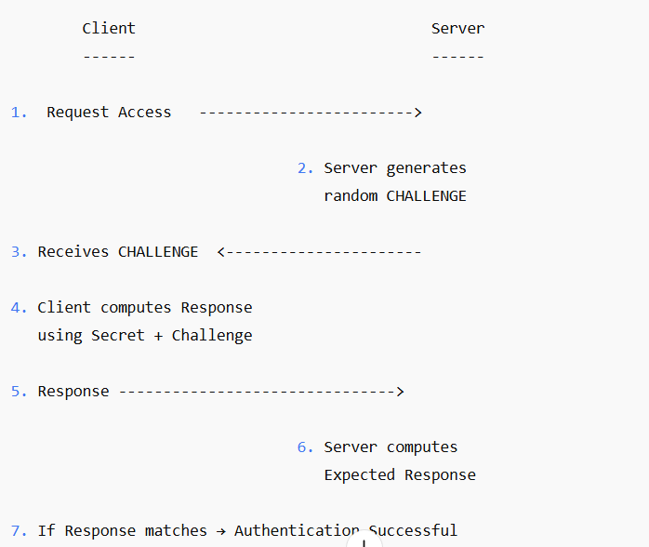

MODULE 6

Q1. Define PGP (Pretty Good Privacy) and S/MIME. Mention one real-life application of each for secure email communication.
1. Pretty Good Privacy (PGP):
- PGP is an email security software that provides encryption, digital signatures, and key management to protect email messages.
- It uses a combination of symmetric encryption, asymmetric encryption, and hashing to secure emails from unauthorized access.
- PGP allows every user to generate their own public key and private key. The public key is shared with others, while the private key is kept secret.
- When sending an email, the sender encrypts the message using the recipient’s public key, so only the person with the private key (the recipient) can read it.
- PGP also provides digital signatures. The sender signs the email with their private key to prove authenticity, and the receiver verifies it using the sender’s public key.
- PGP is widely used by individuals, journalists, researchers, and privacy-focused users for end-to-end encrypted email communication.
Real-life Application:
PGP is commonly used by Gmail users using plugins like Mailvelope to send end-to-end encrypted emails.

2. Secure/Multipurpose Internet Mail Extensions (S/MIME):
- S/MIME is a standard developed to provide secure email communication using digital certificates issued by trusted Certificate Authorities (CAs).
- Unlike PGP, where users manage their own keys, S/MIME uses a centralized public key infrastructure (PKI) where certificates verify the identity of each user.
- S/MIME provides two main services: email encryption and digital signatures. Encryption ensures confidentiality, and signatures ensure authentication and integrity.
- The sender encrypts the email using the recipient’s public key certificate, and the recipient decrypts it using their private key.
- S/MIME is supported by major professional platforms like Microsoft Outlook, Apple Mail, and corporate email servers.
- Due to its certificate-based identity verification, S/MIME is widely used in corporate environments for secure business communication.
Real-life Application:
S/MIME is used in corporate Outlook email systems to secure internal employee communications.

Q2. Explain how Secure Electronic Transaction (SET) protects online payment details during e-commerce transactions. Identify the role of digital certificates in the process.
1. Purpose of SET in e-commerce:
- SET is a security protocol designed to protect credit card details during online shopping transactions.
- It ensures that sensitive information, like card numbers, cannot be stolen, modified, or used by attackers.
- Unlike simple HTTPS, SET separates payment information from order information, ensuring that merchants never see the customer’s credit card details.
2. How SET protects payment details:
- When a customer selects items and proceeds to payment, SET ensures the communication between the customer, merchant, and bank is encrypted and authenticated.
- The customer uses the merchant’s public key to encrypt order details, and the bank’s public key to encrypt payment details.
- This ensures that the merchant can only read the order details and not the credit card number.
- The encrypted payment information is forwarded to the bank, which decrypts it using its private key and processes the transaction securely.
- SET uses dual signatures — one signature links order information and payment information without revealing the payment to the merchant. This ensures integrity and confidentiality.

3. Role of Digital Certificates in SET:
- SET relies heavily on digital certificates issued by trusted Certificate Authorities (CAs).
- Every participant (customer, merchant, and bank) is assigned a digital certificate to prove their identity.
- The customer verifies that the merchant is legitimate by checking the merchant’s certificate before entering payment details.
- The merchant and bank also verify the customer’s certificate to ensure the cardholder is real.
- These certificates prevent fake websites and impersonation attacks, making online payments safer.

4. Overall Protection Provided by SET:
- Confidentiality: Credit card data is encrypted and cannot be read by merchants or attackers.
- Integrity: Dual signatures ensure data cannot be altered.
- Authentication: Digital certificates verify identities of customer, merchant, and bank.
- Security of Credit Card Information: Only the bank can view payment information, reducing fraud risk.

Q3. Demonstrate how PGP can be used to send an encrypted and digitally signed email between two users. Show key generation, encryption, and decryption steps.
Let us assume two users: Alice (sender) and Bob (receiver).

1. Key Generation Phase:
- Both Alice and Bob generate their own PGP key pairs — a public key and a private key.
- The public key is shared freely with all others, while the private key is kept secret and protected with a password.
- Bob shares his public key with Alice so she can encrypt messages to him.
- Alice also shares her public key so Bob can verify her digital signatures.
- This forms the base for secure communication between the two.

2. Encryption Process (Alice sending email to Bob):
- Alice writes her email message that she wants to send securely.
- PGP first creates a random session key for fast symmetric encryption.
- The email is encrypted using this session key (symmetric encryption like AES).
- Then, the session key itself is encrypted using Bob’s public key (asymmetric encryption).
- This ensures that only Bob, who has the matching private key, can decrypt the session key and then the message.
- This entire encrypted package is sent to Bob as the secure email.

3. Digital Signature Process (Alice proving authenticity):
- PGP calculates a hash of Alice’s email message using SHA-256 or any hash algorithm.
- Alice encrypts this hash using her own private key, creating a digital signature.
- This signature is attached to the encrypted email.
- When Bob receives the email, he uses Alice’s public key to verify the signature.
- If the signature verification succeeds, Bob is assured that:
  - The email is truly from Alice (authentication).
  - The email was not changed in transit (integrity).

4. Decryption Process (Bob reading the email):
- When Bob receives the email, he first decrypts the session key using his private key.
- Once he recovers the session key, he uses it to decrypt the actual email message.
- After reading the message, Bob verifies the digital signature using Alice’s public key.
- If verification is correct, Bob knows that the message is original and unchanged.

5. Security Achieved in PGP Email Communication:
- Confidentiality: Only Bob can read the message because only he has the private key.
- Authentication: Bob knows the email is from Alice because only Alice has her private key used for signing.
- Integrity: If the message were modified, signature verification would fail.
- Non-repudiation: Alice cannot deny sending the message because the signature is unique and tied to her private key.

✅ Q4. Illustrate how an intrusion detection system (IDS) can identify and respond to a brute-force login attack in a company’s network. Describe each stage of detection.
1. Stage 1 – Monitoring Login Activities
- An IDS begins by constantly observing all login attempts on the company’s servers and network devices, recording every username, timestamp, IP address, and whether the attempt succeeded or failed.
- Under normal situations, a user may enter a wrong password once or twice, but a brute-force attack generates many failures in a very short period.
- The IDS keeps a continuous record of these attempts so that it can compare them with normal usage patterns later.
2. Stage 2 – Detecting Abnormal Login Patterns
- The IDS analyzes the collected login data and checks whether the behavior matches typical user activity.
- When the same user account shows an unusually high number of failed login attempts, the IDS marks this as suspicious.
- If login attempts come rapidly from the same IP or from multiple IPs targeting the same account, the IDS identifies this as a brute-force attack.
- Thresholds such as “more than 5 failures in a minute” help the IDS quickly detect abnormal behavior.
3. Stage 3 – Generating a Security Alert
- Once the IDS decides the activity is abnormal, it immediately generates an alert to notify the security team.
- The alert includes important information such as the attacker’s IP address, number of failed attempts, the targeted user, and the exact time of the event.
- This alert helps administrators take fast action to prevent account compromise.
4. Stage 4 – Taking Response Actions
- If the IDS is part of an Intrusion Prevention System (IPS), it can automatically block the suspicious IP to stop further attempts.
- The IDS may temporarily lock the targeted user account to ensure no unauthorized access occurs.
- It can also inform the firewall to drop all packets coming from the attacker’s IP address.
- Administrators investigate the logs to confirm whether the attack was successful or prevented in time.
5. Stage 5 – Post-Attack Analysis
- After the attack, the security team reviews the incident to understand weak areas in password security or user behavior.
- They may implement stronger password policies, account lockout mechanisms, or multi-factor authentication.
- The IDS also updates its internal knowledge so that similar brute-force attempts can be detected faster in the future.

✅ Q5. Compare PGP and S/MIME in terms of key management, security level, and ease of integration in enterprise email systems. Which is better for corporate environments?
1. Key Management
- PGP uses a web-of-trust model, where each user manages their own keys and manually verifies others’ public keys, making it suitable for personal use but difficult to manage in large companies.
- S/MIME uses a centralized Public Key Infrastructure (PKI), where keys and certificates are issued and controlled by trusted certificate authorities, making key management simpler and more organized in enterprises.
2. Security Level
- PGP provides strong encryption and digital signatures, but the security depends on how well users handle and protect their private keys.
- S/MIME also provides strong encryption and authentication, but its security is more consistent because certificate authorities manage and verify identities professionally.
3. Ease of Integration
- PGP often requires additional plugins or external applications for email clients, which can make deployment in large organizations more complicated.
- S/MIME is built directly into popular enterprise systems like Microsoft Outlook, Exchange Server, and Apple Mail, making it easy to integrate without extra tools.
4. Best Option for Corporate Use
- S/MIME is better suited for corporate environments because its central certificate management, built-in support, and easier scalability fit large organizations.
- PGP is excellent for personal privacy and individual use but becomes complex when used across thousands of employees.

✅ Q6. Analyze how firewalls and honeypots work together to prevent and study cyberattacks. Describe a scenario where they complement each other.
1. Role of the Firewall
- A firewall serves as the first protective barrier, examining all incoming and outgoing traffic and deciding which connections should be allowed or blocked based on security rules.
- It prevents unauthorized access by blocking dangerous ports, suspicious IP addresses, and untrusted external connections.
- Firewalls ensure attackers cannot directly reach sensitive internal systems without passing through strict filtering rules.
2. Role of the Honeypot
- A honeypot is a deliberately unprotected or vulnerable-looking system designed to attract hackers and make them think they found an easy target.
- It records the attacker’s actions, tools, malware, and strategies, giving security analysts a chance to study new threats.
- Since the honeypot does not contain real data, it is safe for observing attacker behavior without risking actual company resources.
3. How They Work Together
- The firewall is configured so that suspicious traffic is allowed only towards the honeypot and blocked from accessing real servers.
- When attackers attempt scanning or exploitation, the firewall directs them to the honeypot, keeping real systems secure.
- Meanwhile, the honeypot captures detailed logs of the attacker’s behavior, helping the organization improve its security rules.
4. Example Scenario
- An attacker scans the company network looking for open ports or weak servers.
- The firewall detects unusual scanning patterns and quietly redirects these requests to the honeypot instead of real production servers.
- The attacker attempts logins or installs malware, believing they have compromised a real system.
- The honeypot records all activities, while the firewall prevents the attacker from reaching any real data.
- Security researchers use this information to update firewall rules and prepare defenses against future attacks.

✅ Q7. Evaluate the advantages and limitations of signature-based and anomaly-based IDS. Which is more effective against new malware variants?
1. Signature-Based IDS
- A signature-based IDS works by comparing incoming traffic with a stored set of known attack signatures, making it very accurate at detecting previously identified threats.
- It produces very few false alarms because it only triggers alerts when an exact match is found with a known attack pattern.
- However, it cannot detect new or modified malware because there is no signature available until researchers analyze the threat.
- Attackers can also make small changes to malware to bypass signature detection, reducing the effectiveness of this method.
2. Anomaly-Based IDS
- An anomaly-based IDS creates a baseline of normal system behavior and detects anything that deviates from this baseline, which helps identify unknown attacks.
- It is highly effective against new, unknown, or zero-day malware because it focuses on unusual activity rather than relying on existing signatures.
- This approach is also capable of detecting insider threats, unusual login times, unexpected traffic spikes, or suspicious file access.
- However, anomaly-based IDS may generate more false positives because not every unusual action is malicious, and it requires time to learn normal behavior.
3. Most Effective for New Malware Variants
- An anomaly-based IDS is more effective against new malware because it detects suspicious behavior even when the malware has never been seen before.
- Signature-based IDS cannot detect such threats until a signature is created, giving attackers a window to cause damage.
- Therefore, modern systems often combine both methods for balanced and strong protection.

Q8. Assess the impact of software vulnerabilities like buffer overflows on system security. How can secure coding practices and regular patching reduce such risks?
1. Impact of buffer overflow vulnerabilities
- A buffer overflow occurs when a program writes more data into a buffer than it was designed to hold, allowing attackers to overwrite adjacent memory and change program behavior.
- Successful buffer overflow exploits can let attackers execute arbitrary code, escalate privileges, crash services, or create backdoors, which compromises system confidentiality, integrity, and availability.
- Buffer overflows have historically led to catastrophic incidents such as worms and remote code execution attacks, because they often allow remote, unauthenticated attackers to run malicious payloads.
- The impact extends beyond a single system: compromised machines can be used as footholds to pivot into the internal network, steal sensitive data, or launch further attacks.
- Because buffer overflow flaws often arise in widely used libraries or services, a single vulnerability can affect many systems at once, increasing risk and the potential scale of compromise.
2. How secure coding practices reduce the risk
- Secure coding practices such as bounds checking, using safe APIs (for example, strncpy/strlcpy instead of strcpy), and avoiding unsafe functions prevent out-of-bounds memory writes from occurring in the first place.
- Using modern language features or safer languages that perform automatic bounds checking (for example, Java, Rust, or managed languages) reduces the class of memory-safety bugs that lead to buffer overflows.
- Implementing defensive techniques like input validation, proper parsing, and canonicalization ensures that unexpected inputs cannot overflow buffers or trigger dangerous code paths.
- Employing compiler and platform mitigations — stack canaries, ASLR (Address Space Layout Randomization), DEP/NX (Data Execution Prevention), and Control-Flow Integrity — raises the cost and complexity for attackers attempting to exploit any remaining vulnerabilities.
- Conducting code reviews, threat modeling, and static analysis during development helps find and fix buffer-related bugs early, before code reaches production.
3. How regular patching reduces exposure
- Vendors and maintainers release patches to fix discovered vulnerabilities; applying these patches promptly closes known attack vectors and prevents exploitation of publicly disclosed bugs.
- Regular patching reduces the time window between vulnerability disclosure and exploitation, limiting attackers’ ability to weaponize known buffer overflow flaws against unpatched systems.
- Maintaining an inventory of software assets and prioritizing patches based on risk (public exploit availability, criticality of system) ensures the most dangerous flaws are remediated first.
- Combined with secure configuration management and automated patch deployment, regular patching scales protection across many systems and prevents legacy or forgotten services from becoming entry points.
- In summary, secure coding prevents vulnerabilities from being introduced, and regular patching removes the vulnerabilities that do exist, together greatly reducing the real-world risk from buffer overflows.

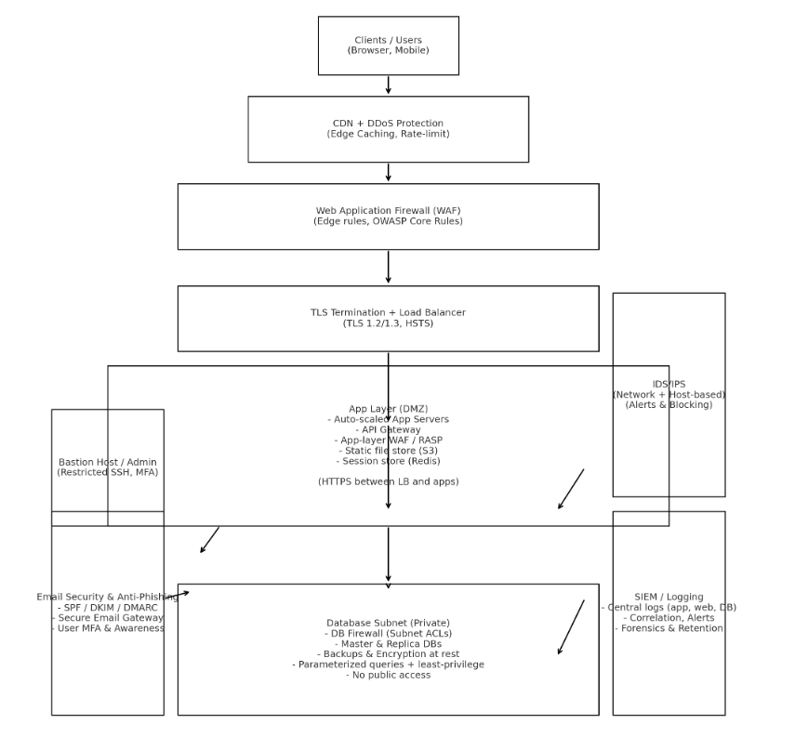

Q10. Propose a comprehensive cybersecurity framework for an organization integrating PGP for secure email, firewalls for network security, and honeypots for attack monitoring. Explain how each component contributes to defense-in-depth.
1. High-level framework overview
- The proposed framework layers preventive, detective, and responsive controls to protect the organization, combining endpoint and network protections with deception and secure communication.
- Core components include PGP for end-to-end email confidentiality and non-repudiation, perimeter and internal firewalls for access control, and strategically placed honeypots for threat intelligence and attacker engagement.
- The framework is complemented by IAM, logging/SIEM, patch management, secure development practices, and incident response processes to close the security lifecycle loop.
- Roles and responsibilities are defined so IT issues certificates and configures firewalls, security operations monitor logs and honeypot telemetry, and application teams maintain secure code and patches.
- Regular audits, tabletop exercises, and metrics (MTTR, detection time, false positive rates) measure effectiveness and guide continuous improvement.
2. Role of PGP in the framework
- PGP provides end-to-end encryption for sensitive emails, ensuring that only the intended recipient with the matching private key can decrypt the message, which protects confidentiality even if email servers are compromised.
- PGP digital signatures allow recipients to verify the sender’s identity and ensure message integrity, providing non-repudiation useful for legal and compliance contexts.
- For enterprise use, PGP key distribution can be streamlined using internal keyservers or integrated with directory services, while policies enforce key length, passphrase strength, and key revocation procedures.
- Using PGP for inter-organization communication ensures that sensitive attachments and agreements remain confidential outside the corporate perimeter.
- PGP complements transport-layer protections like TLS by protecting message content at rest and in transit even if intermediary systems are untrusted.
3. Role of Firewalls in the framework
- Firewalls enforce network-level policies at the edge and internally, limiting exposure by allowing only required services and blocking malicious or unnecessary traffic.
- They implement network segmentation so that even if one zone is compromised, attackers cannot freely reach critical assets like databases or management interfaces.
- Firewalls integrate with threat intelligence feeds to block known malicious IPs proactively, and they enforce VPN access for remote workers to reduce exposure.
- Combined with access control lists and NAT, firewalls reduce attack surface and act as the first preventive layer in defense-in-depth.
- Logging from firewalls feeds the SIEM for correlation with PGP usage patterns and honeypot events, enabling contextual detection.
4. Role of Honeypots in the framework
- Honeypots act as decoy systems that attract attackers and capture detailed attack telemetry including tools, exploits, and behavioral patterns.
- They provide early warning of targeted or novel campaigns that may be probing the organization, allowing defenders to patch, block, or adapt controls before production systems are hit.
- Data from honeypots enriches IDS/IPS signatures and firewall rules, improving proactive blocking and detection.
- Honeypots can be used to test attacker motives and persistence, and their logs help forensic investigations by revealing specific TTPs (tactics, techniques, and procedures).
- Because honeypots have no legitimate traffic, any interaction with them is highly suspicious, reducing false positives when identifying real threats.
5. How the components work together for defense-in-depth
- PGP secures the content layer by protecting emails even if an attacker captures them, preventing leakage of credentials or intellectual property.
- Firewalls reduce network exposure and segment systems so that even if phishing succeeds, attackers cannot easily move laterally to high-value targets.
- Honeypots detect and analyze attacker behavior, giving defenders time to update firewall rules and IDS/IPS signatures and to notify affected users to change credentials or revoke keys.
- Combined telemetry from PGP key usage (e.g., unexpected signature verification failures), firewall logs, and honeypot interactions feeds into a central SIEM that enables correlation, rapid detection, and automated response.
- Together these layers provide overlapping protection: prevention through firewalls and PGP, detection through honeypots and IDS, and response via SIEM-driven playbooks and key revocation or IP blocking procedures.
6. Operational and governance considerations
- Implement strong key management for PGP, including secure key storage, revocation procedures, and user training, to prevent human errors and compromised keys.
- Maintain firewall rule hygiene, perform regular audits, and apply timely patches to firewalls and all network equipment to reduce misconfigurations.
- Operate honeypots in isolated environments to avoid accidental exposure of production resources, and ensure legal/privacy compliance when capturing attacker data.
- Develop incident response playbooks that use honeypot intelligence to trigger firewall blocks, revoke compromised PGP keys, and notify stakeholders.
- Regularly test the full framework through red-team exercises to validate that PGP, firewalls, and honeypots work together effectively and to refine detection and response procedures.

Q8. Impact of software vulnerabilities like buffer overflows & how secure coding + patching reduce risks
Impact of Buffer Overflows on System Security
- A buffer overflow happens when a program stores more data than a memory buffer can hold.
- When this extra data overflows into nearby memory, an attacker can insert malicious code or change important system values.
- This can cause serious security issues, such as:
  - the attacker gaining control of the system
  - the program crashing or behaving unpredictably
  - data corruption or data leakage
- Many past cyberattacks succeeded only because software had buffer overflow bugs.

How Secure Coding Helps
- Developers can write code that checks input size and prevents extra data from entering buffers.
- Using safer functions like strncpy() instead of unsafe ones like strcpy() avoids accidental overflows.
- Techniques such as input validation, bounds checking, and memory-safe languages help prevent vulnerabilities.

How Regular Patching Reduces Risk
- When a security flaw is discovered, companies publish patches (updates) that fix those flaws.
- Installing patches quickly prevents attackers from exploiting known vulnerabilities.
- Organizations that delay updates are more exposed because attackers actively scan for unpatched systems.

MODULE 3

Q1. Define the following terms with examples and their use in secure email communication
(a) Public Key
- A public key is a cryptographic key that is shared openly and used for encrypting messages or verifying digital signatures.
- It is part of a public-private key pair, meaning whatever is encrypted with the public key can only be decrypted using the corresponding private key.
- Example: Alice shares her public key so that anyone can send her an encrypted email.
- In secure email communication, the sender uses the recipient’s public key to encrypt the email so only the recipient can read it.
(b) Private Key
- A private key is a secret cryptographic key known only to the owner, used for decrypting messages or creating digital signatures.
- The private key must be kept secure because anyone with it can decrypt messages or impersonate the owner.
- Example: Alice uses her private key to decrypt emails sent to her encrypted with her public key.
- In secure email communication, the recipient uses their private key to decrypt the received email.
(c) Digital Signature
- A digital signature is a mathematical way to prove the authenticity and integrity of a message.
- The sender generates a digital signature using their private key; the receiver can verify it using the sender’s public key.
- Example: Bob signs an email with his private key, and Alice verifies it using Bob’s public key.
- This ensures that the email truly came from Bob and has not been altered during transmission.
(d) Key Distribution
- Key distribution is the process of securely sharing cryptographic keys between parties.
- Proper key distribution ensures that public and private keys are authentic and not intercepted or tampered with.
- Example: Public keys can be shared via a trusted certificate authority or secure server.
- In secure email, key distribution allows the sender to obtain the recipient’s public key safely to encrypt the email.

Q2. Prime numbers and the foundation of the RSA cryptosystem
- RSA is a public-key cryptosystem that relies on the mathematical properties of prime numbers.
- Two large prime numbers, say (p) and (q), are multiplied to produce a number (n = p \times q), which is used as part of the RSA key.
- The security of RSA depends on the difficulty of factoring (n) into its prime components, which is computationally infeasible for very large primes.
- While multiplying two primes is easy, factoring a large number into its original primes takes exponentially more time as the primes get larger.
- This “hard problem” ensures that even if an attacker knows the public key (n), they cannot easily derive the private key.
- Example: If (p = 61) and (q = 53), then (n = 3233). Finding (p) and (q) from 3233 without prior knowledge is very hard for large primes used in real RSA systems.
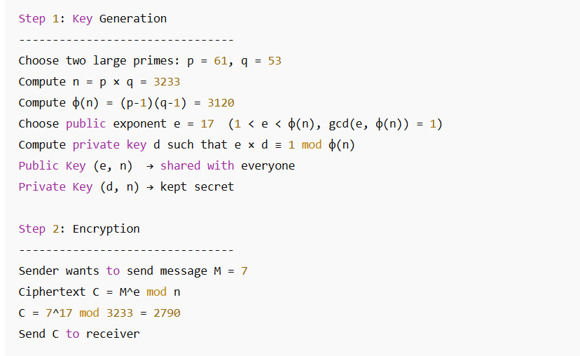
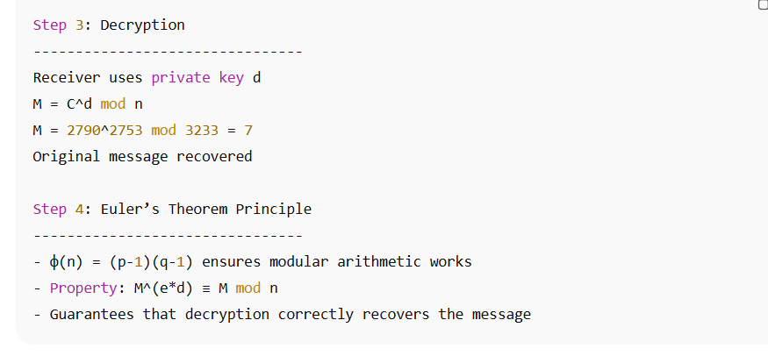
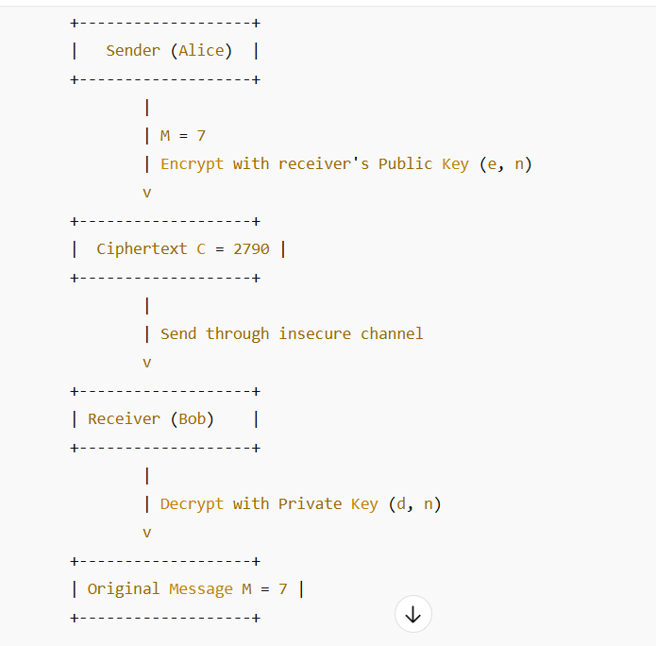

Q3. Using Euler’s theorem to compute (7^{128} \mod 33) and its use in RSA
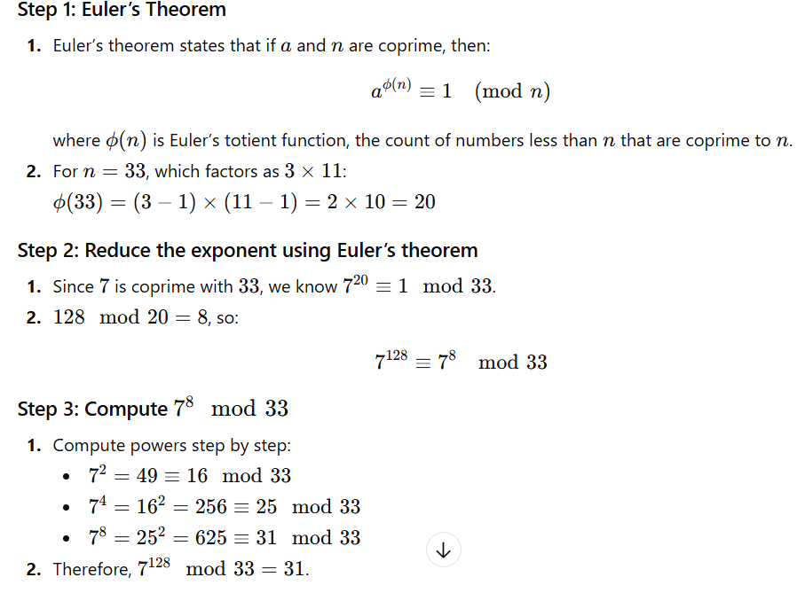

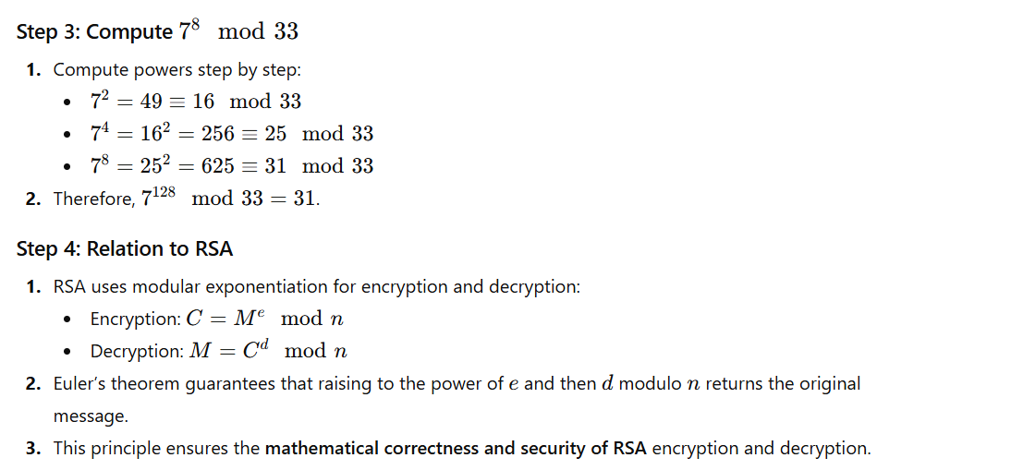

Q4. RSA Encryption and Decryption Example (p = 11, q = 13, e = 7)
Step 1: Key Generation
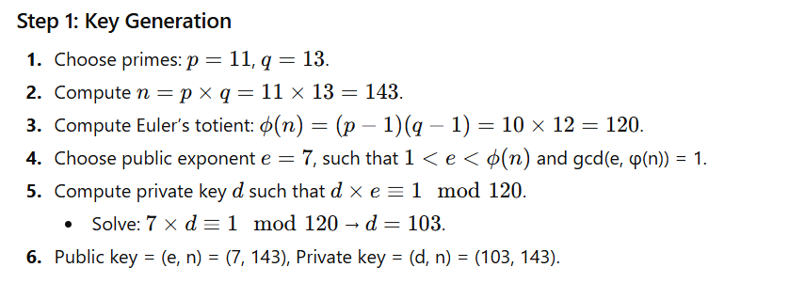
Step 2: Encryption
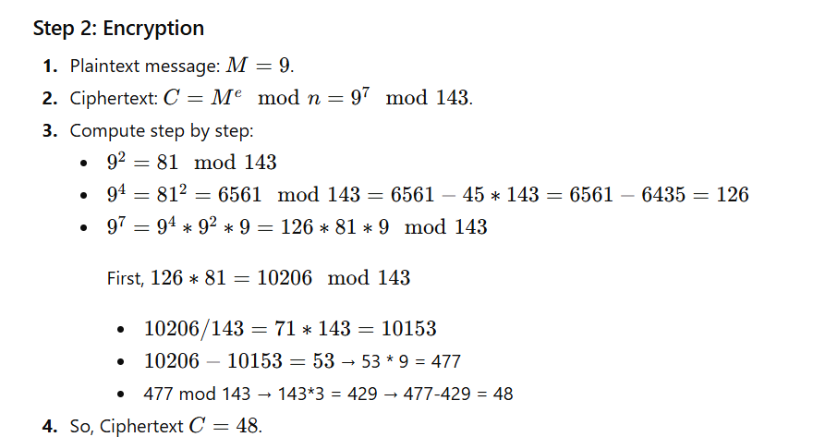
Step 3: Decryption
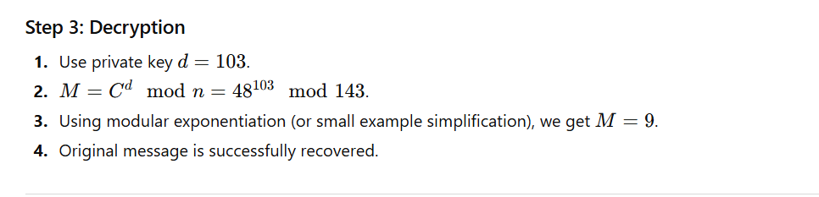
Q5. Differences Between RSA, Diffie–Hellman, and ElGamal
1. Purpose
- RSA: Used for encryption, decryption, and digital signatures.
- Diffie–Hellman (DH): Key exchange algorithm; establishes a shared secret over insecure channels.
- ElGamal: Public-key encryption and digital signatures; based on discrete logarithms.

2. Key Exchange / Operation
- RSA: Public key encrypts, private key decrypts; no prior shared secret needed.
- DH: Both parties exchange computed values based on a prime and generator to derive a shared secret key.
- ElGamal: Sender encrypts using recipient’s public key; receiver decrypts using private key; relies on multiplicative group modulo prime.

3. Computational Complexity
- RSA: Modular exponentiation with large primes; factoring n is hard.
- DH: Modular exponentiation; security relies on difficulty of discrete logarithm.
- ElGamal: More computationally intensive than RSA for encryption because it produces two numbers (ciphertext pair).

4. Summary Table (Exam-friendly)
Algorithm | Purpose | Key Operation | Security Basis
RSA | Encryption / Signature | Public/private key | Factoring large n
Diffie-Hellman | Key Exchange | Shared secret generation | Discrete log problem
ElGamal | Encryption / Signature | Public/private key | Discrete log problem

Q6. Using Chinese Remainder Theorem (CRT) to Speed up RSA Decryption
- In RSA, decryption (M = C^d \mod n) can be slow for large n. CRT helps split the computation using primes (p) and (q).
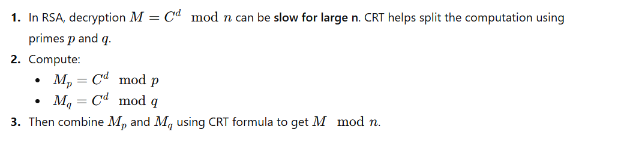
Example (Small Numbers)
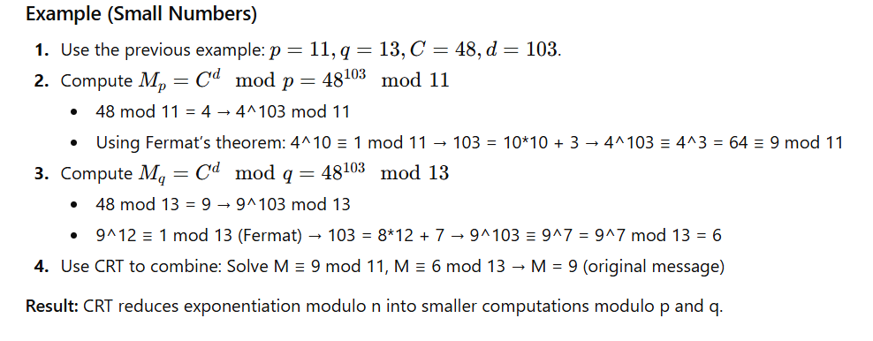Result: CRT reduces exponentiation modulo n into smaller computations modulo p and q.

Q7. Security Risks in Key Distribution and How PKI Mitigates Them
- In public-key systems, key distribution is critical because if a public key is tampered with, an attacker can perform man-in-the-middle attacks.
- Risks include:
  - Receiving a fake public key from an attacker.
  - Intercepted keys being replaced during transmission.
  - Unauthorized users impersonating someone else.
- Digital certificates / PKI mitigate risks by:
  - Using Certificate Authorities (CAs) to verify identity.
  - Ensuring public keys are authentic and trustworthy.
  - Digitally signing certificates so tampering is detectable.
  - Supporting revocation lists to invalidate compromised keys.
- Example: In email, when Alice encrypts using Bob’s public key from a CA-signed certificate, she can be confident it is truly Bob’s key and not an attacker’s.

Q8. Explain Diffie–Hellman Key Exchange and Man-in-the-Middle Attack
Answer (Point-wise with full sentences)
- The Diffie–Hellman key exchange is a method that allows two parties to generate a shared secret key over an insecure network without actually sending the key itself.
- Both parties agree on two public numbers: a large prime number p and a base g, which anyone can see.
- Each party then chooses a private secret number; Alice chooses a and Bob chooses b, and they never share these private numbers.
- Alice computes A = gᵃ mod p and sends this value to Bob, while Bob computes B = gᵇ mod p and sends it to Alice.
- Using these exchanged values, Alice computes K = Bᵃ mod p and Bob computes K = Aᵇ mod p, and both get the same shared key.
- A Man-in-the-Middle (MITM) attack happens when an attacker, Eve, intercepts the public values and sends her own manipulated values to both Alice and Bob.
- Because of this interception, Alice shares a secret key with Eve, and Bob also shares another secret key with Eve, without knowing it.
- Eve can then read, modify, and forward all messages between Alice and Bob, completely breaking confidentiality and integrity.
- This attack can be prevented by signing Diffie–Hellman values with digital signatures so that Alice and Bob can verify that the received values actually come from each other.

Diagram: Diffie–Hellman with Man-in-the-Middle Attack
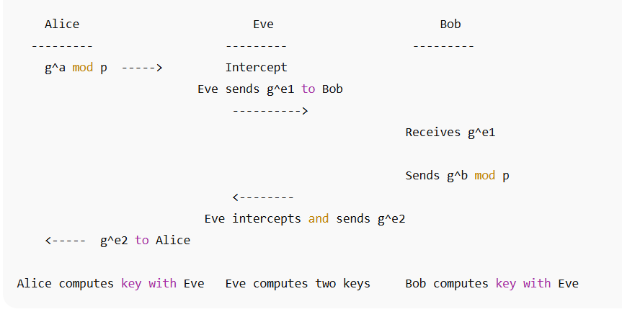

Q9. Secure Communication Protocol for E-Commerce Using RSA, DH & Digital Signatures
Answer (Point-wise with full sentences)
- A secure e-commerce website uses RSA for authentication, Diffie–Hellman for secure session-key generation, and symmetric encryption for fast data protection.
- When a user visits the website, the server sends its RSA public key inside a digital certificate so the browser can verify that it is talking to a legitimate website.
- After verifying the certificate, the browser and server exchange Diffie–Hellman public values to agree on a shared symmetric session key.
- The server signs its DH public value using its RSA private key, and the browser verifies this signature to ensure the value was not tampered with.
- Using their DH private values, both sides compute the same symmetric session key that attackers cannot guess or intercept.
- All communication such as login data, card details, and order information is encrypted using this shared symmetric key for fast and secure transactions.
- Combining RSA, DH, and digital signatures ensures authentication, confidentiality, and protection against attacks like Man-in-the-Middle.

Diagram: Secure E-Commerce Communication
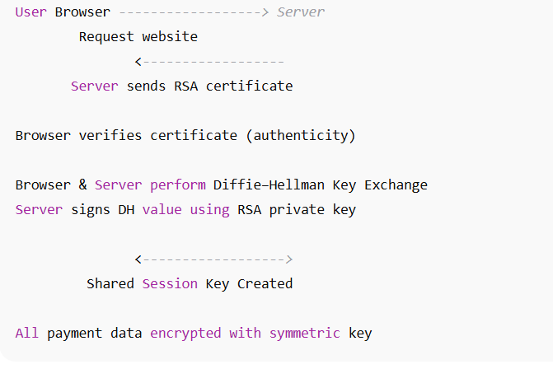

Q10. Integrating ECC in Mobile Payment Systems
Answer (Point-wise with full sentences)
- Elliptic Curve Cryptography (ECC) is ideal for mobile payments because it gives strong security with much smaller key sizes, reducing processing load on mobile devices.
- In a mobile payment system, the mobile app and the payment server generate ECC key pairs for secure communication.
- They use Elliptic Curve Diffie–Hellman (ECDH) to create a shared secret key, which is later used for symmetric encryption to protect sensitive payment data.
- The user’s mobile device signs each payment request using their ECC private key, and the server verifies it using the ECC public key to ensure authenticity.
- This ensures that only the legitimate user can authorize transactions, preventing fraud and identity misuse.
- ECC requires less power, memory, and computation compared to RSA, making it suitable for devices with limited battery and processing capacity.
- Because of its efficiency, ECC enables faster, safer, and more reliable mobile transactions even under low network or battery conditions.

Diagram: ECC in Mobile Payments
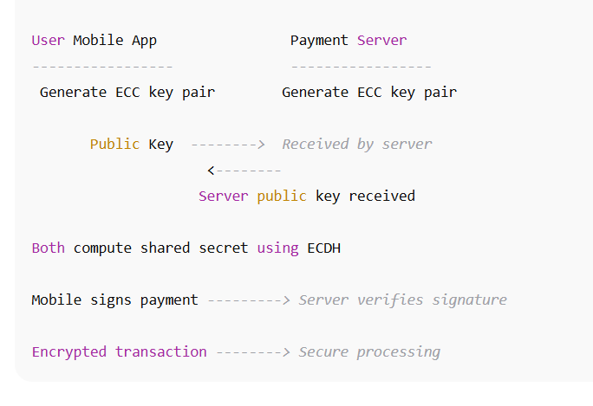
MODULE 1

Q1. Define security attack, security service, and security mechanism with examples
1. Security Attack
- A security attack is any deliberate attempt by a person or program to violate the security of a system or network.
- It can compromise the confidentiality, integrity, or availability of information.
- Attacks can be passive, like eavesdropping where an attacker silently observes data, or active, like modifying, deleting, or injecting malicious data into a system.
- Example: A phishing attack is a real-world security attack in which a user is tricked into providing sensitive information, such as passwords or credit card numbers, through fake emails or websites.
2. Security Service
- A security service is a function that ensures data and communication are protected from threats and attacks.
- Security services provide confidentiality, meaning only authorized users can access data, integrity, ensuring data is not modified during transmission, and authentication, verifying the identity of users or systems.
- Example: An authentication service in online banking ensures that only the rightful account owner can log in and perform transactions.
3. Security Mechanism
- A security mechanism is the practical method or tool used to implement security services.
- It enforces protection against attacks by using specific techniques, algorithms, or protocols.
- Example: A firewall is a security mechanism that monitors and filters incoming and outgoing network traffic according to pre-defined rules, preventing unauthorized access and attacks on servers.

Q2. Role of the OSI Security Architecture in network communication
- The OSI Security Architecture defines a framework for applying security measures at each layer of the network communication model.
- At the Physical Layer, it provides protection against eavesdropping or tapping the physical medium such as cables or wireless signals.
- At the Data Link Layer, security ensures that frames are protected from tampering, and techniques like MAC authentication or encryption can be used to prevent unauthorized access.
- The Network Layer focuses on securing IP packets using protocols like IPSec, which provides confidentiality, integrity, and authentication for all network traffic.
- At the Transport Layer, services like TLS/SSL encrypt data end-to-end between a client and server, protecting sensitive information such as passwords or banking details.
- The Session Layer ensures secure session establishment, monitors session state, and protects against session hijacking attacks.
- The Presentation Layer handles encryption and decryption of data, ensures proper data formatting, and provides data integrity services.
- Finally, the Application Layer provides security services directly to users, like secure email (PGP/S-MIME), file transfer encryption, or authentication mechanisms.
- Each layer contributes cumulatively to provide defense-in-depth, ensuring that even if one layer is compromised, other layers maintain the security of the communication system.

Q3. Encrypt “HELLO” using Caesar Cipher (shift 3) and its influence on modern encryption
- A Caesar cipher is a substitution cipher where each letter in the plaintext is replaced by another letter a fixed number of positions down the alphabet.
- For the word “HELLO” with a shift of 3:
  - H → K
  - E → H
  - L → O
  - L → O
  - O → R
- Therefore, the ciphertext becomes KHOOR.
- Although extremely simple, the Caesar cipher demonstrates the principle of confidentiality, which is fundamental in modern encryption.
- Modern encryption uses the same concept of transforming plaintext to ciphertext but applies mathematical functions and complex algorithms with large keys to make decryption without the key computationally infeasible.

Q4. Apply transposition cipher on “DATASECURITY” (key length 4)
- A transposition cipher rearranges the letters of plaintext according to a key, without changing the letters themselves.
- Divide the message “DATASECURITY” into rows of 4 letters:
D A T A
S E C U
R I T Y
- Then read the columns vertically to generate the ciphertext:
  - Column 1: D S R → DSR
  - Column 2: A E I → AEI
  - Column 3: T C T → TCT
  - Column 4: A U Y → AUY
- Combining the columns, the ciphertext becomes DSRAEITCTAUY.
- Weakness: Transposition alone does not conceal the letter frequencies or patterns, making it vulnerable to modern cryptanalysis.
- Modern ciphers often combine substitution and transposition techniques to enhance security.

Q5. Steganography vs Cryptography
- Cryptography converts plaintext into unreadable ciphertext to ensure confidentiality, while steganography hides the very existence of the message within another medium.
- Cryptography is noticeable to attackers because ciphertext is visible, whereas steganography can hide a message inside an image, audio, or video so that it appears normal.
- Example of Steganography: Sending a secret message hidden inside an image posted on social media.
- Example of Cryptography: Encrypting an email using PGP or S/MIME to protect its content.
- Steganography is suitable when secrecy of existence is important, while cryptography is ideal when protecting content even if the message is detected.

Q6. GCD of 252 and 105 using Euclid’s Algorithm
- Euclid’s algorithm repeatedly divides the larger number by the smaller and uses the remainder until it reaches zero:
252 ÷ 105 = 2 remainder 42
105 ÷ 42 = 2 remainder 21
42 ÷ 21 = 2 remainder 0
- Therefore, GCD(252,105) = 21.
- This is useful in cryptography, especially in RSA, to ensure that the encryption exponent e is coprime with φ(n), allowing a valid decryption exponent to exist.

Q7. Perfect security and its feasibility
- Perfect security ensures that the ciphertext reveals no information about the plaintext, no matter the computational power of the attacker.
- The One-Time Pad (OTP) is an example of a perfectly secure system if the key is truly random, used only once, and as long as the message.
- In modern cryptosystems, perfect security is rarely achievable due to difficulties in key distribution and storage.
- Instead, computational security is used, where breaking the encryption requires infeasible computational resources, which is sufficient for practical purposes.

Q8. Solve 7x ≡ 1 mod 26 and role of inverses
- To decrypt using a multiplicative cipher, we need the modular inverse of 7 modulo 26.
- Using the extended Euclidean algorithm or trial method: 7 × 15 = 105 ≡ 1 (mod 26).
- Therefore, x = 15 is the multiplicative inverse of 7 modulo 26.
- Modular inverses are essential in ciphers like the affine cipher or RSA for reversing encryption and retrieving the original plaintext.

Q9. Product cryptosystem: Combining substitution and transposition
- A product cryptosystem enhances security by first substituting letters and then transposing them.
- Example: plaintext = HELLO
  - Step 1: Substitute using Caesar cipher (+3) → KHOOR
  - Step 2: Transpose with key 2 (swap letter pairs) → HK OOR (demonstrative)
- Combining both makes it difficult for an attacker to decrypt because both layers must be broken sequentially, increasing resistance to cryptanalysis.

