- Download git.
https://git-scm.com/download/win
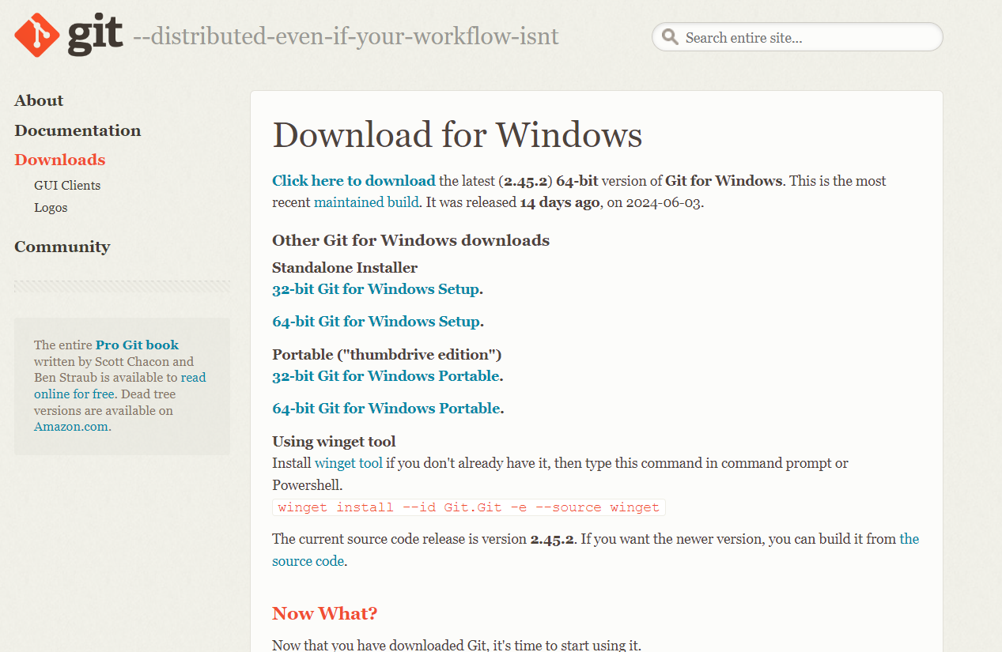
- Choosing the git standalone installer
- Setup the pin and authenticator
- Click on .exe file and Use next-next and finish the git installation
Open git bash terminal from windows:
(can be used as a general terminal as well like for run python command and all)
- Create user name and email
git config --global user.name siddesh
git config --global user.email desaisiddesh223

- check the user name and email values
git config --global user.name
git config --global user.email

Two approaches in git first one is init and second is cloning:

- Init:
- Going inside the folder named “git_learning” using terminal

Command: git init

creates the .git named folder

this can be seen using the command else simple ls won’t show it
Command: ls -lart

- Check the status

Command: git status

(provide the all file’s status like untracked, modified, staged or not commited)

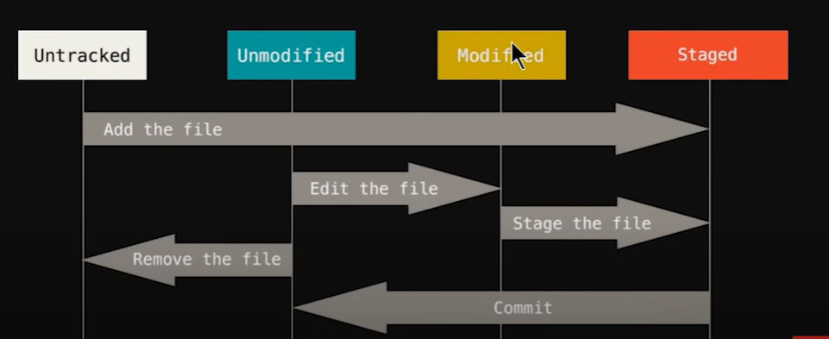

Keeping the file at the staging area:

Command: git add index.html
(only selected file will be added)

committing the file
- With vim editor

Command: git commit

opens a vim editor
press I to type a text
type initial commit (it’s a message of file, description in short)
press esc then :wq

- Without vim editor:
Committing the changes with – m command as it will not require the vim editor changes

Command: git commit -m 'added the text in about.html'

check the status again:
Command: git status
(keep on using it)

- Case when additional new file is created

creating a file using git bash terminal
Command: touch filename

creating the about.html file
touch about.html

now check status
:
Command: git status

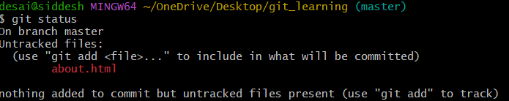

Adding multiple new additional files into staging area
Command: git add -A

now check status
:
Command: git status

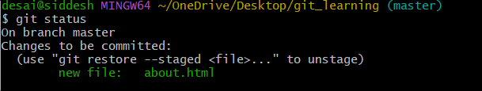

Shows the new file about.html.

- Case when file in staging and later also modified in the system
about.html modification

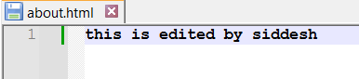

Shows the new file staged not committed and modified but not staged files
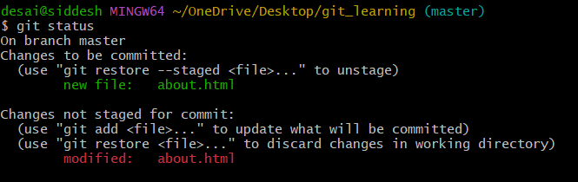

Now add it to the staging area

Command: git add -A

Check status: Git status

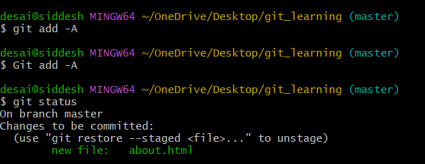

Now status of modified is not there as it is staged. Only new file status in staged is present.
Committing the changes with – m command as it will not require the vim editor changes

Command: git commit -m 'added the text in about.html'

Now check the status

Command: git status
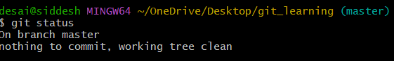

File recovery when the accidently delete the file about.html or deleted the content of it
- Case Single file edited
Deleted the file about.html
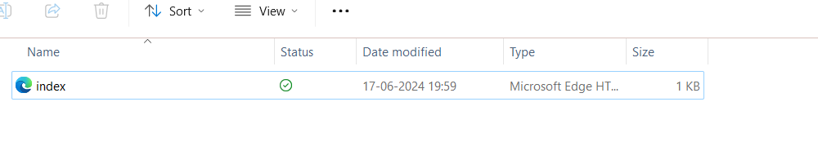

Check status:
Command: git status
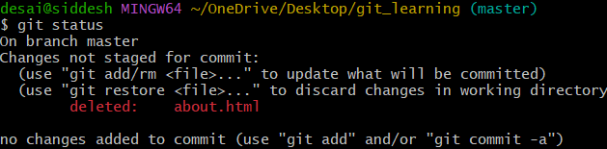
Command: git checkout about.html
(matches with the last commit to the given file name)

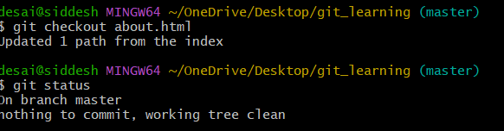

File recovered
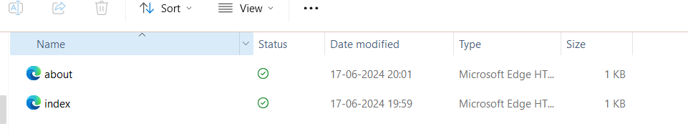
- Multiple file editing
To do this deleting all the files inside the folder
Check status
Command: git

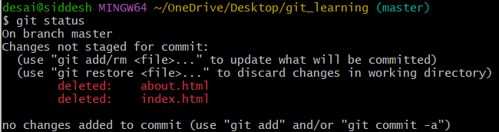
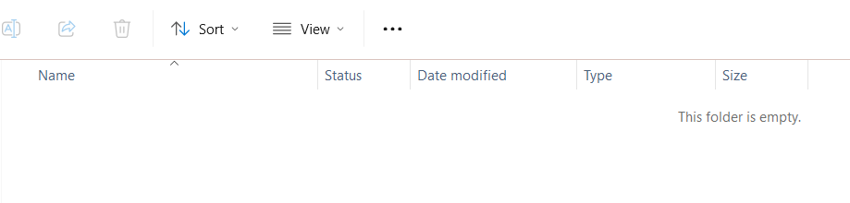
Command: git checkout -f

Check status
Command: git status

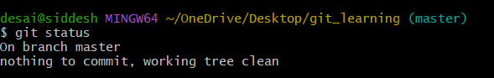

Both the files are recovered
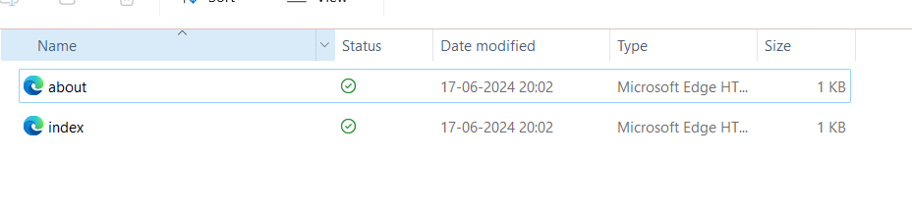
Ignore file
In windows just create the .gitignore file

Command: touch .gitignore

Now the .gitignore file is created

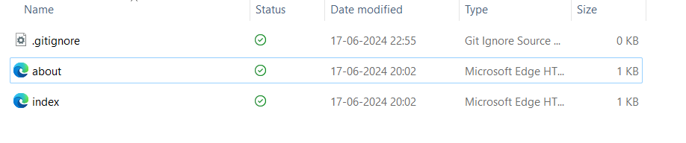

.gitignore file add the file which are unwanted to track or need backup or which can be regenerated like log, images as it will sloq down the transfer of file in push pull stage for git hub.

Command: git status

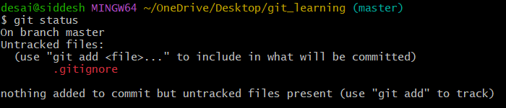

- Creating the log file for demonstrating the usage of .gitignore file

Command: touch mylogs.log
Adiding some random things in mylogs.log file

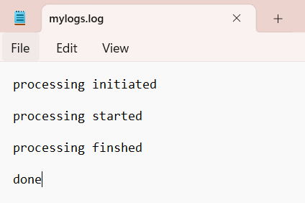

Now add this file name in .gitignore

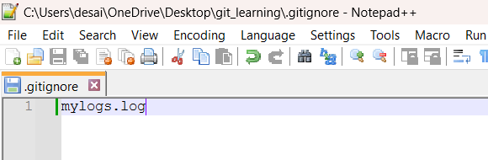

So it will ignore committing the mylogs.log file wherever it is present. Even if it is inside some folder. For example logs folder is created and mylogs.log file is also created within it.
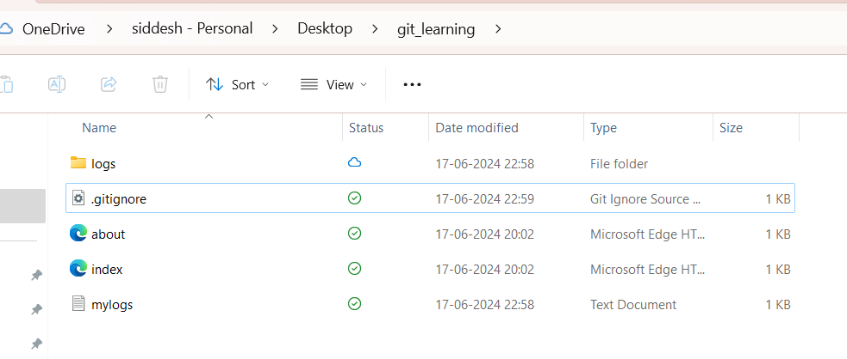
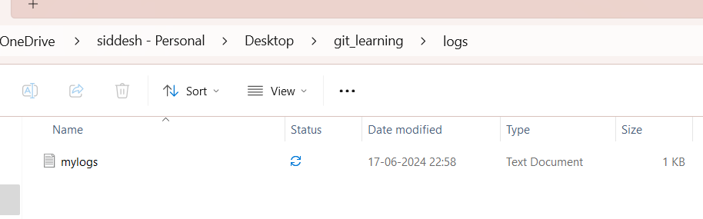

Now check the status:
Command : git status

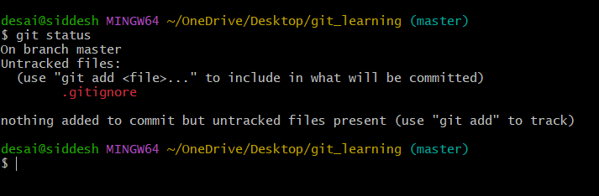

It is showing that all the three new added contents are not tracked

Now adding the files to staging and the nchecking the status
Command : git add -A

Command : git status
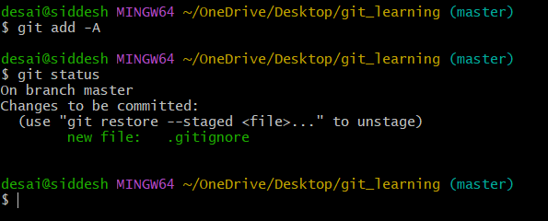

Check the files mylogs.log and log folders are ignored to commit and stage
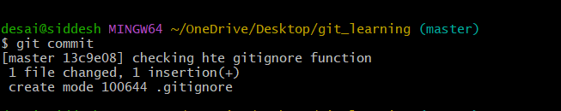

Now if we want to gitignore the mylogs file inside the root directory only then use
/mylogs.log
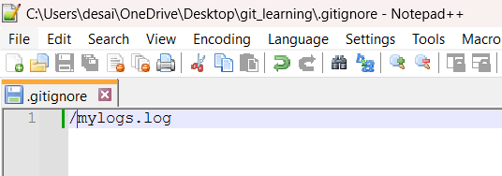
Now check git status:
Command: git status

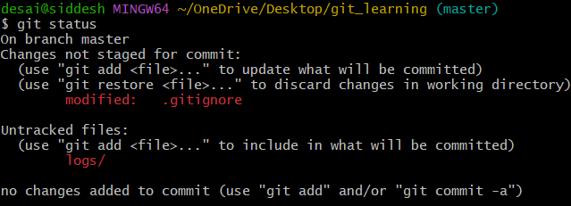

Now you can see logs folder is getting noticed.

Adding to the stages and checking the status

Command: git add -A
Command: git status

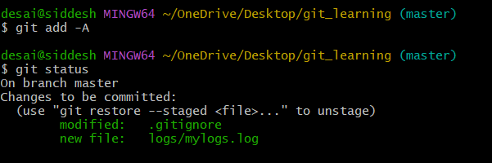

You can see now the new log folder is added and modified .gitignore file is also added.

Command:
git commit -m 'updated the log tracting to root folder only'
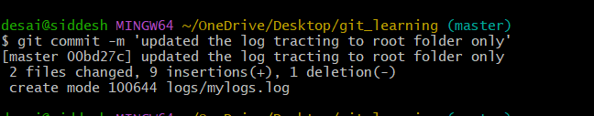

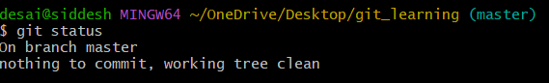

Command: git status to check the staus.
All file having .log extention name to be ignore.

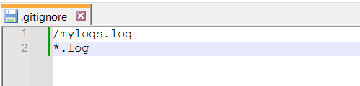

Check git status
Command: git status
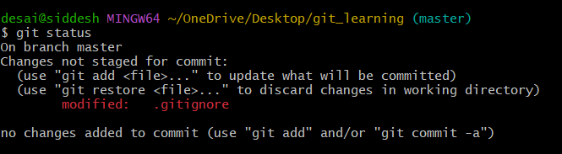

Adding to stages
Command: git add -A
Check status
Command: git status
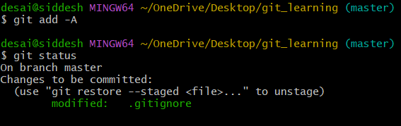

git commit -m 'ignoring all log file using .log extentions'

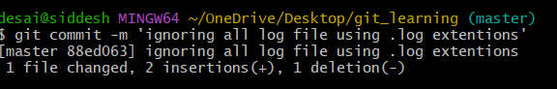

Similarly one can try for *.py, *.cpp and so on….

Now ignoring a folder

Then use folder_name/ in the .gitignore

Example:

To demonstrated it an empty sample_ignore_folder is created

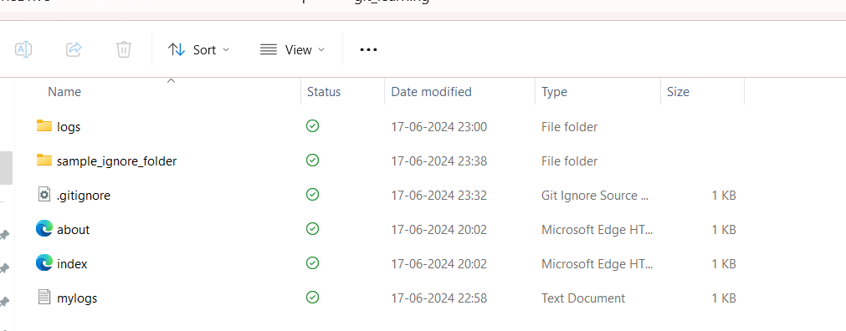

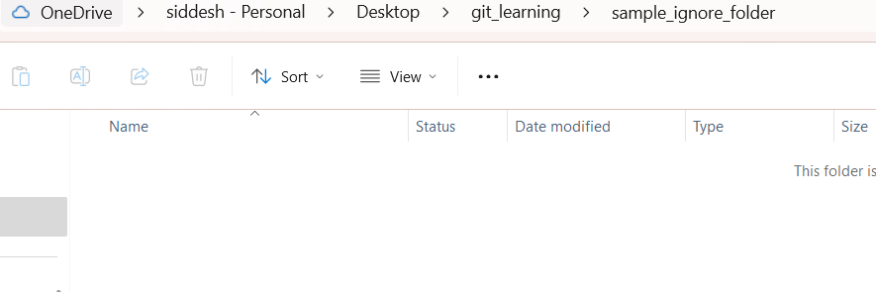
Now check status:
Command: git status

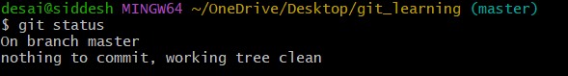
It is not showing anything since the sample_ignore_folder is empty

Now add a sample.html file

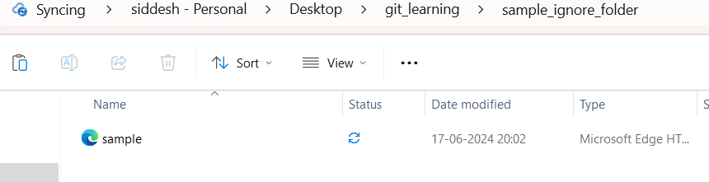

Now checking the status.

Command: git status.

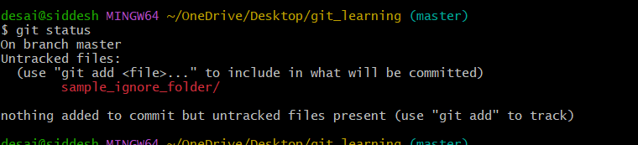

Now it is showing the untracted folder.

To ignore the sample_ignore_folder then add it .gitignore file.

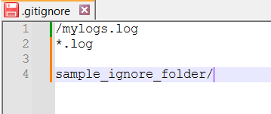

Now check status:
Command : git status

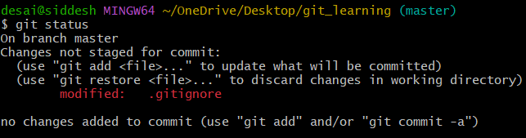

Now tracting of sample_ignore_folder is vanished and modified .gitignore is shoqwn
. Now commit it to save the changes.
Add staging
Command: git add -A
Commit Command:
git commit -m 'all types of ignore is saved'
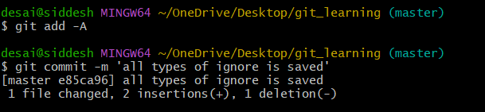

Branches in git:

Master branch is by default branch. It is the main branch where all the work is done.
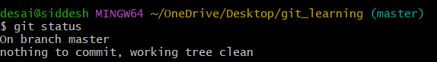

Creating a branch.

Command: git branch <branch_name>
Command: git branch feature1
It creates a new branch where additional work can be done and then can be merged with the master branch as per the need.

Now check all the branches.
Command: git branch
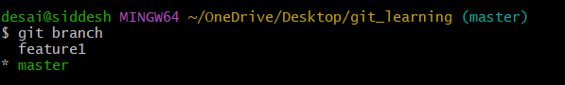

(master) is showing current active branch.
feature1 and master are the git branches.
green colour in *master indicates that it’s a current active branch in the terminal.

- switching the branches in the terminal

Command syntax: git checkout <branch_name>
Switching to feature1

Command: git checkout feature1

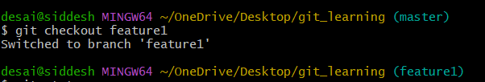

Now it is switched to feature1 one branch.

Merging feature 1 to master branch.

Now modifying the file named index.html
Old file:
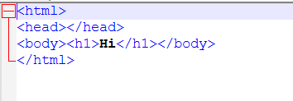
Modified file:
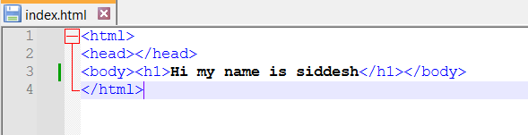

This modification is done in the branch named feature1.
Now check the status:

Command: git status

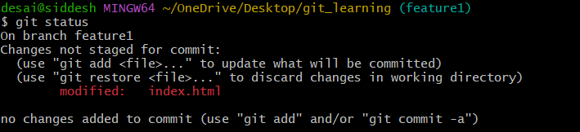

You can see the modification is seen in the feature1 on for the index.html file

Now do the stagging and commit the changes.
Command: git add -A

Command: git status

Command: git commit -m 'added greeting message in the index.html'

Command git status
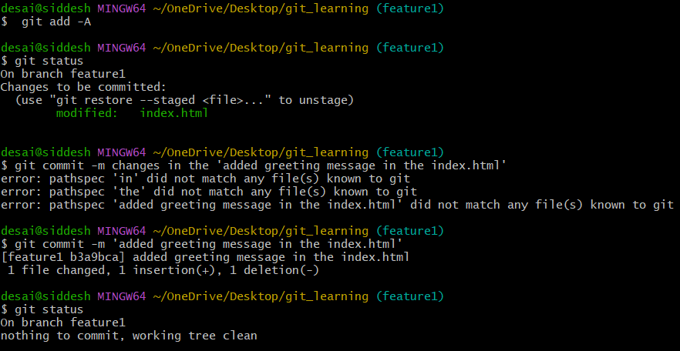

Now if you want to rollback the previous version where the greeting messaage was only ‘hi’ in the index.html file
Command: git checkout master

Now open the index.html file

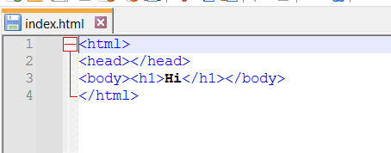
You can see the old file which was committed to master branch is present now.

Now switch to feature1 branch again

Command: git checkout feature1

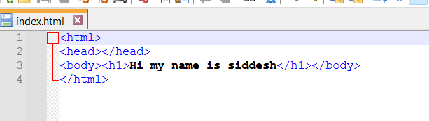

See that feature1 branch has full details of greeting. In short each branch has its own version of files.
Which can be switched at any time.

Now try to merge the feature1 files to master branch.
Open master branch

Command: git checkout master
Now Merge feature 1 with master
Command: git merge feature1

Now check both the branches file

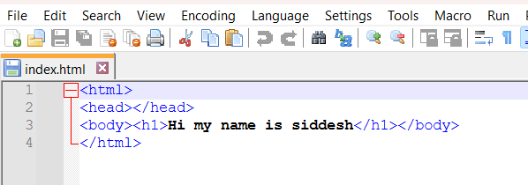

- feature 1 branch.
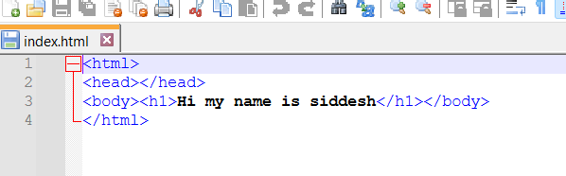

So after merging feature 1 to master branch both the files are same.

Note You can create as many branches as possible.

Commnad to create the new branch and open the new branch
Command syntax: git checkout -b <new_branch_name>
Command: git checkout -b feature2

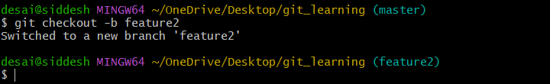

You can see now the current working branch is now the feature2
Check branches now.
Command: git branch

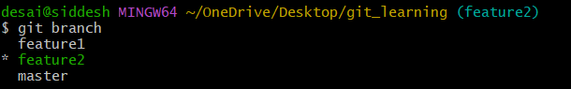

Git hub:-
Create your account at https://github.com.

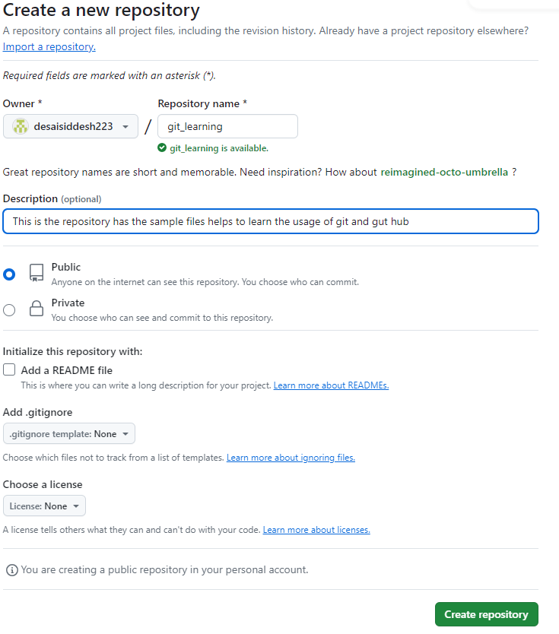

We created a remote repository and our local repository which is created in our local system need to be pushed or need to be copied in the gut hub.

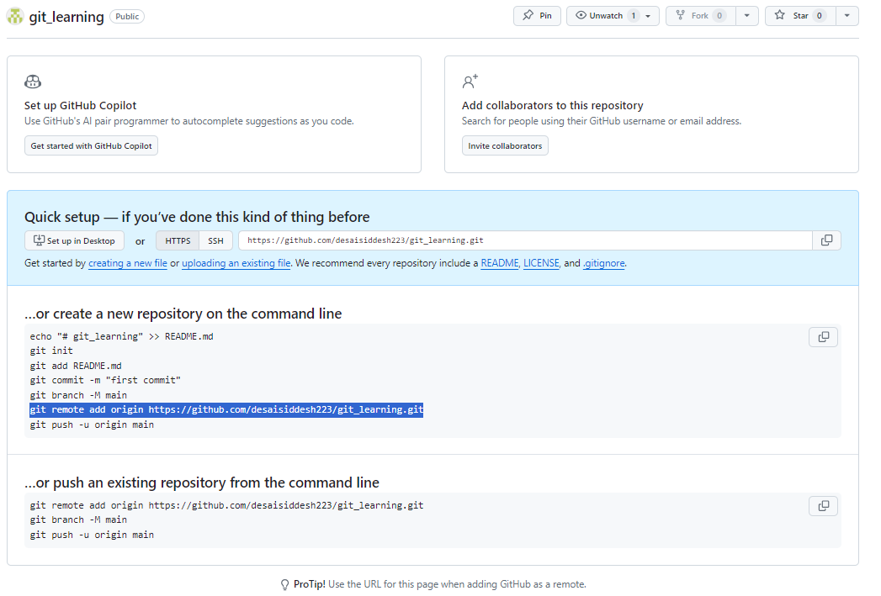

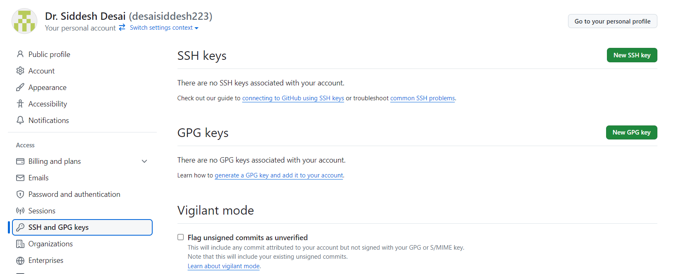

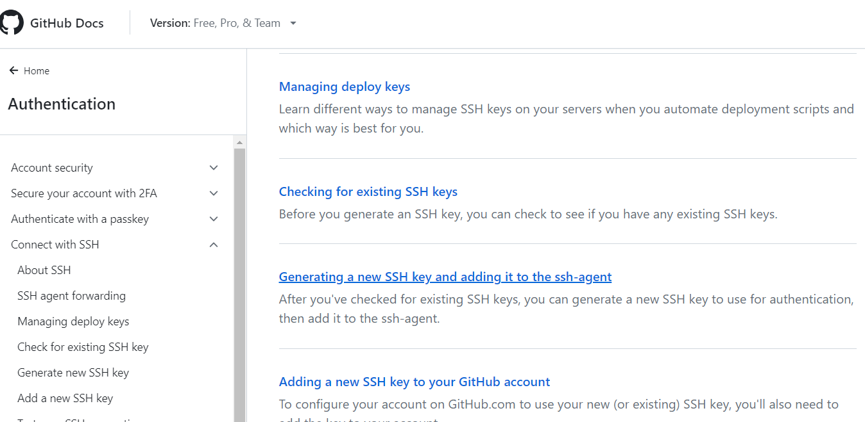

Generating a new SSH key

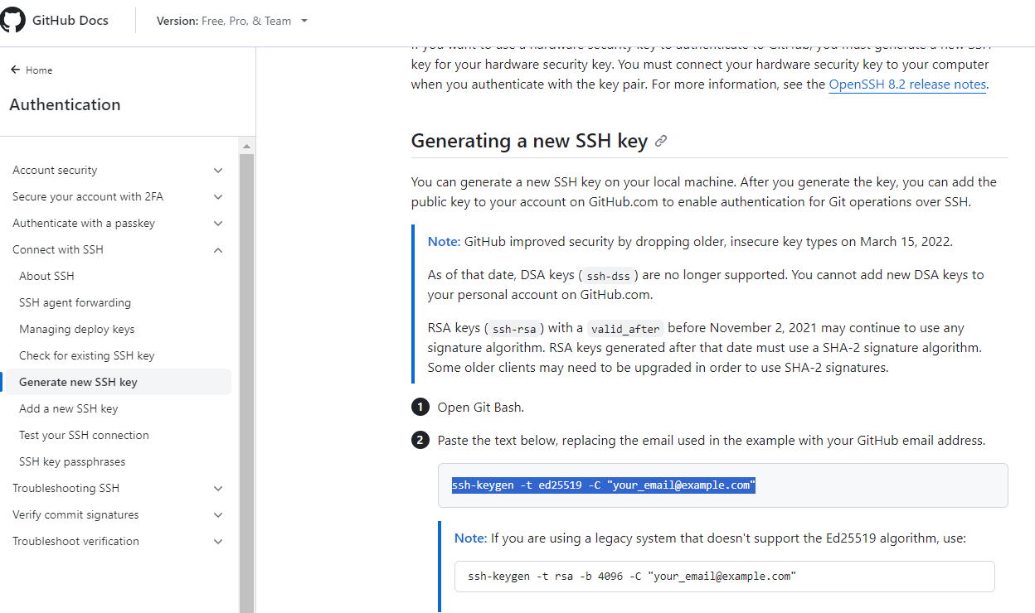

Command Syntax: ssh-keygen -t ed25519 -C your_email@example.com

Command: ssh-keygen -t ed25519 -C desaisiddesh223@gmail.com
Use above command in the git bash terminal.
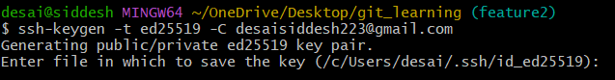

Need to provide the github account to local system. For that wee need SSH keys.
The key's randomart image is:
+--[ED25519 256]--+
| |
| |
| . |
| . o . .|
| * . S o .=|
| = = . + = .E+|
| . B o o + o.+*+|
| + * o . + o+*=|
| .= + .*ooo+.=|
+----[SHA256]-----+

Adding your SSH key to the ssh-agent

Command: eval "$(ssh-agent -s)"

Command: ssh-add ~/.ssh/id_ed25519

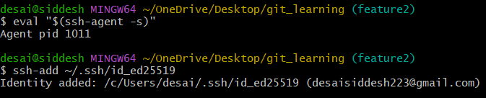
Add the SSH Key to Your GitHub Account

Command: cat ~/.ssh/id_ed25519.pub

ssh-ed25519 AAAAC3NzaC1lZDI1NTE5AAAAIBi4lp0T31rWZn1JDfshBuUUJeV7gSpCNlWFlyh9wIa0 desaisiddesh223@gmail.com
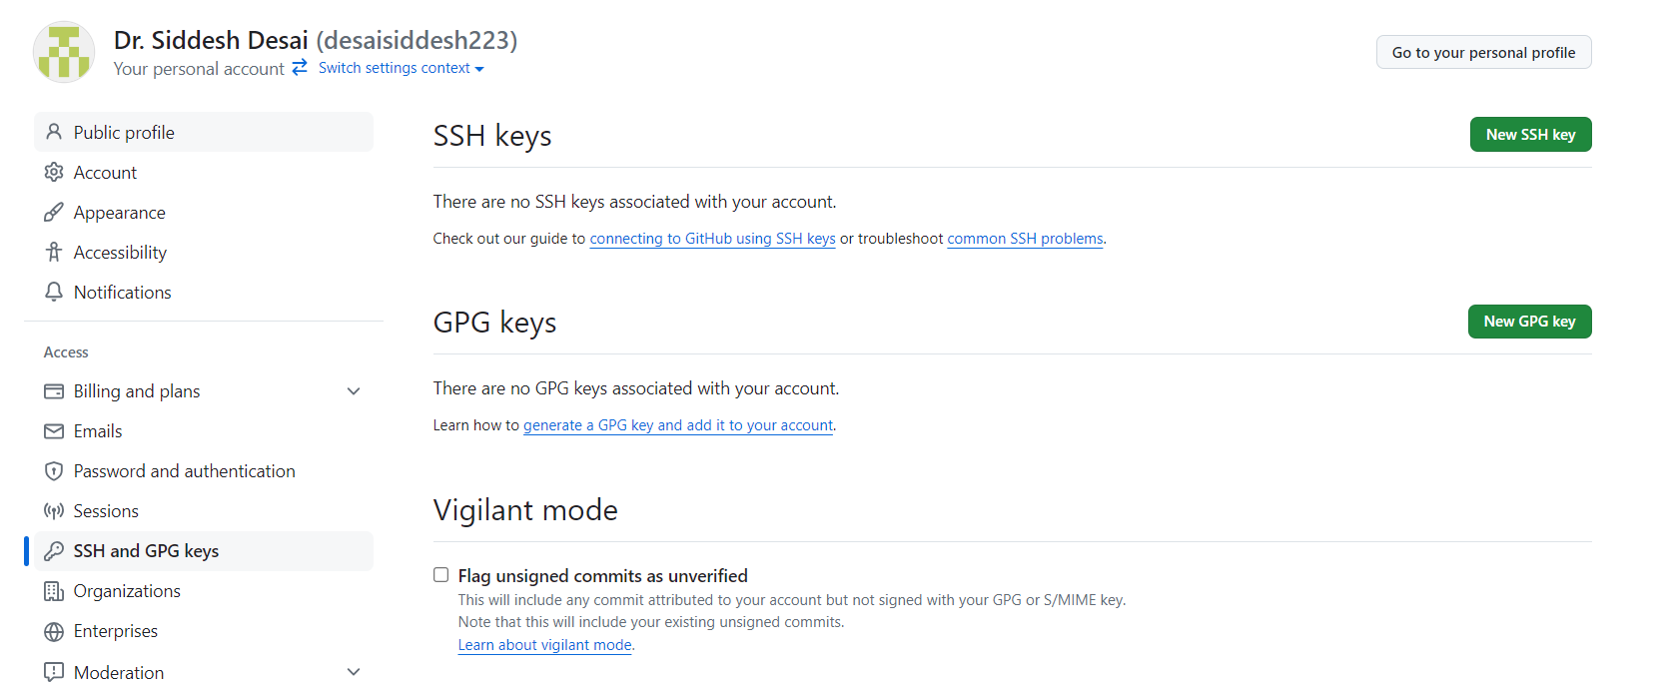
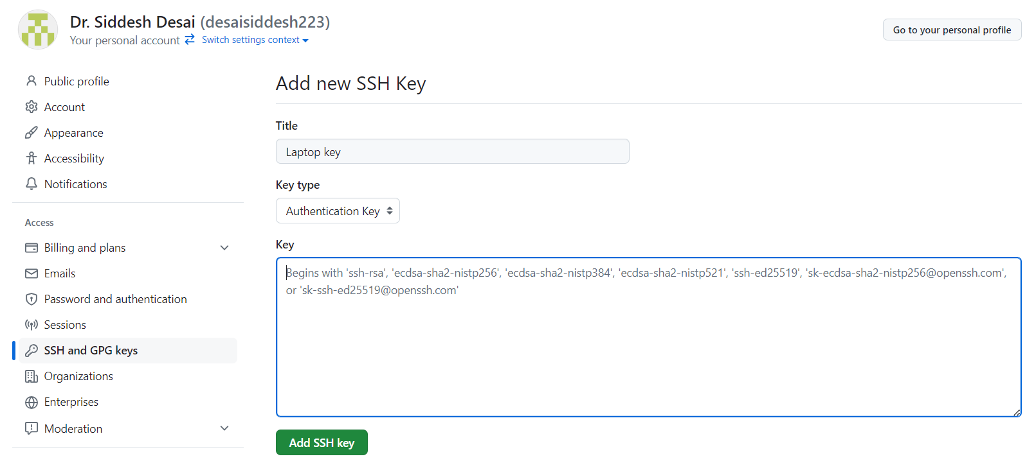
Paste your keys here and then click
add ssh key

After adding required authentication details. This page confirm key addition.
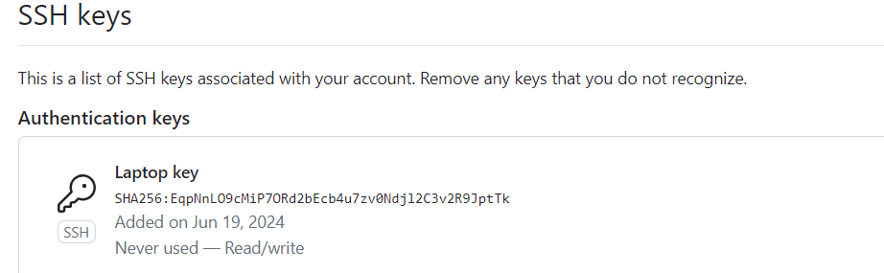
Now got to git bash terminal. Use Command:
Command: git remote add origin git@github.com:<username>/<repo name>.git
Command: git remote set-url origin <ssh url for repository>
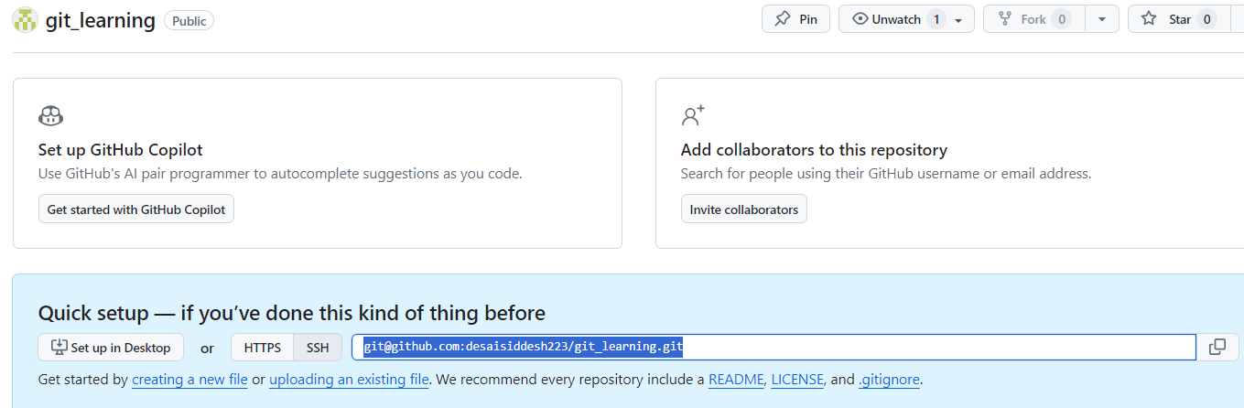

So the final commands are
Command: git remote add origin git@github.com:desaisiddesh223/git_learning.git

Command: git remote set-url origin git@github.com:desaisiddesh223/git_learning.git
Now check remote:
Command: git remote

Push the changes in master branch to the remote repository:
Command: git push -u origin master
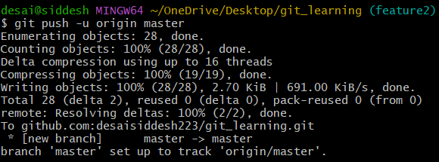

Now check the git hub.
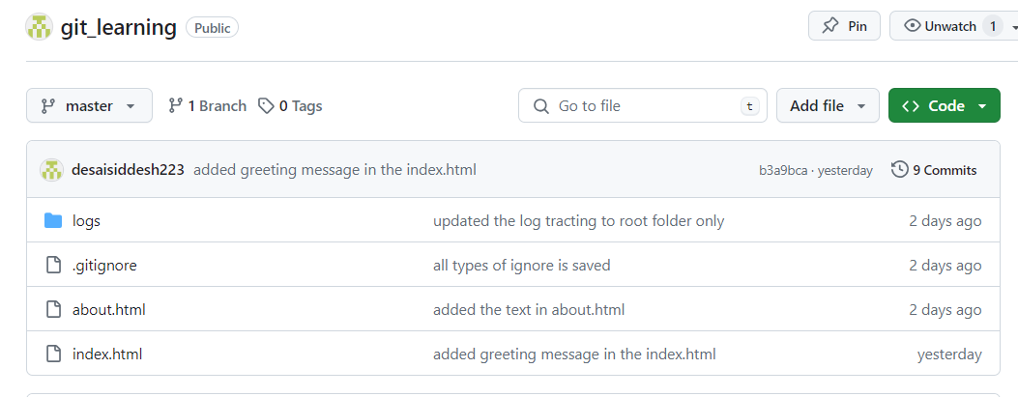

Now push the feature 1 branch:
Command: git push -u origin feature1
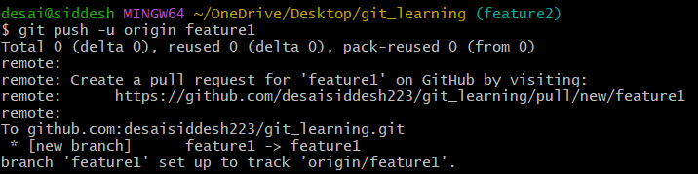

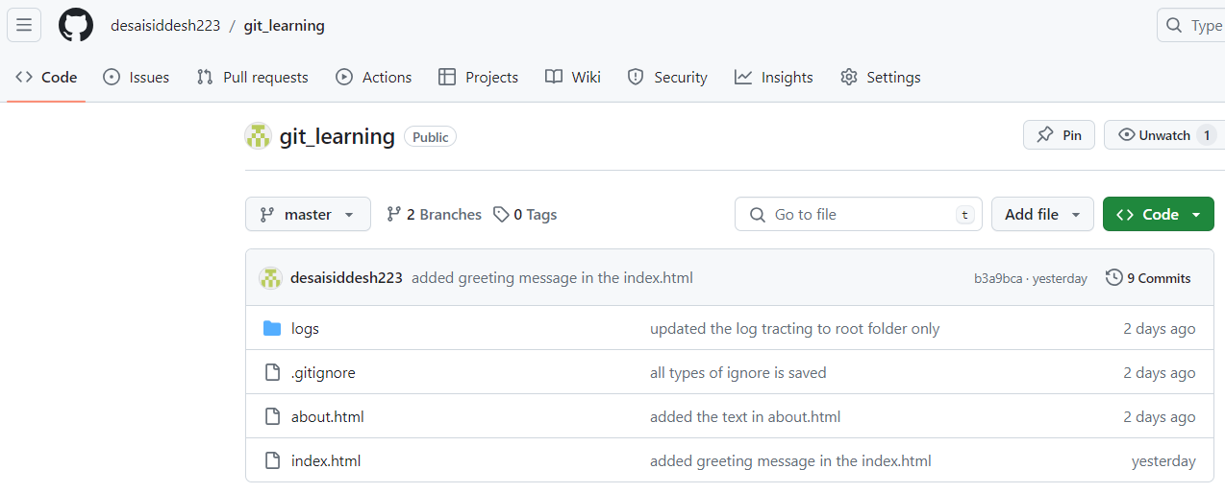

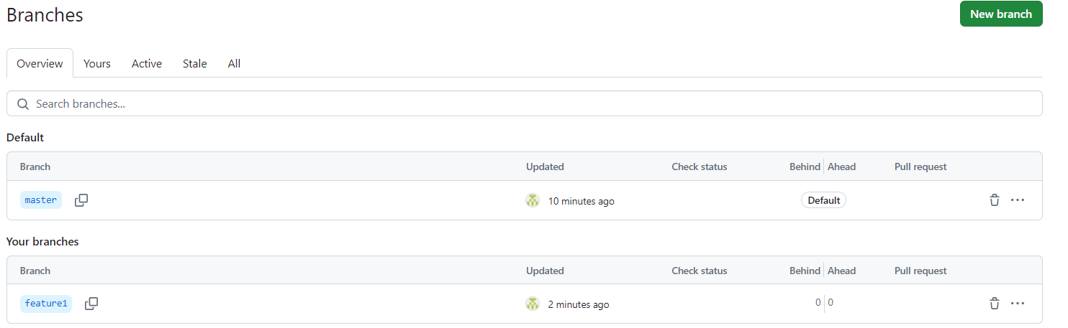
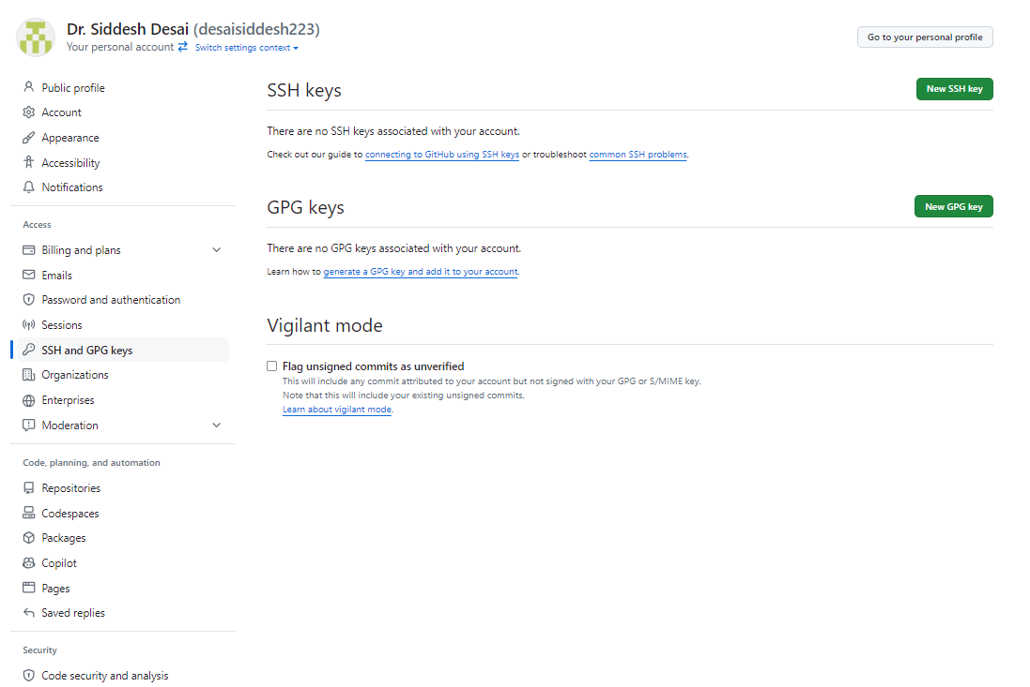

Need to use the selected command which is generated after successful repository creation in the git hub.

If we do only git push. Then it will push the active branch only to the git hub.
Command: git push
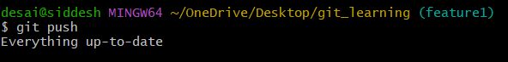

Summary commands:

Set user name and email:
- Use: Configure the Git user name and email for commits.
- Syntax: git config --global user.name "<name>"
- Example: git config --global user.name "siddesh"
- Syntax: git config --global user.email "<email>"
- Example: git config --global user.email "desaisiddesh223"
Initialize a new Git repository:
- Use: Create a new Git repository in the current directory.
- Syntax: git init
- Example: git init
Check the status of the repository:
- Use: Show the working tree status.
- Syntax: git status
- Example: git status
Commit changes with a message:
- Use: Record changes to the repository with a message.
- Syntax: git commit -m "<commit_message>"
- Example: git commit -m "added the text in about.html"
Stage all changes for commit:
- Use: Add all changes to the staging area.
- Syntax: git add -A
- Example: git add -A
Restore a specific file to the last committed state:
- Use: Discard changes in the working directory for a specific file.
- Syntax: git checkout <file_name>
- Example: git checkout about.html
.gitignore file examples:
- Ignore a specific file in the root directory:
  - Use: Exclude a specific file from being tracked.
  - Syntax: /file_name
  - Example: /mylogs.log
- Ignore all files with a .log extension:
  - Use: Exclude all files with a specific extension from being tracked.
  - Syntax: *.extension
  - Example: *.log
- Ignore a specific folder:
  - Use: Exclude a specific folder from being tracked.
  - Syntax: folder_name/
  - Example: sample_ignore_folder/
Create a new branch:
- Use: Create a new branch in the repository.
- Syntax: git branch <branch_name>
- Example: git branch feature1
Create and switch to a new branch:
- Use: Create a new branch and switch to it immediately.
- Syntax: git checkout -b <new_branch_name>
- Example: git checkout -b feature1
Rollback to a previous version:
- Use: Restore the working directory to the state of a specific branch.
- Syntax: git checkout <branch_name>
- Example: git checkout master
Switch to an existing branch:
- Use: Switch to a different branch in the repository.
- Syntax: git checkout <branch_name>
- Example: git checkout feature1
Add a remote repository:
- Use: Add a remote repository to track.
- Syntax: git remote add origin <remote_repository_url>
- Example: git remote add origin git@github.com:desaisiddesh223/git_learning.git
Set or change the URL of a remote repository:
- Use: Change the URL of an existing remote repository.
- Syntax: git remote set-url origin <new_remote_repository_url>
- Example: git remote set-url origin git@github.com:desaisiddesh223/git_learning.git
Check the remote repository configuration:
- Use: Display the names of the remotes.
- Syntax: git remote
- Example: git remote
Push changes to the master branch in the remote repository:
- Use: Push local changes to the remote master branch.
- Syntax: git push -u origin <branch_name>
- Example: git push -u origin master
Push changes to the feature1 branch in the remote repository:
- Use: Push local changes to the remote feature1 branch.
- Syntax: git push -u origin <branch_name>
- Example: git push -u origin feature1

