**Cash-back**

**Data Flow Diagram**

Method: 1

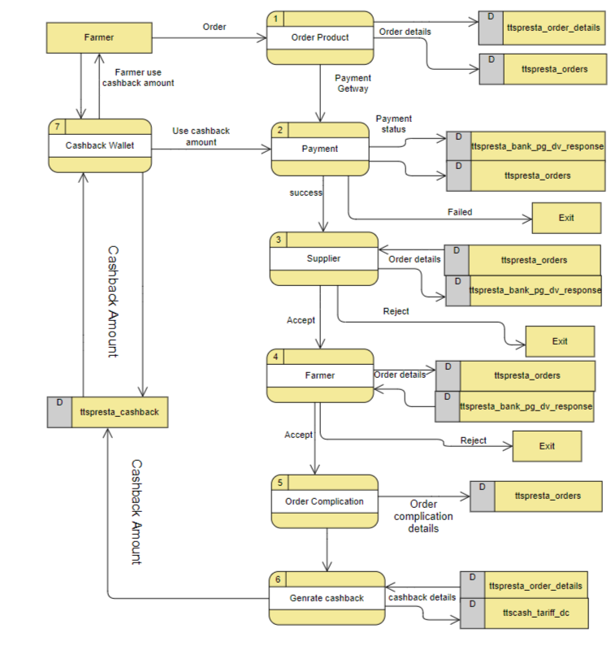 Image 1.0

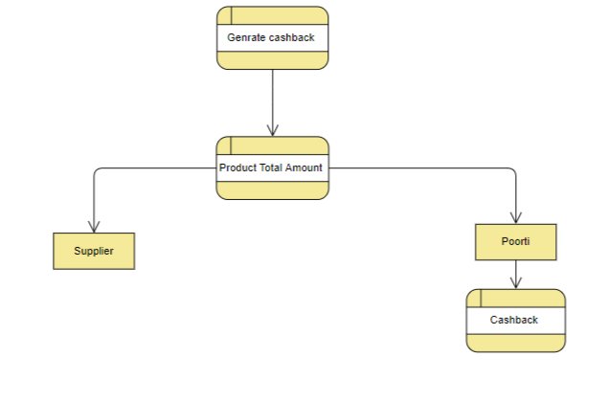

Image 1.1

1. When the farmer orders a product, the details of the order are saved in the ttspresta_order_details and ttspresta_orders table and processed on the payment screen.
2. If the payment becomes successful then the payment details are saved in the ttspresta_orders and ttspresta_bank_pg_dv_response table and if the payment is unsuccessful then the order will go in the waiting list.
3. When the payment is made successfully, the order details go to the supplier and If the supplier accepts the order then the order goes to the farmer to review, And if the supplier does not accept the order due to any reason, the order will be canceled or go to the waiting list and the payment will be returned to the farmer, And the details will be updated in the ttspresta_orders and and ttspresta_bank_pg_dv_response table.
4. After reviewing the order product in this step, if the farmer accepts, then the order will be completed otherwise the payment will be returned to the farmer, And the details will be updated in the ttspresta_orders and ttspresta_bank_pg_dv_response table.
5. After the order is complete, details will store in ttspresta_orders table a cash-back will be generated, as shown in image 1.0, Cash-back amount on each product will be determined by PBO (Poorti Back Office) in Cashbox.
6. On next purchases, the farmer can use the cash-back account that cashback was received upon purchase of the last product.
7. As you can see in image 1.1, the supplier will get the prescribed percentage in the tariff. Which will be set by PBO, and the rest will go to poorti. Out of that amount, poorti will decide how much cash-back to give. And this amount will set by PBO. And this description will be saved in the ttscash_tariff_dc and ttspresta_order_details table. And the cash-back amount will be saved in the ttspresta_cashback table.
8. In this method, the farmer will use his cash-back amount in the next purchase, then that amount will be paid from Poorti account.

Method: 2

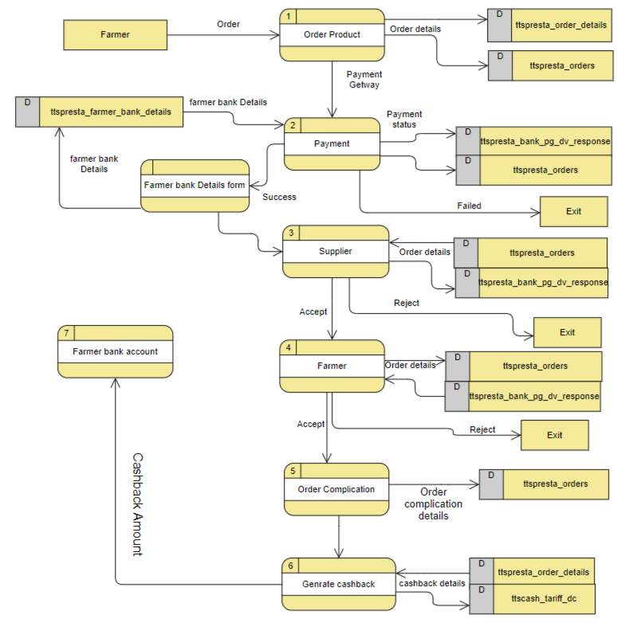

Image 2.0



Image 2.1

1. The similar process in this method will be similar to Method 1, but in this Method, the farmer has to give the bank details after payment.

Like:

1. Branch Name
2. Account Number
3. Account holder name
4. IFSC code

All these details will be saved in the ttspresta_farmer_bank_detailsTable . And if there are already bank details then the farmer does not need to give bank details again.

If the farmer's bank details are wrong then the order will go on the waiting list.

1. In this method, the cash-back amount will go directly to the bank account of the farmer. And this amount will go through Poorti bank account.

**Note:**

Both of these methods have one thing common, in both cases SBI Nodal account must be prefilled with some extra amount otherwise payment can be bounced.

Example: