Electric Vehicle Population Data Analysis Report
Cover Page
- Title: Electric Vehicle Population Data Analysis
- Subject: Data Analytics
- Student Name: Vrushti Desai
- Course: B.Sc. Data Science
- College: Bhagwan Mahavir College of Computer Applications
- Submission Date: 22 july 2026

Table of Contents
- Introduction
- Objectives
- Dataset Description
- Data Preprocessing
- Exploratory Data Analysis (EDA)
- Data Visualizations
- Linear Regression Analysis
- Results and Discussion
- Conclusion
- Appendix
- References

1. Introduction
Briefly introduce Electric Vehicles (EVs) and explain the importance of analyzing EV population data. Mention that Python was used for data preprocessing, visualization, and predictive analysis.

2. Objectives
- Analyze the Electric Vehicle Population dataset.
- Identify the most popular EV manufacturers and models.
- Study EV adoption trends over time.
- Examine EV distribution across counties.
- Predict Electric Range using Linear Regression.
- Gain insights through data visualization.

3. Dataset Description
Include:
- Dataset Name
- Number of Rows
- Number of Columns
- List of important columns:
  - County
  - City
  - Model Year
  - Make
  - Model
  - Electric Range
  - Electric Vehicle Type
  - CAFV Eligibility
  - Vehicle Location

4. Data Preprocessing
Describe the steps performed:
- Imported dataset
- Checked missing values
- Removed duplicates
- Cleaned column names
- Converted categorical variables
- Prepared data for analysis

5. Exploratory Data Analysis (EDA)
Discuss:
- Top EV manufacturers
- Most popular EV models
- Electric Range statistics
- County-wise EV registrations
- Model Year trends
- CAFV eligibility distribution

6. Data Visualizations
Insert screenshots of each graph with a short explanation.
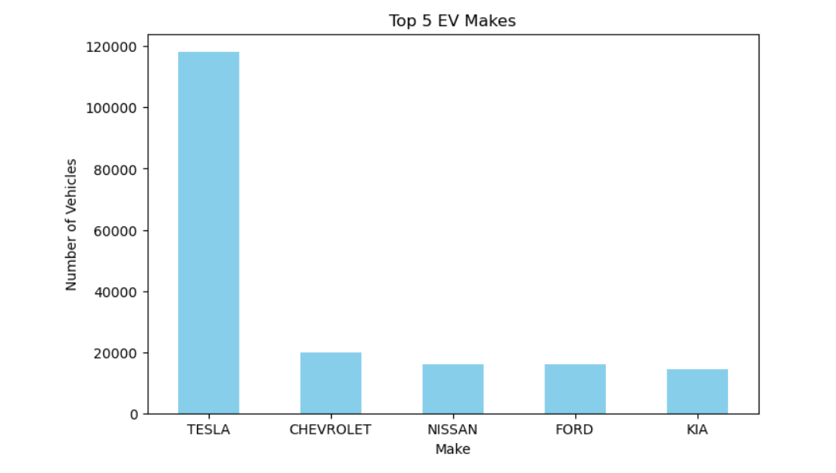
Top 5 EV Makes
Observation:
Shows the manufacturers with the highest number of registered electric vehicles.

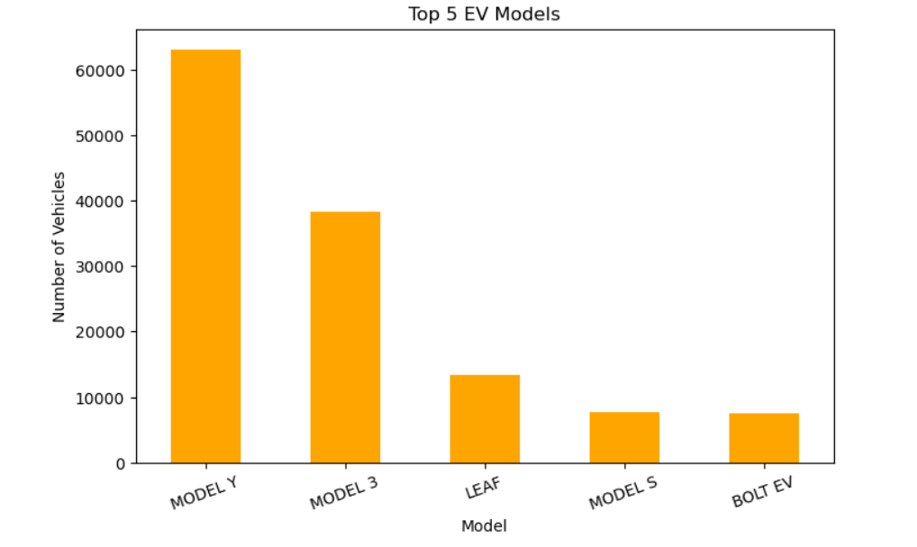
Top 5 EV Models
Observation:
Identifies the most frequently registered EV models.

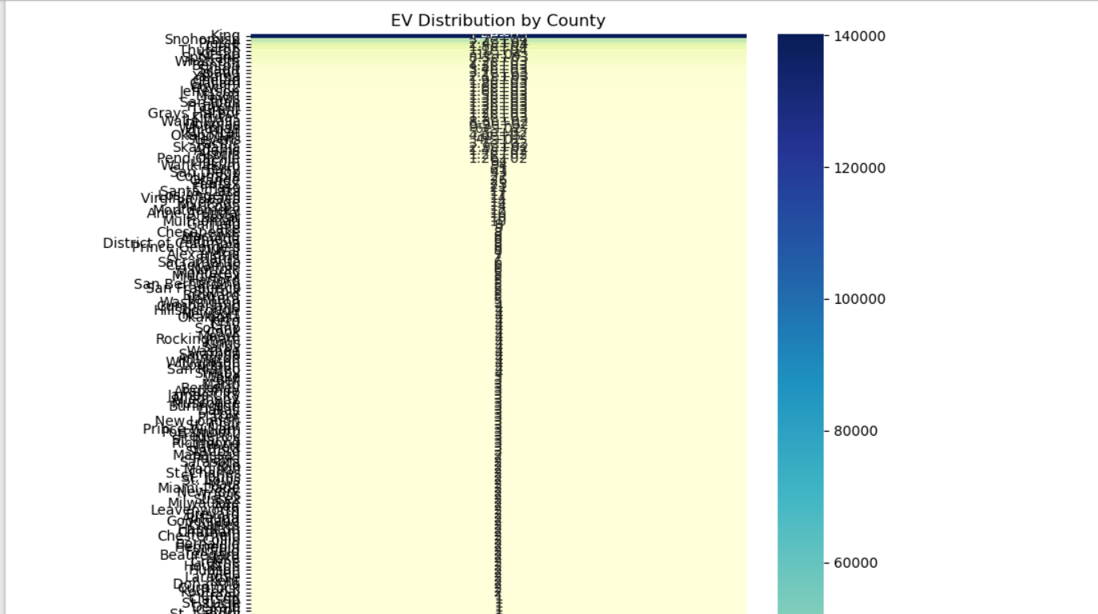
Heatmap of EV Distribution by County
Observation:
Shows counties with higher concentrations of EV registrations.

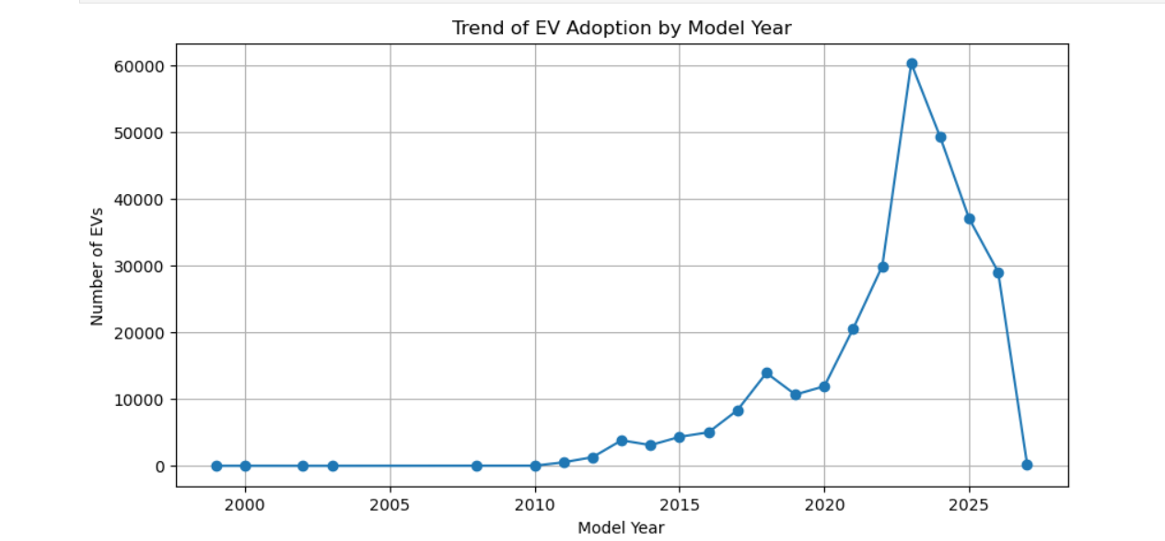
Trend of EV Adoption by Model Year
Observation:
Illustrates the increasing adoption of electric vehicles over the years.

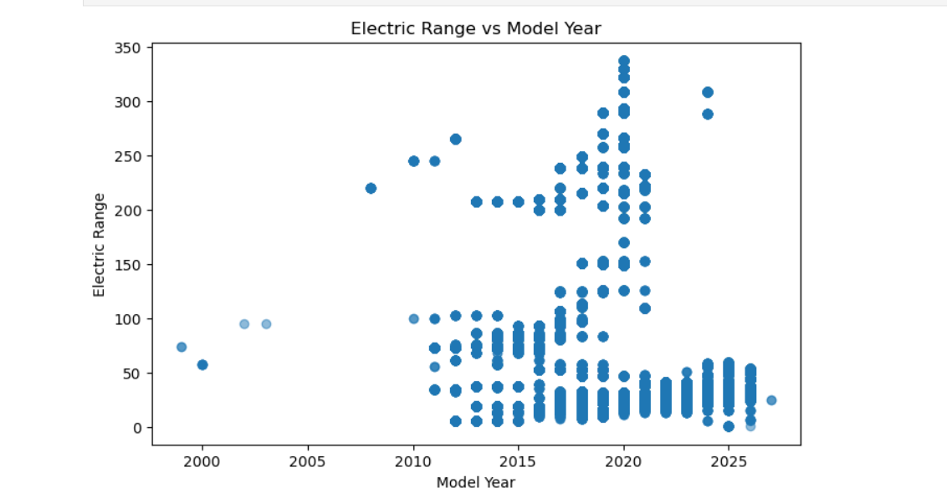
Scatter Plot
(Electric Range vs Model Year)
Observation:
Displays the relationship between vehicle model year and electric range.

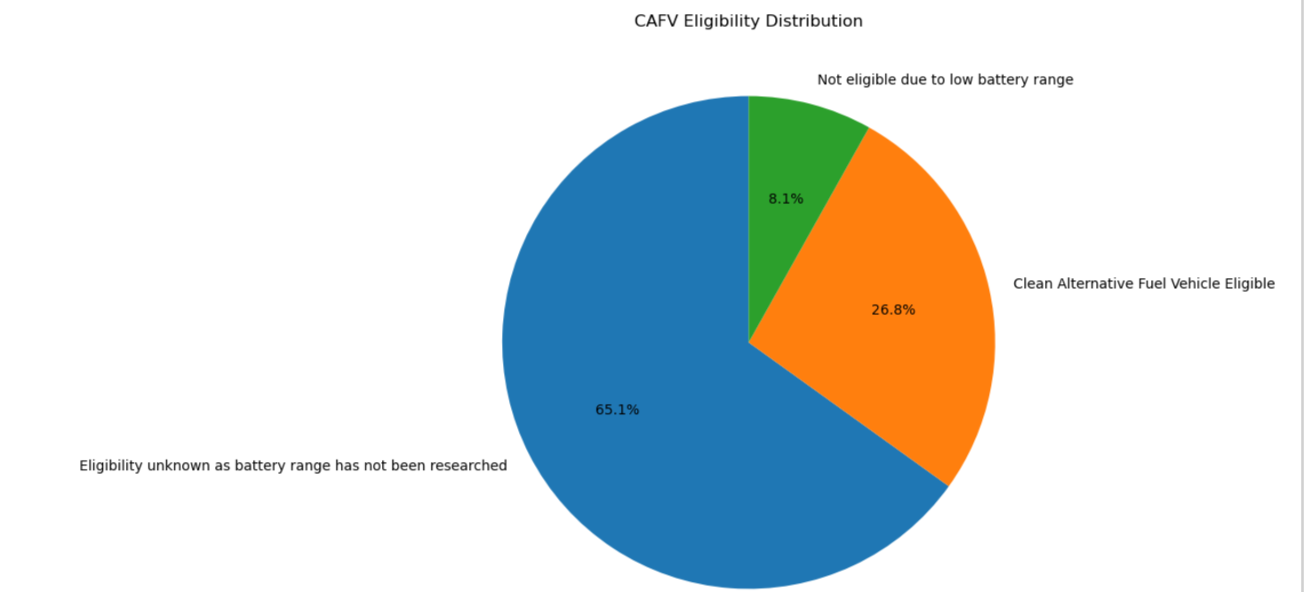
CAFV Eligibility Pie Chart
Observation:
Shows the percentage of CAFV-eligible and non-eligible vehicles.

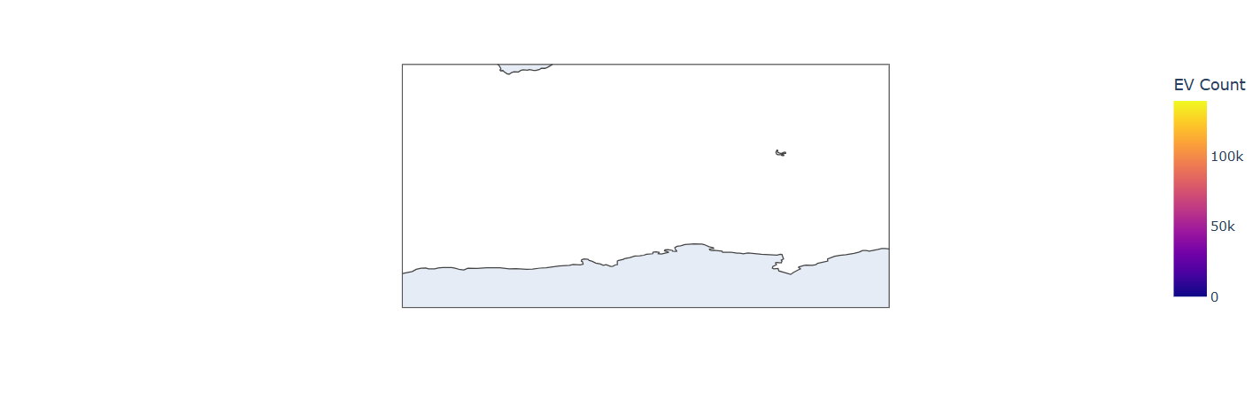
Geospatial Map
Observation:
Displays the geographical distribution of EV registrations.

7. Linear Regression Analysis
Include:
- Problem Statement
- Features Used
- Target Variable (Electric Range)
- Train-Test Split
- Model Training
- Prediction
- R² Score
- Interpretation
Mention that Base MSRP was not available in the dataset, so it was excluded from the regression model.

8. Results and Discussion
Summarize key findings, such as:
- Tesla is one of the leading EV manufacturers.
- EV registrations have increased significantly in recent years.
- Some counties have a much higher concentration of EVs.
- Electric Range varies across manufacturers and vehicle types.
- Linear Regression can predict Electric Range with reasonable accuracy using available features.

9. Conclusion
This project analyzed the Electric Vehicle Population dataset to understand EV adoption trends, manufacturer popularity, and regional distribution. Various visualizations revealed key insights, including the most common EV makes and models, county-wise registrations, and yearly adoption trends. A Linear Regression model was developed to predict Electric Range using available vehicle features. Although the dataset lacked the Base MSRP column, the analysis demonstrated how data preprocessing, visualization, and machine learning can be applied to extract meaningful insights from real-world datasets.

10. Appendix
Include:
- Important Python code
- Additional tables
- Dataset information
- Screenshots (if required)

11. References
- Electric Vehicle Population Dataset
- Pandas Documentation
- NumPy Documentation
- Matplotlib Documentation
- Seaborn Documentation
- Scikit-learn Documentation

