Q. Find ratio of revenue.
Query:
select product_category,
sum(quantity*price_per_unit) as revenue,
(sum(quantity*price_per_unit)*100/(select sum(quantity*price_per_unit)from dmart_orders)) as revenue_ratio
from dmart_orders
group by product_category;

Screenshot:
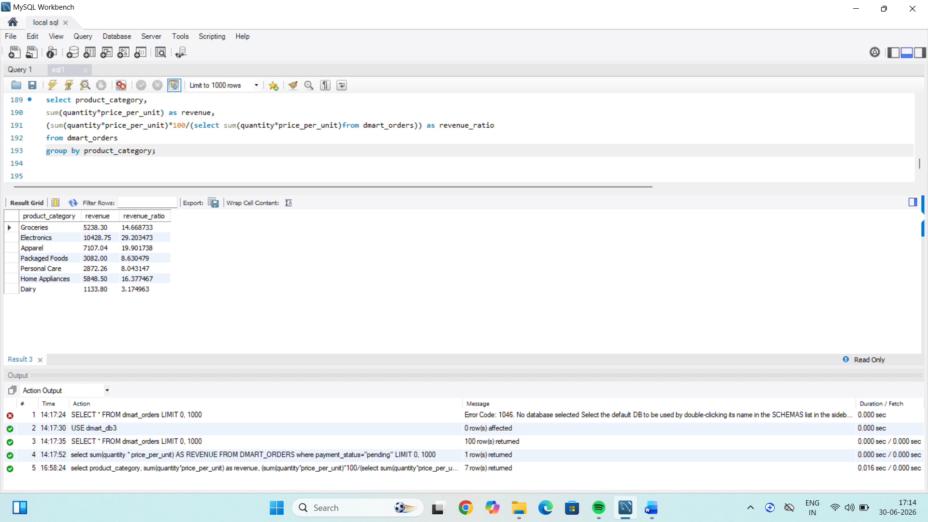

Insights:
1. The Calculates the total revenue of all orders.
2. revenue is calculated as Quantity*price_per_unit.
3. Divide each category revenue by the total revenue and multiply by 100.

