Q1.Inner join
Query:
select
T1.teacher_id,
T1.teacher_name,
D1.dept_name department3
From
department3 D1 INNER JOIN TEACHER T1
ON D1.dept_id=T1.dept_id;
Screenshot:
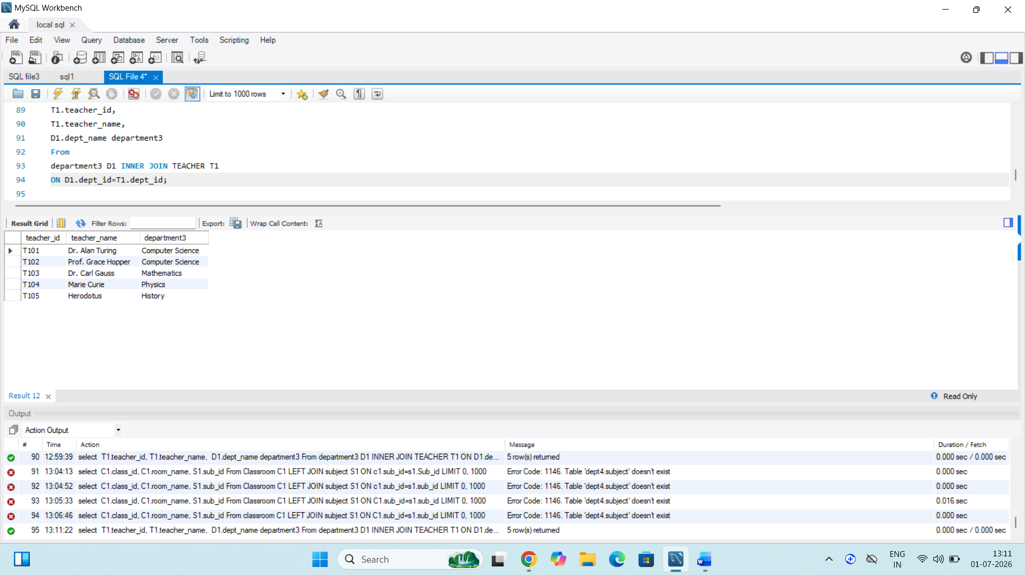
Insights:
1.teachers without a matching department are not included in the result.
2.only teachers who are assigned to a valid department are shows.

Q2.Right joins
Query:
select
c1.class_id,
c1.room_name,
s1.sub_name
From
Classroom c1 Right join subject1 S1
ON S1.sub_id=c1.sub_id;

Screenshot:
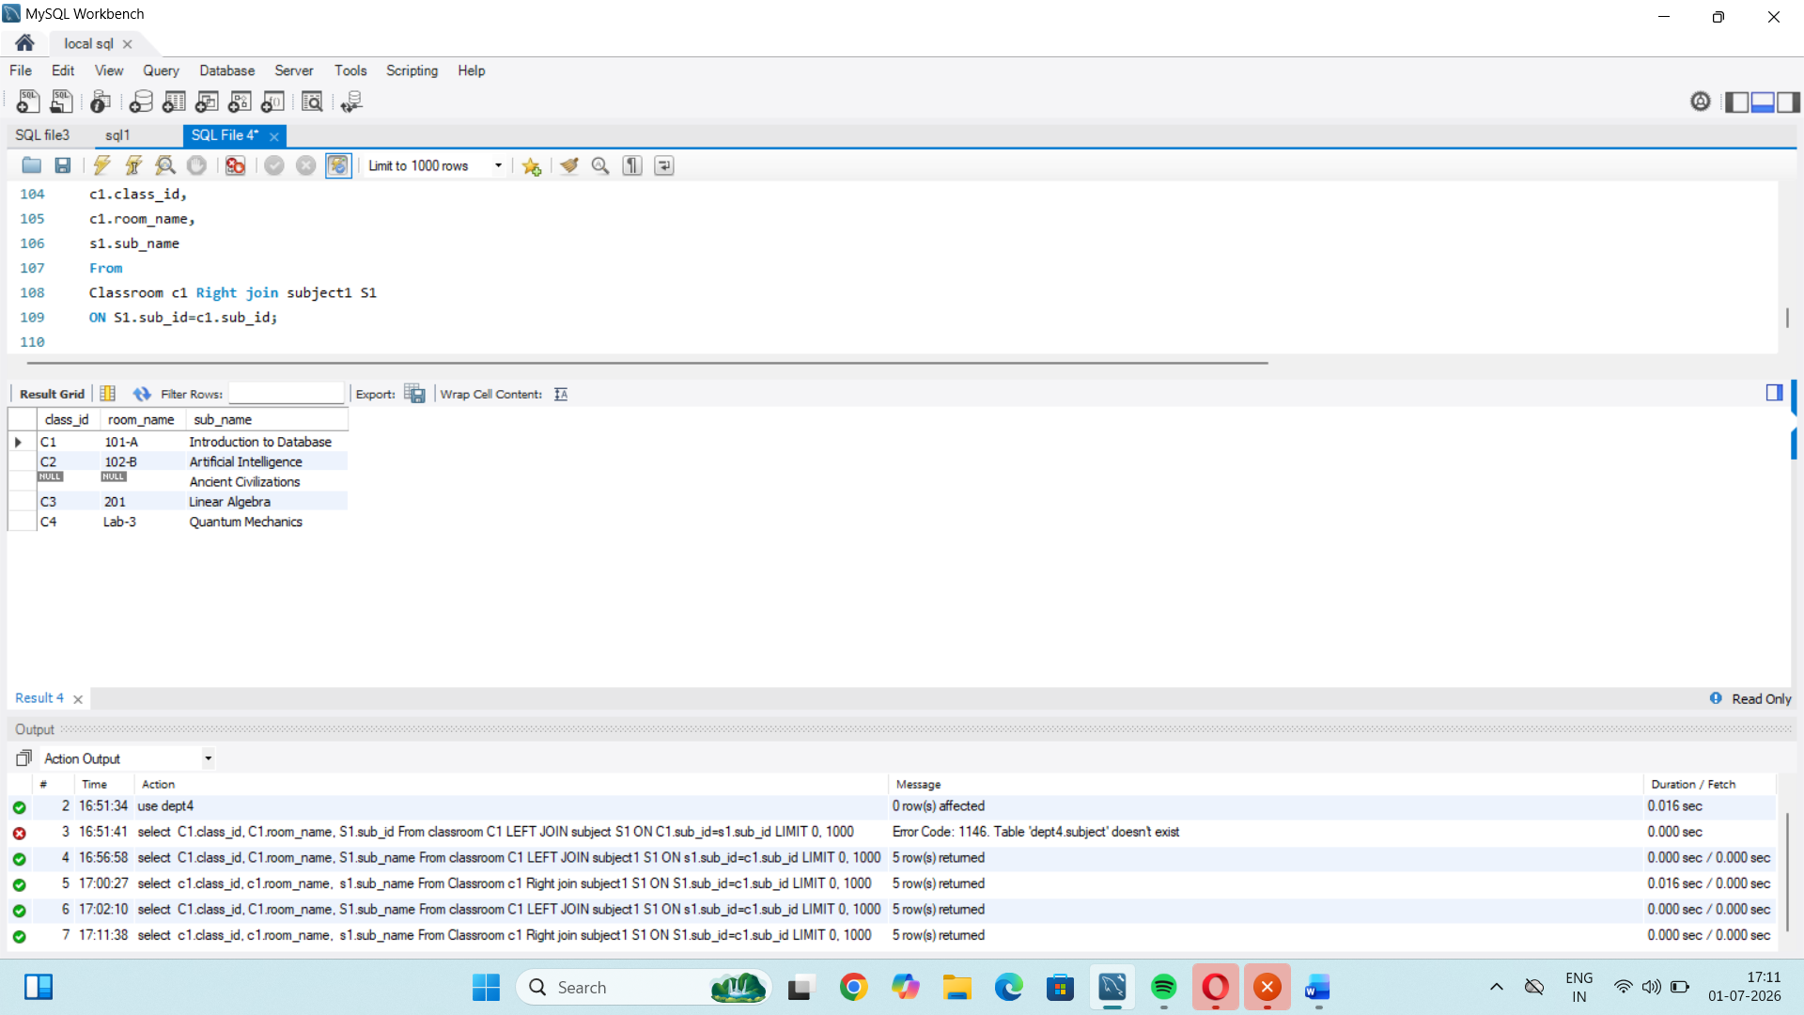
Insights:
1. it return all records from the teachers table.
2. if a teachers has no matching department name is null.

Q3. Left join
Query:
select
C1.class_id,
C1.room_name,
S1.sub_name
From classroom C1 LEFT JOIN subject1 S1
ON s1.sub_id=c1.sub_id;
Screenshot:
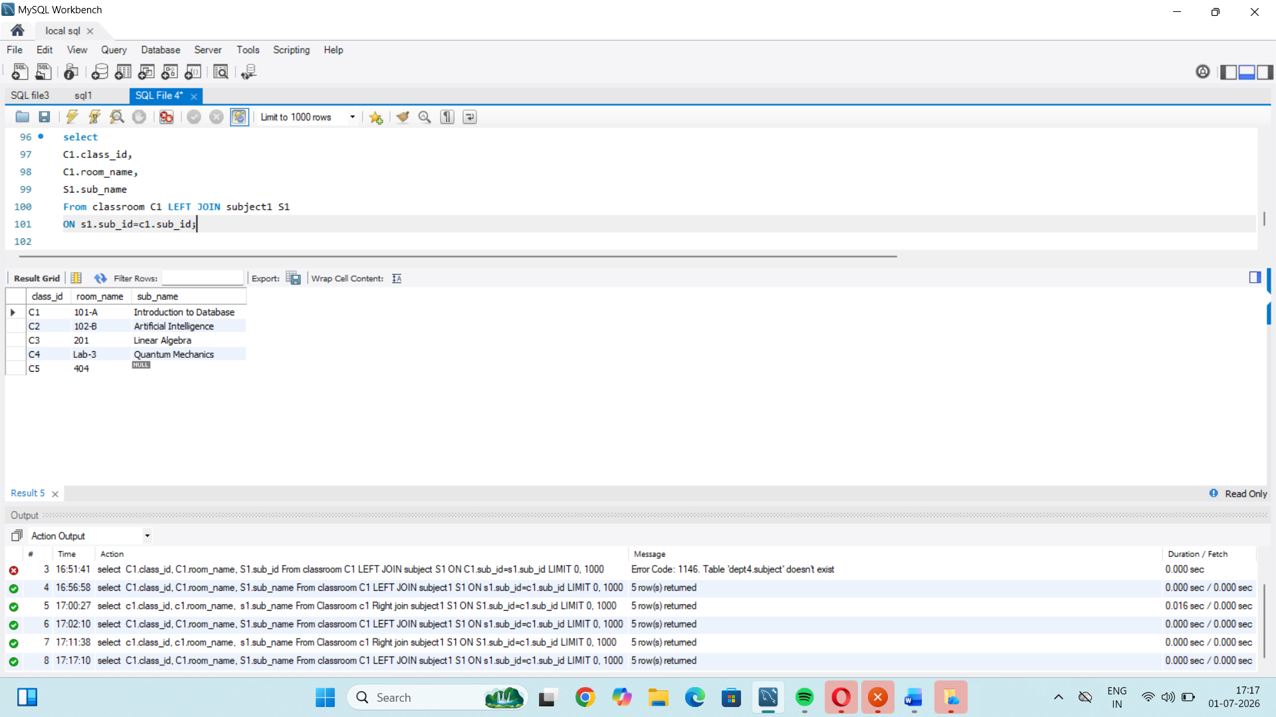
Insights:
1. it returns all records from the classroom table.
2. displays class id, room name, and subject id.

