Q2. Print customer name with highest number of orders
Query:
select customer_id,count(*) as total_orders
from dmart_orders
group by customer_id
order by total_orders desc limit 1;
Screenshot:

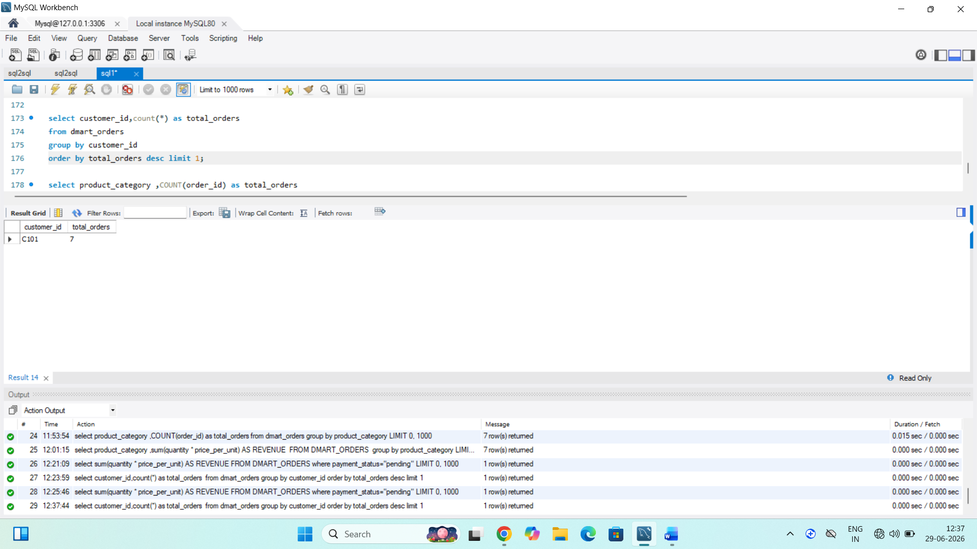
Insights:
1.This table customer name for highest order in table.
2. Identify the customer name order.

Q3. Find total number orders per category.
Query:
select product_category ,COUNT(order_id) as total_orders
from dmart_orders
group by product_category;
Screenshot:

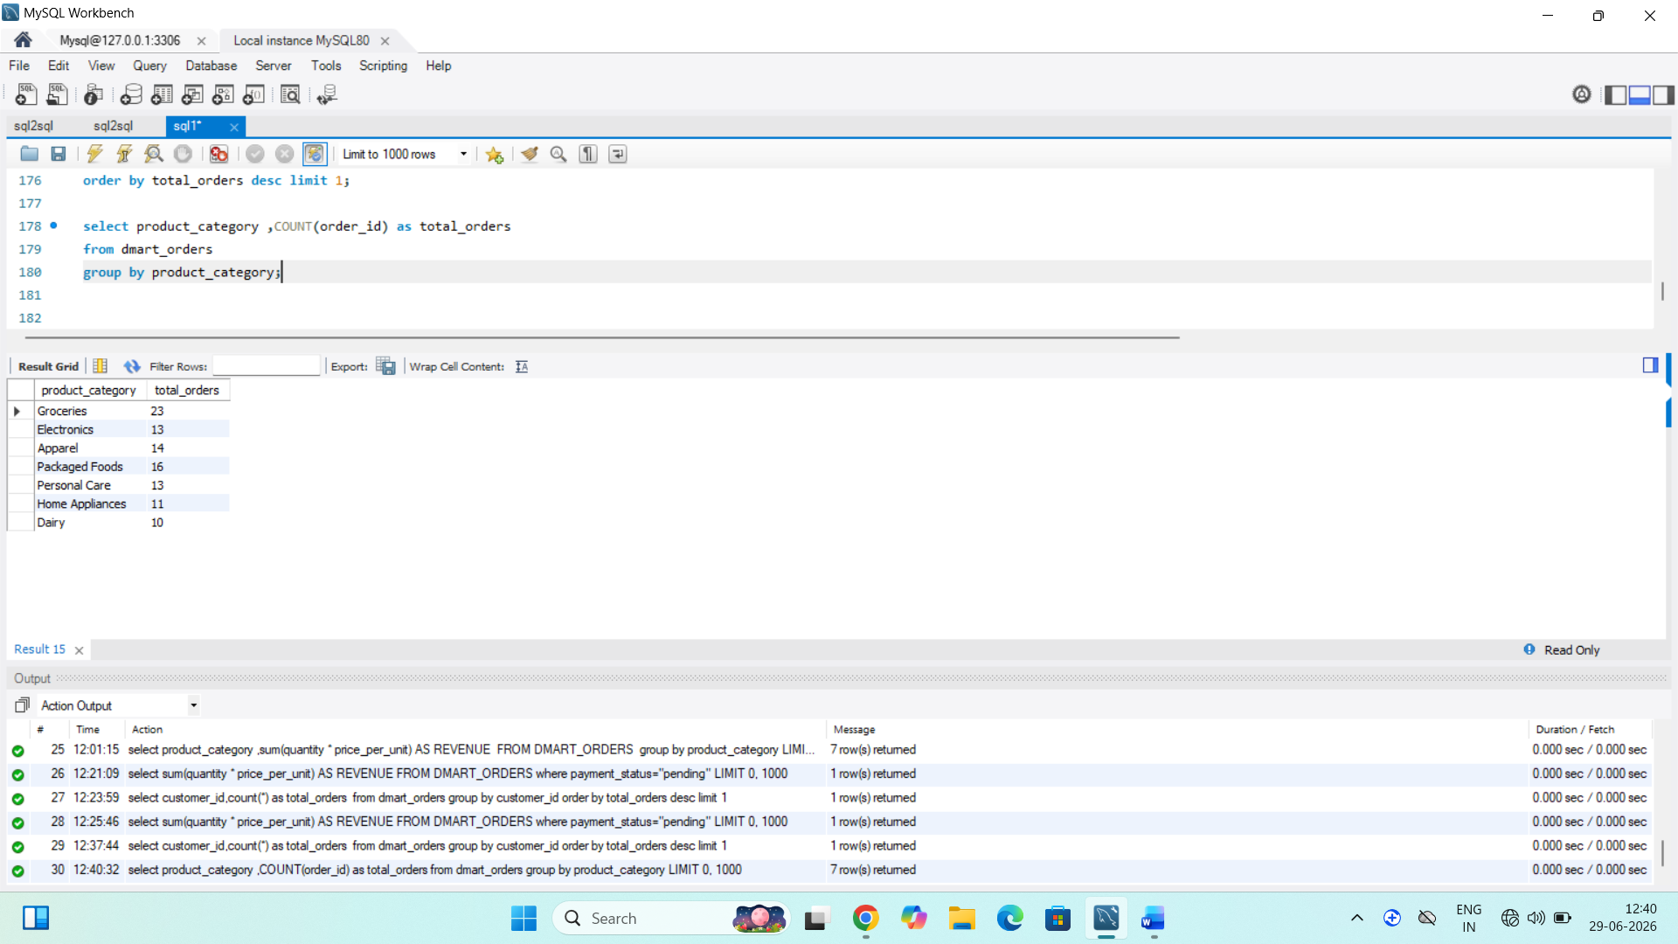
Insights:
- Shows which product category is most popular.
- Find the total number order.

Q4. Print Revenue per order category.
Query:
select product_category ,sum(quantity * price_per_unit) AS REVENUE
FROM DMART_ORDERS
group by product_category;
Screenshot:

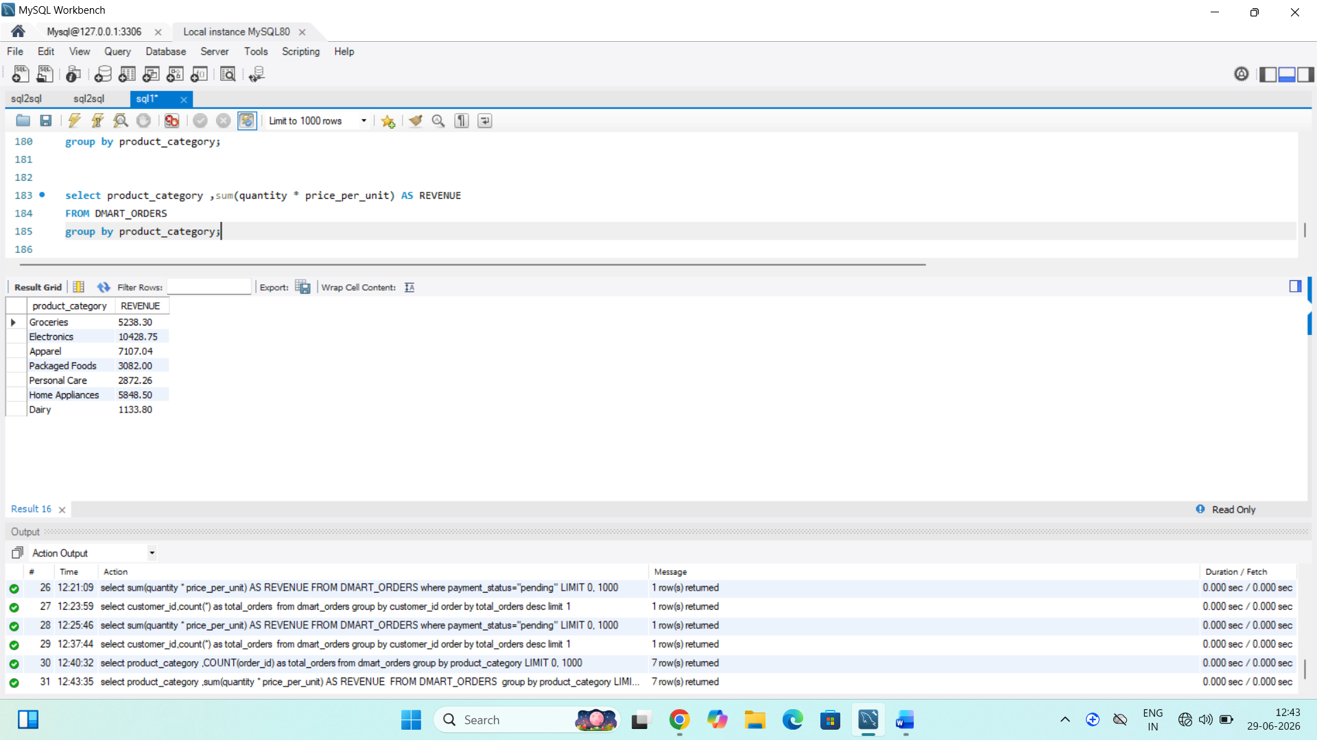

Insights:
- Identifies the category generating the highest sales.

Q5. Find credit amount.
Query:
select sum(quantity * price_per_unit) AS REVENUE FROM DMART_ORDERS where payment_status="pending";

Screenshot:

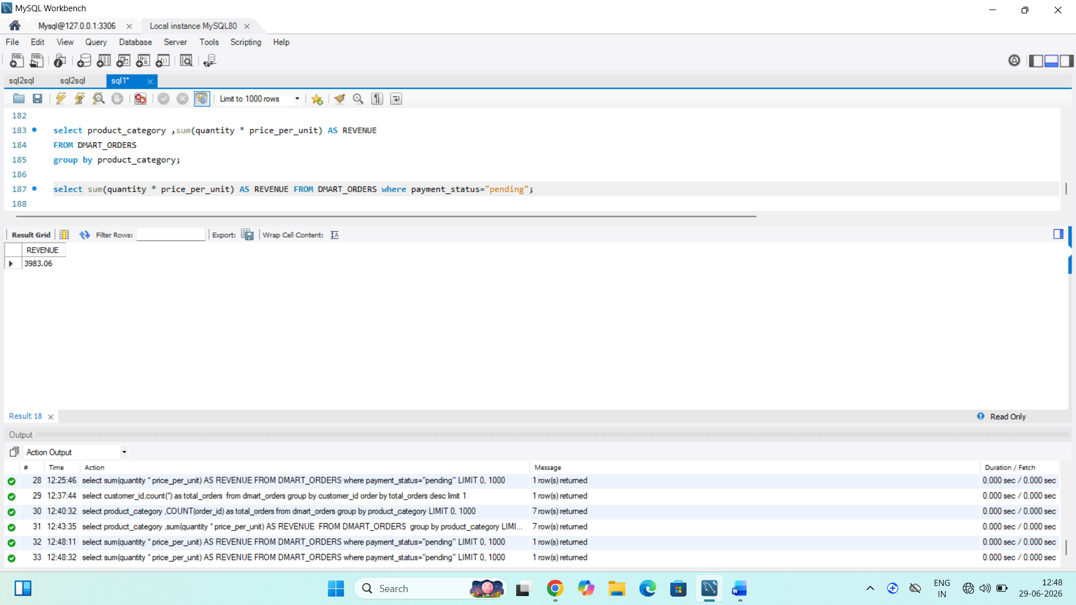

Insights:
- Shows the total sales made on credit.
- Total amount calculate this category.

