1.A light bulb can be either Working (1) or Not Working (0).
Write a Python program to:
Generate 10 Bernoulli random values.
Print the generated values.
Count how many bulbs are working.
Code:
import numpy as np
bulbs=np.random.binomial(1,0.5,10)
print("Generated values:",bulbs)
working=np.sum(bulbs)
print("Working bulbs:",working)

Screenshot:


Insights:
1. 1 represents a working bulb and 0 represents a non-working bulb.
2. The program generated 10 bulb values using the Bernoulli distribution.

2.A coin is tossed 5 times.
Write a Python program to:
Simulate the experiment using the Binomial distribution.
Print the number of heads obtained.
Repeat the experiment 5 times.
Code:
import numpy as np
for i in range(5):
heads=np.random.binomial(5,0.5)
print("Experiment",i+1,":Heads=",heads)
Screenshot:
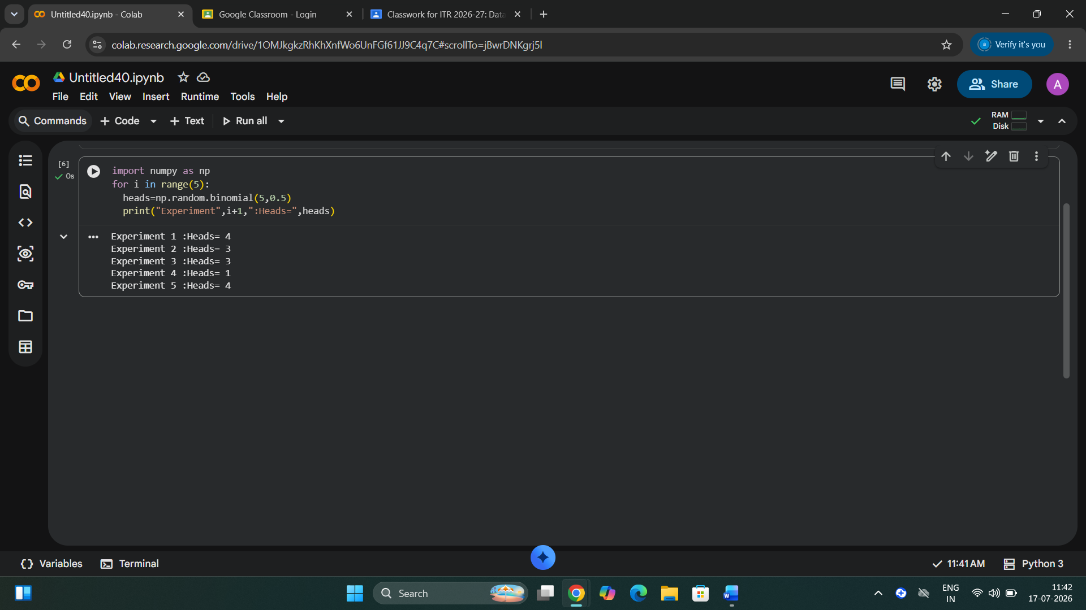

Insights:
1.Experiment 1: 4 heads were obtained.
2. Experiment 2: 3 heads were obtained.
3. Experiment 3: 3 heads were obtained.
4. Experiment 4: 1 heads were obtained.
5. Experiment 5: 4 heads were obtained.

3.A player has a 50% chance of winning a game.
Write a Python program to:
Generate 10 Geometric random values.
Print the generated values.
Find the maximum number of attempts required for the first win.
Code:
import numpy as np
a=np.random.geometric(0.5,10)
print(a)
print("Maximum:",max(a))
Screenshot:

Insights:
1. generated values are 2 1 3 1 3 1 1 1 1 1.
2. maximum attempt required for first win is 3.

4.A shop receives an average of 2 customers per hour.
Write a Python program to:
Generate customer arrivals for 10 hours.
Print the generated values.
Find the highest number of customers received in an hour.
Code:
import numpy as np
a=np.random.poisson(2,10)
print(a)
print("Highest:",max(a))
Screenshot:

Insights:
1. generated values are 3 2 0 0 3 3 3 0 3 3.
2. The highest of customers received in an hour is 3.

5.Write a Python program to generate 5 random values from each of the following distributions:
Bernoulli Distribution
Binomial Distribution
Geometric Distribution
Poisson Distribution
Print the generated values for each distribution separately.
Code:
import numpy as np
print("Bernoulli:")
print(np.random.binomial(1,0.5,5))
print("Binomial:")
print(np.random.binomial(5,0.5,5))
print("Geometric:")
print(np.random.geometric(0.5,5))
print("Poisson:")
print(np.random.poisson(2,5))
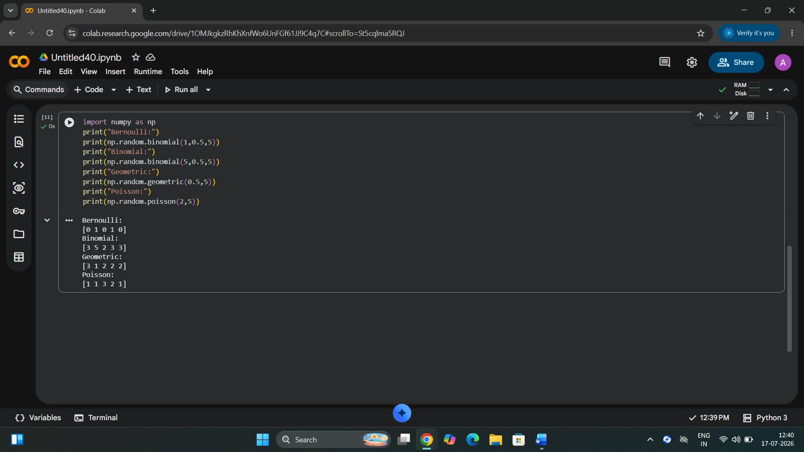
Insights:
1.Bernoulli distribution values are 0 1 0 1 0
2.Binomial distribution values are 3 5 2 3 3
3.Geometric distribution values are 3 1 2 2 2
4.Poisson distribution values are 1 1 3 2 1

