Q1. Percentile using Python
Write a Python program to calculate the 25th percentile, 50th percentile, and 90th percentile
for the following dataset.
Your program should:
• Import NumPy.
• Calculate the 25th, 50th, and 90th percentiles.
• Print all three percentile values.
marks = [42, 48, 51, 55, 58, 60, 63, 67, 70, 72,
75, 78, 80, 83, 85, 88, 90, 92, 95, 98]
Code:
import numpy as np
marks=marks = [42, 48, 51, 55, 58, 60, 63, 67, 70, 72,
75, 78, 80, 83, 85, 88, 90, 92, 95, 98]
p25=np.percentile(marks,25)
p50=np.percentile(marks,50)
p90=np.percentile(marks,90)
print("25th percentile=", p25)
print("50th percentile=", p50)
print("90th percentile=", p90)

Screenshot:
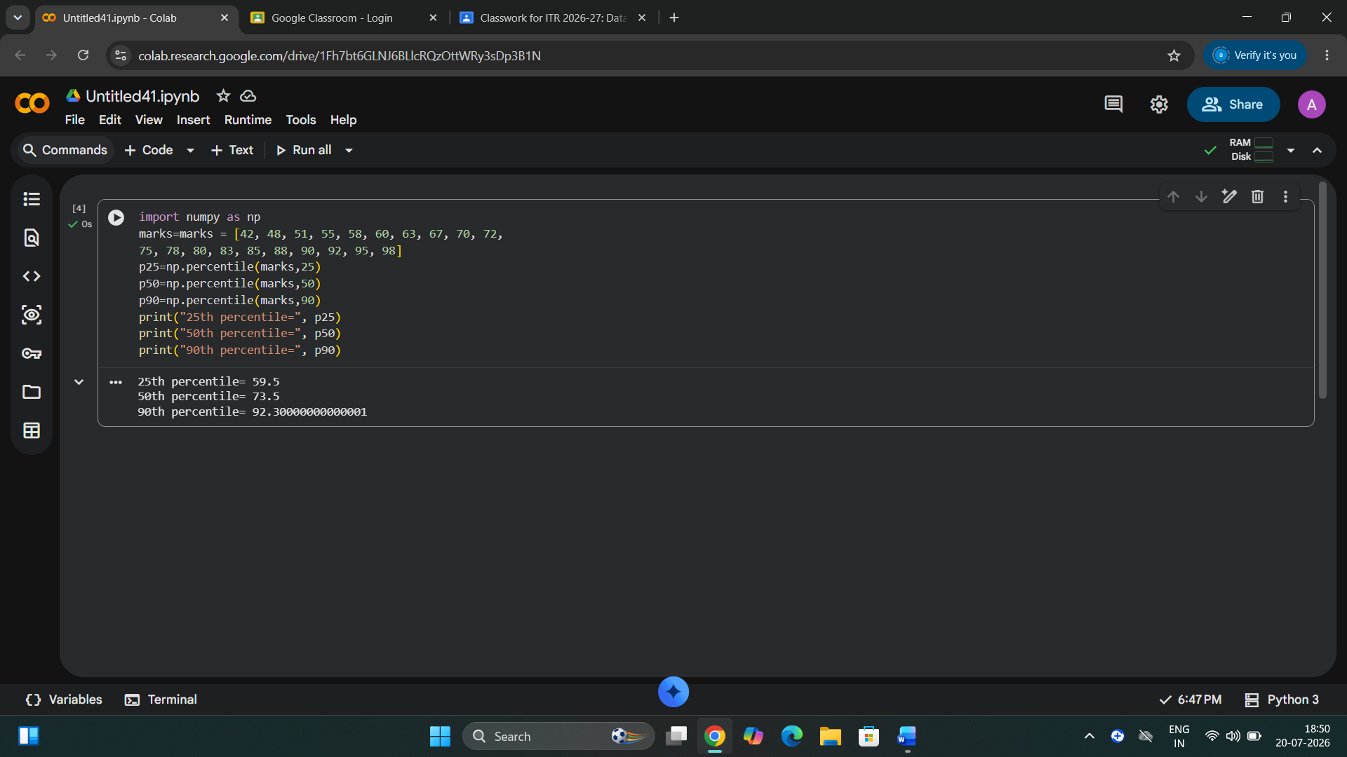

Insights:
1. 25th percentile (59.5): 25% of student scored 59.5 or below.
2. 50th percentile (73.5): The median score is 73.5, meaning half the students scored above and half score.
3. 90th percentile (92.3):Only 10% of students scored above 92.3, showing high performance among top score.

Q2. Quantile using Python
Write a Python program to calculate the quantiles and Interquartile Range (IQR) for the
following dataset.
Your program should:
• Calculate Q1 (25%).
• Calculate Median (Q2).
• Calculate Q3 (75%).
• Calculate the Interquartile Range (IQR).
• Print all values.
sales = [15, 18, 20, 22, 25, 28, 30, 32,
35, 38, 40, 42, 45, 48, 50, 52]
Code:
import numpy as np
sales = [15, 18, 20, 22, 25, 28, 30, 32,
35, 38, 40, 42, 45, 48, 50, 52]
Q1=np.quantile(sales,0.25)
Q2=np.quantile(sales,0.50)
Q3=np.quantile(sales,0.75)
IQR=Q3-Q1
print("Q1=",Q1)
print("Q2(Median)=",Q2)
print("Q3=",Q3)
print("IQR=",IQR)

Screenshot:
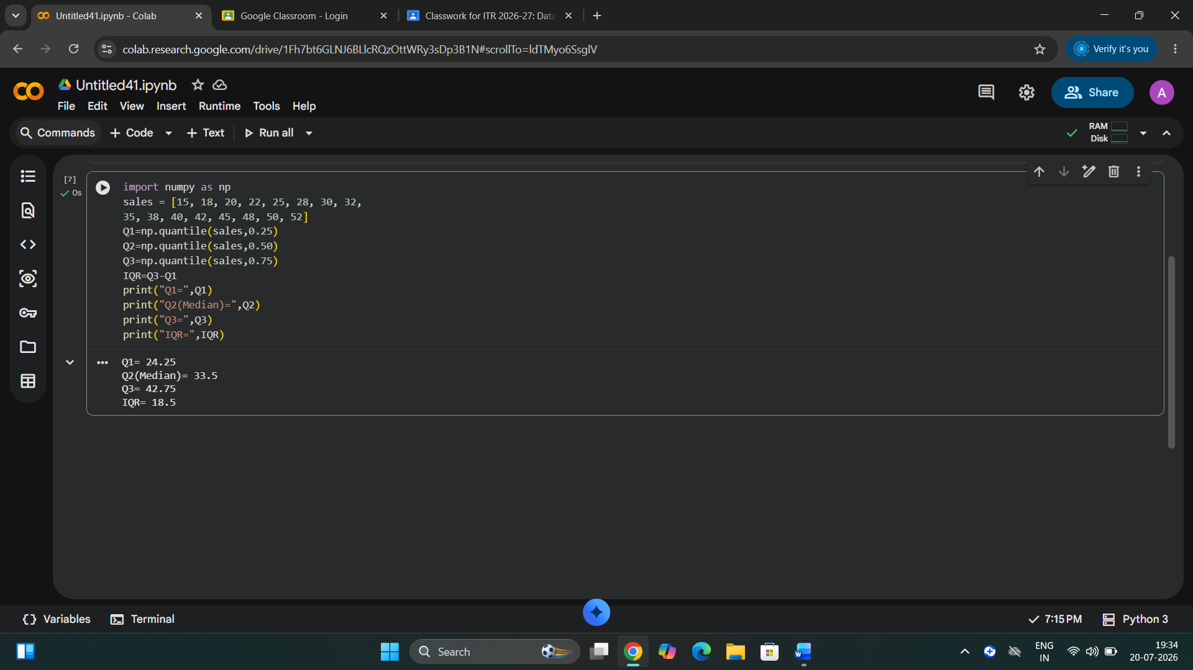

Insights:
1. Q1=24.25: 25% of the sales values are 24.25 or below.
2. Q2(Median)=33.5: Half of the sales values are below 33.5 and half are above 33.5.
3. Q3=42.75: 75% of the sales values are 42.75 or below.
4. IQR=18.5: The middle 50% of the sales data is spread over 18.5 units, indicating a moderate variation in sales.

Q3. Boxplot using Python
Write a Python program to create a boxplot for the following dataset and identify any outliers.
Your program should:
• Draw a boxplot using Matplotlib.
• Calculate Q1, Q3, and IQR.
• Calculate the lower fence and upper fence.
• Print all outliers in the dataset.
visitors = [-1 ,-30,22, 25, 27, 30, 32, 35, 36, 38, 40,
42, 45, 48, 50, 52, 55, 58, 90, 95]
Code:
import numpy as np
import matplotlib.pyplot as plt
visitors = [-1 ,-30,22, 25, 27, 30, 32, 35, 36, 38, 40,
42, 45, 48, 50, 52, 55, 58, 90, 95]
Q1=np.percentile(visitors,25)
Q3=np.percentile(visitors,75)
IQR=Q3-Q1
lower_fence=Q1-1.5*IQR
upper_fence=Q3+1.5*IQR
outliers=[x for x in visitors if x<lower_fence or x>upper_fence]
print("Q1=",Q1)
print("Q3=",Q3)
print("IQR=",IQR)
print("lower fence=",lower_fence)
print("Upper fence=",upper_fence)
print("Outliers=",outliers)
plt.boxplot(visitors)
plt.title("Boxplot of visitors")
plt.show()

Screenshot:
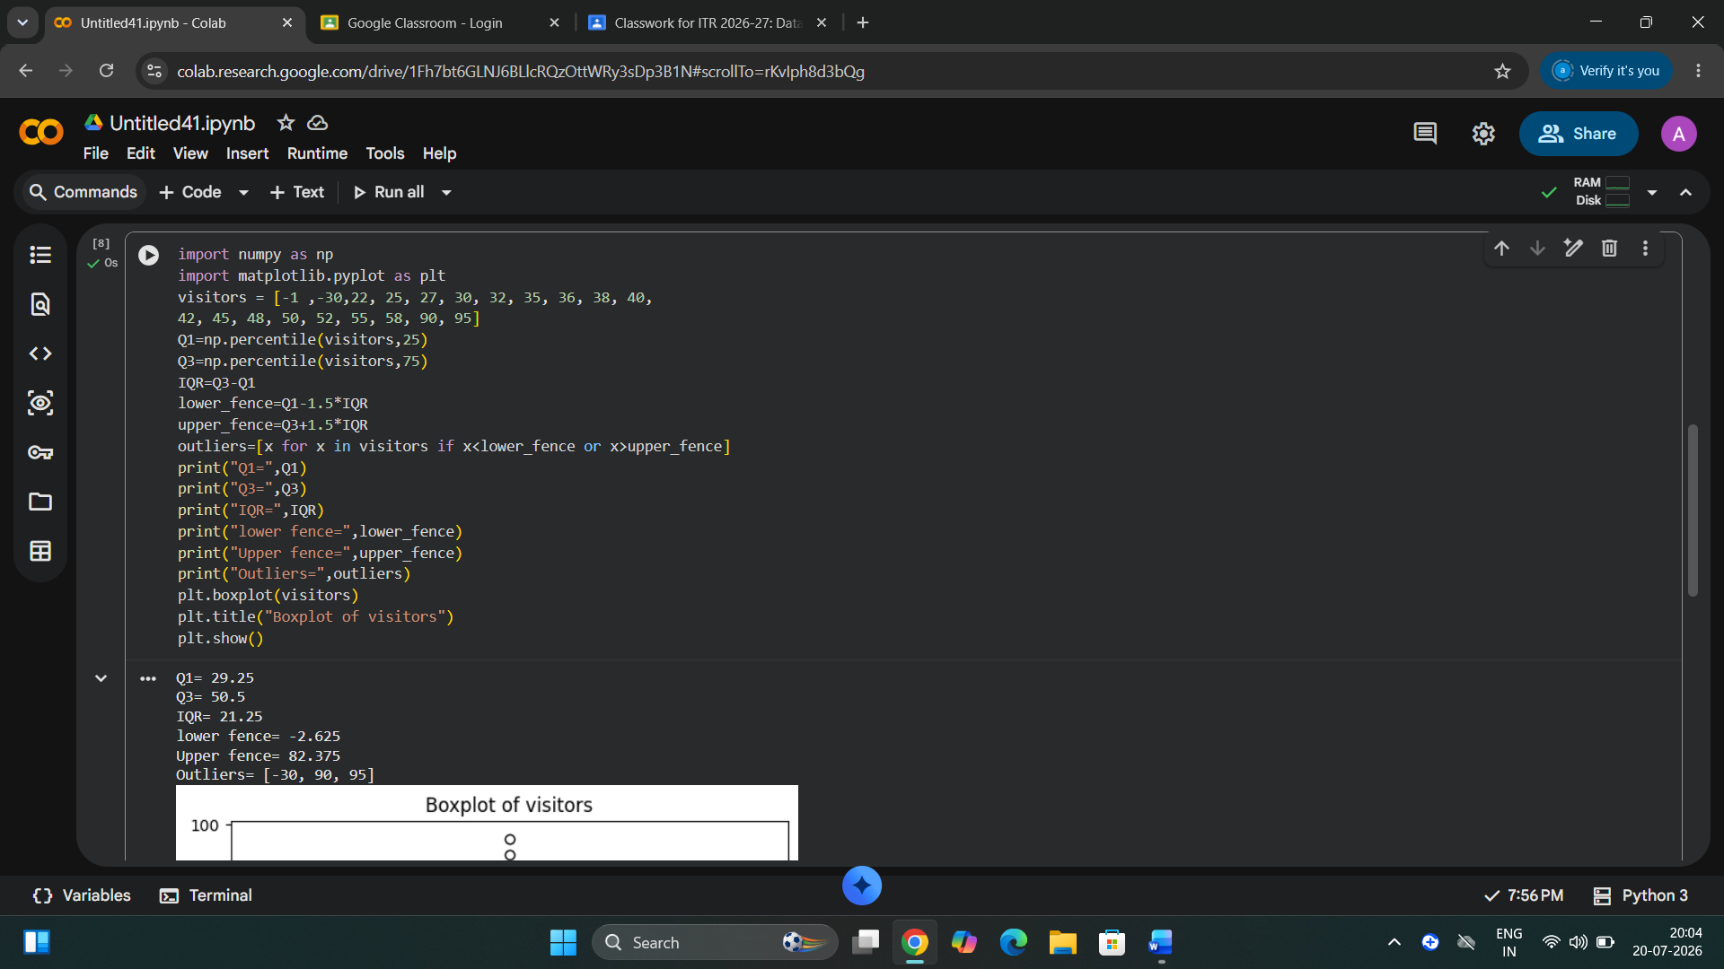

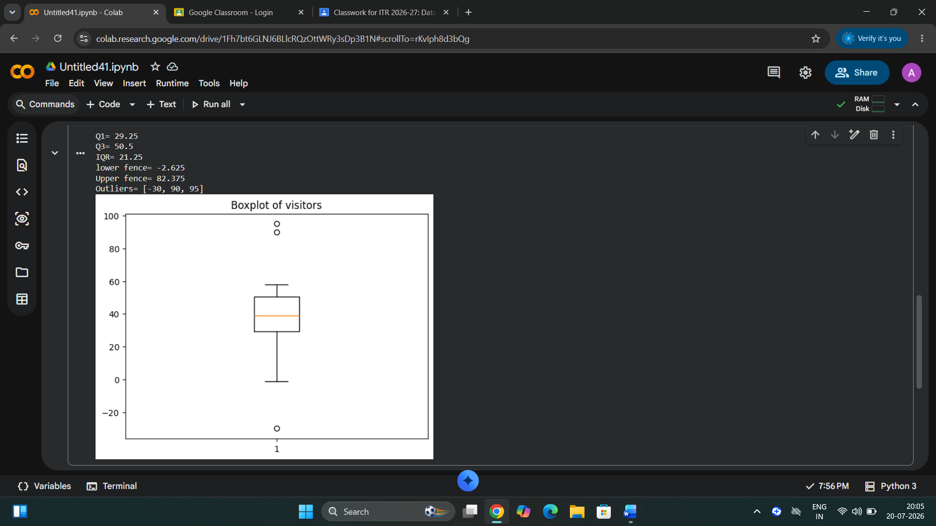

Insights:
1. Q1=29.25 is 25% of visitors counts are 29.25 or below.
2. Q3=50.50 is 75% of visitors counts are 50.50 or below.
3. IQR=21.25 The middle 50% of the data has a moderate spread.
4. Lower fence=-2.625: Values below -2.625 are considered lower outliers.
5. Upper fence=82.375: Values above 82.375 are considered upper outliers.
6. Outliers(-30,90,95): These are unusual visitors counts outside the normal range.

