- How many jobs are currently open?
Query -> %sql
SELECT COUNT(*) as open_cnt
FROM bronze_lhdev.jobs
WHERE lower(status) = 'open'

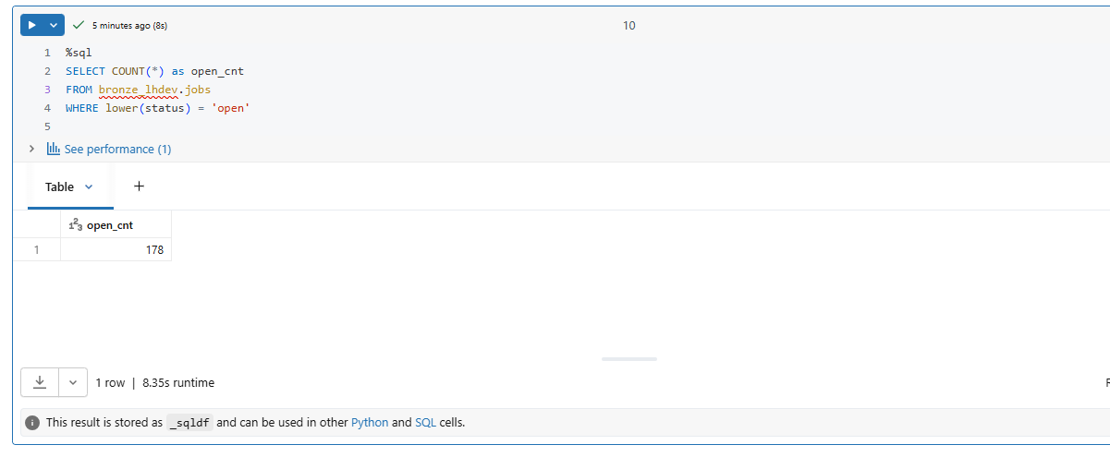
Q2) How many jobs are currently open?
%sql
SELECT
j.department,
COUNT(*) AS total_applications
FROM bronze_lhdev.applications a
JOIN bronze_lhdev.jobs j
ON a.job_id = j.job_id
GROUP BY j.department
ORDER BY total_applications DESC
LIMIT 5

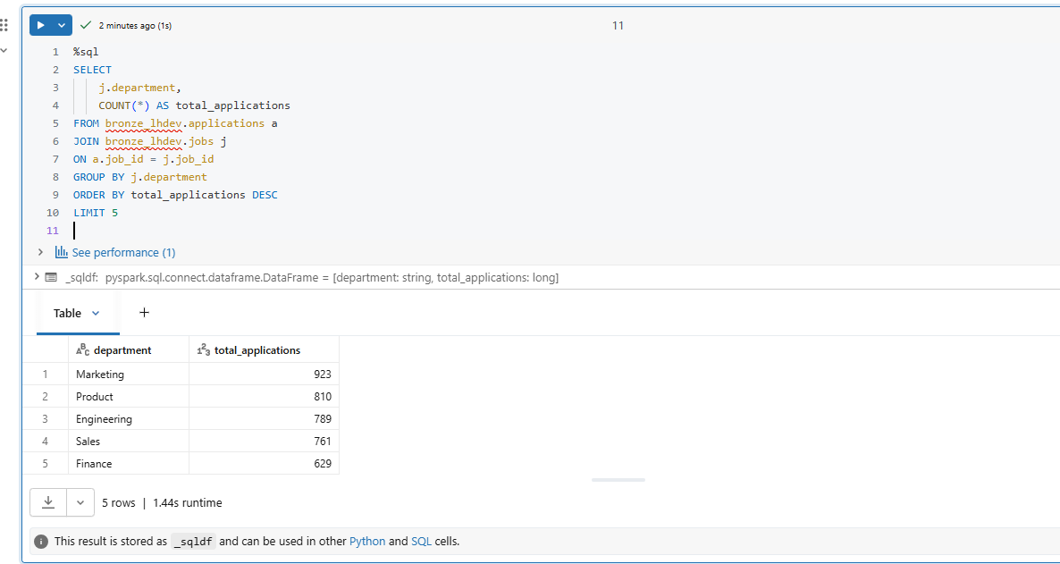
Q3) List candidates who applied to more than 3 jobs.
%sql
SELECT
c.candidate_id,
c.first_name,
c.last_name,
COUNT(a.job_id) AS applications
FROM bronze_lhdev.candidates c
JOIN bronze_lhdev.applications a
ON c.candidate_id = a.candidate_id
GROUP BY
c.candidate_id,
c.first_name,
c.last_name
HAVING COUNT(a.job_id) > 3
ORDER BY applications desc

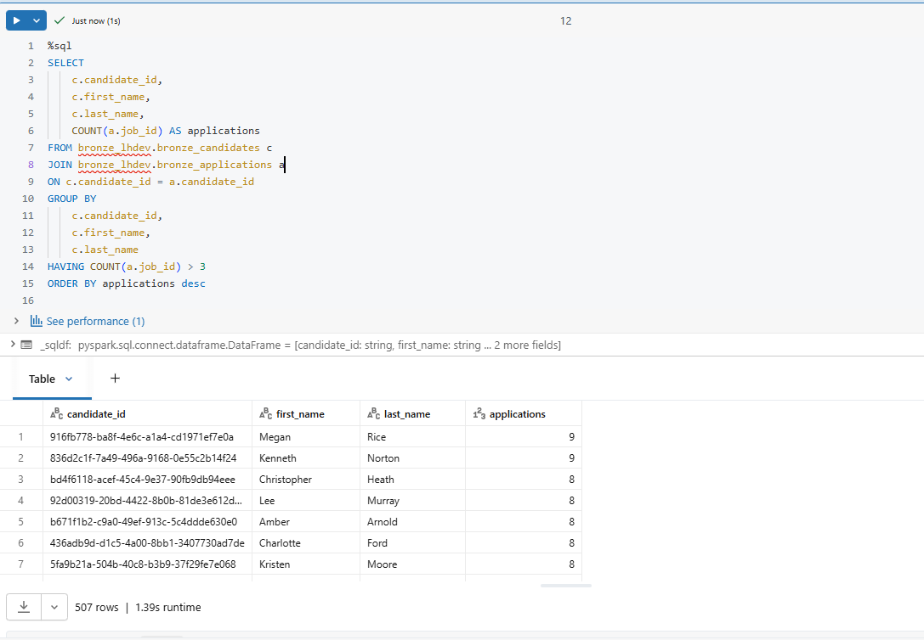

%sql
with applied_ts as(
select application_id, min(event_timestamp) as applied_date from base_workflow where upper(new_status) = "APPLIED" group by application_id
),
hired_ts as (
select application_id, min(event_timestamp) as hired_date from base_workflow where upper(new_status) = "HIRED" group by application_id
),joined_data as (
select * from base_workflow as wf
left join applied_ts on wf.application_id = applied_ts.application_id
left join hired_ts on wf.application_id = hired_ts.application_id)

select * from joined_data where hired_date < applied_date

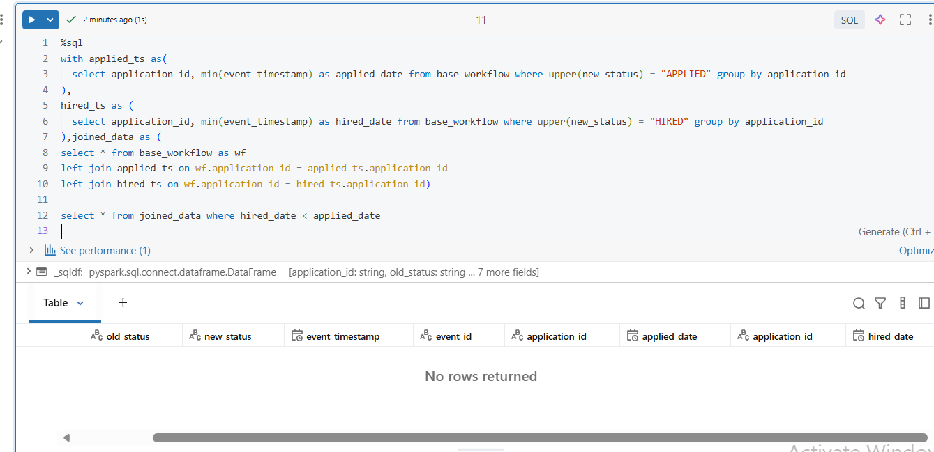
# DQ Check Table
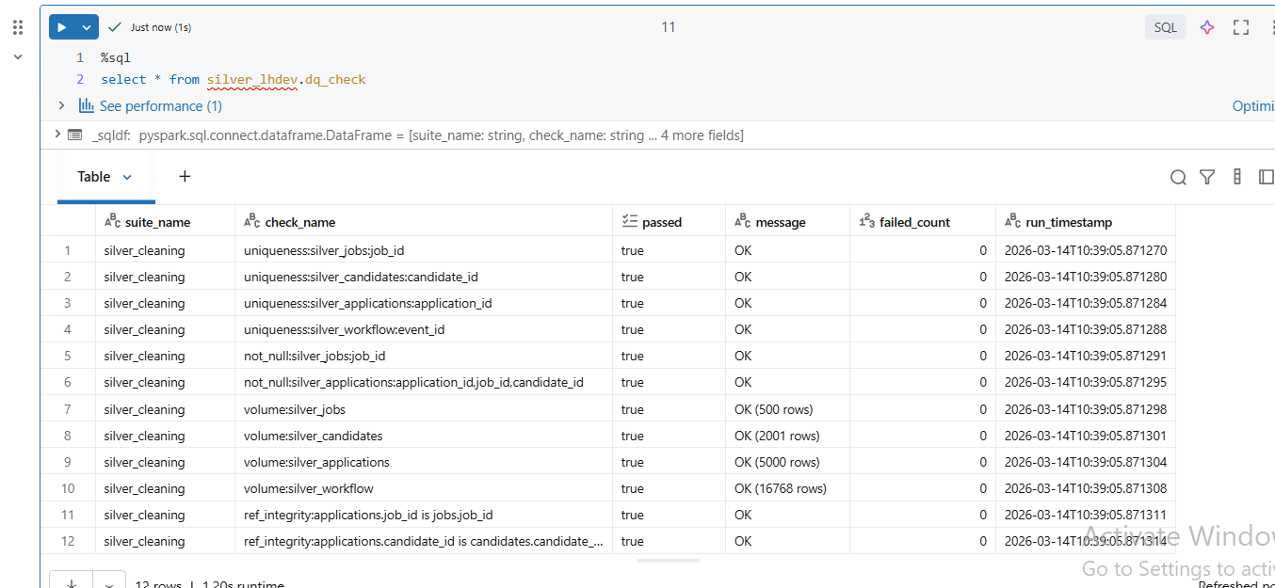

# test run results
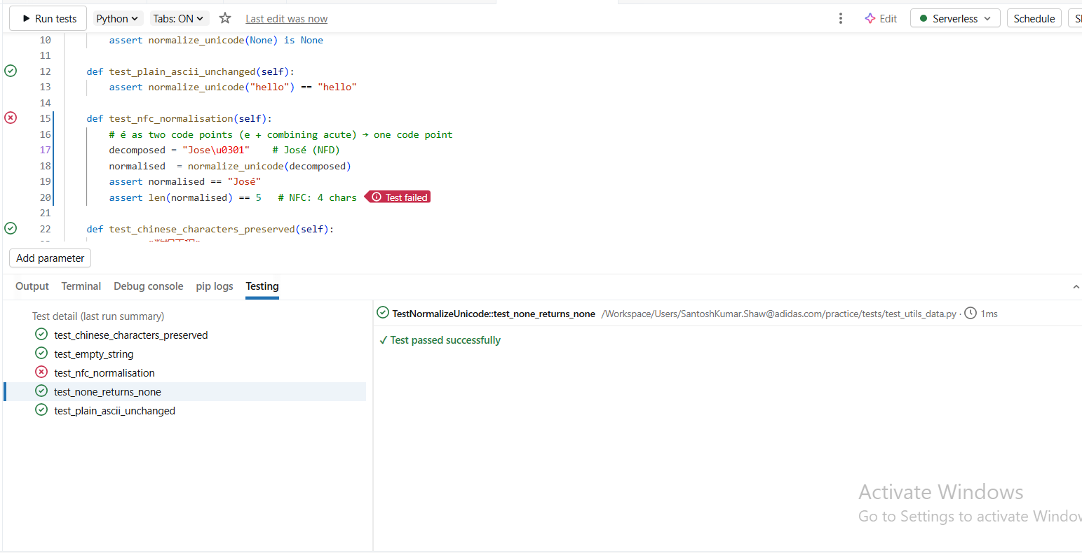

#Metrics Calculation results


