Justification Documentation

# Contents

1 Contents 2

2 Analytics and Reports 3

2.1 Google Analytics 3

2.2 Google Webmaster Tools 3

3 Influencer Outreach 3

4 Content 3

4.1 Infographs 3

4.2 Alt tags 3

4.3 Page titles without company name 3

4.4 Use unique page descriptions 4

4.5 Landing pages to generate leads 4

4.6 SEO 4

4.7 Rich Snippets 4

4.8 Setup a Blog 6

4.8.1 Setup RSS FEED 6

5 Testing 6

6 Social Media 6

6.1 SnapChat – 6

6.2 Social sharing buttons 6

6.3 Twitter 6

6.4 Facebook 7

7 Marketing automation 7

# Analytics and Reports

* **Why is this important?** You can't be sure you're improving something if you're not measuring it. Set up marketing analytics on your website so you can track your improvements over time.
* **What are we looking for?** Marketing Grader reviews your homepage looking for the javascript of the major analytics tools.

## **Google Analytics**

* To determine demographics, behavioral analysis, UX patterns, browsers, and monitor top sources

## **Google Webmaster Tools**

* To determine top competitors, keyword analysis, page errors, pages with room for improvement, top browsers, and improve SEO listing

# Influencer Outreach

* By partnering with influencers, you can spread awareness to a demographic that’s hard to reach through traditional media.
* Case study: Sour Patch Kids partnered with social media star Logan Paul for a “[Real-life Sour Patch Kid](http://www.adweek.com/news/technology/sour-patch-kids-snapchat-effort-first-mondelez-brands-158775)” Snapchat campaign. Paul, who has 500,000 Twitter followers, directed his social media followers to the Sour Patch Kids Snapchat account so they could see his sweet and sour pranks.
* More great examples: <http://www.convinceandconvert.com/social-media-case-studies/5-creative-ways-brands-are-using-snapchat/>

# Content

## Infographs

## Alt tags

* **Why is this important?** 70% of the links search users click on are organic - not paid. Using keyword-rich alt text can help you rank higher so that you can capture some of that delicious organic traffic for yourself.
* **What are we looking for?** Marketing Grader reviews the HTML of your homepage looking for each image. When it finds an image, it checks to see if the image has alt text.

## Page titles without company name

* **Why is this important?** Because 60% of all organic clicks go to the top three organic search results, you need to do everything you can to nail one of those top spots. Optimize your page titles and use compelling meta data to get off on the right foot.
* **What are we looking for?** Marketing Grader looks at a sample of pages from your website and checks how many of them start with your company name. The tool assumes that your company name is what's between the www. and the .com of your url. Ideally no pages use the company name in the title.

## Use unique page descriptions

* **Why is this important?** 75% of users never go further than the first page of search results. You've got to do what you can to stand out in the pack of results, and compelling page descriptions is a good place to start.
* **What are we looking for?** Marketing Grader looks at a sample of pages from your website and checks how many of the page descriptions are unique.

## Landing pages to generate leads

* **Why is this important?** Businesses with more than 40 landing pages get 12X more leads than those with only a few landing pages.
* **What are we looking for?** Marketing Grader looks at a sample of pages from your website and determines if any of them include a conversion form.

## SEO

## Rich Snippets

* + Back in January 2012, search marketing firm Catalyst confirmed the classic SEO theory that rich snippet does indeed [increase CTR and traffic](http://www.catalystsearchmarketing.com/2012/01/how-rich-snippets-can-improve-your-ctr/).  
    Here’s what their analytics looked like: 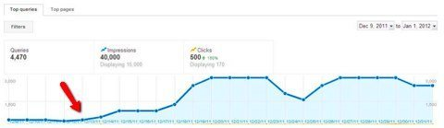  
    That amounts to a 150% increase in visits and page views! 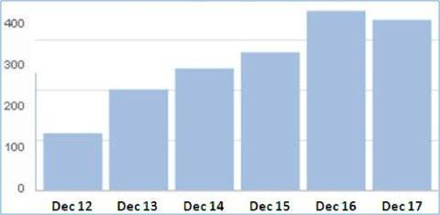
  + So, by implementing Google’s authorship markup and getting the rich snippet to show up for its content, Catalyst *dramatically* improved its performance in search engines.  
    If you don’t exactly know what I’m talking about, let me give you an example of what a rich snippet is and how it [pertains to Google’s authorship markup](http://www.searchenginejournal.com/how-to-create-an-effective-google-seo-content-strategy/39734/). 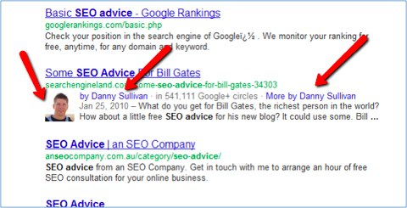
  + What Danny Sullivan has done is he *claimed his content*, which in turn provided incredible benefits for him in the search engine rankings.
* The profile picture lends instant credibility.
* If you click the “by Danny Sullivan” link, you’ll get sent directly to his Google+ page.
* Click “More by Danny Sullivan”, and you’ll get a Google search page dedicated to all of Danny’s content. 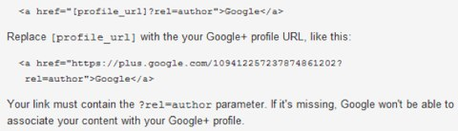

## Setup a Blog

* **Why is this important?** Did you know that companies that blog get 55% more web traffic and 70% more leads than those that don't? Blogging is the best way there is to reach your target audience with the useful, educational information they're out there looking for. Not to mention how much it helps your search rankings.
* **What are we looking for?** Marketing Grader searches for either an auto-discoverable RSS feed or a link on the homepage with the word "blog" as part of the anchor text. Alternately, you can just enter in your blog URL.

### Setup RSS FEED

* **Why is this important?** About 46% of daily internet users read more than one blog every day. Adding an auto-discoverable RSS feed makes it super easy for power users to get your latest blog posts and news stories as soon as you publish them.
* **What are we looking for?** Marketing Grader searches the homepage or the blog for an auto-discoverable RSS feed. Alternately, you can just enter your blog RSS feed.

# Testing

# Social Media

## **SnapChat** –

* Over 100 million daily active users and 400 million snaps per day. It is one of the fastest-growing social networks with 71% of the snaps in the U.S. users are between 15 and 34.
* 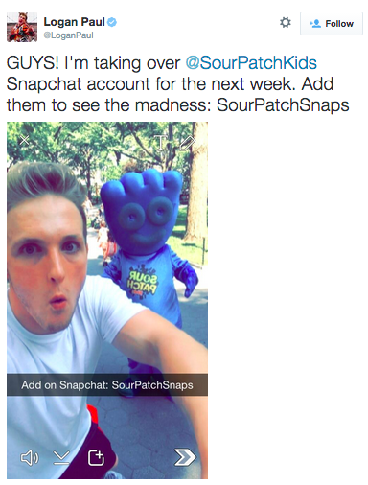Snapchat stories last for 24 hours and there are over 1 billion views of these video narratives daily

## Social sharing buttons

## Twitter

* **Why is this important?** Companies with 51 to 100 Twitter followers generate 106% more traffic than those with 25 or fewer.
* **What are we looking for?** Marketing Grader reviews your homepage and looks for links to Twitter, Facebook, LinkedIn or Google+ on your homepage.
* – increase social rankings and social shares.
* A study by Branded3 correlates a connection between tweets to a particular URL and SEO ranking. The results:
  + **50 tweets or fewer**– Not sure how much, but URLs received benefit in rankings with 50 tweets or fewer, but those benefits declined after that.
  + **5,000 tweets** – There’s a huge jump for a page that gets an average of 5,000 tweets. This would be content that goes viral on Mashable, BuzzFeed or Copyblogger.
  + **7,500 tweets** – When a page gets 7,500 or more tweets, it can easily show up in the top five SERPs on Google.

## Facebook

* **Why is this important?** The average company saw a 185% increase in traffic after crossing 1,000 Facebook likes.
* **What are we looking for?** Marketing Grader reviews your homepage and looks for links to Twitter, Facebook, LinkedIn or Google+ on your homepage.

# Marketing automation

* **Why is this important?** Automation can be an effective tool when used to engage potential customers on their terms.
* **What are we looking for?** Marketing Grader reviews your homepage looking for marketing automation tools.