**CrossOver**

**Design Document for Airline Ticket Reservation System**

**Author : Mario de Sa Vera**

**Date : May 9th 2016**

1. High Level Requirement Analysis
2. High Level Data Model

The high level data model consists of two basic modules. The first module is a the CORE reservation model responsible for the reservation schedule persistence :

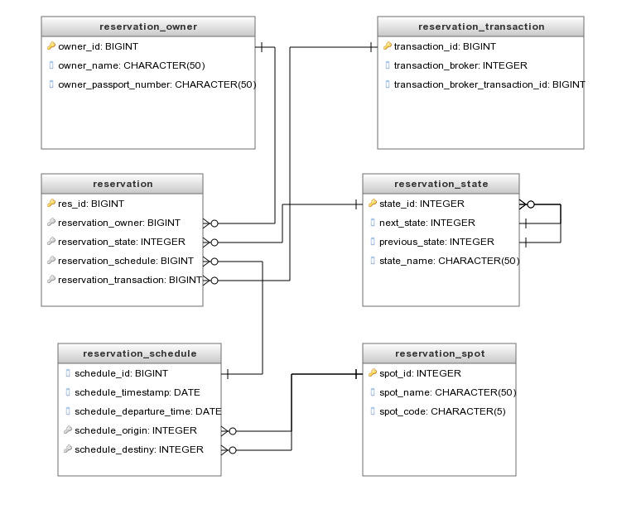

Figure 1 - CORE DATABASE MODEL

The second module is responsible for session control for user navigation on the system :

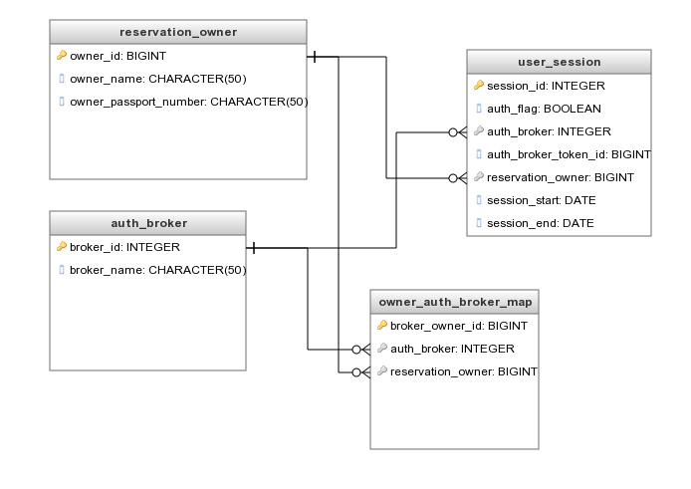

Figure 2 - USER SESSION DATABASE MODEL

1. Architecture Diagrams
2. UI Screens