Damon Schafer

CS328 Semester Project Game Design

November 17, 2019

**Pixel City.**

This document describes the design and intricate details of Pixel City. It is organized by main feature/system.

*Game Startup*

As the game starts, a start menu opens containing the title of the game and button options to load, continue, start a new game, and get help. The continue option immediately loads the last saved and opened city if it exists. The load and save options open a modal dialog to select the file saved in the saved games folder. The help button will open a modal dialog that contains a detailed description of how to play the game. The new game option opens a modal dialog allowing the player to specify the name of the city. This will then close this view and open the game view.

The game view/scene consists of the map, all the objects attached to the map, and the UI elements. The player can select items and tools in the UI to place objects in the map. The details that compose how the map works, and how buildings develop and level up is described below.

*Demand System and Zoning*

Just like other common city builders, Pixel City features a full-fledged demand system. The idea is that buildings are only built in zones when the demand allows. So instead of the player placing single residential houses or commercial properties, the user zones sections of the map. These zones include Residential, Commercial, and Office.

Residential buildings create commercial demand. Not only do residents want places to spend money, but they also want jobs which are provided by commercial properties. The excess amount of commercial or office jobs creates additional residential demand.

Both office and commercial buildings provide jobs for residents. Office jobs are only suitable for educated residents.

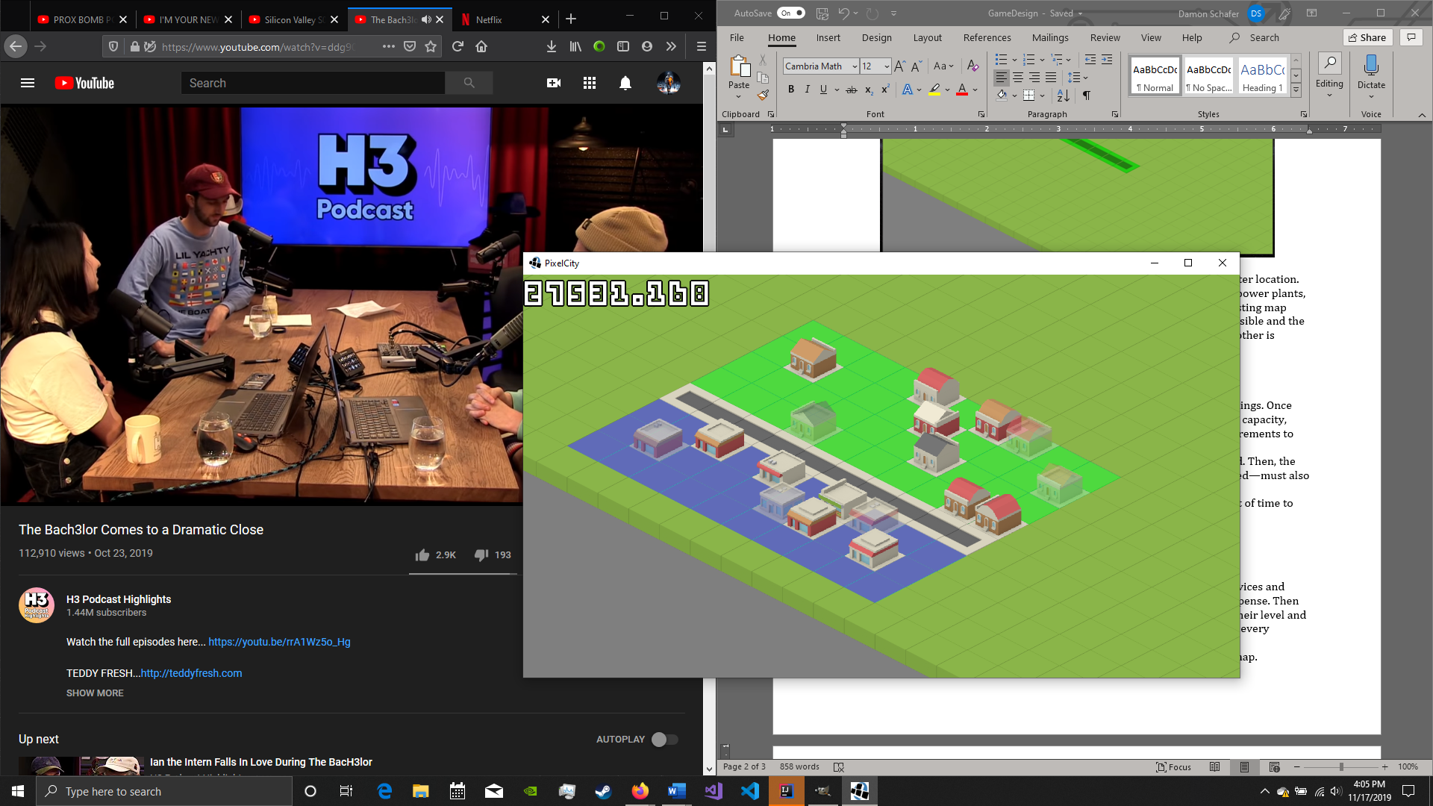

*Placing Items*

The UI will contain a variety of tools used by the player to place objects in the map. This includes placing roads, zones, service buildings, and deleting placed objects. When placing objects, a preview of that object is shown on the map. The following image shows a road being placed.

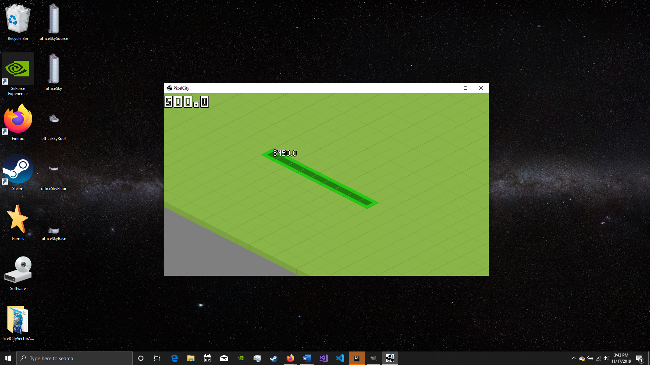

As the image shows, if a cost is applicable, then it will be displayed at the pointer location. This same placement system will be implemented for all other items, such as power plants, zoning, water sources, etc… If the player is trying to place a object over an existing map object, or trying to spend too much money, then the placement will not be possible and the green color will be changed to red. In the cases where placing an object on another is allowed, and changes the existing object, that cell is shown in yellow.

*Levelling Up*

The real challenge and unique part of Pixel City is the levelling system of buildings. Once the needs of buildings are met, they can level up into a version that has higher capacity, appears larger, provides more income, creates demand, and has stricter requirements to level up again.

For a building to level up, it must be full, and every resident must be employed. Then, the total happiness of the building—dependent on the number of services provided—must also be above a certain threshold.

Then if these criteria are met, the building must maintain this for a set amount of time to level up.

Every time a building levels up, it increases in size by one floor.

*Money, Expenses, and Income*

Every MapObject can have a source of income/expense associated with it. Services and infrastructure such as roads, power plants, fire stations, etc… is a source of expense. Then residential, office, and commercial buildings are sources of income based on their level and size. All these sources affect the total money that the player has access to, and every interval, expenses – income is added to the current balance.

The current balance is the amount of money available to place objects in the map.

*Research*

To help provide a better progression system, a research system will be implemented. The player will have to dedicate funds and time to research and unlock certain buildings. The levelling system is very significant, and research will be required for buildings to reach certain levels. Once research is completed, it creates more available research options usually with greater cost and requirements.

*Service Buildings*

To increase happiness of the city, essential services must be provided. These include police, fire, health, education, power, and water. Power and water services are described as utilities. When a new utility is created, it adds more resources—water or power—to the available pool. All other services have a “zone of influence” and provide that service to every building within a certain distance from the service.

*High Score*

Each city will have several statistics that determine the high score. These categories include the wealth of the city, the education in the city, and the overall happiness of the city. Then all these values are multiplied together to get the final score.

The wealth of the city is determined by the balance and ratio of income to expenses. The education is based on the percentage of educated residents.