Git and GitHub

To clone a repository:   
 git clone **url to repository** (optional: add a new directory: “cloned-repo”)

**To save changes to your ‘cloned’ repo:   
git remove origin This is because you can’t push to the original**

run npm install, or yarn install to gather all of the necessary packages  
  
To get status:

git status

Add files to ‘watch’

git add **filename**

### Deploying Application

Create a new repository

$ git install gh-pages –save-dev

$ git remote add origin **url to repository**

$ npm run deploy

### Update npm packages

$ npm update

One quick note about cloning GitHub projects from the links provided throughout this course. If you wish to make commits and push code up after cloning down from any of the GitHub links, you should actually fork the project first. The reason for this is because the GitHub project links provided are pointing to repositories you do not own, in order to own the repository, you have to fork it so you get a copy of the project in your own GitHub account that you do own!

You can see the fork button in the top right corner of every GitHub project; click it and a copy of the project will be added to your GitHub profile under the same name as the original project.

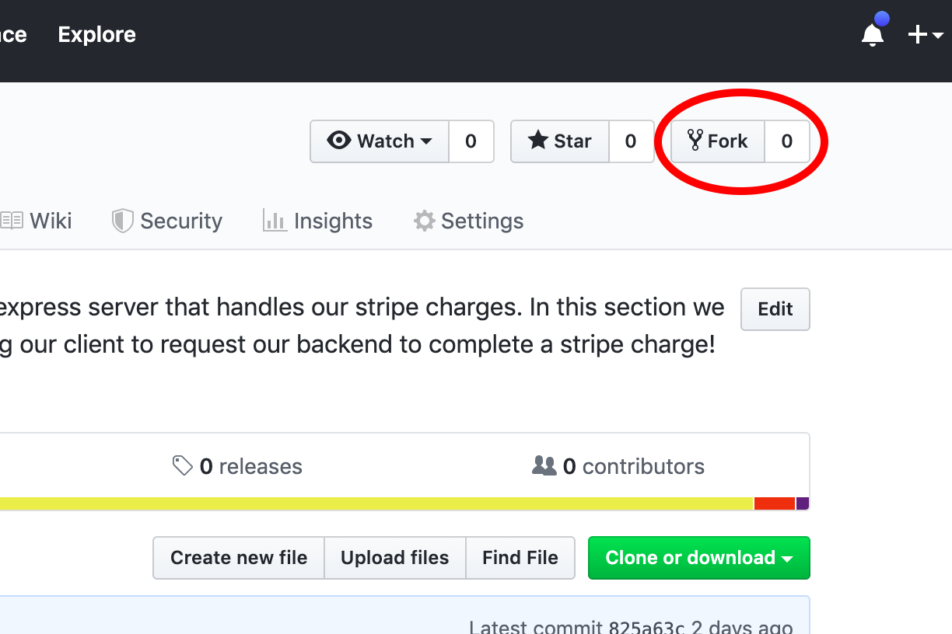

After forking the project, simply clone it the way you would from the new forked project in your own GitHub repository and you can commit and push to it freely!