finding percentage

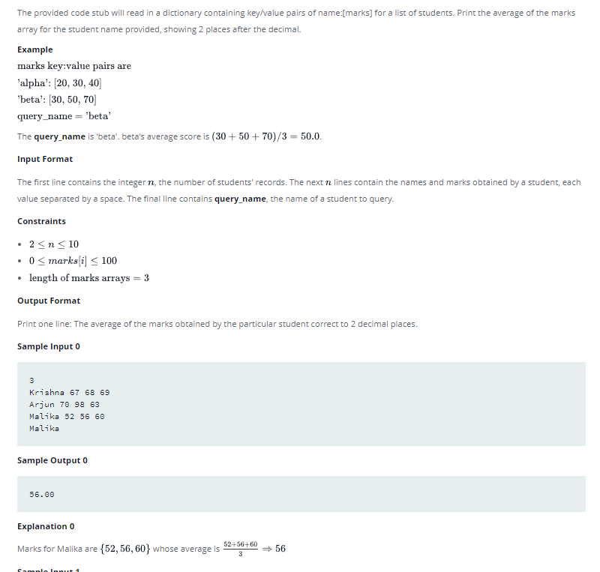

if __name__ == '__main__':
n = int(input())
student_marks = {}
for _ in range(n):
name, *line = input().split()
scores = list(map(float, line))
student_marks[name] = scores
query_name = input()
all_scores_target=student_marks[query_name]
total=0
for score in all_scores_target:
total=total+score

print("{:.2f}".format(total/len(all_scores_target)))

