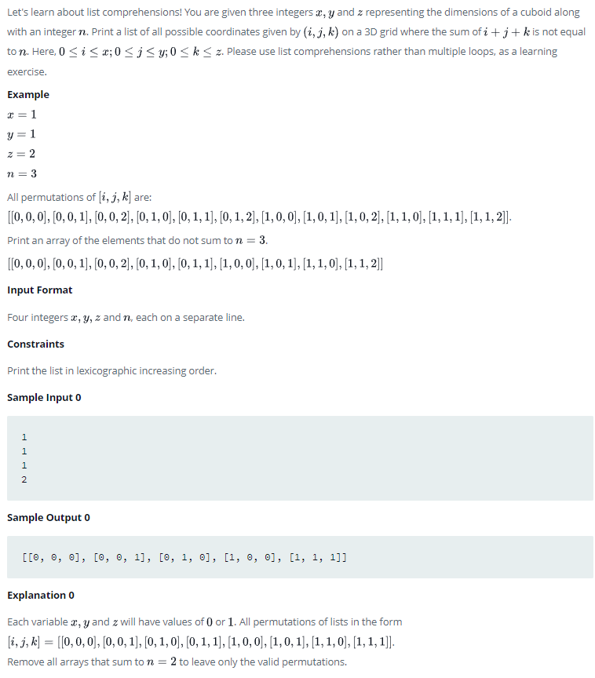
answer:
if __name__ == '__main__':
x = int(input())
y = int(input())
z = int(input())
n = int(input())
combos=[[a,b,c] for a in range(x+1) for b in range(y+1) for c in range(z+1) if (a+b+c)!=n]
print(combos)

