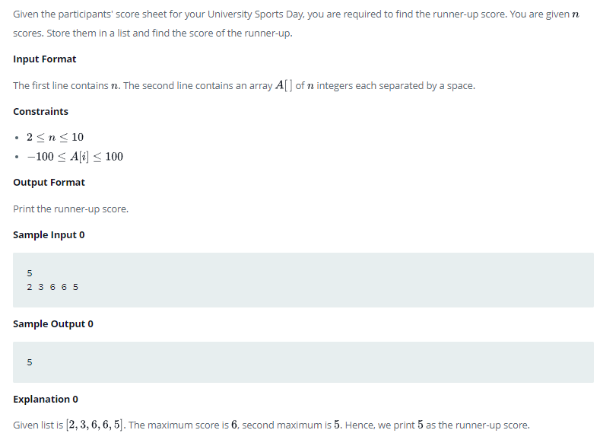

if __name__ == '__main__':
n = int(input())
arr = map(int, input().split()) #int conversion because otherwise they are strings
arrlist=list(arr)
maxvalue=max(arrlist)
#arrlist.remove(maxvalue) #this does not work because it removes only one instance the first occuring in the list
newarr=[x for x in arrlist if x !=maxvalue]
print(max(newarr))

