Nested lists

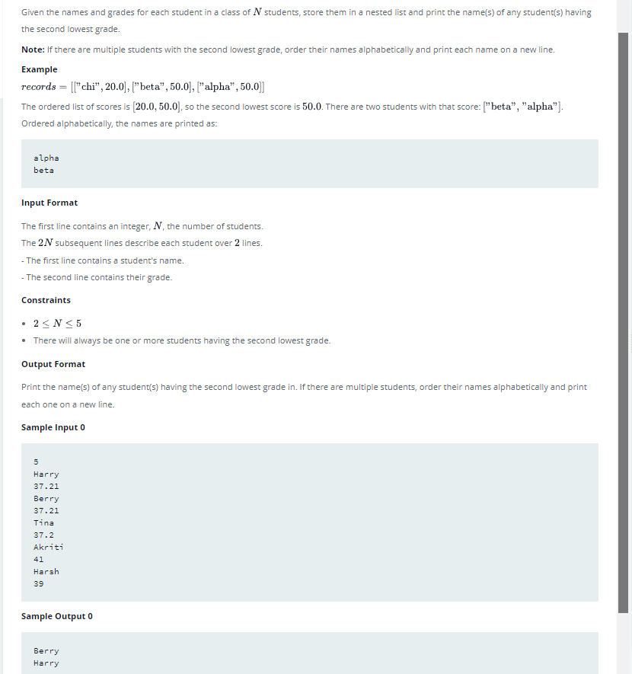

if __name__ == '__main__':
mylist=[]
for _ in range(int(input())):
name = input()
score = float(input())
mylist.append([name,score])
#print(mylist) #full list of people
scorelist=[]
for x in range(len(mylist)):
scorelist.append(mylist[x][1])
scorelist.sort() #full list of scores
scorelistset=set(scorelist) #unique list of scores
#print(list(scorelistset)[1]) #second highest score
secondhighestscore=list(scorelistset)[1]
secondhighestscoredlist=[[x,y] for x,y in mylist if y==secondhighestscore]
secondhighestscoredlistpeoplenames=[name[0] for name in secondhighestscoredlist]
secondhighestscoredlistpeoplenames.sort()
for name in secondhighestscoredlistpeoplenames:
print(name)

