Validating UID

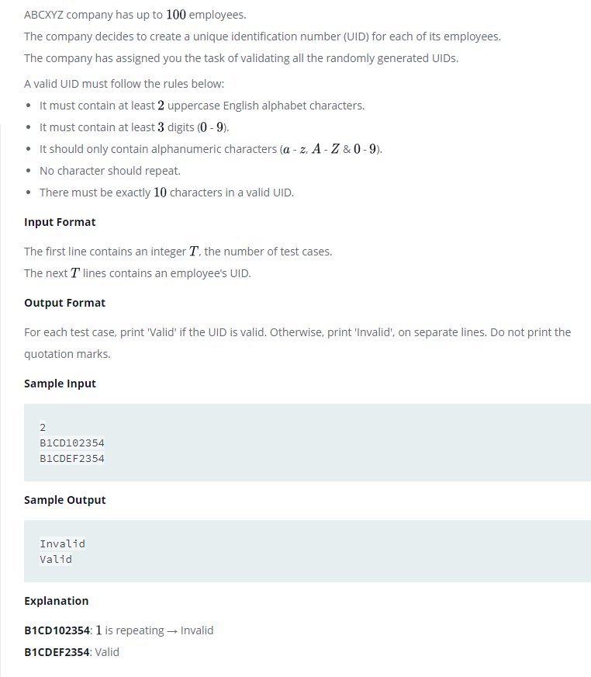

# Enter your code here. Read input from STDIN. Print output to STDOUT
import string
no_of_testcases=int(input())
listvalues=[]
for x in range(no_of_testcases):
listvalues.append(input())

def checkUID(myUID):
uidgood=0
upper_count=0
lower_count=0
number_count=0
repeat=0
if len(myUID) !=10:
uidgood=0
return uidgood
if len(set(myUID)) !=10:
uidgood=0
return uidgood
for x in myUID:
if x in string.ascii_uppercase:
upper_count+=1
elif x in string.ascii_lowercase:
lower_count+=1
elif x.isdigit() ==True:
number_count+=1
else: pass
if (upper_count+lower_count) >=2 and number_count>=3 and (upper_count+lower_count+number_count)==10:
uidgood=1

return uidgood

for x in range(no_of_testcases):
status=checkUID(listvalues[x])
if status ==1:
print("Valid")
else:
print("Invalid")

