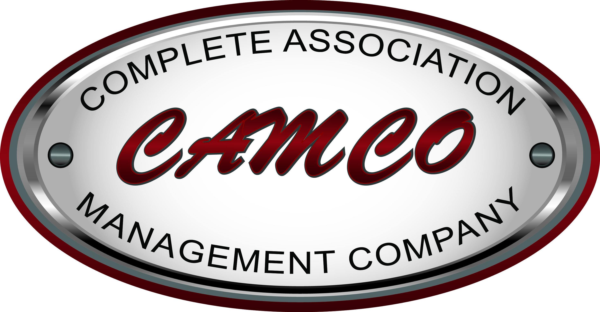

**Complete Association Management Company**, LLC (CAMCO) is synonymous with care and the complete and customized management services we have provided for homeowners associations and their residents for over 16 years.

We provide professional management services for master-planned communities, condominiums, townhomes, and developers of new-home communities.  CAMCO also provides professional services for management of high-rise condominiums, mixed-used high-rise condominiums and high-rise condo hotels.

Our goal is to ensure the highest level of professional service to our clients.  We do that by regular evaluation of our organization and our work performance.

We recognize that our client has made a substantial financial investment in the community and we find it our professional obligation to maintain and to enhance the value of our client's property.

Our team has the experience, knowledge and support to provide you with the highest level of professional services.

**Our History**

In October of 1994 William Locatelli, a local Realtor specializing in apartment management, decided that the Homeowner Association Industry was beginning to take off and he wanted to be a part of it.  Complete Association Management Company, LLC. is the direct result of that idea.

In October of 1998, CAMCO hired Ken Williams to help with growth and management.  Mr. Williams had been employed with the Howard Hughes Corporation when Mr. Locatelli first approached him.  He was offered an opportunity to help grow a company from the ground up.  At that time, the organization had ten (10) homeowners associations.  With Mr. Williams help and the support of several local developers in the valley CAMCO grew very rapidly.  In 2002 Mr. Williams was promoted to General Manager.

In January of 2004, Mr. Williams purchased CAMCO from Mr. Locatelli.  At that time the organization had grown to forty five (45) accounts.  With the guidance of Mr. Williams, a program that centered on longevity and retention as well as several local and national developers, CAMCO is now one of the largest family owned Community Association Management Companies in Nevada.  Mr. Williams attributes this success to taking care of his staff and loyalty to the developers that build the homeowner associations in the valley.

**What we do**

CAMCO is a full-service management company that has provided management services to the real estate industry of Nevada for the past 16 years. Today, CAMCO manages communities throughout Southern Nevada. Our claim to high-quality services is due to the fact that our company is structured quite differently than other Association Management companies.

We have separate and distinct divisions for our services and yet we are an integrated team of highly qualified professional Managers, supported with a diverse and experienced group comprised of:

* Pre-Development Division Manager
* Portfolio Division Manager
* High Rise Division Manager
* Supervising Community Association Managers
* Community Association Managers, Provisional Managers and Assistants
* An Accounting Director with full-time accounting staff
* An Operations Manager to handle company billings to Associations
* A Human Resources/Business Manager
* A Government Affairs Representative, who interfaces with the Secretary of State

**Here to serve YOU**

It is our pleasure to serve the needs of all the Associations we manage. We offer the following:

* Accessible, certified Association Managers
* 24 hour Web site access: online account information
* 24 hour emergency service
* Provide monthly financial reports to the Board of Directors
* Read, study and understand all governing documents of the Association. Correspond with members in violation of the CC&Rs, By-laws, Rules & Regulations and report the status of all noncompliance to the Board of Directors in a timely manner.
* Act as the custodian of the corporate records. Coordinate preparing annual tax returns for the Master Association.
* Preparation and scheduling for Board meetings and annual membership meetings.
* Monitor delinquencies; send late notices and present problem accounts to the Board of Directors with recommendations for further action.
* Managers personally conduct compliance inspections.
* Correspond with new members upon notification by the title company, providing the member with a welcome package explaining their benefits as well as responsibilities for all Association matters.
* Prepare the annual budget for Board approval.
* Prepare for, notice, and attend the budget ratification meeting.
* Prepare for, notice, and attend the annual meeting. This includes the taking and transcribing of minutes.
* Prepare for, notice, and attend all regular Board of Director meetings. This includes the taking and transcribing of minutes.
* Prepare for, notice and attend all Executive sessions & hearings of the Board of Directors. This includes taking and transcribing of minutes.
* Obtain, award, supervise bids and work as required and directed by the Board of Directors.
* Collect all revenues and disburse payments to vendors as directed by the Board of Directors.
* Represent the Association as registered agent with the Secretary of State.
* Monitor and supervise vendors as directed by the Board of Directors.
* Bank Security with ACH Filter/Block and Positive Pay to avoid fraud on any account.
* **Most importantly, we return your phone calls!**