The Wolf Who Howled Boy
Authors:
Andrew Frost, Tyler Goffinet
Description:
It’s almost dark, a wolf stalks the lands, and a boy must get to the safety of a fire located in a corn maze. A wolf hunts the boy using his wolf senses and tracking abilities. The boy must get to the fire before the wolf tracks him down. Prey or predator. Life or death. The destiny of a savage brute or an innocent child are in your hands. Which ever side you play, don’t let them down.

User Manual:
To start the game double click on the icon, select your graphics settings in the game start menu, and hit play. This will bring you to the start screen. Press start to start the game.

Playing the game:
The rules of the this game are simple. If you are playing as the wolf your mission is to stop the boy from reaching safety at all costs. Use your heightened senses to track the child and ensure that he does not reach his destination. If you are the boy your mission is to escape the danger of the wolf. Run through the maze to the fire pit for safety. Be sure to choose your path wisely.
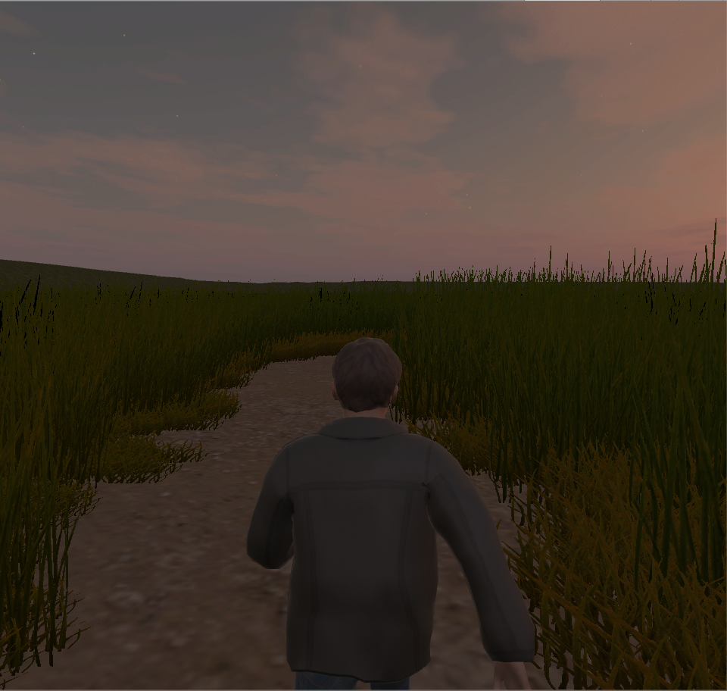

The boy running down the maze.

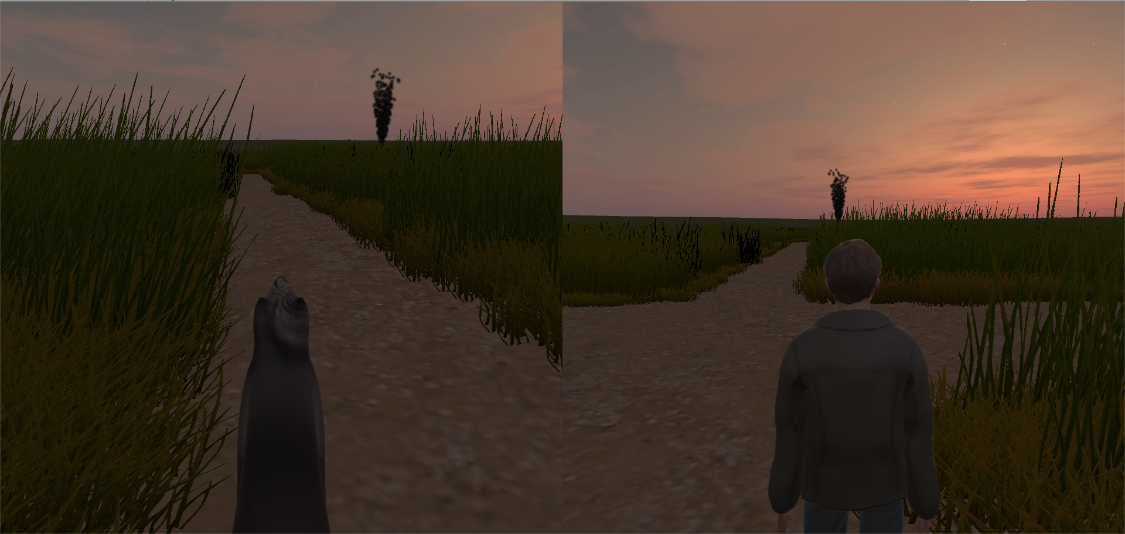
The wolf howling to activate the wolf sense and the boy pondering which way he should go.
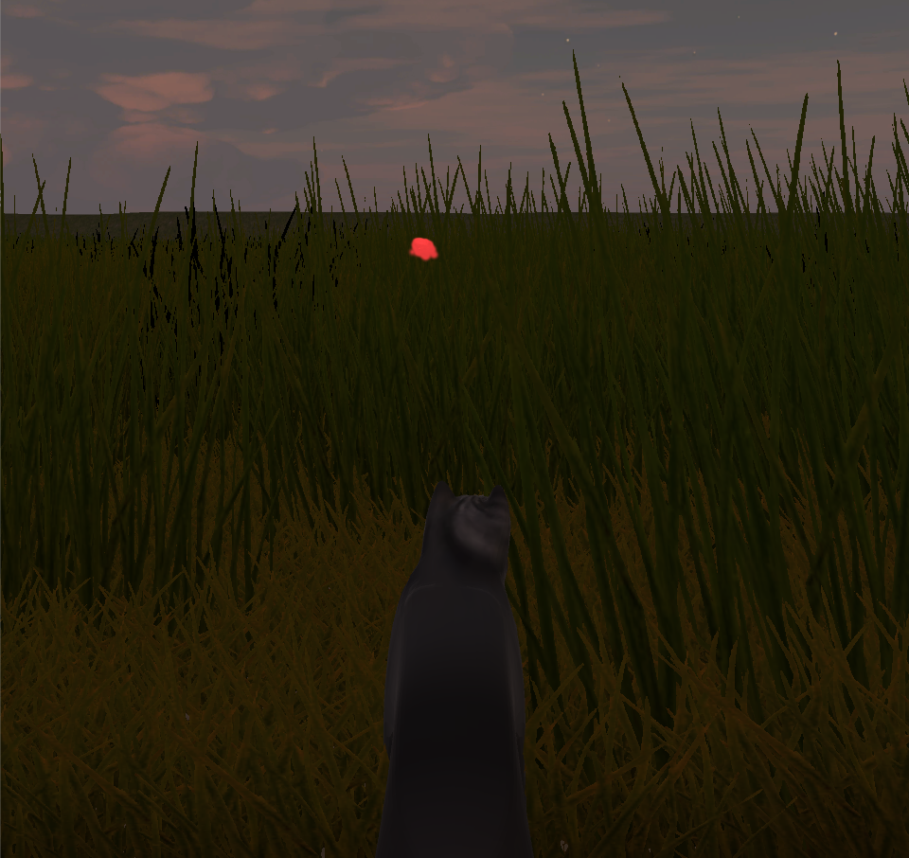

The use of Wolf Sense to highlight the boys scent.

Controls:
Wolf
- Translation
  - Forward: W
  - Backward: S
- Rotation
  - Left: A
  - Right: D
- Wolf Sense
  - F
Boy
- Translation
  - Forward: Up
- Rotation
  - Left: Left
  - Right: Right
- Enter Grass
  - Enter or space

Design Experiences:
Design Decisions
We decided to use a randomly generated pathway to generate the maze. This allows for interesting, procedural levels at the cost of slow level load times. We also added the wolf’s ability to smell the boy. This adds an interesting advantage to the wolf in that the wolf can spot his prey at any time. To make game play balanced the wolf’s movement was slowed to walking while this was activated and a cool down period was placed on his senses. The boy was clothed to blend in with the corn to encourage the wolf to use his special abilities.

Design Deficiencies
Although the levels are procedural, the game lacks any variation in scenery. The mazes and the maps may be different, but after a while the corn all looks the same. The use of land marks could make the game more interesting. Additionally, whether or not the boy or the wolf will win seems to be largely based off of how favorable the generated maze is to the boy. Sometimes the fire pit is, by chance, placed in a straight line with the boy and the wolf has little chance of stopping him from reaching the end.

What Would We Change
The path rasterization code would be multi-threaded to speed up level loading. More features and landmarks would be added. More wolf abilities would be added. The boy would be given some way or ability to mislead or trick the wolf.

Work Done by each Team Member
Andy created the artwork, the modeling, the animations, the path generation, the howling sound, the boy winning condition, and the movement controls. Tyler created the UI, the footstep sounds, the pausing mechanics, and the wolf winning condition.

