SOA Analysis and design:

Introduction:

* Is SOA Dead?

In 2009 there was a very famous topic that made a lot of discussions and the topic title was SOA is dead. A lot of people agree with this topic, but we thought that the agreement was due to 2 things: misconceptions and false expectations. But we will learn how to build a correct SOA which is not dead.

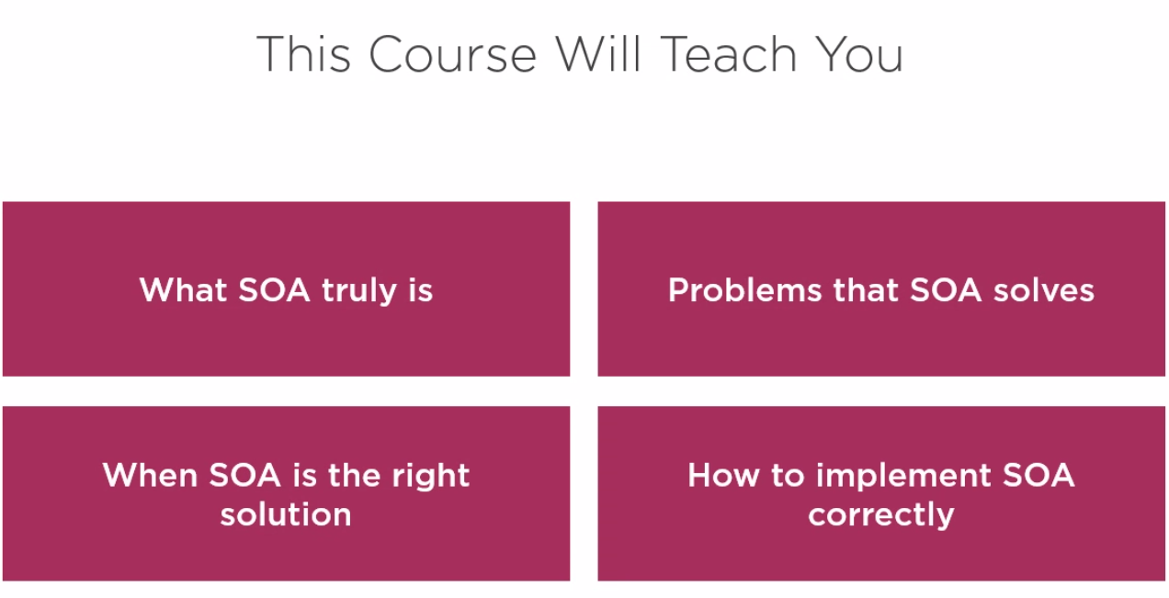

* Common problems that most SOA implemented projects suffers from:
  + They focus on how to implement it technically and neglect the question of Why we should use SOA in this case, and also the question of what is the scope of SOA, is it a full solution for our problem or we can use it as a partial solution in addition to other solutions.
  + Most of the applications take the theoretical approach. And leave us wondering how SOA is implemented in real word.
* We will try to solve the above problems by:
  + Understanding the business motivations behind SOA.
  + Covers a real-world scenarios.
* What we cover in this course:

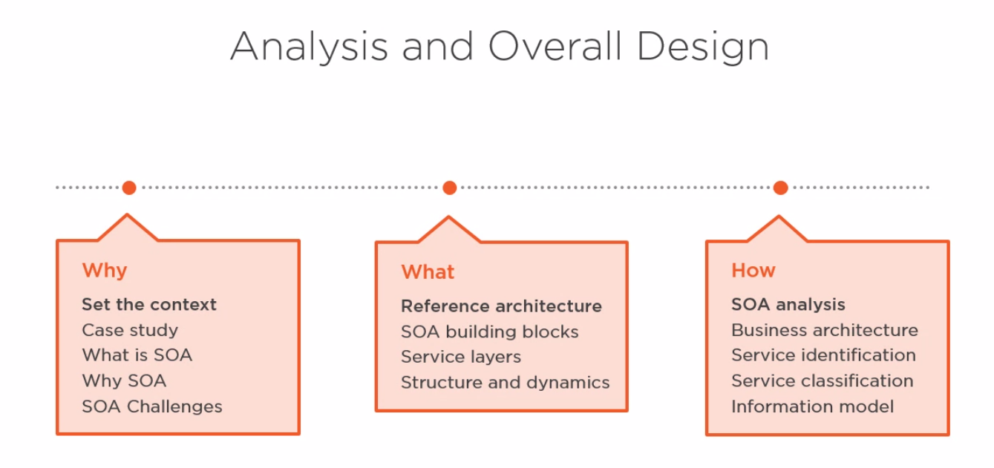

* Case Study:
  + We start with the first area and that is understanding the context, and the first step is understanding the case study. This is very important because unless you understand the problems that we are trying to solve, you won't be able to understand the value of SOA.
  + Sketch:

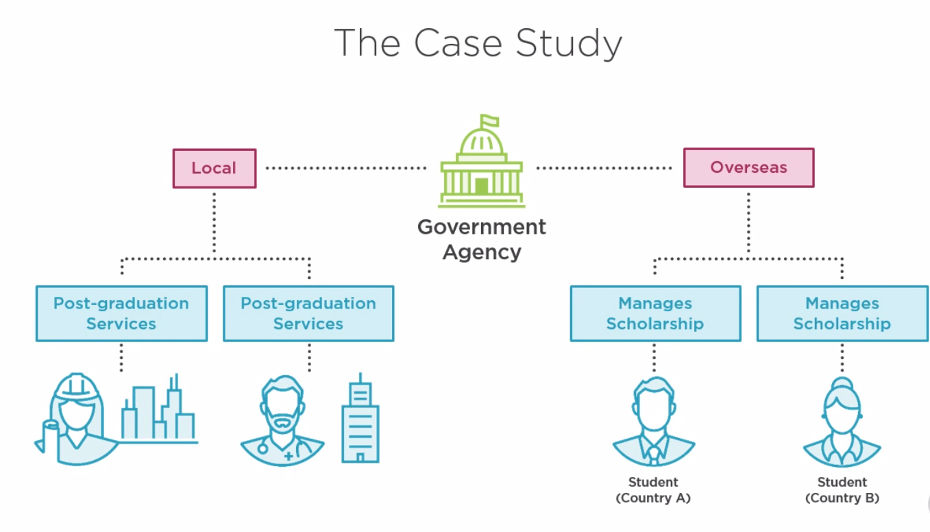

* + High level scenario:

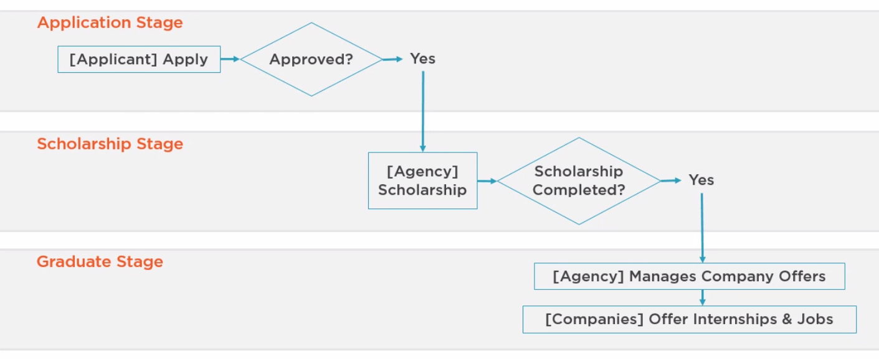

* + Understanding the system:

We have a government agency that funds and manages the scholarship of post-graduate students who are studying overseas to earn their Masters or Ph.Ds. After completing scholarships, the agency also offers post-graduation services, which help the graduates find internships and jobs. The type of students, their selections, the allocated funds, and other complex business concerns are not relevant to this discussion.

The high-level scenario goes as follows. First, there are three stages, the application stage where applicants submit their requests and get either approved or rejected, the scholarship stage, this is the core of their business where approved applicants get their entire scholarship managed in terms of finance and administration, and the graduate stage where students that have finished their scholarships get services that help them get internships and jobs. In a high level, an applicant applies to a scholarship. If approved, the student then travels to its nation country and starts the study lifecycle. During this time, the government agency manages everything related to this scholarship, such as funding, changing the major, and grade striking, financial requests, pausing and resuming the scholarship, and so on. After the conclusion of the study phase, graduates go back to their home country and the government agency then manages the post-graduation lifecycle helping graduates lending, internships, and jobs offered by partner companies.

* + Understanding the problem:

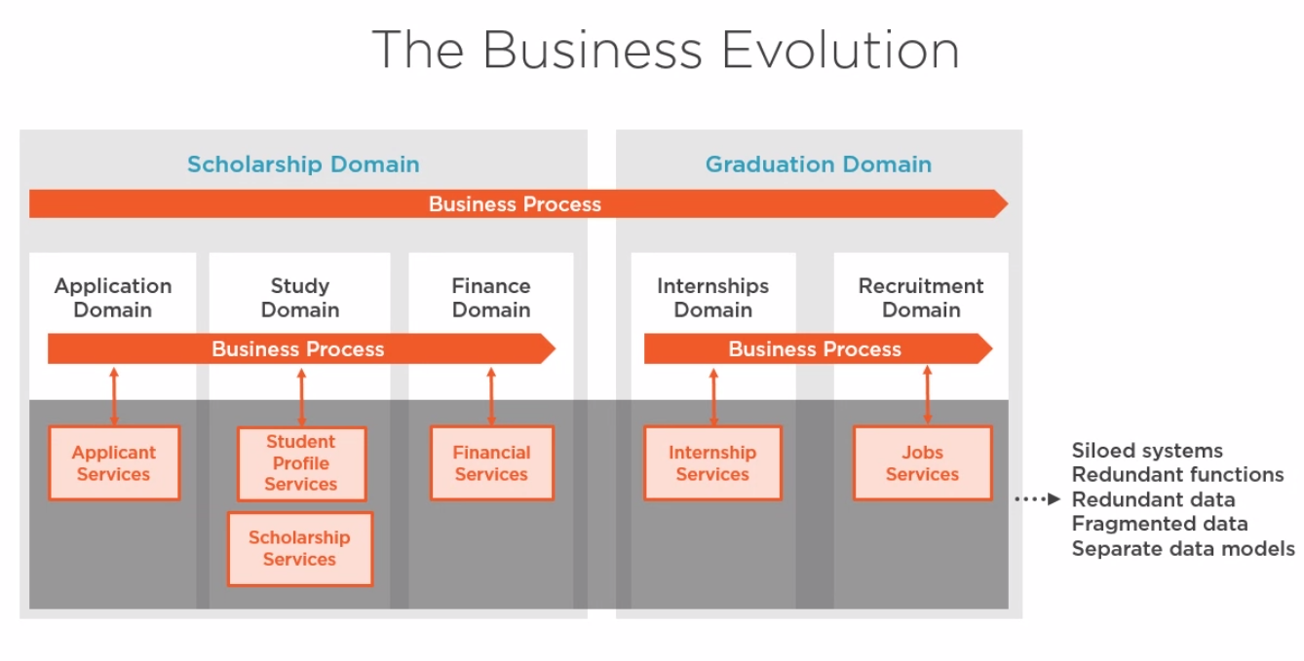

The problem is that the system is not building with solid architecture in mind so they build each service separately and then they group the related services in a domain but now they want to apply a business roles through services and domains and also they want the domains and services to communicate, but because there was no architecture from the beginning they faced a lot of problems in flexibility and cost.

* + Understanding the business need:

They want to apply a lot of business enhancements and also add new features as shown:

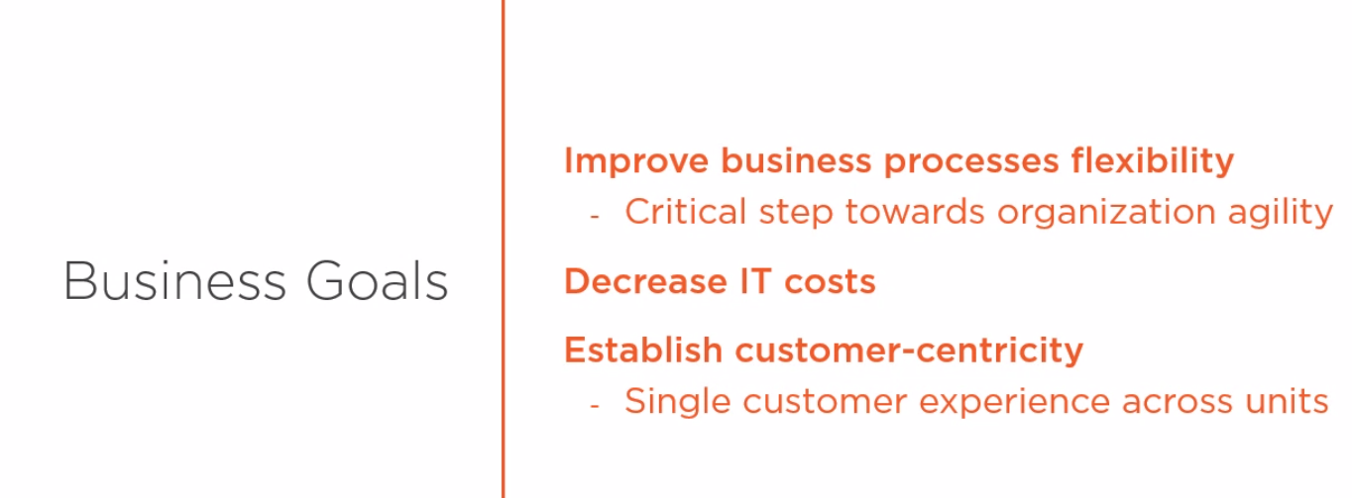

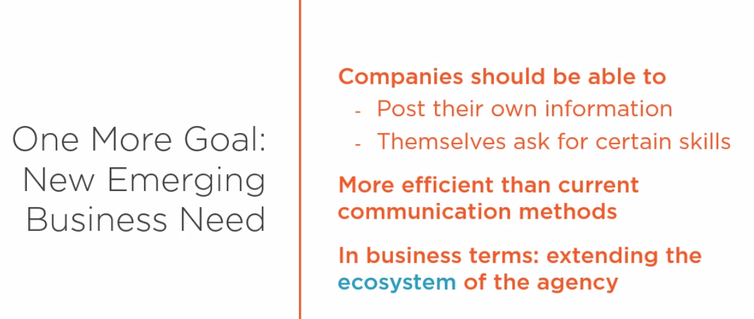

What is SOA?

* Some important words:

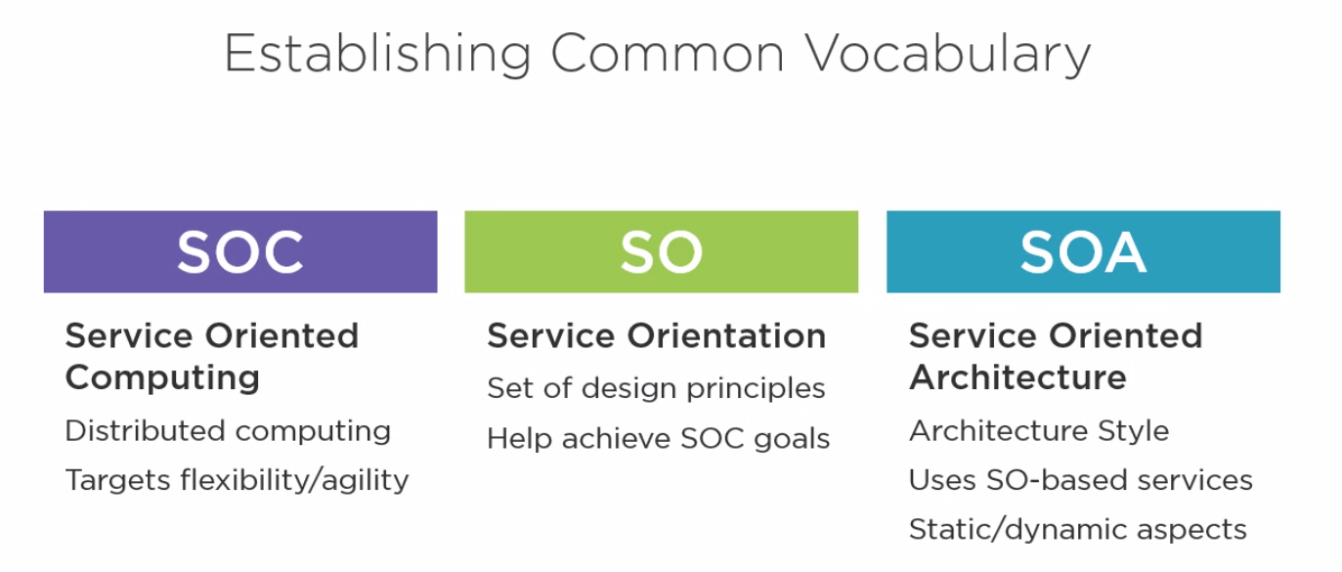

The term Service Oriented Architecture or SOA has been used so broadly that it is sometimes mixed with the related terms, such as service oriented computing and service orientation. Knowing the difference between these terms is not necessarily an essential thing that you should do, but establishing a consistent vocabulary is important for clear communication.

1. Service oriented computing presents a distributed computing platform that helps organizations achieve a set of strategic goals by helping organizations to be more flexible and agile in response to ongoing business demands.
2. Service orientation, the first to a set of design principles that when applied to service design help achieve these strategic goals associated with service-oriented computing.
3. service oriented architecture is an architectural style for building IT architectures based on services designed following the service orientation design principles. SOA decides the structure of these services, their interactions, and their interrelations with existing assets.

* What is service in SOA?

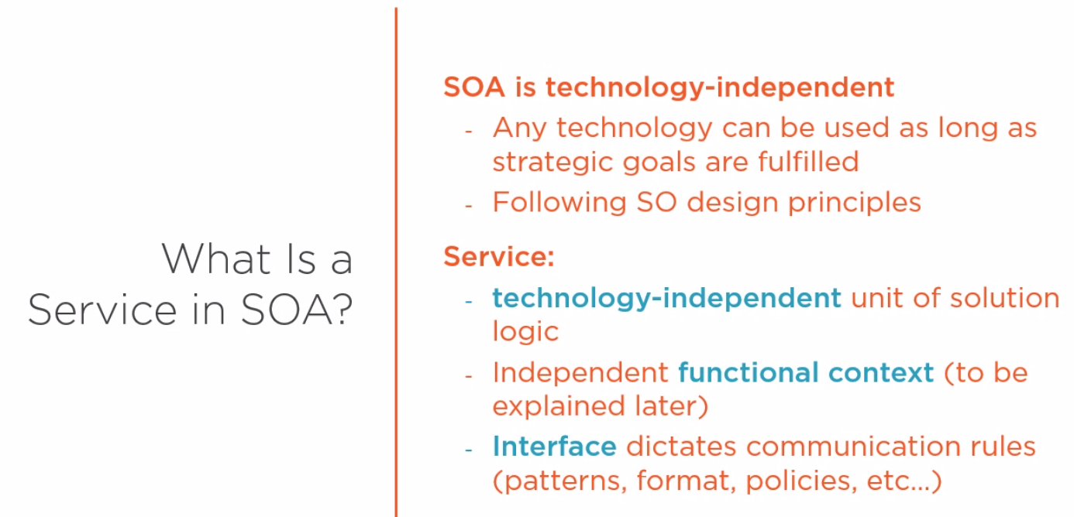

But in practical we use web services (SOAP or REST) in the implementation for some important reasons:

* + First, the interoperability of web services eases up communication between different platforms.
  + In addition, it allows us to build reusable services because they can be accessed by various communication frameworks, which increases the potential consumer base of the service.
  + The nature of how web services expose contracts in a decoupled manner from the logic enhances loose coupling and abstraction. As we will see later, characteristics such as interoperability, reuse, loose coupling, and abstraction are critical to the successful server.