Learning How to Learn: Powerful mental tools to help you master tough subjects:

1. Course Objectives:

By the end of the course, we expect you to be able to do the following:

* Explain the difference between focused and diffuse modes of thinking.
* Explain what a chunk is, and how and why you can and should enhance your chunking skills.
* Explain how working memory and long term memory differ from one another.
* Describe key techniques to help students learn most efficiently such as: the Pomodoro, metaphor, story, visualization, deliberate practice, and interleaving.
* Describe actions that hinder students from learning most effectively, such as procrastination, over-learning, Einstellung, choking, multi-tasking, illusions of learning, and lack of sleep.
* Describe the most important aspects of proper test preparation.
* Explain the importance of “mindset” in learning.

1. Focused versus Diffuse Thinking:

Diffuse mode is:

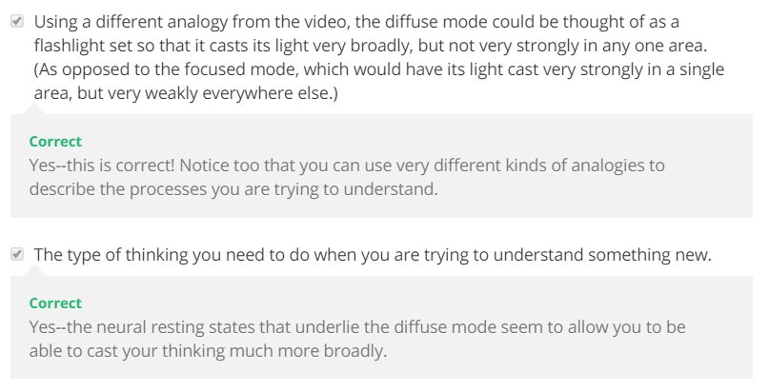

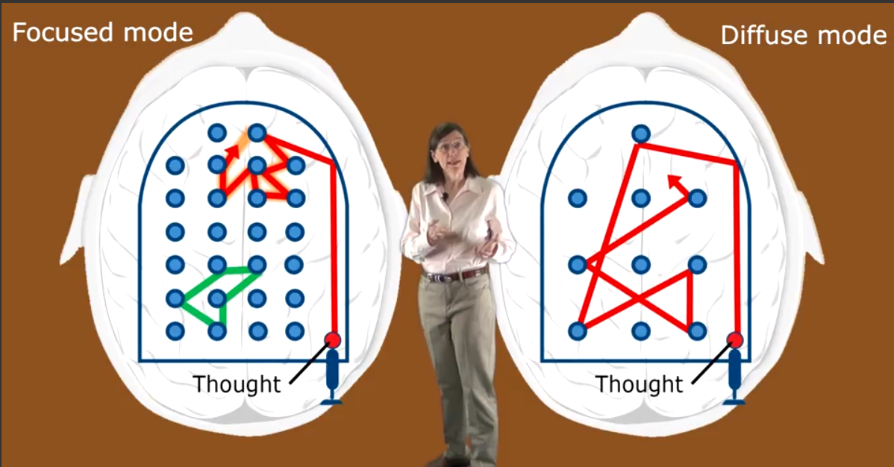

We using diffused mode to think in the new things that we didn’t think to it before. It helps us find a new techniques and ideas, while using focused mode is used when you think in the thing you know before. We can’t use the 2 modes in the same time

1. Using the Diffuse and Focused mode to improve thinking:

Many well-known inventors and smart people used to put a ball into their hand and try to made diffuse think tell they sleep so the ball is fallen and then they wake up and convert to focused mode using the ideas from diffuse mode and this conversion is very important to practice it when thinking in new and difficult thing and very important also to train your mind everyday on this like the gym for your body.

1. What is learning:

* This brain weighs three pounds, but it consumes ten times more energy by weight than the rest of the body, a very expensive organ. It is the most complex device in the known universe.
* All of your thoughts, your hopes, and your fears are in the neurons (خلايا عصبية) in this brain. We prize (نُقدر) our abilities to do chess and math, but it takes years of practice to acquire these skills. And digital computers are much better at it than we are. It came as a surprise to discover that what we do so well and take for granted, like seeing, hearing, reaching, running, are all much more complex problems than we thought and way beyond the capability of the world's fastest digital computers. What this illustrates is that we are not consciously aware of how our brains work.
* أي أن يوجد أشياء نتعلمها مثل قدرتنا على الحساب و تكون الحواسب أفضل منا بكثير و أشياء أخرى نفعلها كالسمع و الرؤيا نفعلها أفضل بمراحل من الحواسيب و كنا نظن أنها أشياء بسيطه لكن اتضح انها معقدة جداً و الحقيقة أننا لا نفهم حقا كيف يعمل عقلنا. وجد العلماء أن العقل يقوم بأعمال شديدة التعقيد على مستوى العقل الاواعي و نحن لا ندرك الا مقدار بسيط جدا مما يحدث و هذا من رحمة الله لانه لو قمنا بأدراك ذلك لهلكنا و لكن العلماء بالنيابة عنا قاموا بالعمل لعشرات الاعوام بدراسة العقل اللاواعي و تأكدوا أن التأثيرات تشمل عمليات التفكير والذاكرة والعواطف والتحفيز. نحن ندرك فقط جزء صغير جدا من كل نشاط في الدماغ، لذلك نحن بحاجة إلى الاعتماد على تقنيات التصوير الدماغ لتوجيهنا.
* The brain have many network insides and the 2 main areas were as shown below:
* Left Image is side view and right one is middle view.

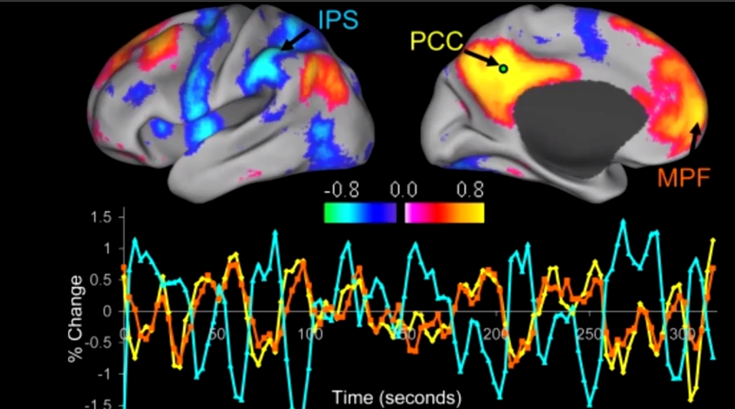

1. Blue areas are highly active when the person interact with the world.
2. Default Mode Network (In Red-Orange) is a large scale brain network of interacting brain regions known to have activity highly correlated with each other and distinct from other networks in the brain. The default mode network is most commonly shown to be active when a person is not focused on the outside world and the brain is at wakeful rest, such as during daydreaming and mind-wandering. But it is also active when the individual is thinking about others, thinking about themselves, remembering the past, and planning for the future. The network activates "by default" when a person is not involved in a task. Though the DMN was originally noticed to be deactivated in certain goal-oriented tasks and is sometimes referred to as the task-negative network, it can be active in other goal-oriented tasks such as social working memory or autobiographical tasks. The DMN has been shown to be negatively correlated with other networks in the brain such as attention networks.
3. There are also a lot of areas and networks that being active for specific tasks and missions.

* New Synapses created after learning and sleep:

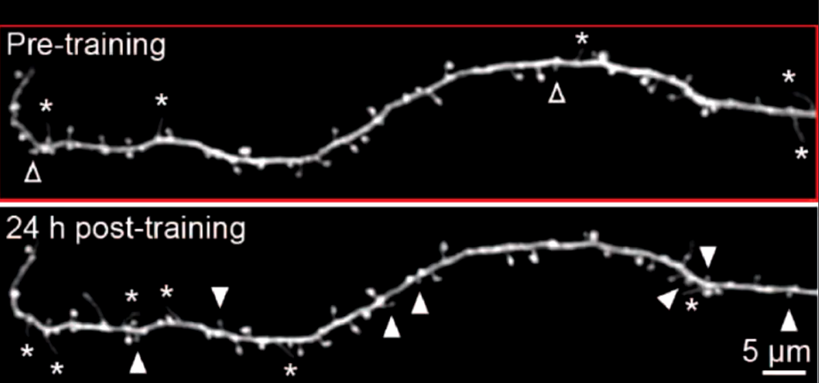

* But also there are a synapses that disappeared so how are the memories still saved? Answer: <http://www.brainfacts.org/thinking-sensing-and-behaving/learning-and-memory/2016/catharine-young-how-memories-form-and-how-we-lose-them-040516>
* But what we want to say that the brain restructured every day and time dynamically and you are not the same person after you wake up from sleep.
* A good website to learn more about your brain: <http://brainfacts.org/>

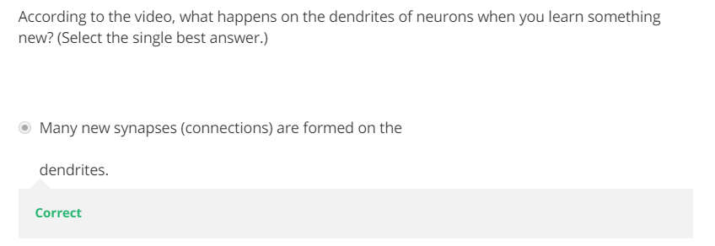

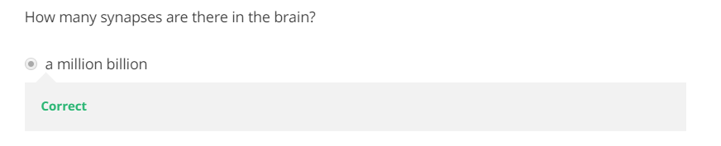

1. Procrastination, Memory, and Sleep:

5-1. a procrastination Preview:

1. fff