# Full Stack Web Developer with Meteor and React:

## Installation:

For Windows from the Website via installer.

## Some important commands:

From terminal/cmd:

* Meteor --version
* Meteor --help

## What is meteor and why should I use it:

Meteor is nothing than a collection of tools that designed to work well together.

### What is Meteor?

* Meteor is a full-stack JavaScript platform for developing modern web and mobile applications. Meteor includes a key set of technologies for building connected-client reactive applications, a build tool, and a curated set of packages from the Node.js and general JavaScript community.
* Meteor allows you to develop in **one language**, JavaScript, in all environments: application server, web browser, and mobile device.
* Meteor uses **data on the wire**, meaning the server sends data, not HTML, and the client renders it.
* Meteor **embraces the ecosystem**, bringing the best parts of the extremely active JavaScript community to you in a careful and considered way.
* Meteor provides **full stack reactivity**, allowing your UI to seamlessly reflect the true state of the world with minimal development effort.
* Meteor used Nodejs in server side and JS in client side so u can do a full stack development using it.
* Meteor also using sockets by default to made a 2 way communications.
* Meteor uses npm for a generic JS packages and atmospherejs package manager for the Meteor specific packages.
* Meteor uses mongodb as a default data store system.
* Meteor comes with a UI framework called Blaze but we will use React here instead and also we can use VueJs or Angular

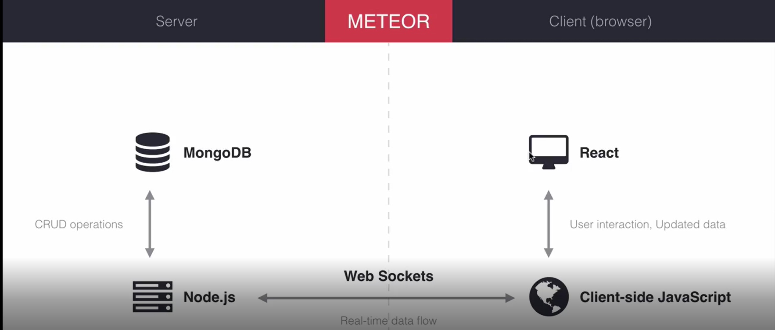

## What is meteor and why should I use it:

* Atom
* VS code
* WebStorm