PMP Notes:

* Project: Temporary (has definite start and end) endeavor undertaken to create a unique product or service or result.
* Management: Creating and maintaining an environment in which resources can accomplish the required goals effectively and efficiency.
* Project Management: Application of knowledge, skills & techniques to project activities to meet up with project requirements & stockholders expectations.
* As every project is temporary and unique, so planning and controlling a project is always a challenge to project management team.
* Project Vs. Operation:

Projects require project management, while operations require business process management or operations management. Projects and Operations will interact with each other at key points in a product’s life cycle.

Operations are ongoing, but projects are temporary.

Both projects and operations are carried out by people, both require planning, both require management, and both are constrained by a fixed amount of budget, resources, and timelines.

Example of Project / Operations: A plumber may be doing a support work to fix a leak. Each day he fixes leaks in 20 locations. Each leak may require a different solution (some may need a new washer, or a new pipe, or some putty), but it is still support work.

But let’s say during a leak fix, he realizes that the whole tubing is weak, damaged at many locations, and is going to explode at any time. Thus, he informs the home owner that a “Redesign the bathroom” project should be undertaken if you want a permanent fix, and the plumber can then give the details of the work required (scope), and a quotation (budget), and estimated time to fix the whole thing (schedule).

If the home owner (Sponsor) agrees to the time/cost/scope, a “remodel the bathroom” project is born. If not, then the ‘fix the leak’ support ticket is completed and closed with the required documentation updates (payments, sign-off).

Some projects are ended and operation is starting after it. Like project to design a new car prototype and after that the process start of produce many cars.

* Project Constrains:

A constraint, in project management, is any restriction that defines a project's limitations; the scope, for example, is the limit of what the project is expected to accomplish.

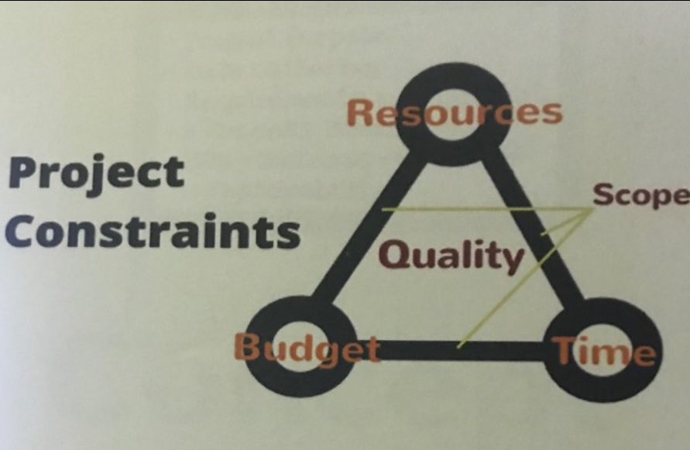

* Project Management Steps:

