Math - Algebra:

1. Introduction to algebra:
   1. Overview and history of algebra:

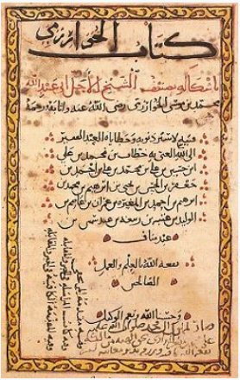

* Algebra is a science introduce by the Muslim’s mathematics and scientists called Khwarizmi and algebra means: restoration or completion.
* أسم الكتاب: الكتاب المختصر في حساب الجبر و المقابلة.
* The Brief book in calculation by completion and balancing.
* But Algebra traces shows that it’s 2000 B.C contributions.
* Khwarizmi start using the terms of algebra and balancing equations but the beginning of all of this is 2000 B.C and there is also another mathematics which is called Diophantus which born about 100 A.C in Alex, Egypt who have a lot of contributions in a specific problem sets related to algebra. So Babel in 2000 B.C then Diophantus then Indian mathematics called Brahmagupta in 650 A.C then Khwarizmi who have a lot of great contributions.
* A lot of people said that Khwarizmi is the father of algebra and algebra is an Arabic word because Khwarizmi made us think of algebra in abstract way devoid of some specific problems.

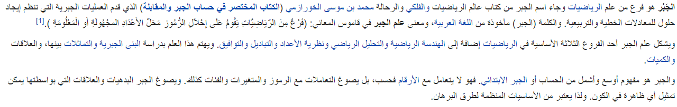

* 1. Abstract-ness:
* Idea or concept is the abstract and implementation is the real world.
* For example, cube is an abstract and implementation may be a dice or a cubical home design, or any shape that relate to cube.
* Also, Dog word is an abstract on a dog in my mind. Number 5 is abstract that represent a quantity of 5 things.
  1. The beauty of algebra:
* Algebra is all about abstract things more and more. So, algebra may solve abstract problems with an abstract solution and you can take those solutions and apply it in a lot of domains like economics, politics, physics etc. For example, there is a sale of 30% on a product of 30$, In algebraic we should go toward abstraction by made this equation. y = p. x which p is the percentage of discount and x is the price. And we can apply this equation to get the products of any numbers and we can use it in a lot of domains to solve a lot of problems like the discount on product problem or force in mechanics which F = m . a we can transfer symbols to be y = p. x which p is the mass and x is the acceleration.
* The other interesting thing is that you will be able to manipulate the abstraction to get another forms and then use them in a lot of domains with a lot of applications:

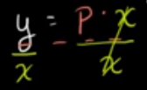

* 1. Intro to the coordinate plane:
* Rene Descartes is a well know mathematical and phosdiphen and he has the main role in linking between algebra and geometry as shown below:

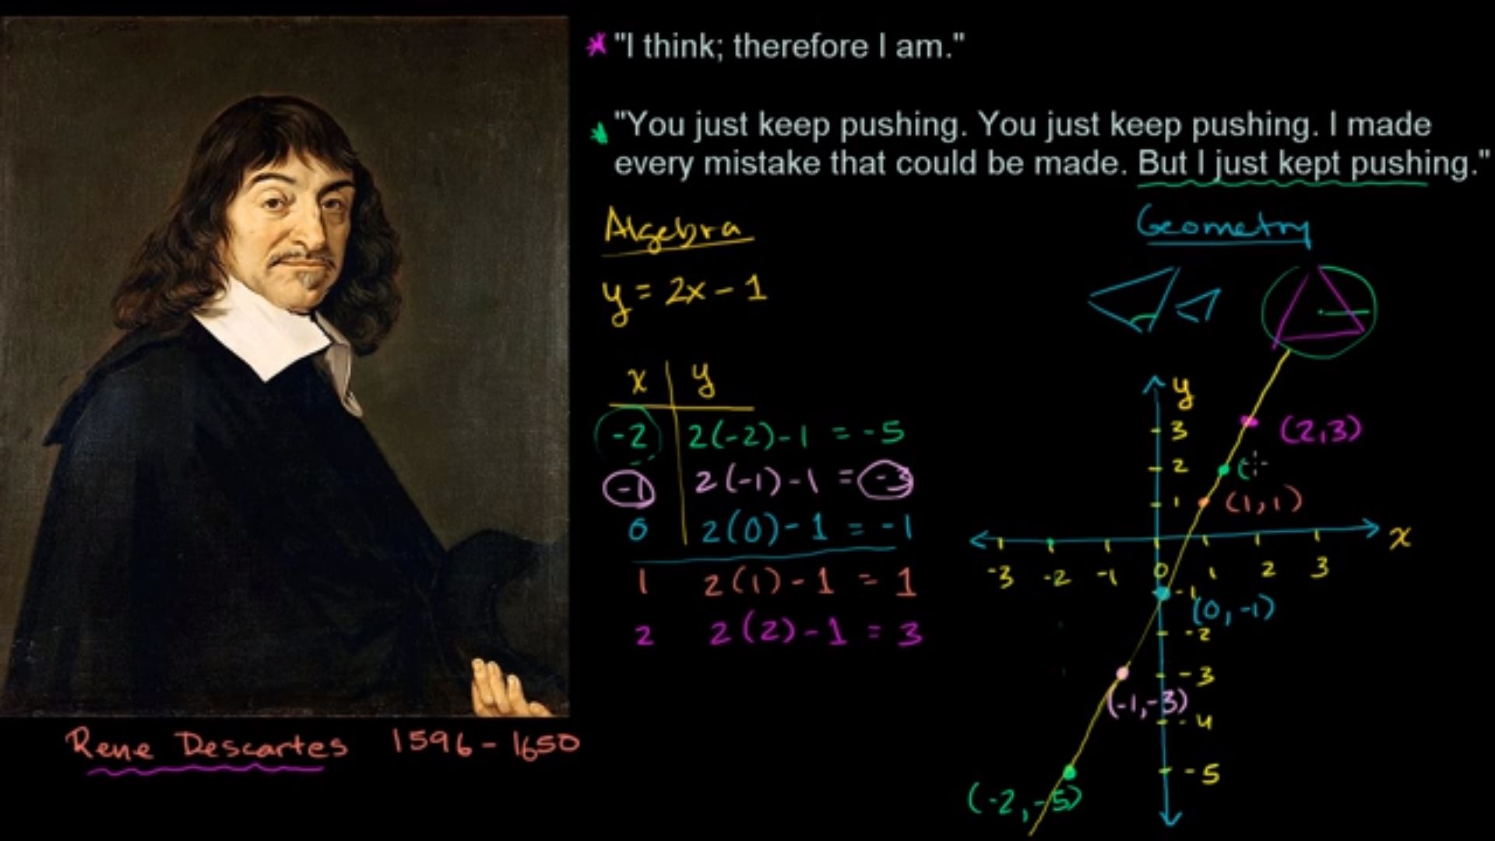

* So, this equation draws a line which is a linear equation, or another way of thinking is that any point on this line represents a solution to this equation right over here so using the graph you can get a solution or you can find y based on x throw the graph.
* So, we know that y =2x – 1 is a linear equation through the linking algebra by the geometry via Rene Descartes.
* The coordinates called cartesian coordinates as a referral to Rene Descartes.
  1. Intro to variables:
* Variable is a symbol that represents a variable value.
* X.y called x product y, x(y) called also x product y, xy called x times y.
  1. Substitution and evaluating expressions:

1. Solving basic equations & inequalities (متباينات) (one variable, linear)
2. Linear equations, functions, & graphs
3. Sequences (متتابعات)
4. System of equations
5. Two-variable inequalities
6. Functions
7. Absolute value equations, functions, & inequalities
8. Quadratic equations & functions
9. Polynomial expressions, equations, & functions:
   1. Introduction to polynomial (متعدد الحدود)

* A polynomial is something that is made up of some of terms.
* A polynomial is a general term that represent the sum of finite number of **terms** where each term has a **coefficient** (مُعامل)(which is a constant real number (-VE or +VE) multiplied by the variable of the term) multiplied by a **variable** being raised to a non -VE **integer power**.
* In the image below, the left column contains example of polynomial and the right contains an example of non-polynomial.

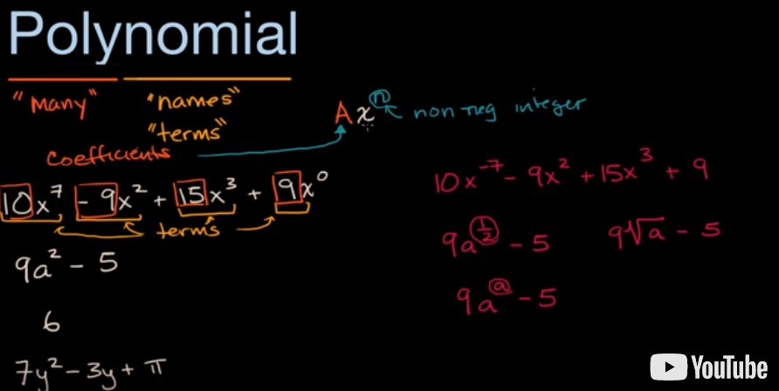

* Monomial, Binomial, Trinomial are a specification of polynomial:

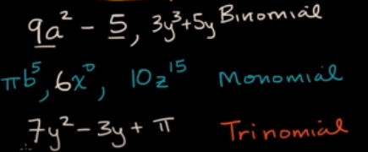

* There is a **degree of the polynomial** which is the largest power in the equation or a **degree of a one term of polynomial** which is the power we are raising the term’s variable to.
* Standard form happened when you write equation in a right degree orders so the leading one is the largest degree term.
* Examples:





* The parts of polynomial expressions:

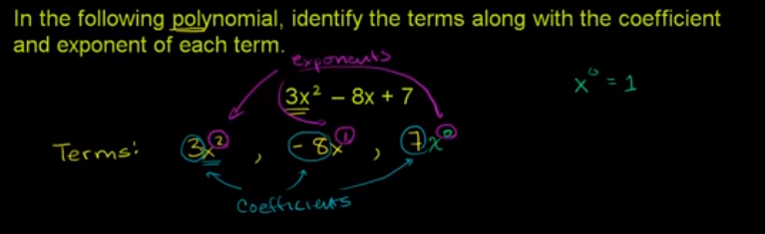

* Evaluating a polynomials:

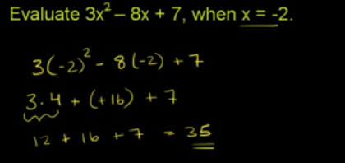

* Simplifying polynomials:

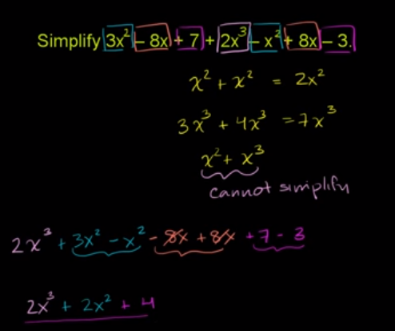

* 1. Adding & subtracting polynomials:
  2. fff

1. Exponential & logarithmic functions:
   1. Exponent properties review:
   2. Radicals:
   3. Rational exponents intro:
   4. Properties of exponents (rational exponents)
   5. Fff
   6. Fff
   7. Fff
   8. Fff
   9. Dff
   10. Fff
   11. Fff
   12. Fff
   13. Eee
   14. Eee
   15. Eee
   16. Eee
   17. Eee
   18. Eee
   19. Eee
   20. Eee
   21. Eee
   22. Introduction to logarithms (Algebra 2 level):

* Intro:

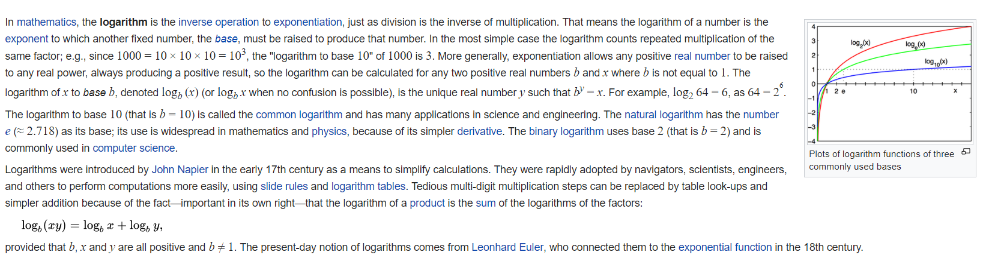

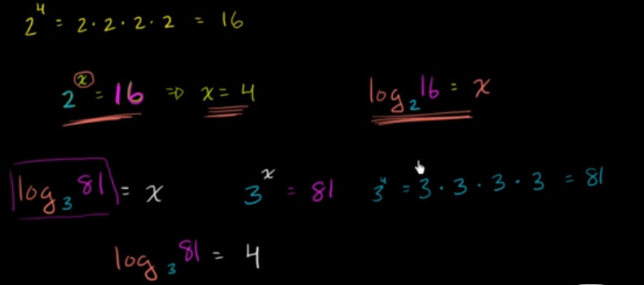

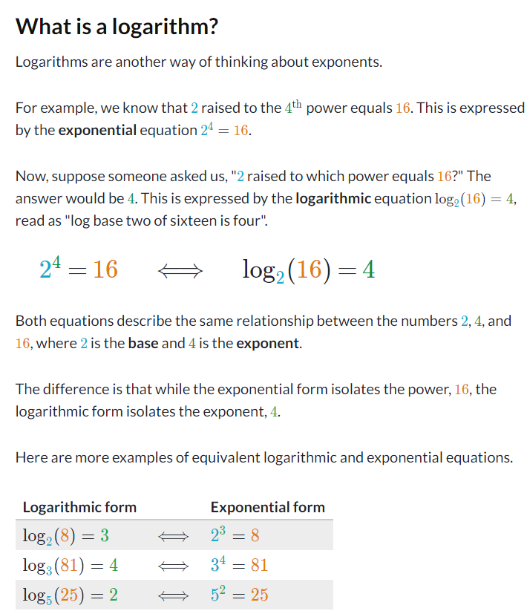

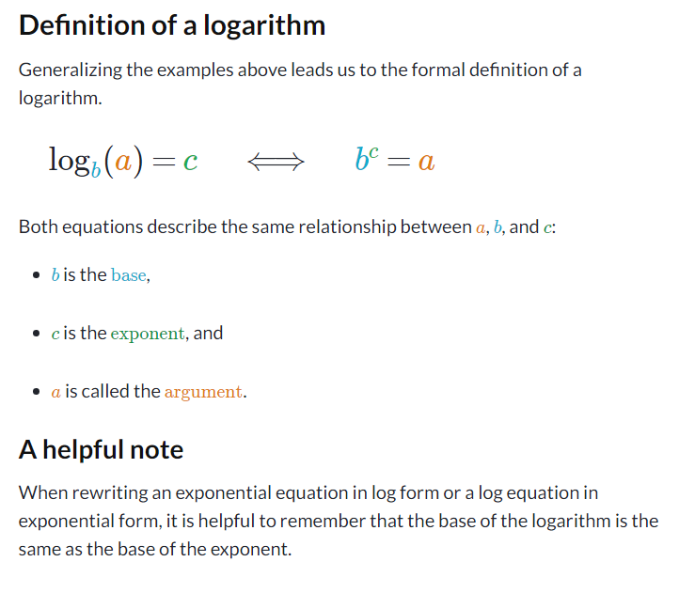

* You should be familiar with exponents, preferably including negative exponents.
* Examples:

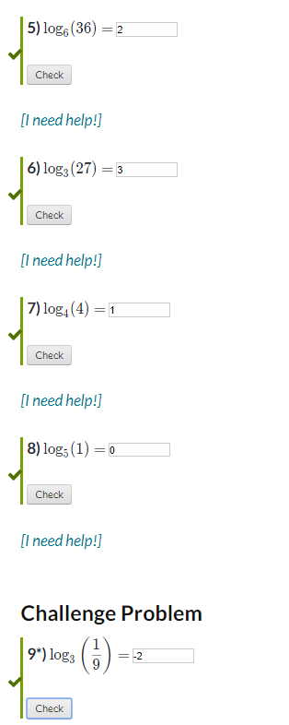

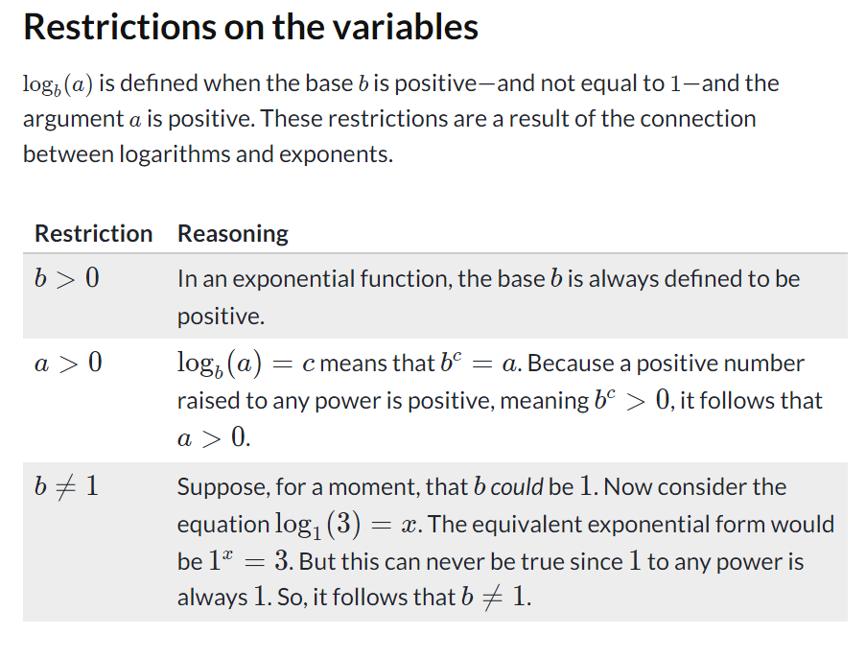

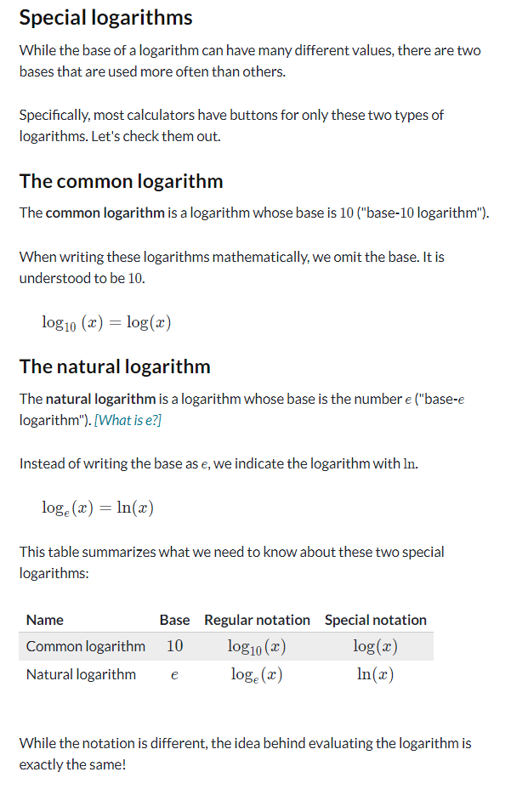

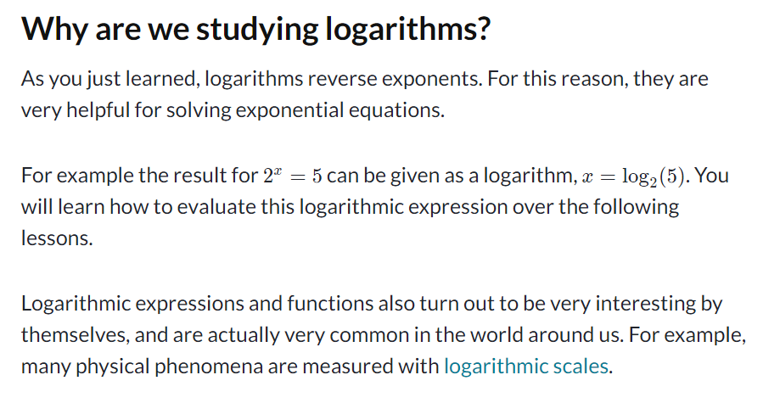

* Main rules of logarithms while working with programming:

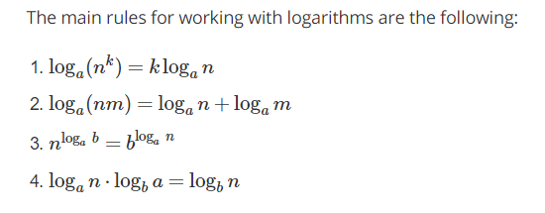

* Evaluating logarithms (advanced):
  1. The constant e and the natural logarithm (Algebra 2 level)
  2. Properties of logarithms (Algebra 2 level)
  3. Eee
  4. Eee
  5. Eee
  6. Eee
  7. Eee
  8. eee

1. Radical equations & functions
2. Rational expressions, equations, & functions
3. Trigonometric functions
4. Algebraic modeling
5. Complex numbers
6. Conic sections
7. Series & induction
8. Vectors
9. Matrices