**Q1. Construct a self-complementary graph on 4n or 4n+1 vertices, for any given positive integer n. Describe the procedure step-by-step.**

**Assignment - 1**

**Submitted by: Gavali Deshabhakt Nagnath**

**Roll No.: 202CD005**

**Department: Mathematics and Computational Sciences**

**Specialization: Computational and Data Science**

**Subject: Selected Topics in Graph Theory**

**Instructor: Prof. Dr. Shyam Kamath**

**Submitted on: 28/02/2021**

**Answer:**

A self-complementary graph is a graph which is isomorphic to its complement.

A complement of graph A is a graph Ā on the same vertices such that two distinct vertices of Ā are adjacent [if and only if](https://en.wikipedia.org/wiki/If_and_only_if) they are not adjacent in A. That is, to generate the complement of a graph, one fills in all the missing edges required to form a [complete graph](https://en.wikipedia.org/wiki/Complete_graph), and removes all the edges that were previously there.

So now keeping these two definitions we can construct a self-complementary graph on 4n or 4n+1 vertices.

We will consider n = 1 for constructing self-complementary graph:

Steps:

1. Calculate 4n (or 4n+1)
$$∴Total number of vertices=4*1=4$$

2. Constructing graph, A and Ā:

a

d

c

b

Graph: Ā

A

C

B

D

Graph: A

1. Checking for isomorphism:

For a two graphs to be isomorphic they have to obey following conditions,

1. Equal number of vertices
2. Equal number of edges
3. Same degree sequence
4. Same number of circuits of particular length.

(Note: Circuit is closed trail)

Now in our case,

1. Graph A and Ā has same number of vertices i.e., 4 (also Ā is A’s complement so they must have same number of vertices)
2. Number of edges in A are 3 and in Ā its also 3. So second condition is also satisfied.
3. The degree sequence of graph A and Ā are: {1,1,1} and {1,1,1} respectively. Therefore 3rd condition is also satisfied.
4. From graphs it can be seen that neither of them has a circuit, so 4th condition is also satisfied.

Therefore, the two graphs are isomorphic. Also they are complement of each other.

As the two graphs are isomorphic and complement of each other, therefore graph A is a self-complementary graph.

Similarly, using above steps we can construct self-complementary graphs from 4n+1 vertices.

**Q2.** **Show that a graph is connected if and only if for every partition of its vertices into two non-empty sets, there exists an edge with its end vertices in both the partitions.**

**Answer:**

Let’s assume a connected graph G such that, V(G) = {x0, x1, x2, …., xn}. Now divide these vertices into two non-empty sets X and Y such that V(G) = X U Y.

We need to show that G has an edge with one endpoint in X and the other in Y.

Select vertices x in X, and y in Y. Since G is connected, there has to be a path in G that joins x to y. Denote this path as follows:

x = x0, x1, x2, …., xn = y

The first vertex x0 of this path is in X, and the last vertex xn is in Y. All other vertices are either in X or in Y. Let i be the smallest index for which xi ∈ Y, (such an i exists, because xn ∈ Y, so i is at most n).

Therefore, we have xi−1 ∈ X and xi ∈ Y so xi−1 xi is an edge of G with one endpoint in X and the other in Y.

Hence the proof.

**Q3. If u and v are distinct vertices of a graph G, then show that every u-v walk in G contains a u-v path.**

**Answer:** By definition,

1. A walk in a graph is an alternating sequence of vertices and edges, beginning and ending with vertices. Therefore, in a walk, there can be repeated vertices.
2. A path in a graph is a walk in which no vertices are repeated.

To prove the statement, we consider a graph such that

V(G) = {u1, u2, u3, …., un} and V(E) = {e1, e2, e3, …, en}.

Let us consider a walk u1 un, since graph G has distinct vertices the u1un walk is a u1un path.

Now let’s assume a walk u1un in which a vertex (say uj) is repeated, then we can have a u1un path by just excluding the portion of walk because of which we arrive at same vertex i.e. uj and arrive at un.

This shows that, every u1un walk has a u1un path, and in turn, every u-v walk has a u-vpath.

Hence the proof

Note: If a vertex is repeated in walk then length of the walk will not be same as length of path.

(Length of path will be lesser in that case)

**Q.4 Determine whether the following graphs are isomorphic:**

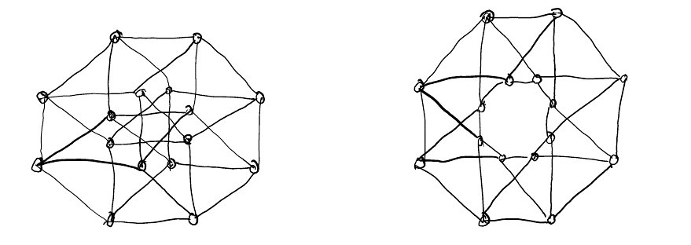

**Justify your answer.**

**Answer:** Let us label the graphs G and H and vertices as u1, u2, …, u16 and as v1, v2, …, v16 respectively.

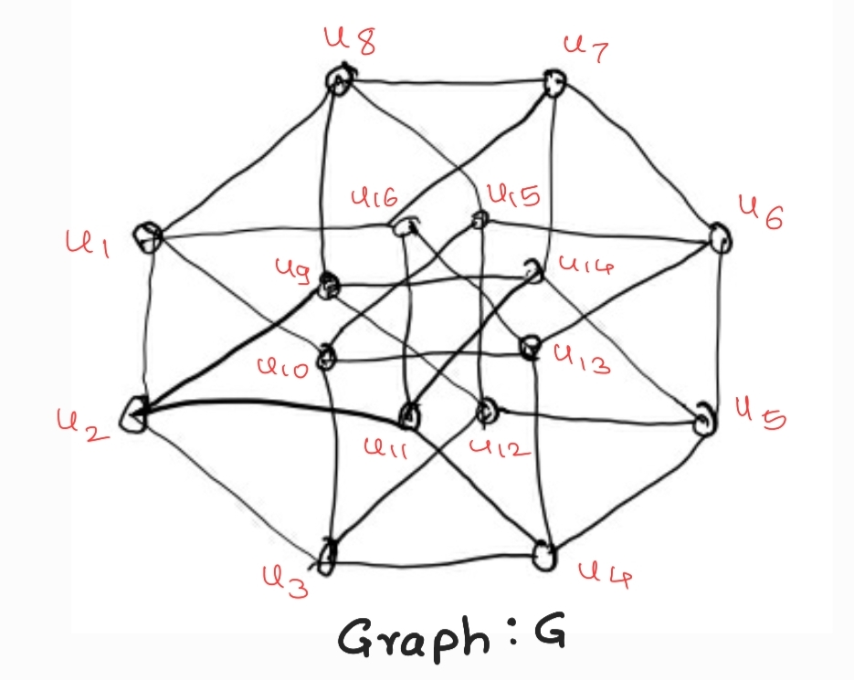 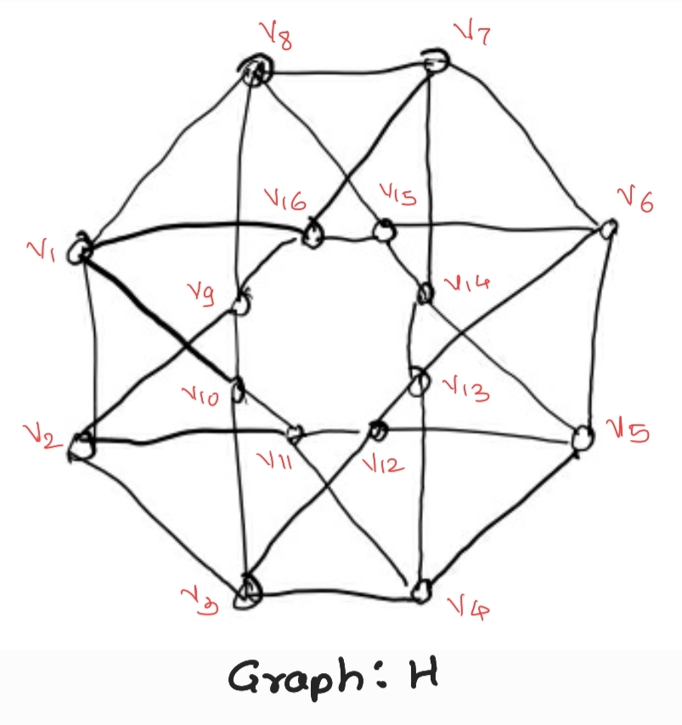

The adjacency matrices of these to graphs are as follows:

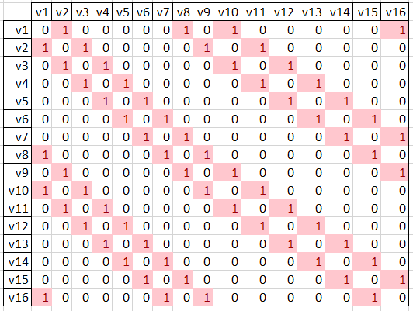

**Adjacency matrix of graph H**

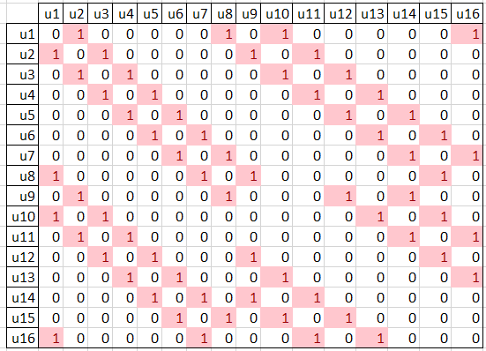

**Adjacency matrix of graph G**

Following are the conditions for isomorphism:

1. Equal number of vertices
2. Equal number of edges
3. Same degree sequence
4. Same number of circuits of particular length.

Checking conditions one by one:

1. The number of vertices in graph G are 16 and in graph H also 16.
2. The number of edges in graph G are 32 and in graph H also 32
3. From adjacency matrices it can be seen that both the graphs have same degree sequence which is {4, 4, 4, 4, 4, 4, 4, 4, 4, 4, 4, 4, 4, 4, 4, 4}
4. In the graph G, every vertex appears in only six 4-cycles, whereas in the graph H, every vertex appears in eight 4-cycles.

Thus as 4th condition is not mate the graphs are **not isomorphic**.

Also, by assuming a bijection function, f: V(G) -> V(H) which maps edges in two graphs as follows,

u1 🡪 v1

u2 🡪 v2

u3 🡪 v3

.

.

.

u16 🡪 v16

From adjacency matrix we can see that, the edges from vertices u1 to u8 perfectly maps with the edges from vertices v1 to v8, but from u9 onwards the edges in both graphs do not map with each other with the current bijection function. Also, even if we change the bijection then also the edges won’t map to each other. Hence the given two graphs are not isomorphic.