Q.4 Determine whether the following graphs are isomorphic:

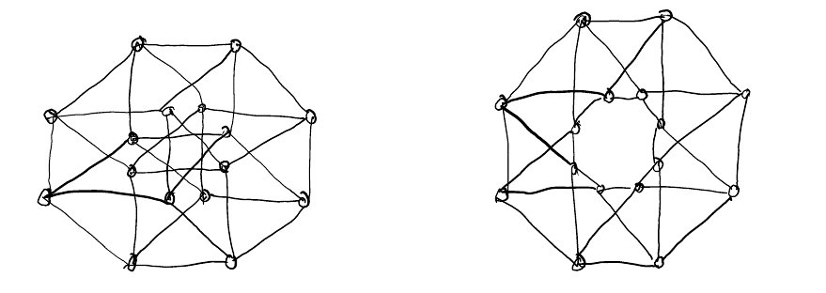

Justify your answer.

Ans:

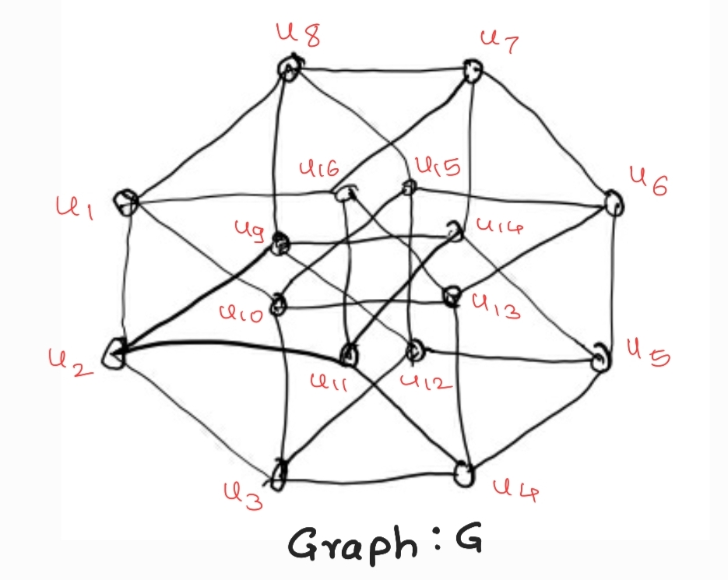 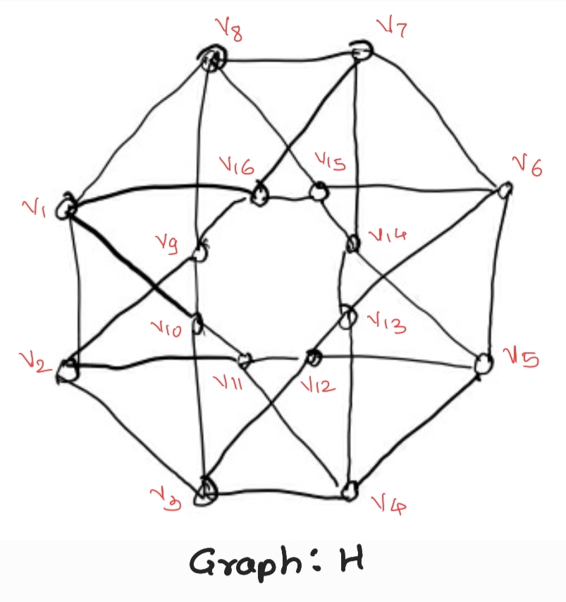

Let us name the vertices in graph G as u1, u2, …, u16 and in graph H as v1, v2, …, v16.

The adjacency matrices of these to graphs are as follows:

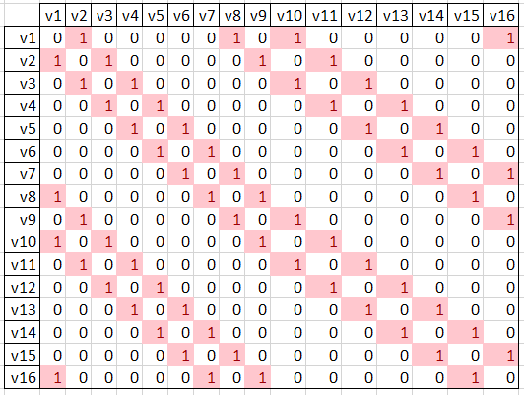

**Graph H**

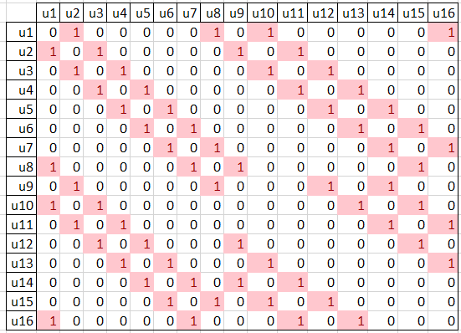

**Graph G**

From adjacency matrix it can be seen that, in the graph H, every vertex appears in eight 4-cycles, where as in graph G every vertex appears in only six 4-cycles. Thus, they are not isomorphic. Also, in graph H, for every vertex there are five vertices having common neighbors with it, while in graph G there are only six such vertices.