**Name: Gavali Deshabhakt Nagnath Roll No.: 202CD005**

Q1-Answer:

a) Taking required accuracy = 0.00001

1. For w = 0.9

Solution: Iteration = 31

x1 = 1.299979 x2 = -0.300015 x3 = 4.199998 x4 = 4.200009 x5 = -0.299984 x6 = 1.300015

1. For w = 1.0

Solution: Iteration = 26

x1 = 1.299985 x2 = -0.300011 x3 = 4.199999 x4 = 4.200007 x5 = -0.299989 x6 = 1.300010

1. For w = 1.2

Solution: Iteration = 21

x1 = 1.299997 x2 = -0.300002 x3 = 4.200002 x4 = 4.200001 x5 = -0.300001 x6 = 1.300001

b)

1) Table for w = 0.9

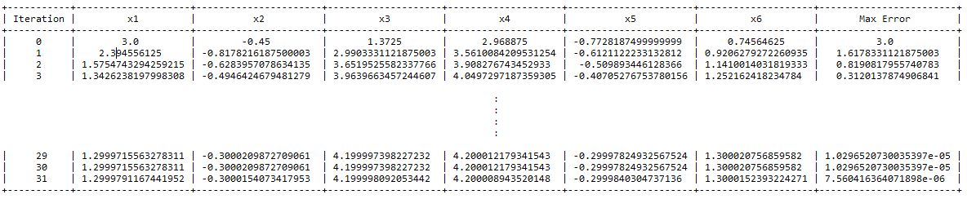

2) Table for w = 1.0

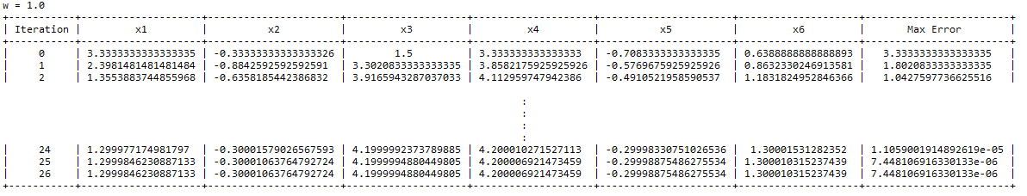

3) Table for w = 1.2

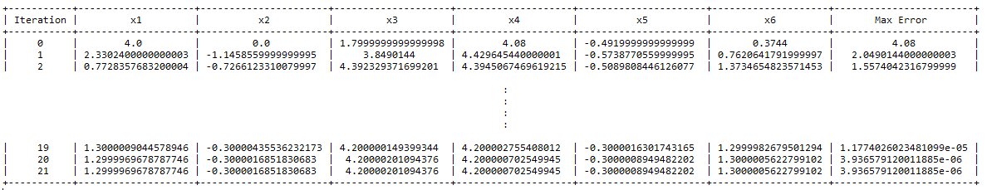

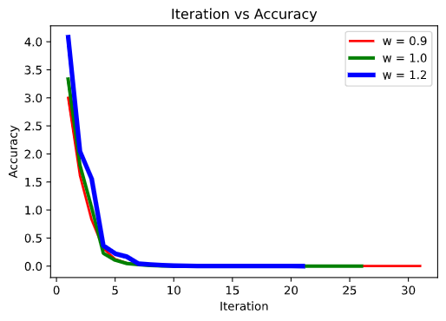

1. From tables we can see that, for w = 1.0 the number of iterations taken to find solution of given system with desired accuracy are 26 and for w = 1.2 it is just 21.
2. As we know that for w = 1.0, the successive iteration method behaves as Gauss Siedel Method.
3. Hence in this case, over relaxation gives better convergence than Gauss Siedel method.

c)

i) Given Matrix is not diagonally dominant.

ii) Although the given matrix is not diagonally dominant, the Gauss Siedel and SOR method converge for given matrix.

ii) As the matrix G satisfies the necessary and sufficient condition for convergence i.e. spectral radius of G less than 1, (where Spectral radius of G is = max(absolute(eigen Values))). Hence system not being diagonally dominant does not contradict with convergence of Gauss Siedel and SOR method.

Matrix G:

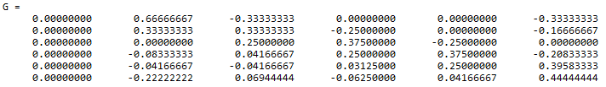

Eigen Values of G are

Eigen Values are:

0j

(-0.2392452174491157+0j)

(0.3195662365909472+0.29595646601563347j)

(0.3195662365909472-0.29595646601563347j)

(0.6736262499035985+0j)

(0.45426427214140114+0j)