**Name: Gavali Deshabhakt Nagnath Roll Number: 202CD005**

**Q2 Answer:**

1. **Function Plot:**

From graph it can be seen that root lies close to (0,0)

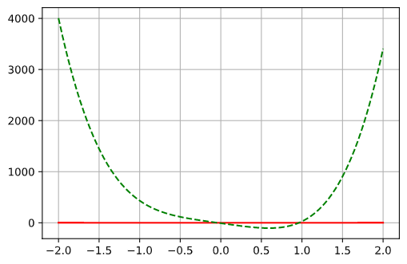

1. **For a0 = -0.5 and b0 = 0.5**
2. **False Position Method:**

Output:

Final Root Found Iteration- 20, x0 = -0.040659 x1 = -0.040659 x2 = -0.040659 and f(x2) = 0.000000 Required Root is: -0.040659

Table:

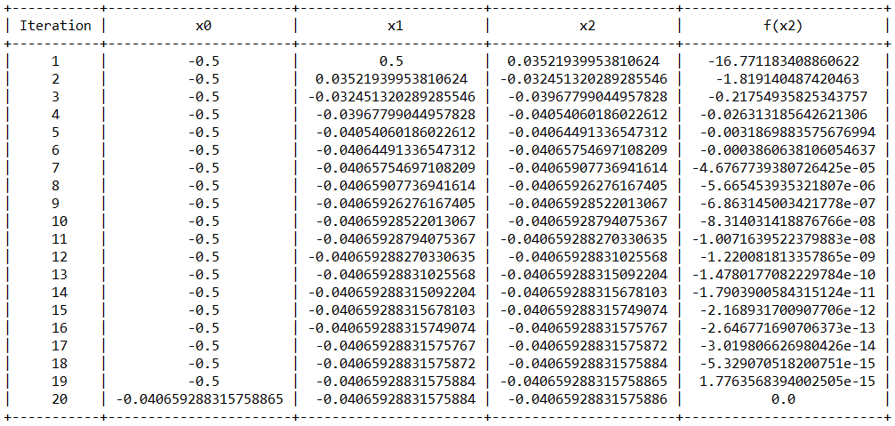

**ii) Secant Method:**

Output:

Final Root Found Iteration- 5, a = -0.040606 b =-0.040659 c = -0.040659 f(x2) = 0.000000

Required root is: -0.040659249655343

Table:

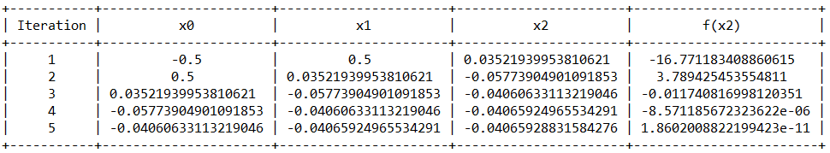

1. **Combined Plot between Regula Falsi and Secant Method:**

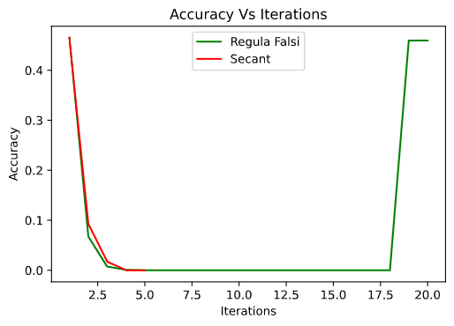

Here it can be seen that for given function with initial gausses (a0,b0) = (-0.5,0.5), Secant method converges much faster than Regula Falsi method, because order of convergence for secant method is 1.681 and for Regula Falsi method, it’s only 1.

1. Let us consider a non-bracketing interval (a0,b0) = (-1.5,-0.5)

Output:

Final Root Found Iteration- 6, a = -0.040692 b =-0.040659 c = -0.040659 f(x2) = 0.000000

Required root is: -0.040659298013109

Table:

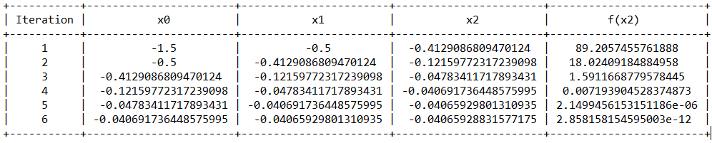

Graph:

