PROGRAMMING ASSIGNMENT

Submitted by: | Gavali Deshabhakt Nagnath
Roll No.: | 202CD005
Department: | Mathematics and Computational  Sciences
Specialization: | Computational and Data Science
Subject: | Big Data Analytics
Instructor: | Dr. Pushparaj Shetty
Submitted on: | 13/05/2021
Q1. Regression in python

A. Multivariate Linear Regression:

The linear regression models are of the form y = a + bx. As the given problem can have more than one indepedent variables i.e. x_{i}’s, the equation becoms

y = a₀ + a_{1*}x₁ + a_{2*}x₂ + .... + a_{n*}x_{n}

The following algorithm can be used for solving these type of problems.

Algorithm:

1. Import/define database
2. Take array of independent variables and dependent variable as input
3. create two variables corresponding to input array of independent variables:
Here we can use shape of input array to create 2 – variables of which the first one will be our sample size (i.e. rows in input array of independet variables) and second one i.e. columns will be our number of features.

4. Now we can use gradient descent approach to find out the multipliers/coefficients of our
regression equation
the formulas for gradient descent approach would be as follows

i. finding deriavative with respect to unknown coefficients
dw = (1 / n_samples) * np.dot(X.T, (y_predicted - y))

ii. Finding deravative with respect to unknown constant
db = (1 / n_samples) * np.sum(y_predicted - y)

iii. update coefficients and constant
self.weights -= self.lr * dw
self.bias -= self.lr * db

*here lr is learing rate which can be defined in program.

5. At the end of 4th step we will have our coefficients and constant and using this we can simply
predicted values as follows

y_approximated = np.dot(X, self.weights) + self.bias

Program:
import numpy as np
import matplotlib.pyplot as plt
import pandas as pd

class LinearRegression:
def __init__(self, learning_rate=0.001, n_iters=1000):
self.lr = learning_rate
self.n_iters = n_iters
self.weights = None
self.bias = None

def fit(self, X, y):
n_samples, n_features = X.shape

# init parameters
self.weights = np.zeros(n_features)
self.bias = 0

# gradient descent
for _ in range(self.n_iters):
y_predicted = np.dot(X, self.weights) + self.bias
# compute gradients
dw = (1 / n_samples) * np.dot(X.T, (y_predicted - y))
db = (1 / n_samples) * np.sum(y_predicted - y)

# update parameters
self.weights -= self.lr * dw
self.bias -= self.lr * db

def predict(self, X):
y_approximated = np.dot(X, self.weights) + self.bias
return y_approximated
def score(self,y,y_pred):
return np.mean((1-abs(y-y_pred)))

def visualize(self,x,y,y_pred):
plt.scatter(x,y,color='r')
plt.plot(x,y_pred,color='g')
plt.xlabel('X')
plt.ylabel('Y')
plt.title('Multivariate Linear Regression')
plt.show()

if __name__ == '__main__':
# Input Section
df = pd.DataFrame({
'x1' : [ 1.1, 1.3, 1.5, 2. , 2.2, 2.9, 3. , 3.2, 3.2, 3.7, 3.9, 4. , 4. , 4.1, 4.5, 4.9, 5.1, 5.3, 5.9, 6. , 6.8, 7.1, 7.9, 8.2, 8.7, 9. , 9.5, 9.6, 10.3, 10.5],
'x2' : [ 2.1, 2.3, 1.4, 2.5 , 2.9, 2., 3. , 3.2, 3.2, 3.7, 3.1, 4.2 , 4.6 , 4.3, 4.1, 4.7, 5.2, 5.4, 5.0, 6. , 6.6, 7.1, 7.9, 8.2, 5.7, 9. , 9.5, 9.6, 10.3, 10.5],
'y' : [ 1.1, 1.3, 1.5, 2. , 2.2, 2.9, 3. , 3.2, 3.2, 3.7, 3.9, 4. , 4. , 4.1, 4.5, 4.9, 5.1, 5.3, 5.9, 6. , 6.8, 7.1, 7.9, 8.2, 8.7, 9. , 9.5, 9.6, 10.3, 10.5]
})
# Linear Regression
le = LinearRegression()
x = df.iloc[:,:2].values
y = df.y.values
le.fit(x,y)

y_pred = le.predict(x)
for i in range(len(y)):
print(f'{y[i]} {y_pred[i]:10.5f}')

accuracy = le.score(y,y_pred)
print('\nAccuracy = ',accuracy)

# we cannot visualize resutls if number of independent variables are more than 1
if (len(x))==1:
le.visualize(x,y,y_pred)
Output:

1.1 1.53477
1.3 1.73530
1.5 1.50639
2.0 2.24194
2.2 2.52054
2.9 2.59776
3.0 3.04937
3.2 3.24990
3.2 3.24990
3.7 3.75121
3.9 3.63942
4.0 4.13008
4.0 4.28623
4.1 4.23034
4.5 4.39715
4.9 4.87628
5.1 5.19393
5.3 5.39445
5.9 5.60564
6.0 6.05725
6.8 6.78127
7.1 7.16014
7.9 7.96224
8.2 8.26303
8.7 7.59317
9.0 9.06513
9.5 9.56644
9.6 9.66671
10.3 10.36855
10.5 10.56907

Accuracy = 0.8312599035317786

B. Polynomial regression:

The equation of polynomial regression is as follows

y = a₀ + a₁*x + a₂*x² + ...... + a_{n}*x^{n}

This type of regression is useful when data is not linearly dependent. Here we get a curve fitting between our data points. Our ultimate goal in any regression problem is to minimize least squared error.
Let us consider a quadratic regression problem or polynomial regression problem with degree 2. For this problem our equation will be

y = a₀ + a₁*x + a₂*x²

Algorithm:
So, our least square error will be,

E = (1/N)*(∑(y - y_predict)²)
E = (1/N)*(∑(y - (a₀ + a₁*x + a₂*x²))²)
where,
N = Sample size/ number of data points
y = actual y (from database)
y_predict = y’s predicted using computed coefficients and constant

Now we to get normal equations we’ll differenting above equation with respect to unkown variables one by one.

differentiating w.r.t a₀:

dE/da₀ = -(2/N)*(∑(y - (a₀ + a₁*x + a₂*x²)))

simplifying above equation,

∑y = n*a₀ + a₁*∑x + a₂*∑x² --- (1)

similiarly by differenting with respect to a₁ and a₂ respectively we get,

∑x*y = a₀*∑x+ a₁*∑x² + a₂*∑x³ ---- (2)

∑x²*y = a₀*∑x²+ a₁*∑x³ + a₂*∑x⁴ ---- (3)

now we have 3 equationg with 3 unknows (i.e. a₀ , a₁ , a₂). We can solve above three equations using any method such as gauss elimiation or cramers rule, etc.
Writing aboe equation in matrix form,
Let A = Matrix of summations on RHS of above equation
b = Matrix of terms of LHS of above equation
X = Matrix of Unknows i.e. a₀ , a₁ , a₂

A = X = b =

Then,
X = A⁻¹*b
Thus, we’ll get our unknow coefficients and constant.
We can generalize this for a n-degree polynomial like, y = a₀ + a₁*x + a₂*x² + ...... + a_{n}*x^{n} .
The matrices for n-degree polynomial would be,

A = X = b =
Program:
import numpy as np
import matplotlib.pyplot as plt
import pandas as pd

class PolynomialRegression:
def __init__(self, learning_rate=0.001, n_iters=1000,degree=2):
self.lr = learning_rate
self.n_iters = n_iters
self.coefficients = None
self.degree = degree

def fit(self, x, y):

X_t = []
y_t = []
n = len(x)

X_t.append(n)
i = 1
while(True):
X_t.append(sum((x**i)))
if(i/2 == self.degree):
break
i += 1
y_t.append(sum(y))
for i in range(1,self.degree+1):
y_t.append(sum((x**i)*y))
A = np.zeros((self.degree+1,self.degree+1),dtype=float)
b = np.zeros((self.degree+1,1),dtype=float)

for i in range(self.degree+1):
k = i
for j in range(self.degree+1):
A[i,j] = X_t[k]
k +=1
for i in range(self.degree+1):
b[i,0] = y_t[i]

self.coefficients = np.matmul(np.linalg.inv(A),b)

def predict(self, X):
y_approximated = np.zeros(len(X))
for i in range(0,self.degree+1):
for j in range(len(X)):
y_approximated[j] += self.coefficients[i]*(X[j]**i)
return y_approximated
def score(self,y,y_pred):
accuracy = 0
for i in range(len(y)):
accuracy += abs(1-(y[i][0]-y_pred[i]))
return accuracy/len(y)
def visualize(self,x,y,y_pred):
plt.scatter(x,y,color='r')
plt.plot(x,y_pred,color='g')
plt.xlabel('X')
plt.ylabel('Y')
plt.title('Polynomial Regression')
plt.show()

if __name__ == '__main__':

# Input Section
# Polynomial Regression

df = pd.DataFrame({
'x' : [2, 5, 8, 11, 14, 17, 20, 23, 26, 29, 32, 35, 38, 41, 44, 47, 50, 53, 56, 59, 62, 65, 68, 71, 74, 77, 80, 83, 86, 89, 92, 95, 98, 101, 104, 107, 110, 113, 116, 119, 122, 125, 128, 131, 134, 137, 140, 143, 146, 149],
'y' : [5, 140, 455, 950, 1625, 2480, 3515, 4730, 6125, 7700, 9455, 11390, 13505, 15800, 18275, 20930, 23765, 26780, 29975, 33350, 36905, 40640, 44555, 48650, 52925, 57380, 62015, 66830, 71825, 77000, 82355, 87890, 93605, 99500, 105575, 111830, 118265, 124880, 131675, 138650, 145805, 153140, 160655, 168350, 176225, 184280, 192515, 200930, 209525, 218300]
})

le = PolynomialRegression()

x = df.x.values
x = x.reshape(len(x),1)
y = df.y.values
y = y.reshape(len(y),1)

le.fit(x,y)
y_pred = le.predict(x)

accuracy = le.score(y,y_pred)
print('\nAccuracy = ',accuracy)

le.visualize(x,y,y_pred)

Output:
5 5.00000
140 140.00000
455 455.00000
950 950.00000
1625 1625.00000
2480 2480.00000
3515 3515.00000
4730 4730.00000
6125 6125.00000
7700 7700.00000
9455 9455.00000
11390 11390.00000
13505 13505.00000
15800 15800.00000
18275 18275.00000
20930 20930.00000
23765 23765.00000
26780 26780.00000
29975 29975.00000
33350 33350.00000
36905 36905.00000
40640 40640.00000
44555 44555.00000
48650 48650.00000
52925 52925.00000
57380 57380.00000
62015 62015.00000
66830 66830.00000
71825 71825.00000
77000 77000.00000
82355 82355.00000
87890 87890.00000
93605 93605.00000
99500 99500.00000
105575 105575.00000
111830 111830.00000
118265 118265.00000
124880 124880.00000
131675 131675.00000
138650 138650.00000
145805 145805.00000
153140 153140.00000
160655 160655.00000
168350 168350.00000
176225 176225.00000
184280 184280.00000
192515 192515.00000
200930 200930.00000
209525 209525.00000
218300 218300.00000

Accuracy = 0.9999999999345164

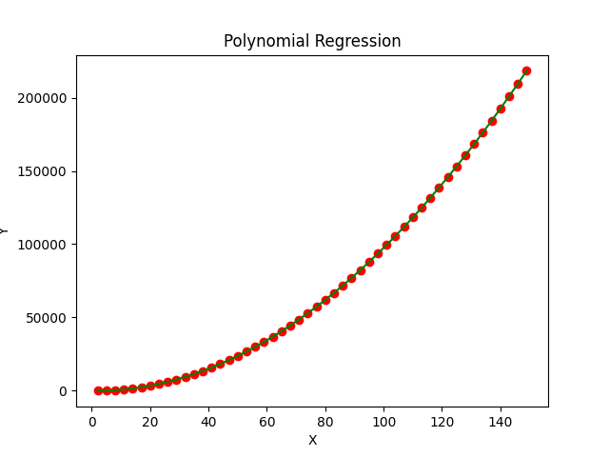

Here the curve perfectly fits with actual data because I’d generated data using libre excel. This is not always the case. In most scenario we’ll have some points off from the curve or in worst case there may not be any point on the curve. The main thing to note is that we are not drawing curve through given points, but we are drawing a curve which best fits given data points i.e. minimizing least square error.
2. K Means Clustering in python

Introduction:
Given a set of observations (x1, x2, ..., xn), where each observation is a d-dimensional real vector, k-means clustering aims to partition the n observations into k (≤ n) sets S = {S1, S2, ..., Sk} so as to minimize the within-cluster sum of squares (WCSS) (i.e. variance). Formally, the objective is to find:
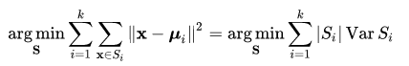

where μi is the mean of points in Si. This is equivalent to minimizing the pairwise squared deviations of points in the same cluster:
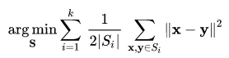
The equivalence can be deduced from identity,
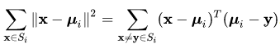

Because the total variance is constant, this is equivalent to maximizing the sum of squared deviations between points in different clusters (between-cluster sum of squares, BCSS), which follows from the law of total variance.

Algorithm:
The most common algorithm uses an iterative refinement technique. Due to its ubiquity, it is often called "the k-means algorithm"; it is also referred to as Lloyd's algorithm. It is sometimes also referred to as "naive k-means", because there exist much faster alternatives.

Given an initial set of k means m₁⁽¹⁾,...,m_{k}⁽¹⁾ (see below), the algorithm proceeds by alternating between two steps:

Assignment step:
Assign each observation to the cluster with the nearest mean: that with the least squared Euclidean distance. (Mathematically, this means partitioning the observations according to the Voronoi diagram generated by the means.)

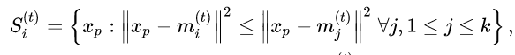

where each x_{p} is assigned to exactly one S_{(t)}, even if it could be assigned to two or more of them.

Update step:
Recalculate means (centroids) for observations assigned to each cluster.
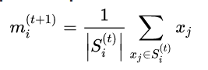

The algorithm has converged when the assignments no longer change. The algorithm is not guaranteed to find the optimum.
The algorithm is often presented as assigning objects to the nearest cluster by distance. Using a different distance function other than (squared) Euclidean distance may prevent the algorithm from converging. Various modifications of k-means such as spherical k-means and k-medoids have been proposed to allow using other distance measures. Initialization of centroids is mostly done using random points.

Program:
import numpy as np
import pandas as pd
from matplotlib import cm
import matplotlib.pyplot as plt
import copy

class KMeansClustering:
colormap = {}
centroids = {}
df = pd.DataFrame()
labels = {}
number_of_clusters = None
lower_bound = None
upper_bound = None

# Constructor
def __init__(self,K,dataframe,seed=None):
if(seed!=None):
np.random.seed(seed)

self.number_of_clusters = K
self.df = dataframe
self.df['color'] = 'k'

# Creating Color map using Set1 colormap format
for i in range(self.number_of_clusters):
color = cm.Set1(np.random.randint(0,10))
self.colormap[i+1] = color
self.labels[color] = 'Cluster ' + str(i+1)

# offseting lower_bound and upper_bound by offset in order to increase range from finding random centroids
offset = 20

# finding lower_bound and upper_bound from database
self.lower_bound = min(self.df.iloc[:,0].min(),self.df.iloc[:,1].min()) - offset
self.upper_bound = max(self.df.iloc[:,0].max(),self.df.iloc[:,1].max()) + offset

# Generating random centroids
for i in range(self.number_of_clusters):
x = np.random.randint(self.lower_bound, self.upper_bound)
y = np.random.randint(self.lower_bound, self.upper_bound)
self.centroids[i+1] = [x,y]

# Function for assigning clusters/centroids
def assigning_clusters(self):
for i in self.centroids.keys():

# Finding distance of points from ith centroid
self.df[f'distance_from_{i}'] = (np.sqrt(
((self.df.iloc[:,0] - self.centroids[i][0]) ** 2) +
((self.df.iloc[:,1] - self.centroids[i][1]) ** 2))
)
# Assigning Centroids to clusters
centroid_distance_cols = [f'distance_from_{i}' for i in self.centroids.keys()]
self.df['closest'] = self.df.loc[:, centroid_distance_cols].idxmin(axis=1).apply(lambda x: int(x[-1]))
self.df['color'] = self.df['closest'].map(lambda x: self.colormap[x])
return self.df

# Function for updating centroids
def updatingCentroids(self):
old_centroids = copy.deepcopy(self.centroids)

for i in self.centroids.keys():
self.centroids[i][0] = np.mean(self.df[self.df['closest'] == i].iloc[:,0])
self.centroids[i][1] = np.mean(self.df[self.df['closest'] == i].iloc[:,1])

return old_centroids,self.centroids

# function for visualizing cluster
def visualize(self):
plt.scatter(self.df.iloc[:,0], self.df.iloc[:,1], color=self.df['color'], alpha=0.8)
for i in self.centroids.keys():
plt.scatter(*self.centroids[i], color=self.colormap[i], label = self.labels[self.colormap[i]], marker='x')
plt.xlim(self.lower_bound, self.upper_bound)
plt.ylim(self.lower_bound, self.upper_bound)
plt.legend()
plt.title('Cluster Visualization')
plt.show()

# Plotting updated cluster
def plot_updation(self,old_centroids,iteration):
plt.figure(figsize=(5, 5))
ax = plt.axes()

# Plotting data points
plt.scatter(self.df.iloc[:,0], self.df.iloc[:,1], color=self.df['color'], alpha=0.8)

# Plotting centroids
for i in self.centroids.keys():
plt.scatter(*self.centroids[i], color=self.colormap[i],label=self.labels[self.colormap[i]], marker='x')

plt.xlim(self.lower_bound, self.upper_bound)
plt.ylim(self.lower_bound, self.upper_bound)

# Plotting arrow in direction of centroid movement
for i in old_centroids.keys():
old_x = old_centroids[i][0]
old_y = old_centroids[i][1]

scaling_difference_between_distance_of_old_and_new_centroids = 0.75

dx = (self.centroids[i][0] - old_centroids[i][0]) * scaling_difference_between_distance_of_old_and_new_centroids
dy = (self.centroids[i][1] - old_centroids[i][1]) * scaling_difference_between_distance_of_old_and_new_centroids
ax.arrow(old_x, old_y, dx, dy, head_width=2, head_length=3, fc=self.colormap[i], ec=self.colormap[i])
plt.title(f'Iteration = {iteration}')
plt.legend()
plt.show()

# Main Function For execution of Kmeans clustering
def kmc_predict(self,plot=False):
if(plot):
self.visualize()
self.df = self.assigning_clusters()
iteration = 0
while True:
iteration += 1
closest_centroids = self.df['closest'].copy(deep=True)
self.df = self.assigning_clusters()

old_centroids,self.centroids = self.updatingCentroids()
if(plot):
print(f'Iteration = {iteration}')
self.plot_updation(old_centroids,iteration)

if closest_centroids.equals(self.df['closest']):
if plot:
self.visualize()
return self.df['closest'].values

# Input Section
df = pd.DataFrame({
'x': [12, 20, 28, 18, 29, 33, 24, 45, 45, 52, 51, 52, 55, 23, 55, 61, 64, 69, 72],
'y': [39, 36, 30, 52, 54, 46, 55, 59, 63, 70, 66, 63, 58, 23, 14, 8, 19, 7, 24]
})

seed = 200 # for generating random numbers
number_of_clusters = 3
show_graphs = True

knn = KMeansClustering(number_of_clusters,df,seed)
predicted_clusters = knn.kmc_predict(show_graphs)
print('Clusters ',predicted_clusters)

Output:
# Visualizing Cluster Before Assignment
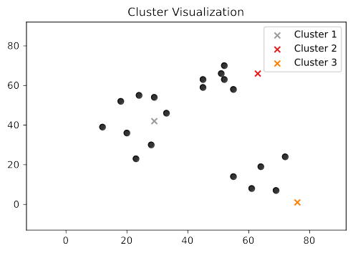

Iteration = 1
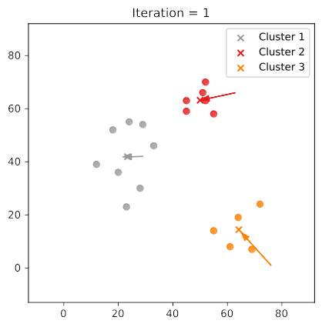
# Arrow shows direction of cluster movement
#Clusters after applying clustering algoritm (we can see proper separation of 3 clusters from our database)

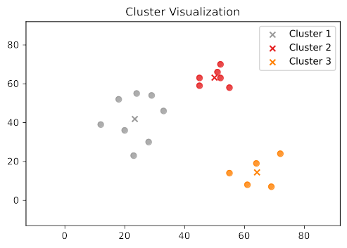
#This array shows clusters assigned to each row

Clusters [1 1 1 1 1 1 1 2 2 2 2 2 2 1 3 3 3 3 3]

