**REQUIREMENTS:**

**Objective:**

To develop a software application system for the online pizza shop. The application provides different services to their customers. The services can be of selecting a type of pizza, placing an order, making payment through online and receiving acknowledgement from the system.

Each customer can create his own account for fast deliveries and he may get some coupons if he is regular customer.

**FUNCTIONAL REQUIREMENTS:**

* Customers must be able to see our menu for ordering a pizza(like what type of pizza we will offer.
* Customer must be able to choose pizza type.(type of crust,cheese,etc)
* Customer must be able to pick the size of a pizza.(large, small, big).
* Customers must be able to know what ingredients are there in the pizza.(useful allergic people.
* Customers must be able to pay bill through 3 different types( credit,debit,pay on delivery.)
* Customers can be able to order pizza as by creating his membership or as guest user.
* The application must show different **locations** of the pizza shop and it should be able to provide a nearest pizza shop center for the customers’ by taking the details of the customer.
* The application must be able to show the **contact information** of the shop.

**NON FUNCTIONAL REQUIREMENTS:**

* When the application is in offline all the customers’ data should be encrypted without any loss of information.
* If the application is updated then it should not disturb the data of the user.
* The color used in the application should represent the company features and user should not disturbed with these features.
* If there any security issues it should be resloved very fastly for that we have to track the system performance.
* We have to see that system is in reliable condition or not.
* The application should work in any kind of platform.
* Customers data should be secure.

**SOFTWARE REQUIREMENTS:**

* Operating system: windows XP/vista/7 or higher version, Linux OS, Mac OS that supports networking.
* Net Beans IDE 8.0
* JAVA coding
* Web browsers: Google chrome, Mozilla Firefox, Internet Explorer.
* MySQL DBMS.

**HARDWARE REQUIREMENTS:**

Microsoft Windows XP/ vista/7 or higher version:

* Processor: Min. 800MHz Intel Pentium 3 or higher,
* Memory: 512 MB RAM
* Disk space: 750 MB of free disk space.

Linux OS:

* Processor: Min. 800MHz Intel Pentium 3 or higher,
* Memory: 512 MB RAM
* Disk space: 650 MB of free disk space.

**SCENARIOS:**

**1)**

**Scenario name** : login

**Participating actor**:Raj: customer

**Flow of events**:1. Raj activates the “Customer Registration” function of the . system by clicking on the SIGN UP button.

2. He enters his personal information to register and login.

3. The system opens the login page by showing user name and password.

4. The user enters his username and password.

5. The system validates the above username and password if the

user enters any other details then it will show the error

otherwise it will open the customer’s home page.

2)

**Scenario name** :Ordering a pizza

**Participating Actor**  :Raj:Customer

**Flow of events** : 1.Raj enters in to the system home page.

2.Home page displays the ordering menu.and raj enters his type of toppings and type of crust and he press the next button in the display.

3.the system displays the checkout as guest or login option.

4.Raj has already account in our system so he login in to the system.

5. raj enters his user name and password and login in to the system.

6.raj checkout by choosing pay on delivery and enters his delivery address.

7.Raj gets acknowledgment from the system that delivery has placed and estimated time.

3)

**Scenario name**: Updating information of the user.

**Participating Actor**:Admin:Sam,Customer:Raj

**Flow of events**:1.Raj enters into the system and login to his account.

2.Raj click the update password and update his password and logout.

3.sam enter the system as admin.

4.sam enters the updated information in database and send the acknowledgment to raj.

5.The home page of Raj shows your password is updated.

USE CASE DIAGRAM:

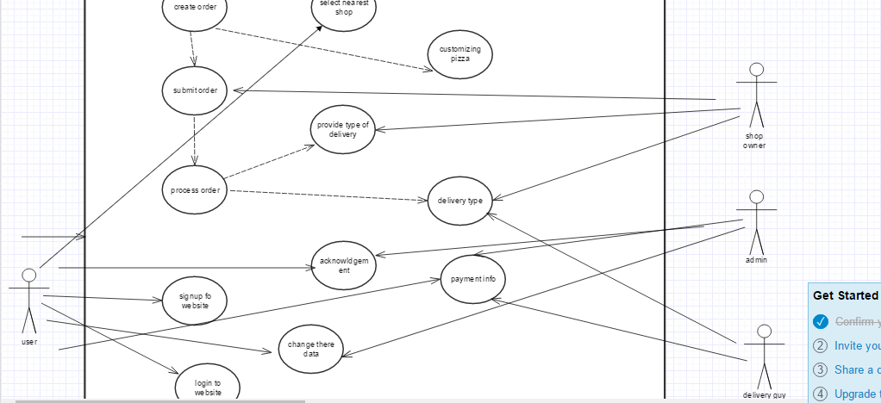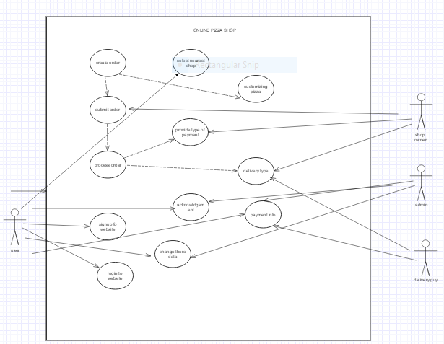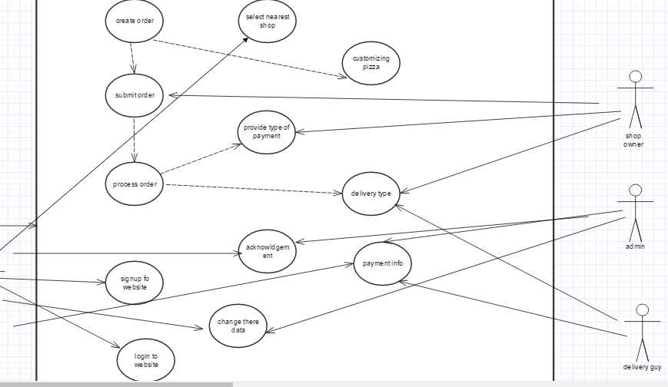

* The above is use case diagram for online pizza order system.
* Where it consists of four actors Customer,Pizza shop,Delivery boy,Admin.
* The things that are in the oval shapes are use cases which are related to each other in the system.
* Where create order use case which includes the customizing pizza and it also include to submit order.Which that again included to processing the order.
* Every actor should be keep on the outside of the system,and every actor should be related to any one of the use case in the system.

USE CASE:

**Use case name** :Ordering a pizza.

**Participating actors**:User:Raj,shop owner:ana,Delivery guy:san.

**Flow of events**:1)raj enters the website and click the order now button.

2)Raj customized his own pizza by selecting toppings and size of the crust and he enters next.

3)raj navigates to login page were he has to login with his own details and he pays the money for his order.

4)the order placed acknowledgement went to the Raj that hisorder has placed.In the same time nearest shop owner receives the order of Raj.

5)if the order was finished the delvery guy takes the pizza and went out for the delivery.

**Entry condition:**Raj enters the website.

**Exit condition**:Order was take by the delivery guy.

**Quality:**The customer should get acknowledgment in 10 seconds.