

GILDART HAASE SCHOOL OF COMPUTER SCIENCES AND ENGINEERING

University College: Arts – Sciences – Professional Studies

Fairleigh Dickinson University

__________________________________________________________

*Student’s Name: Professor:*

Desham,RajeshReddy (1682826) *Alex Rudniy,Ph.D* **LastName, First Name(Student I.D)**

**CSCI 6830_81**

**Big Data Analytics with Hadoop and R**

**SPRING 2016**

Assignment-1

STEP1:

Establishing vpn connection to fdu by using Cisco any Connect

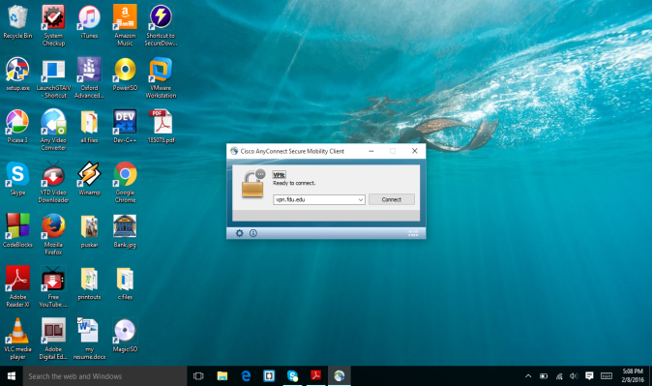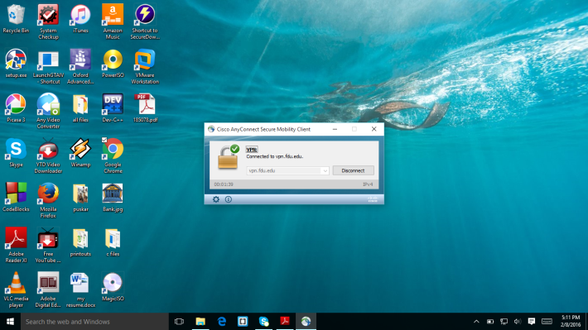

Above screenshort says that I am connected to vpn.fdu.edu

STEP2:

Homepage of Ambari FDUCluster, this screen was appeared after I log into the cluster.

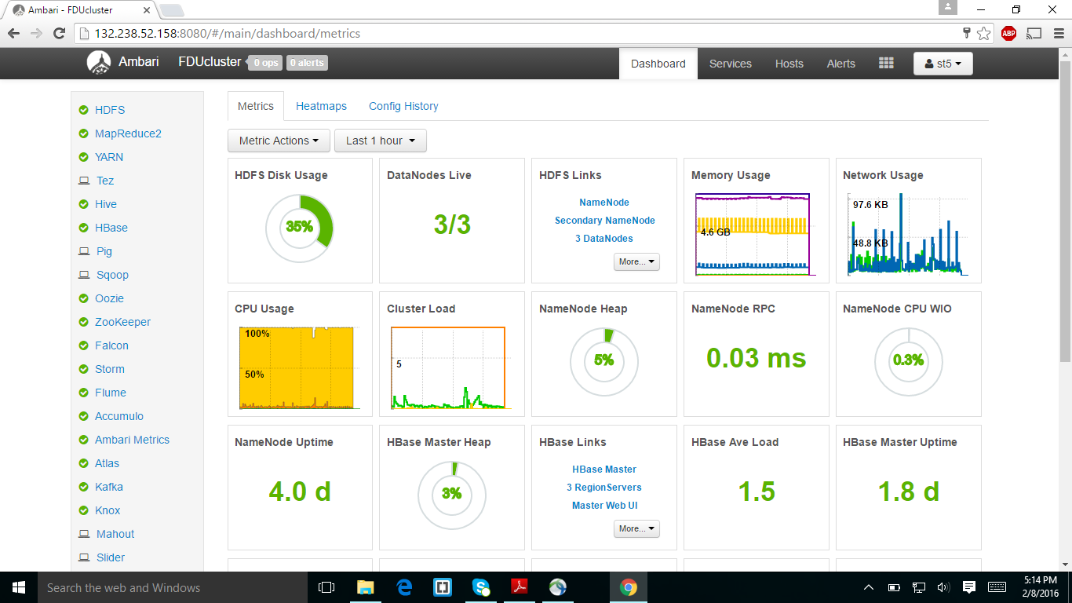

STEP3:

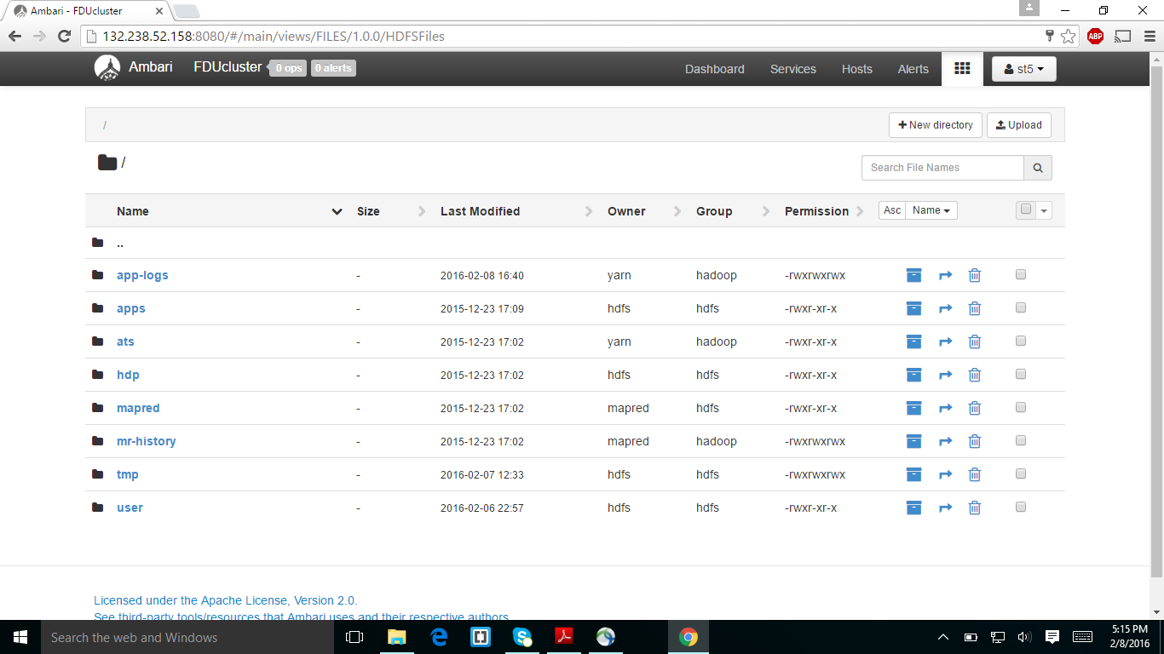

The above screen was the hadoop distribution file system(HDFS) page which it consists of different folders.

STEP4:

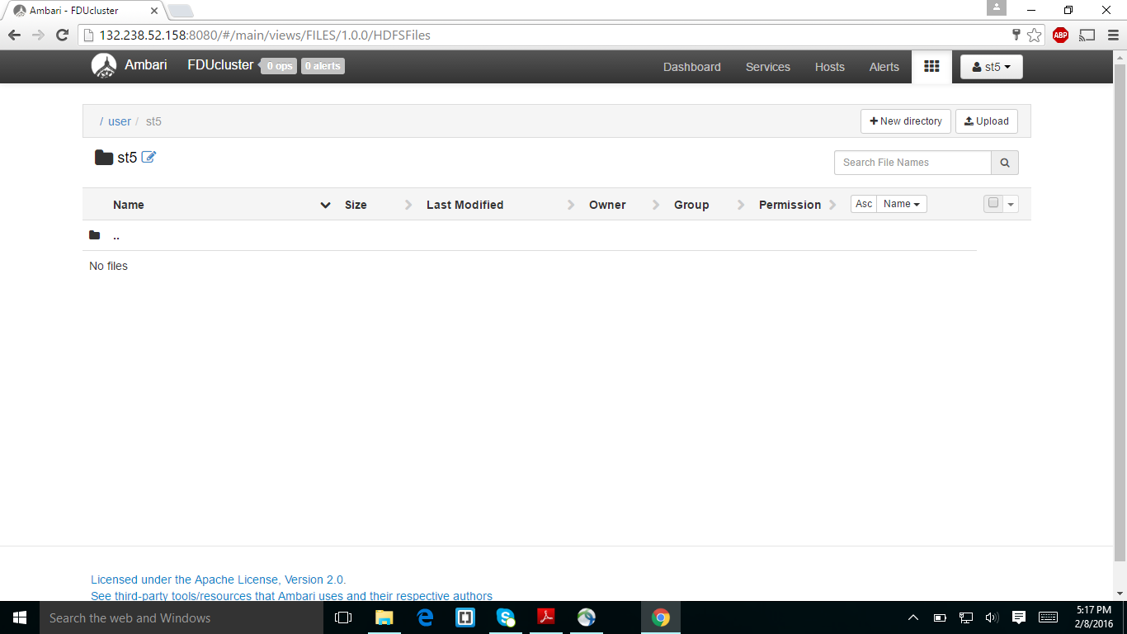

The above screen short is of my folder (st5) where it says no files.

STEP5:

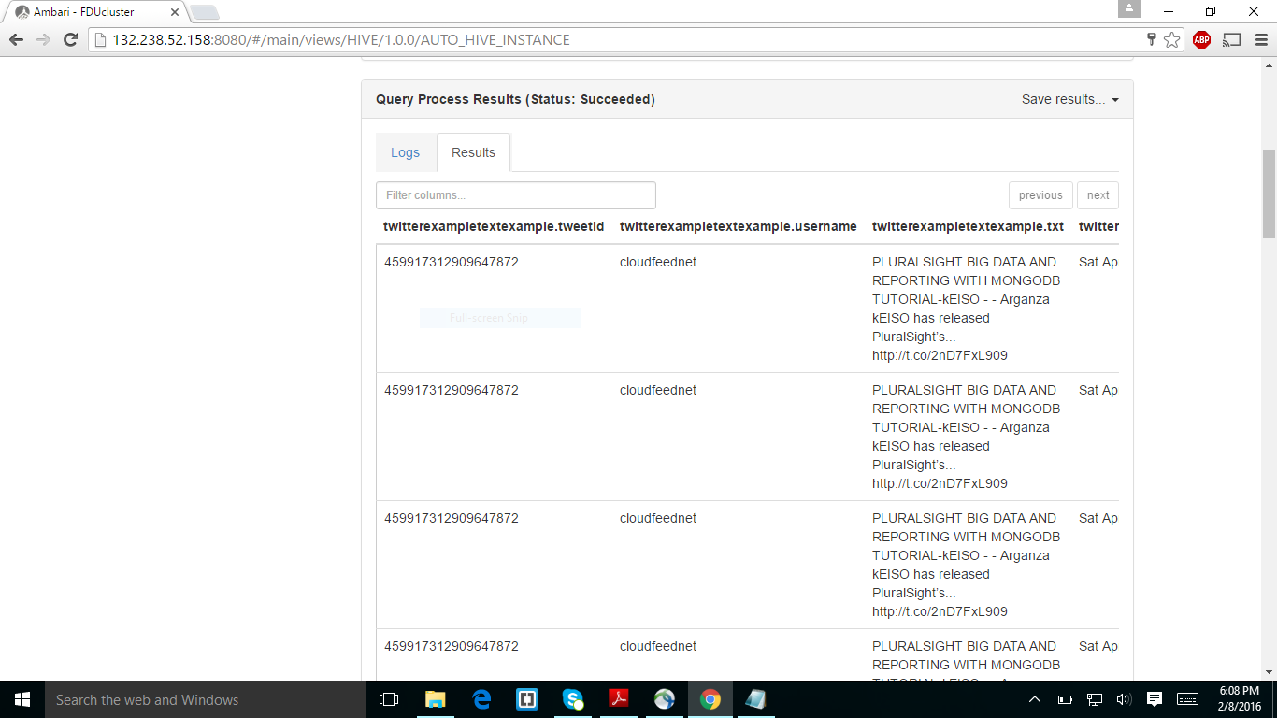

Before appearing of this screen I created the twitterexampletextexample table and the above screenshot was I displayed the screen.

STEP6:

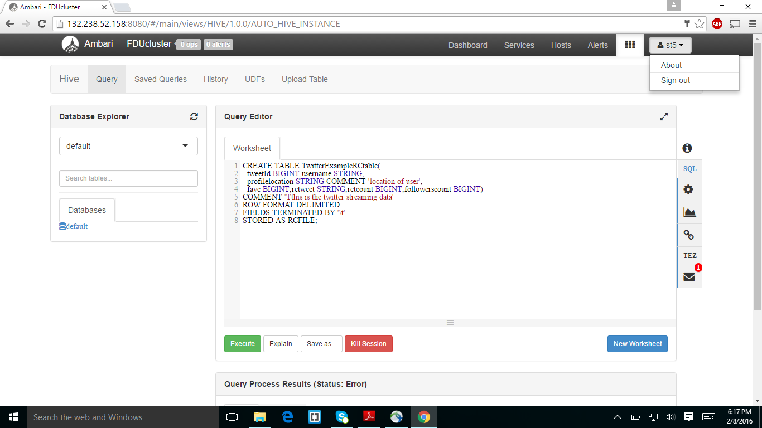

The above screenshot was I created the table of twitter example RC table.

The above screenshot is I am overwriting the twitterExampletextExample with twitterexampleRCtable

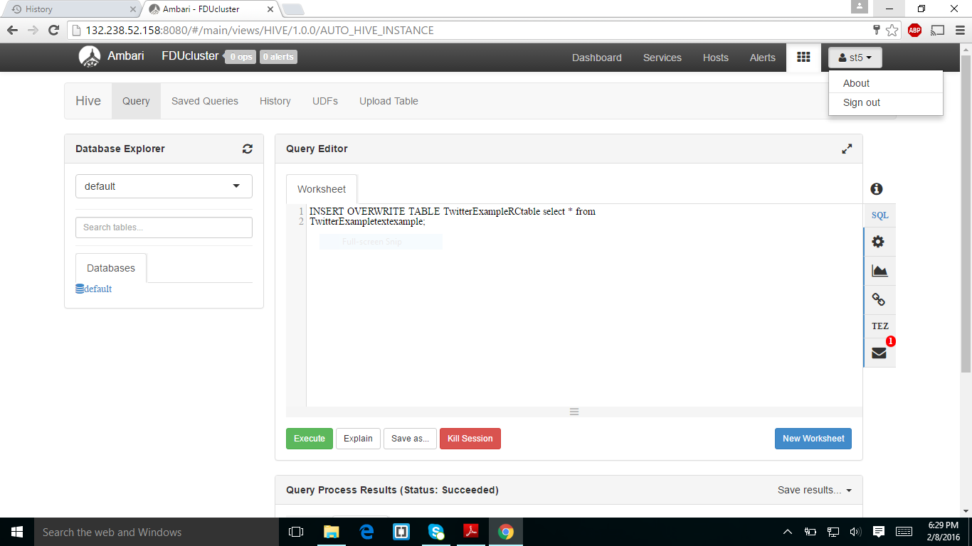

STEP8:

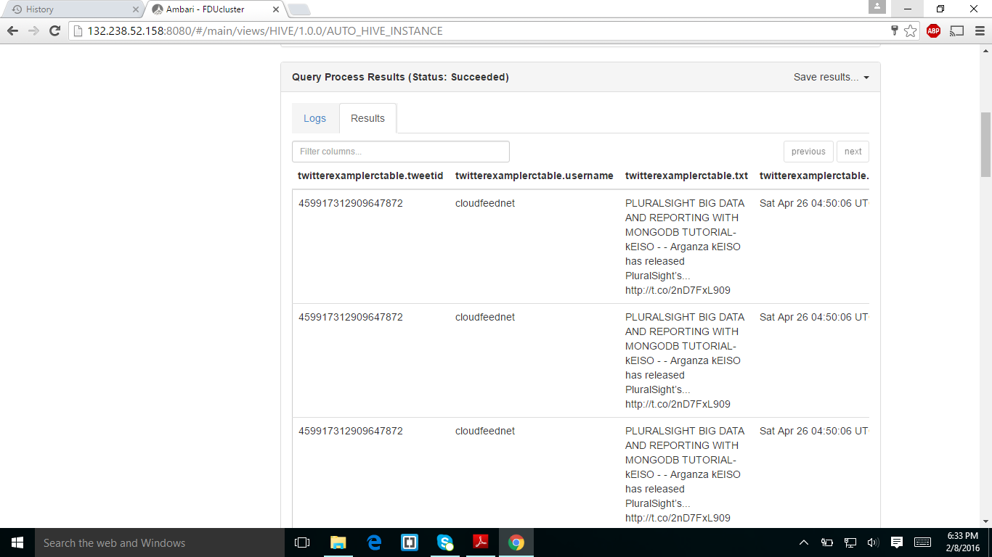

The above screen shot is twitterExampleRCtable

STEP9:

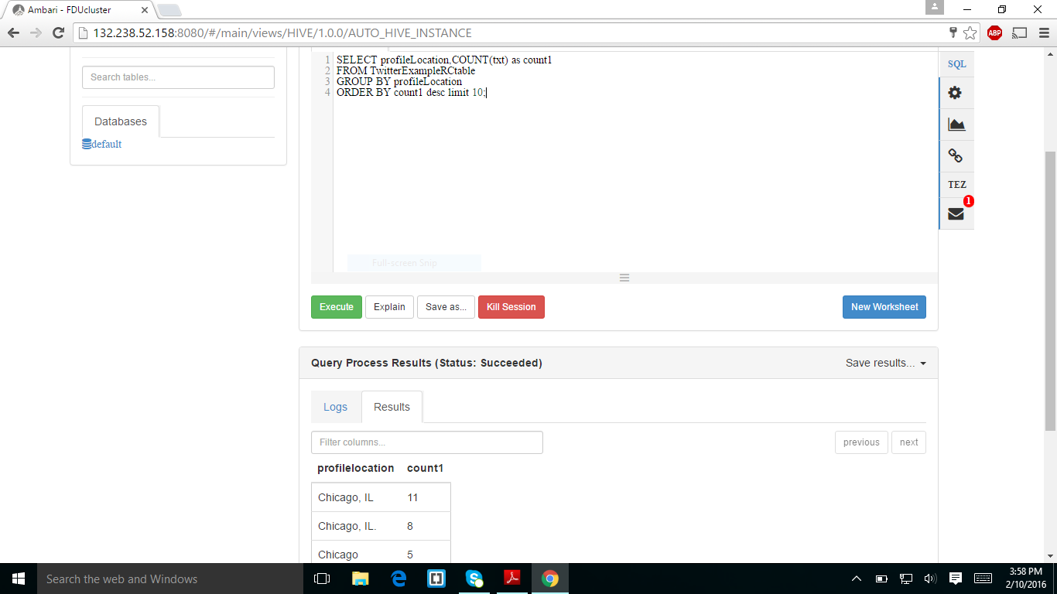

This screen shot was taken after running an analytical query it checks the number of records per location.

STEP10:

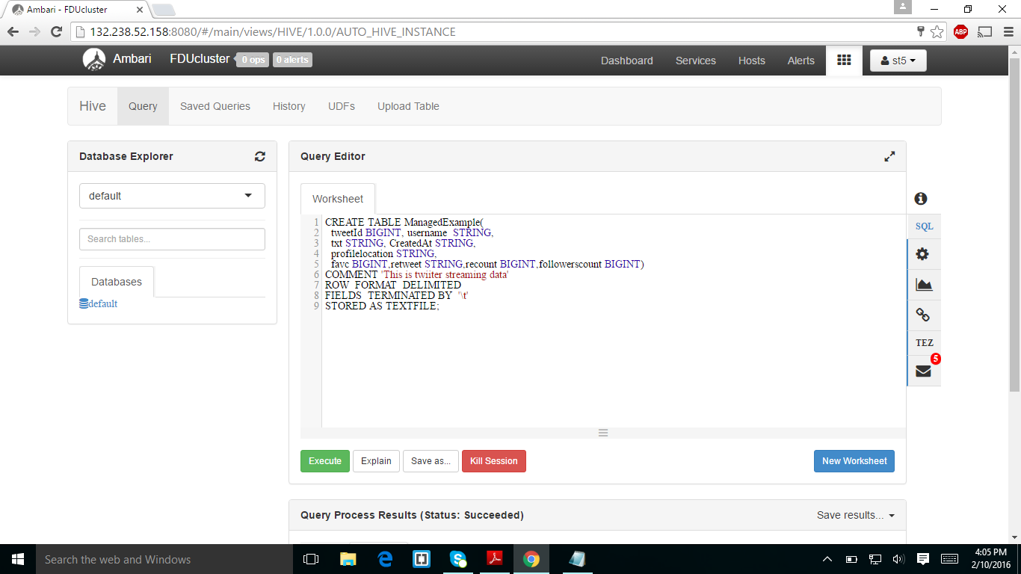

The above screenshot was I created the managed example table.

STEP11:

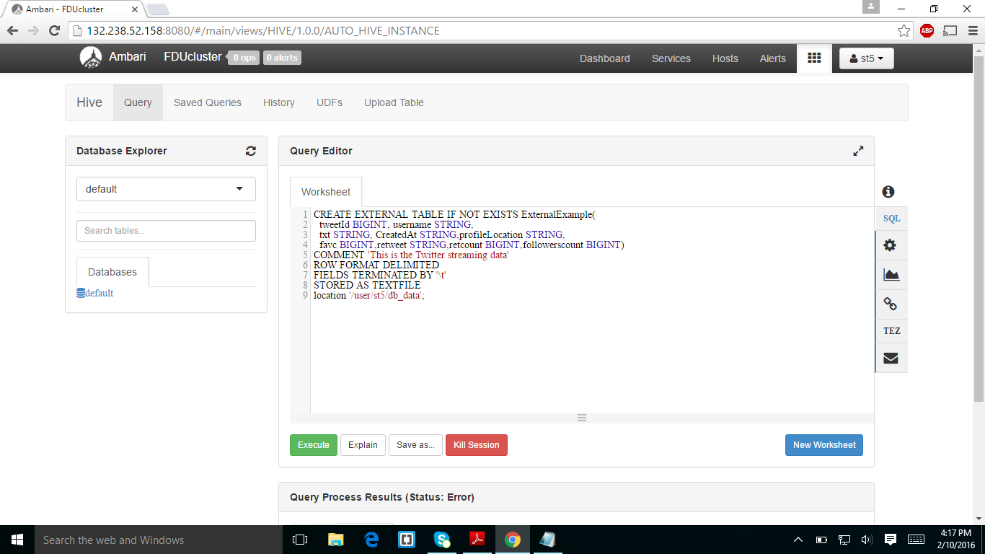

The above screenshot was I created the externalexample table.

STEP12:

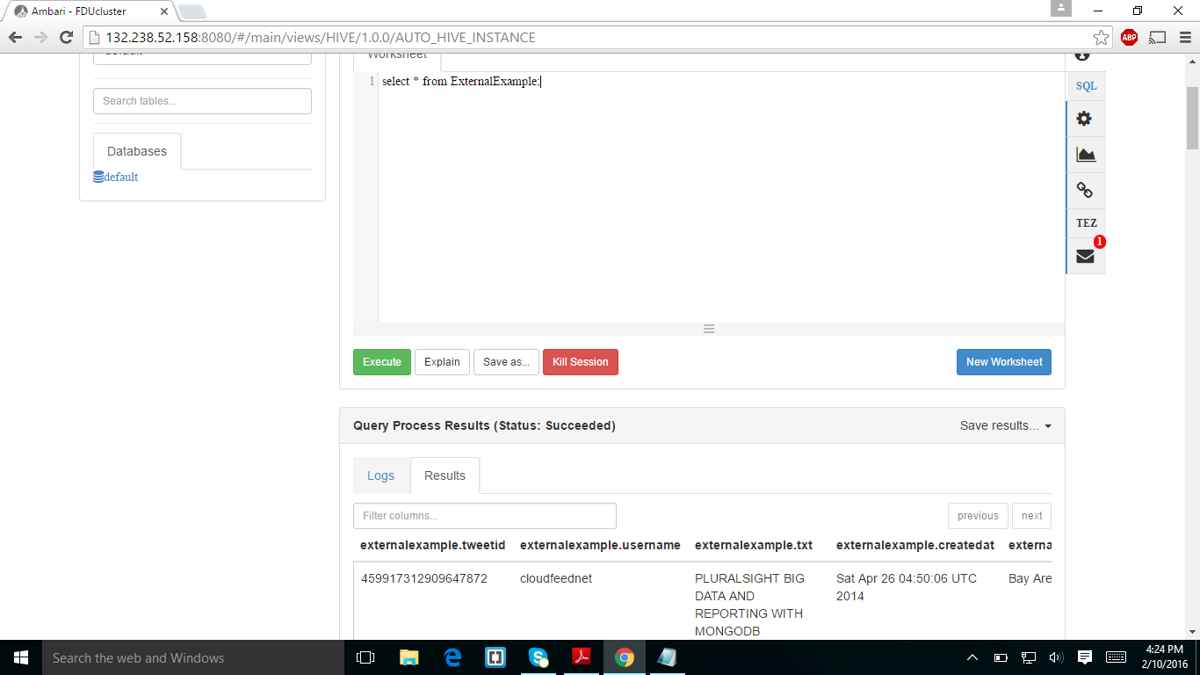

The above screen is display of external example table

STEP13:

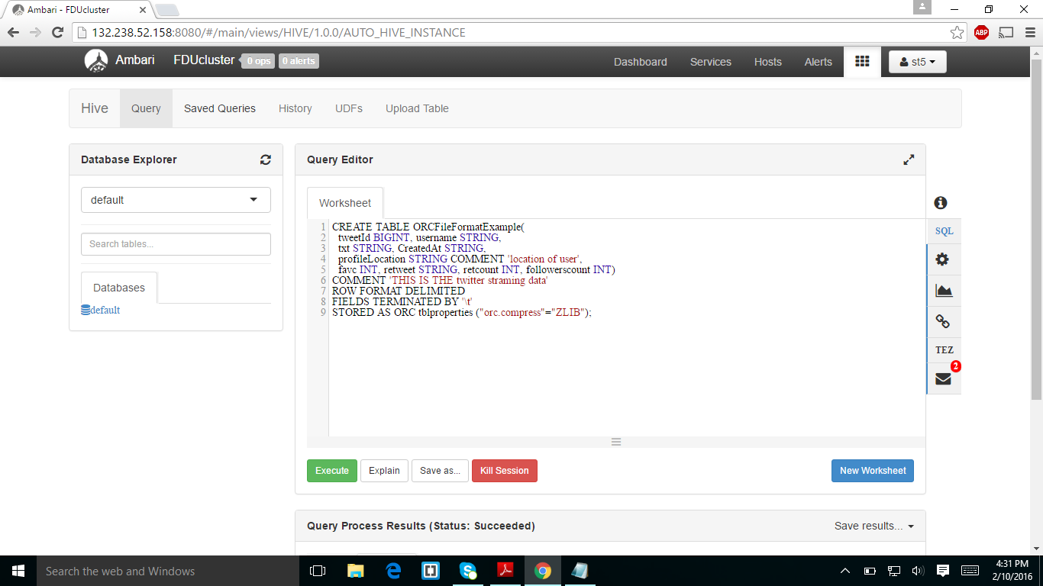

The above screenshot was I created a ORCFIle formatExample

STEP14:

I CREATED A TABLE OF PARTITIONED example.

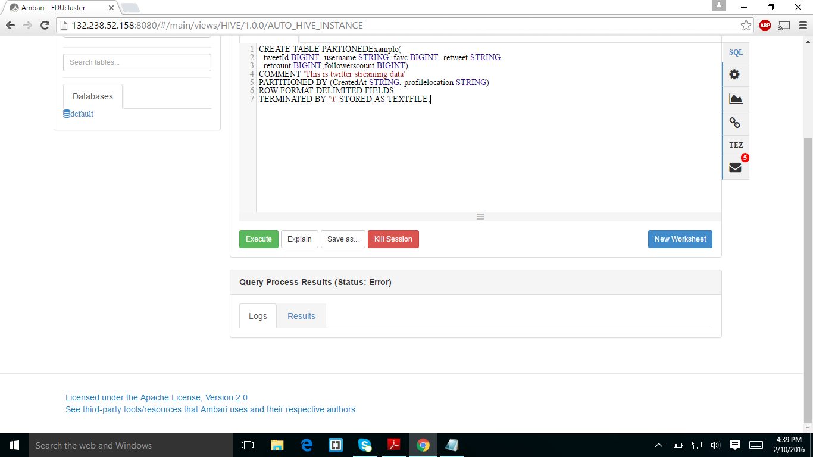

STEP15:

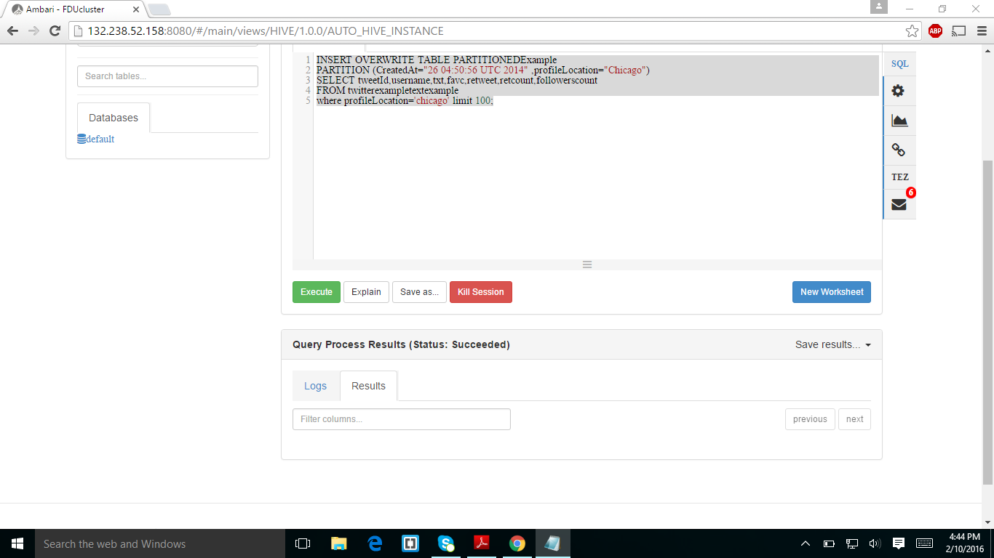

In the above screenshot I am overwriting the partitioned table.

STEP16:

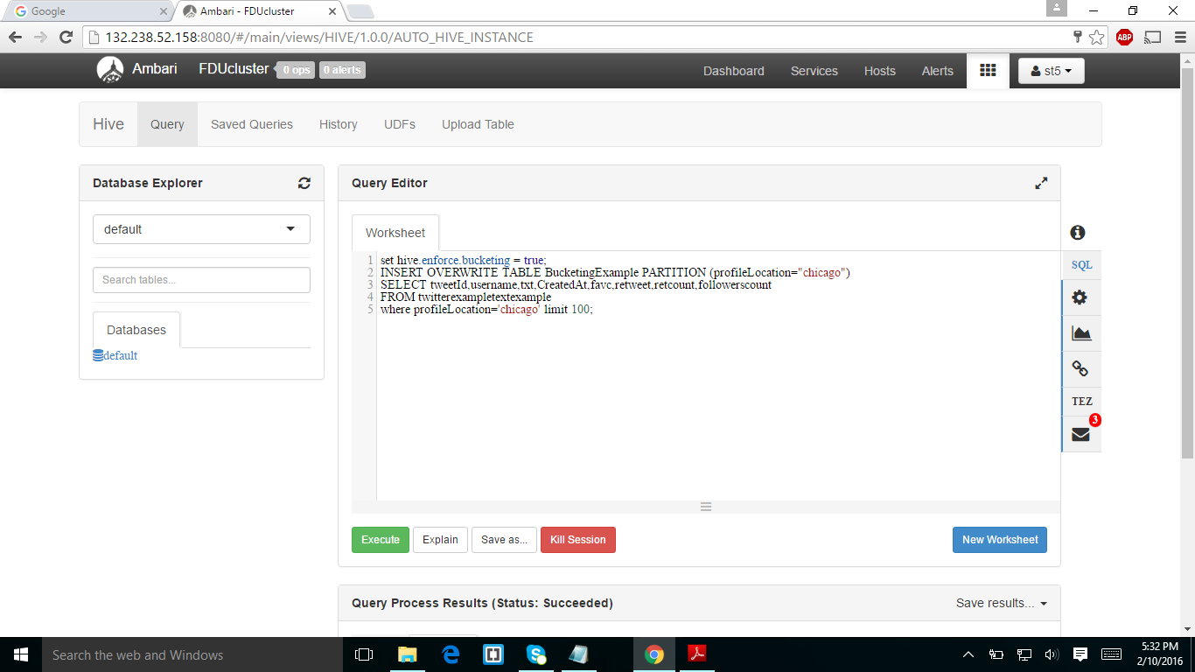

I created a bucketing example and with the above screenshot I am loading the data into bucketing example.

STEP17:

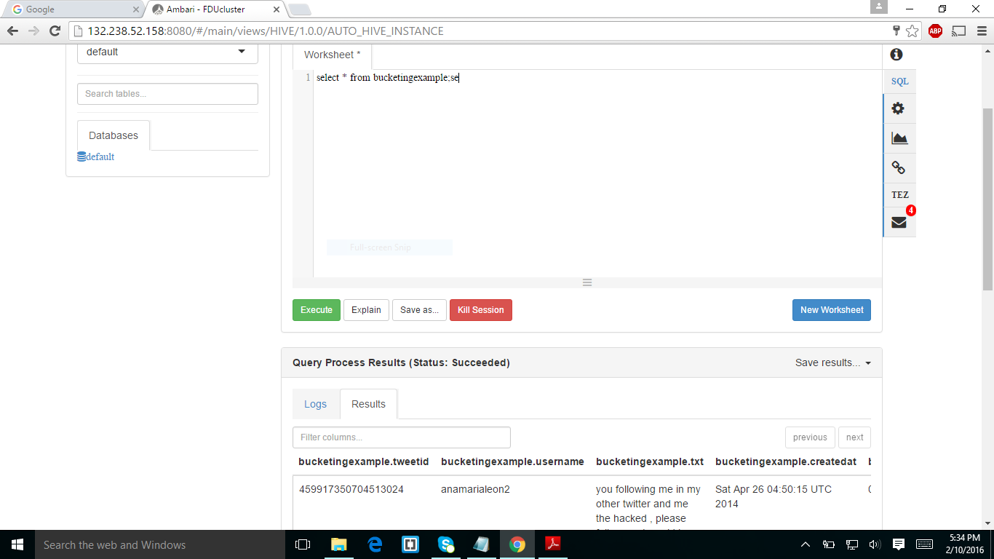

Showing the data of bucketing example.