

GILDART HAASE SCHOOL OF COMPUTER SCIENCES AND ENGINEERING

University College: Arts – Sciences – Professional Studies

Fairleigh Dickinson University

__________________________________________________________

*Student’s Name: Professor:*

Desham,RajeshReddy (1682826) *Alex Rudniy,Ph.D* **LastName, First Name(Student I.D)**

**CSCI 6885_81**

**Big Data Analytics with Hadoop and R**

**SPRING 2016**

Assignment-2

**STEP1:**

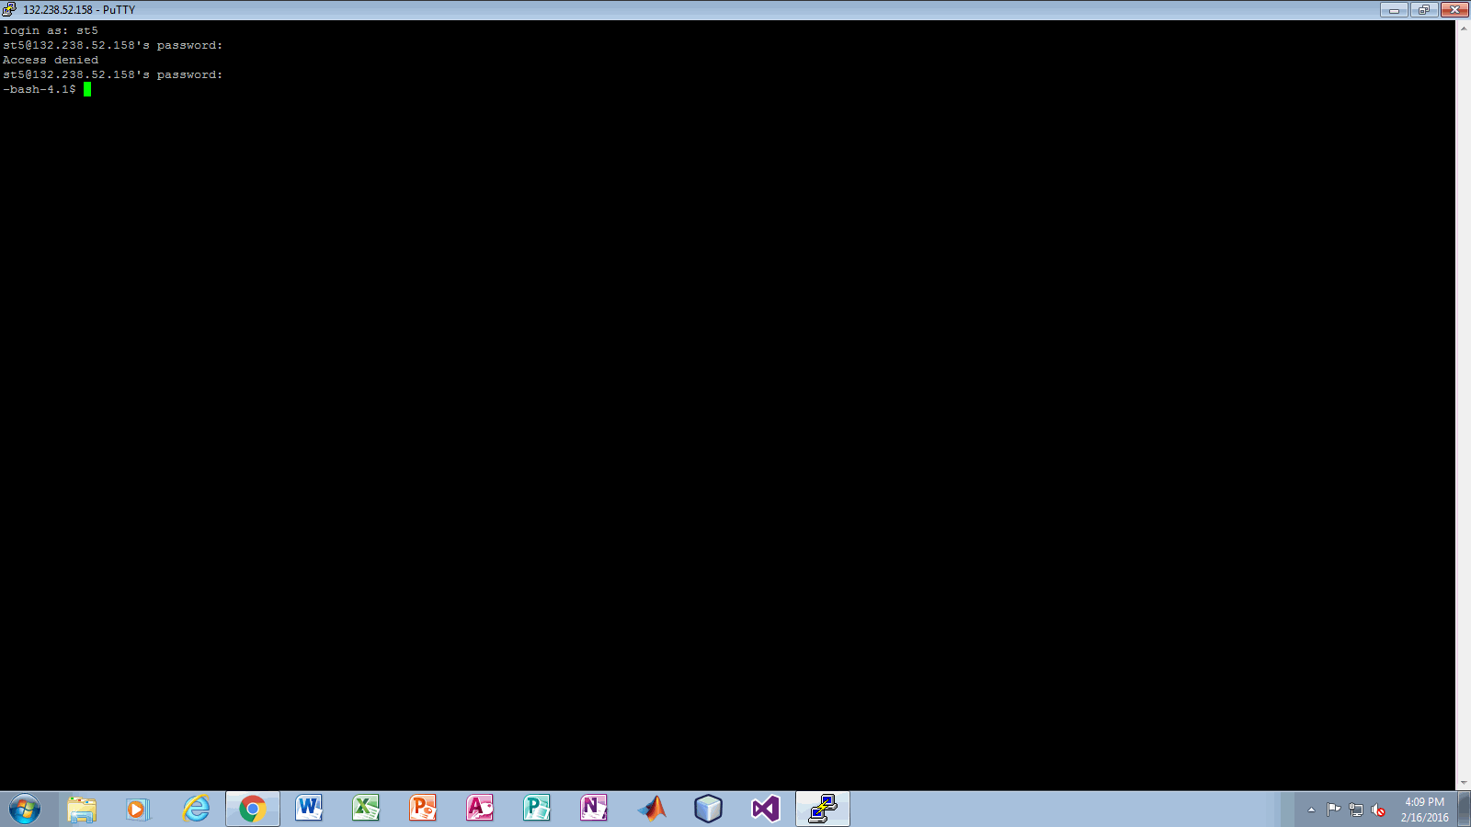

* I connected to bash using my username and password by using putty.

**Step2:**

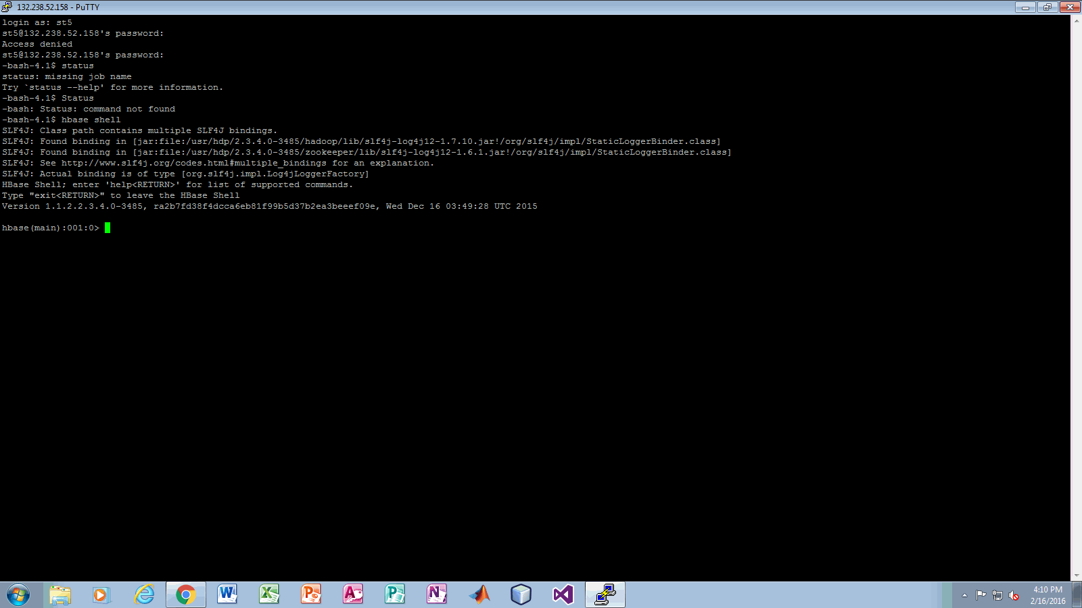

* I connected to hbase by using command(hbase shell).

**STEP3:**

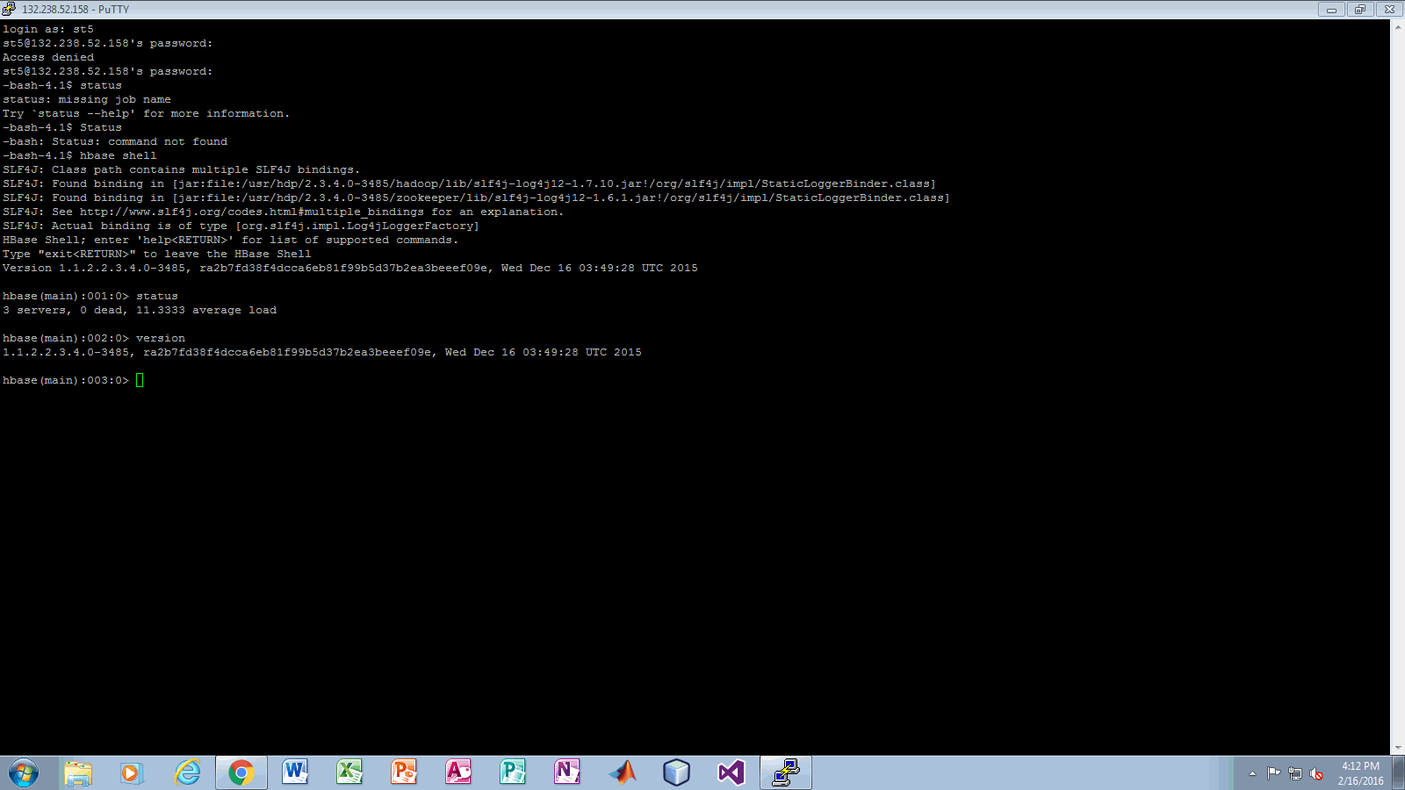

* I checked the status of hbase and version of hbase and it says 3 servers in status.

**STEP4:**

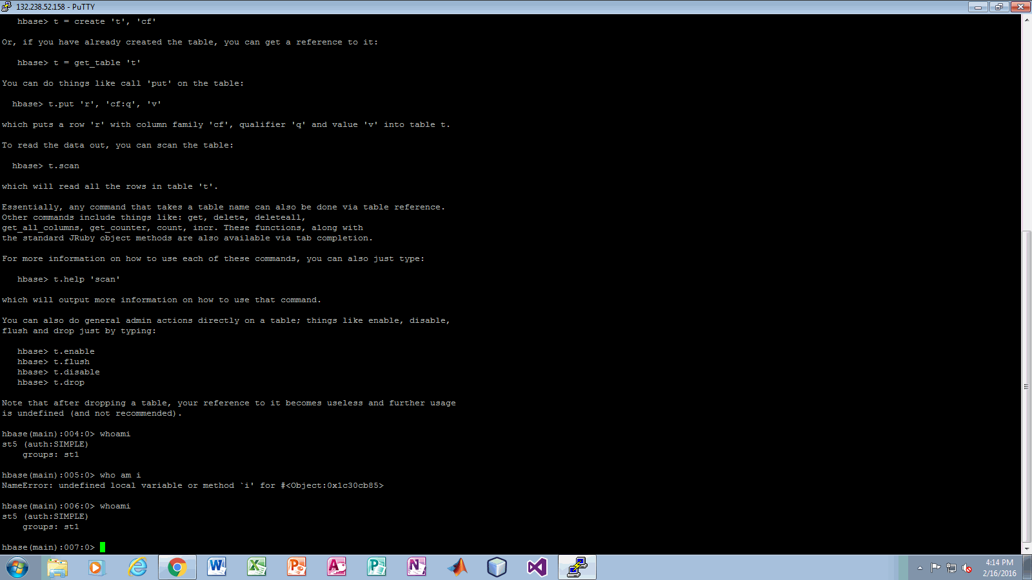

* In the above screen shot I had run two commands one is table_help which shows help menu and I run whoami command which shows st5my username and groups st1.

**STEP5:**

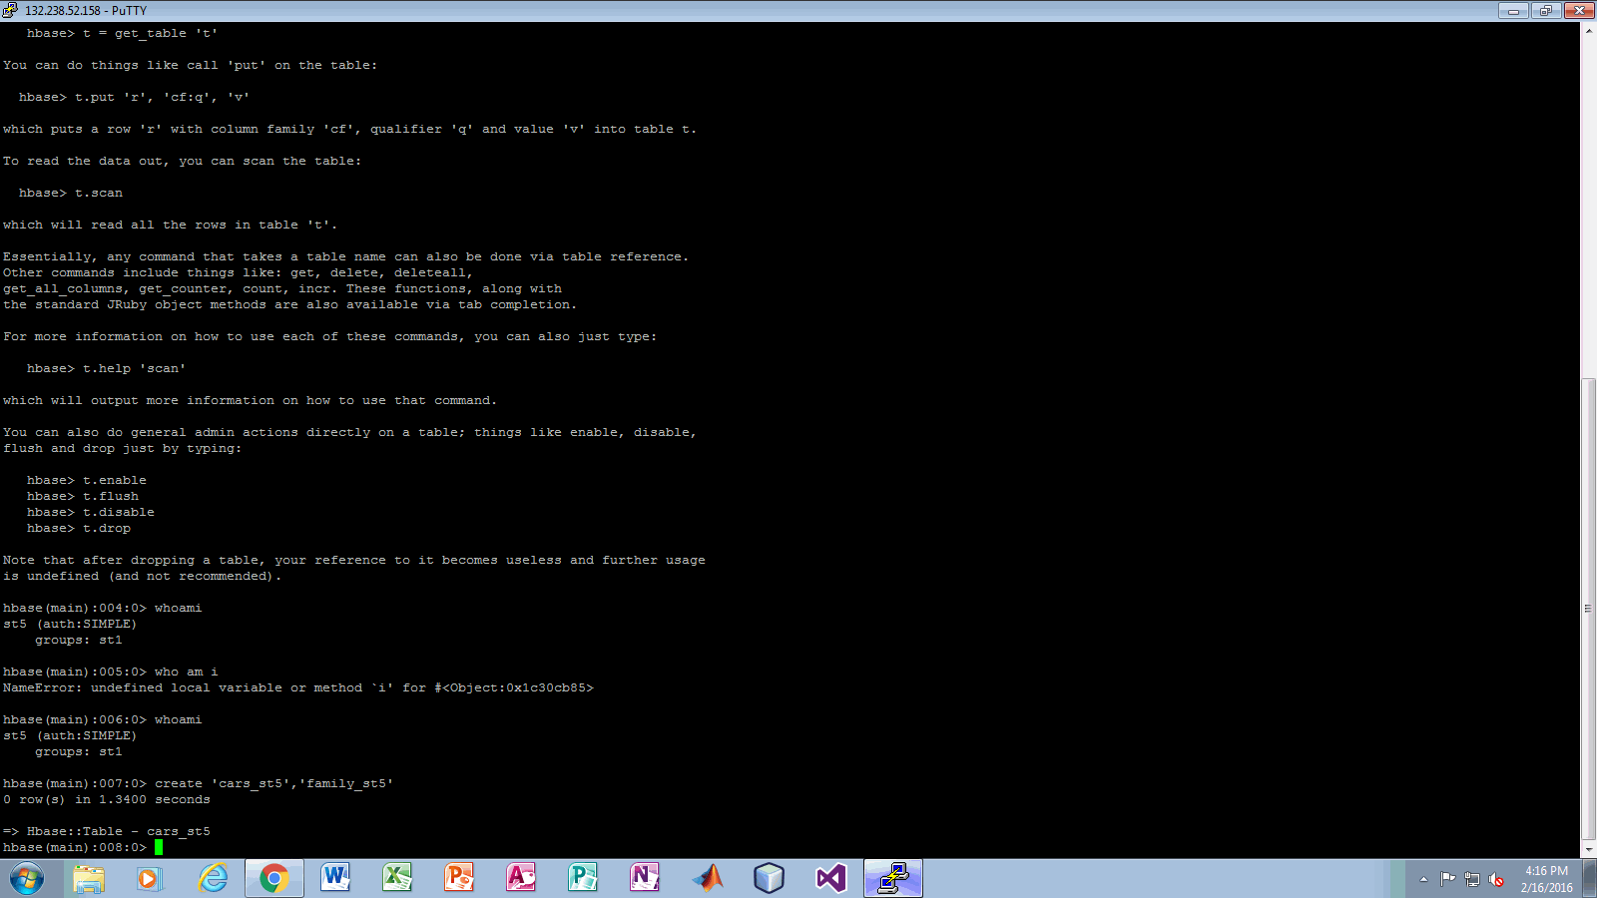

In the above screen shot I created cars_st5 table with single column family st5.

**STEP6:**

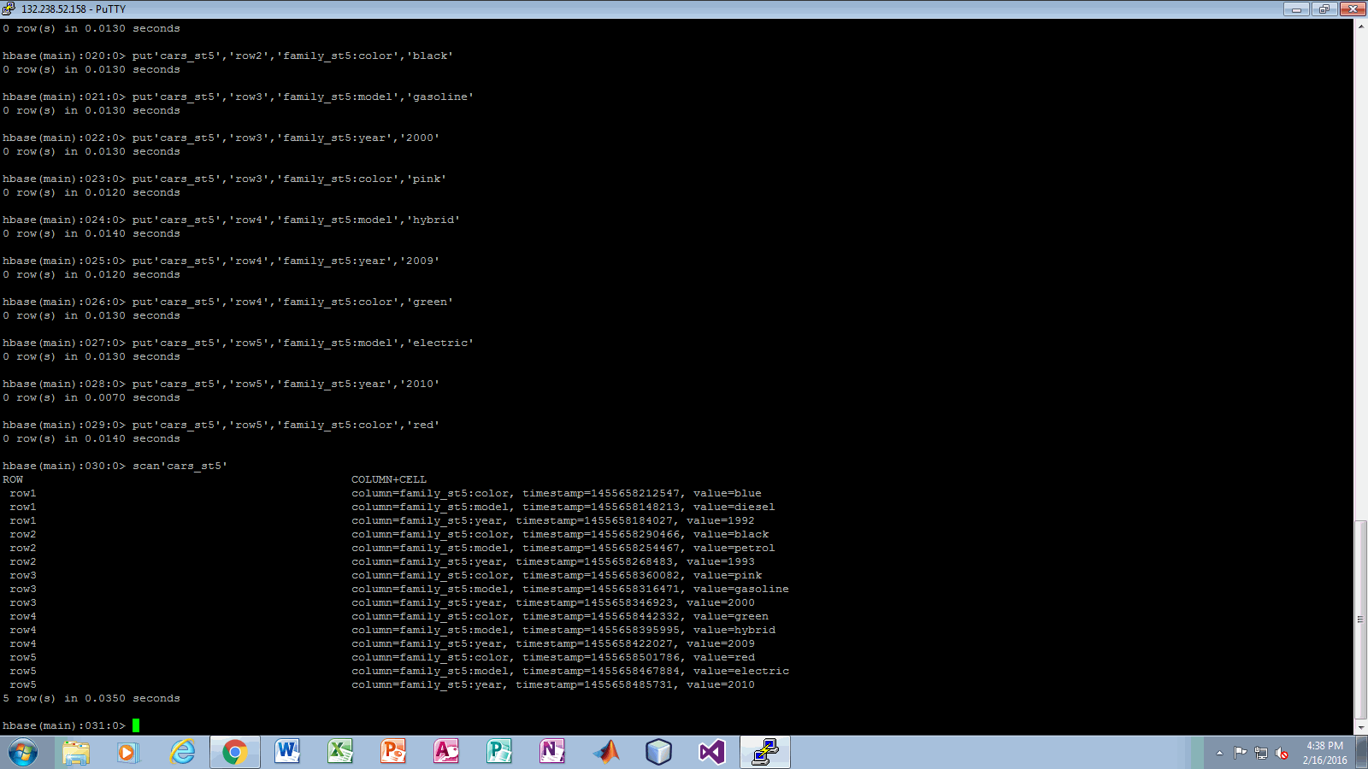

In the above screen shot I had created 5 rows with 1 single column family with 3 columns(colour,model,year).and I displayed my table which displayed the table by using command scan ‘cars_st5’.

**STEP6:**

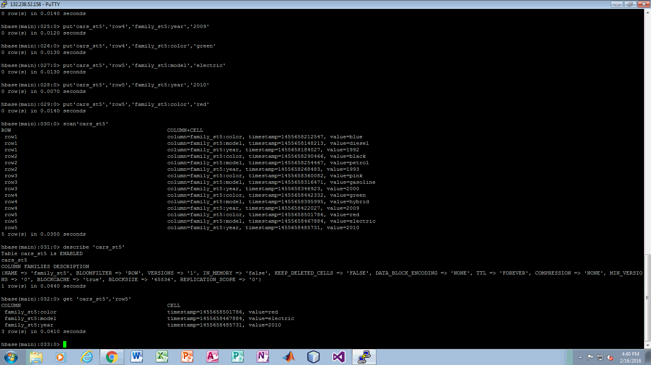

In the above screen I run two commands.

1)(describe ‘cars_st5’) which describe the settings of the table cars_st5.

2)(get ‘cars_st5’,’row5’)which display the row number five.

**STEP7:**

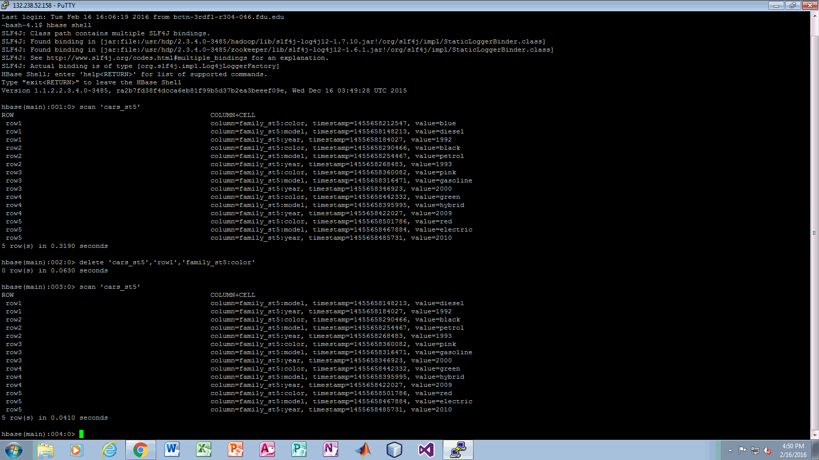

* In the above screen shot I deleted the cell value in row1 of column color.
* And I displayed the table after executing the delete command.

**STEP8:**

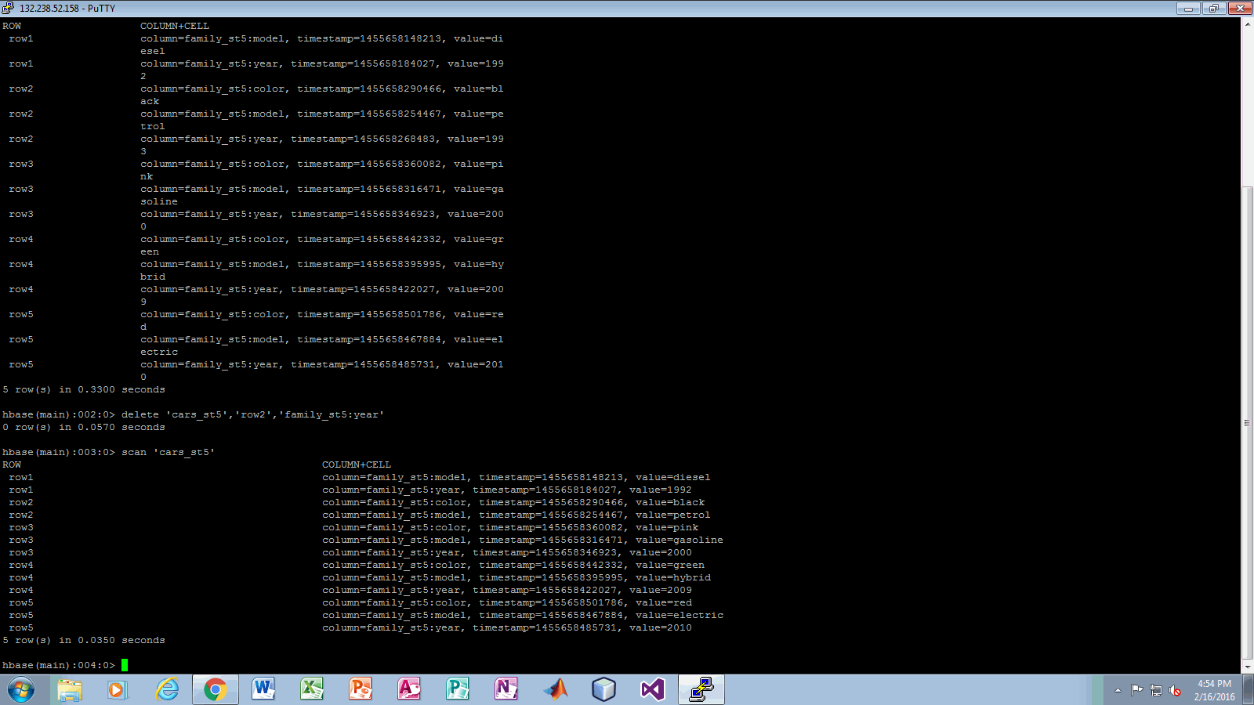

* I had deleted the cell of column year in row2 and I displayed the table after executing delete command.

**STEP9:**

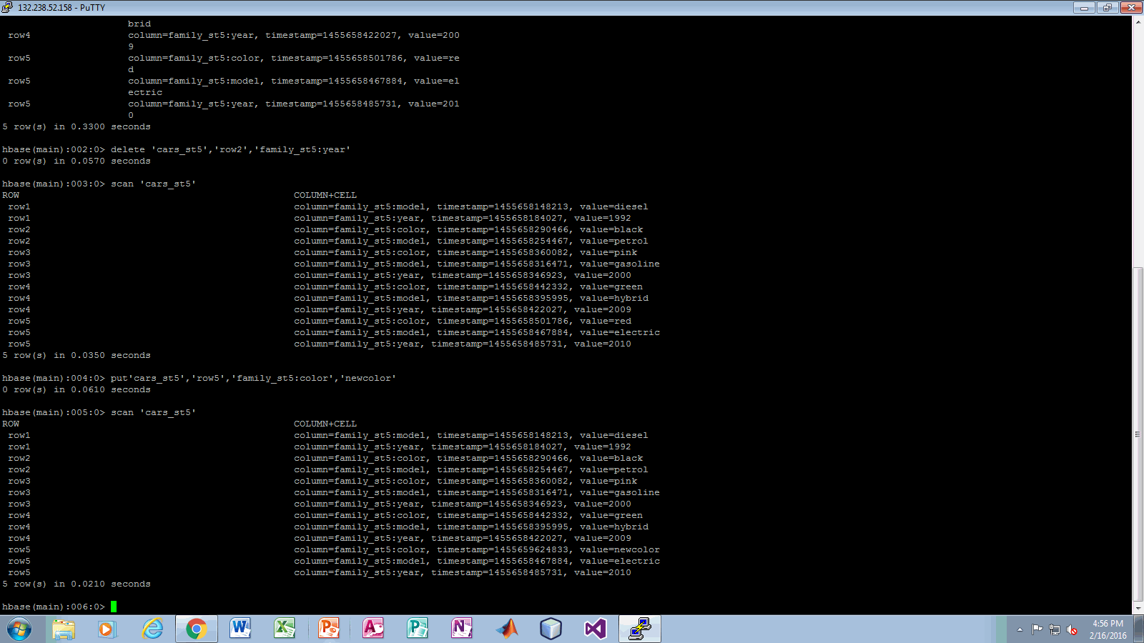

* In the above screen I updated the value in row5 of column color. I updated the value by using put command.

**STEP 10:**

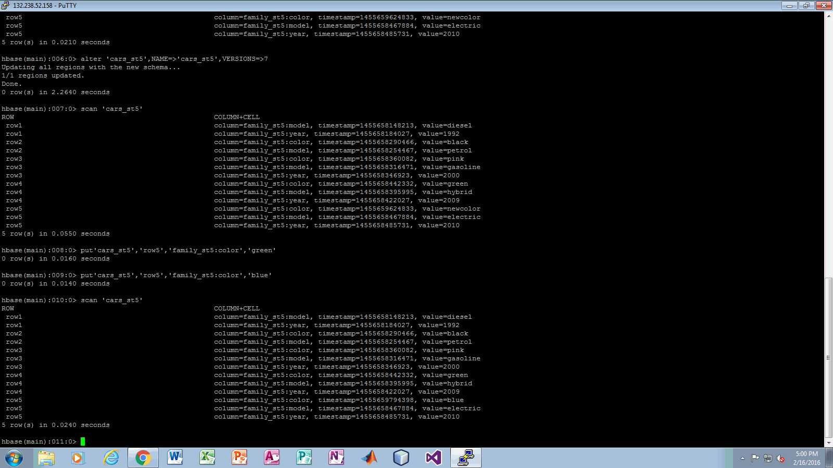

* In the above screen shot return a command to hbase to keep the 7 versions of data.
* I updated the row 5 of column color two times and I displayed the table using scan command.

STEP 11:

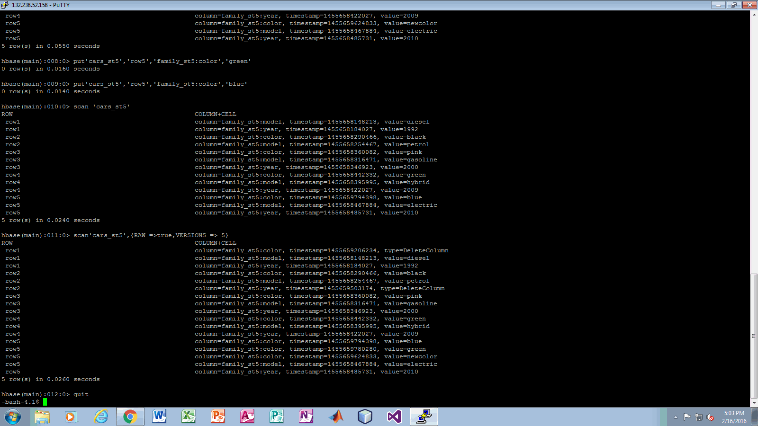

* In the above screen shot I displayed the different versions of data with different time stamps.
* After that I exit the Hbase using quit command.