

GILDART HAASE SCHOOL OF COMPUTER SCIENCES AND ENGINEERING

University College: Arts – Sciences – Professional Studies

Fairleigh Dickinson University

__________________________________________________________

*Student’s Name: Professor:*

Desham,RajeshReddy (1682826) *Alex Rudniy,Ph.D* **LastName, First Name(Student I.D)**

**CSCI 6885_81**

**Big Data Analytics with Hadoop and R**

**SPRING 2016**

Assignment-3

STEP1:

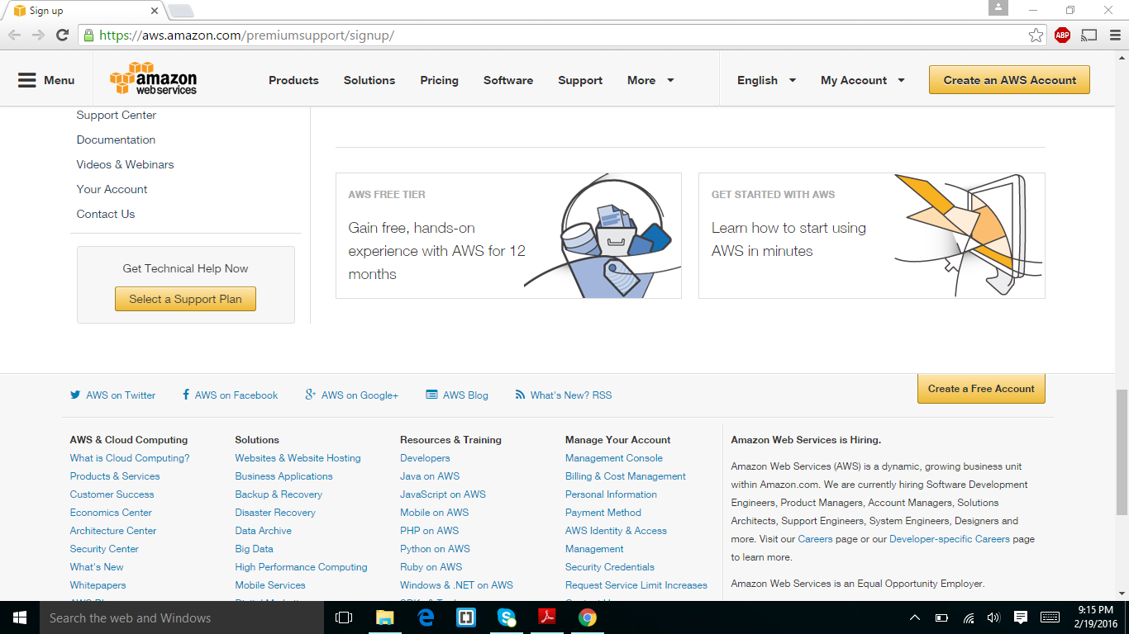

STEP2:

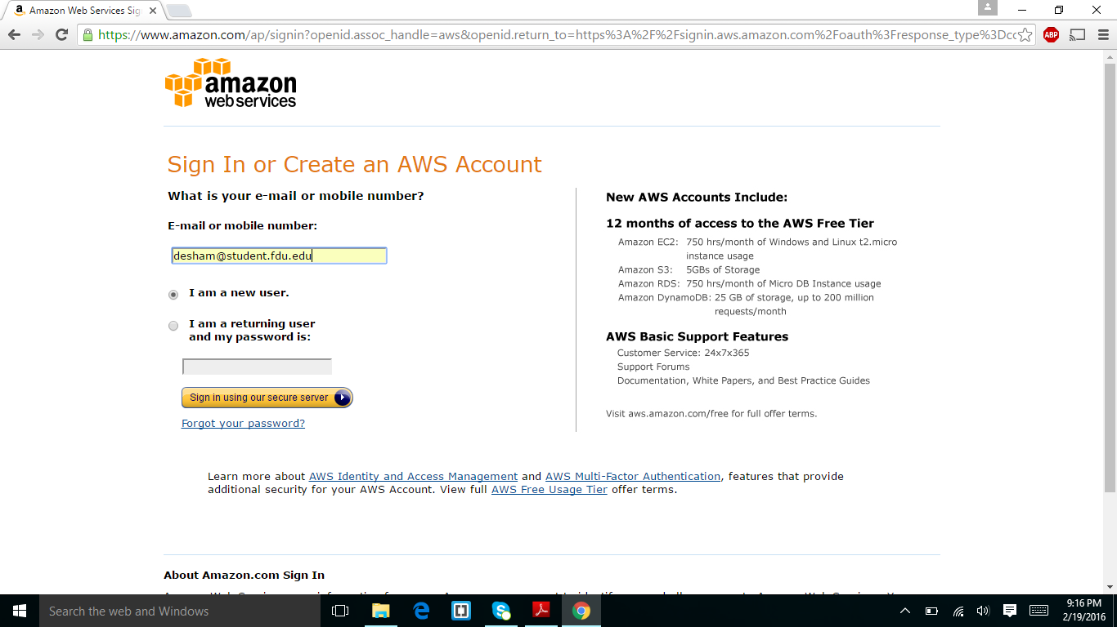

I entered my email address and mobile number

STEP3:

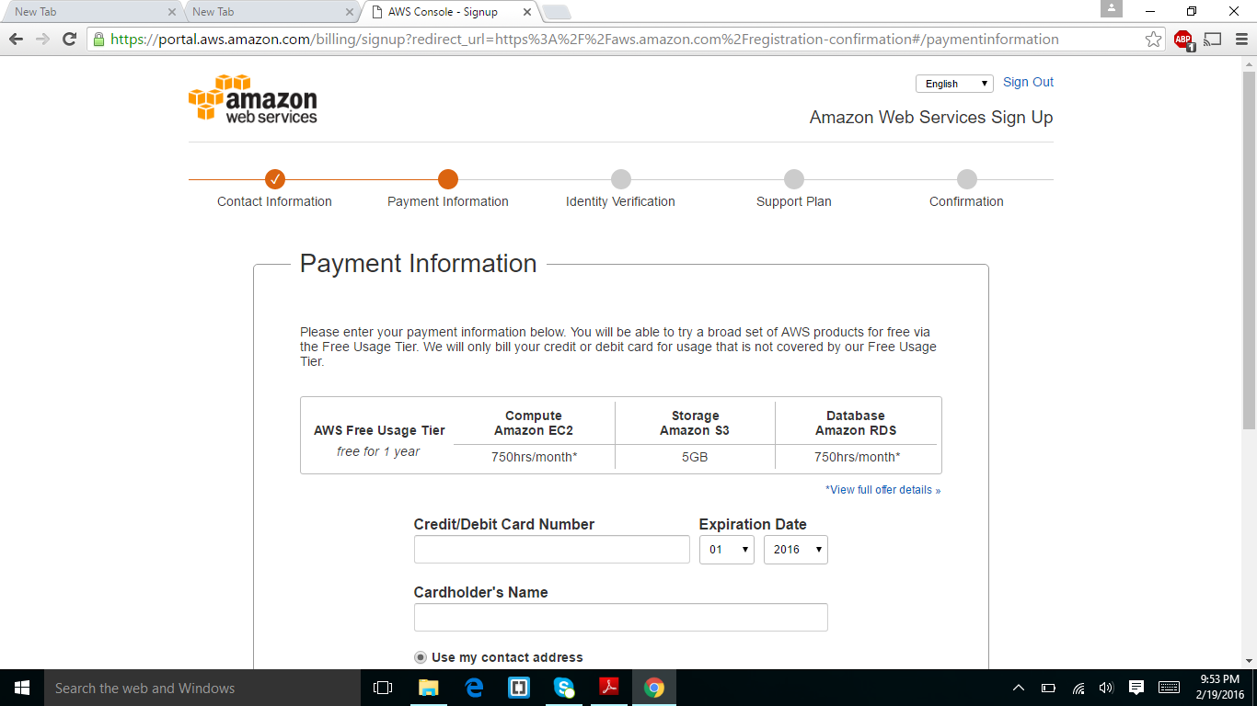

I entered my contact information and the next step is shown in the above screen shot to enter the payment information.

STEP4:

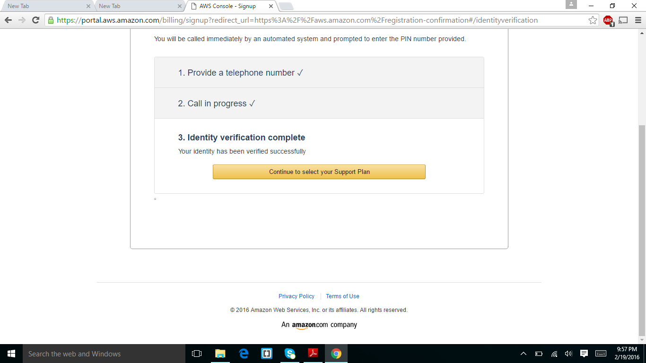

I confirmed my identity using phone number.

STEP5:

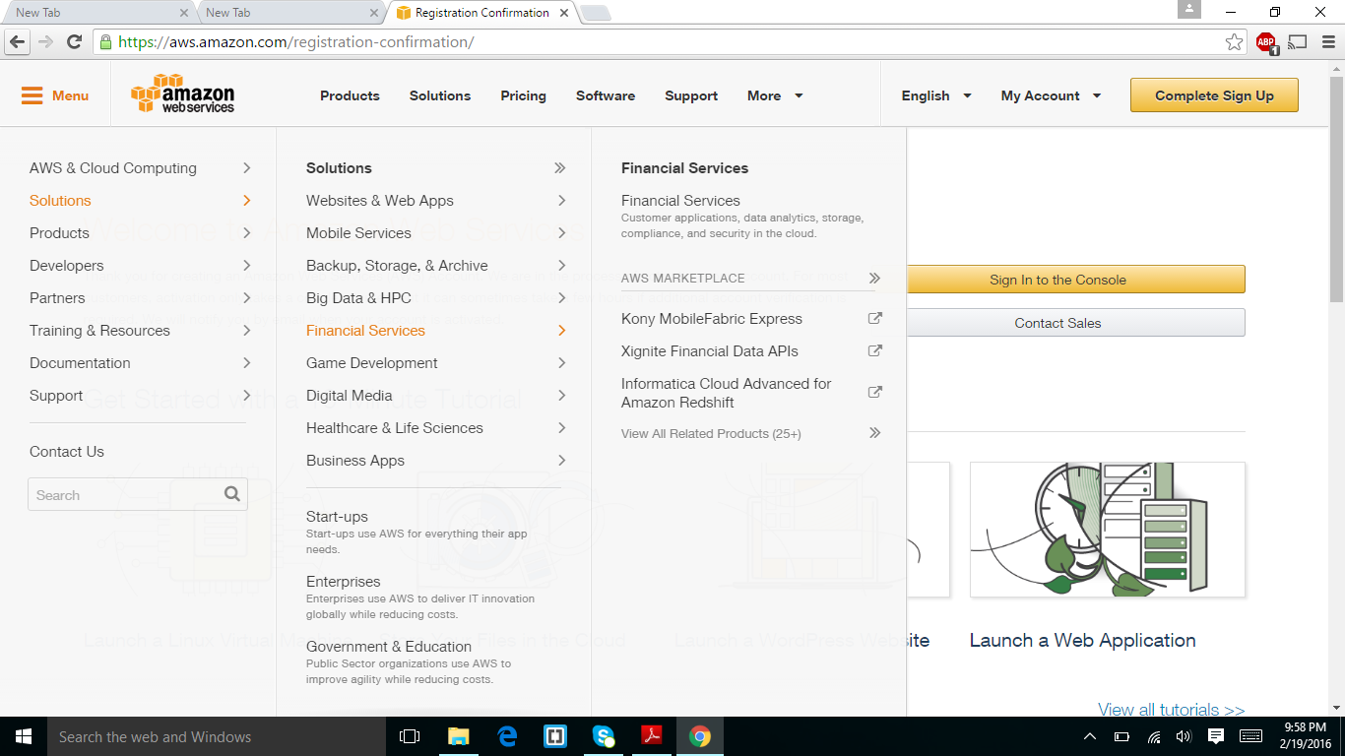

The above screen shot is I created a amazon web services account and after this step I have to press the sign into console

STEP6:

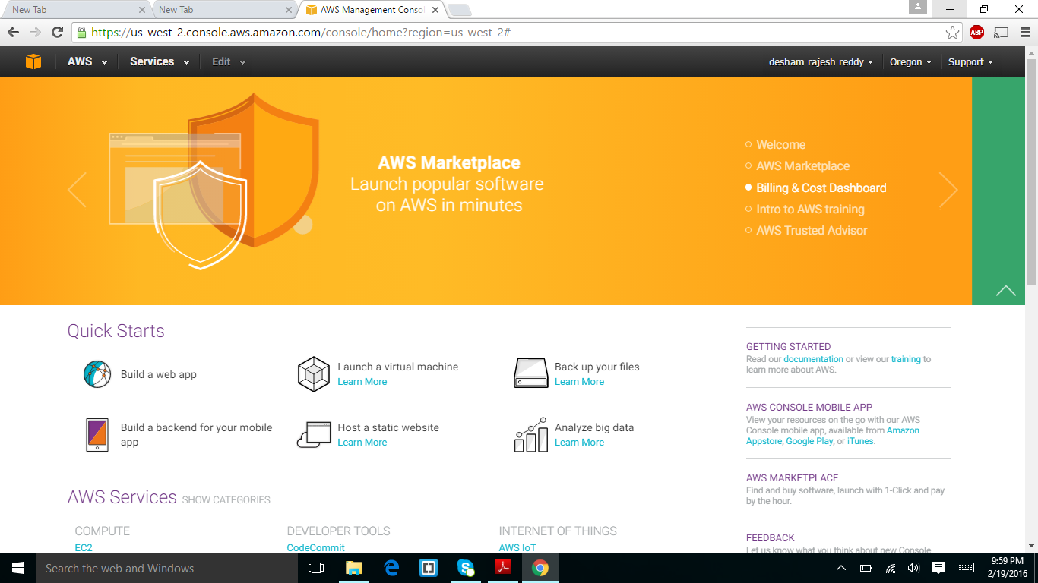

This is my home page of amazon web services account.

STEP7:

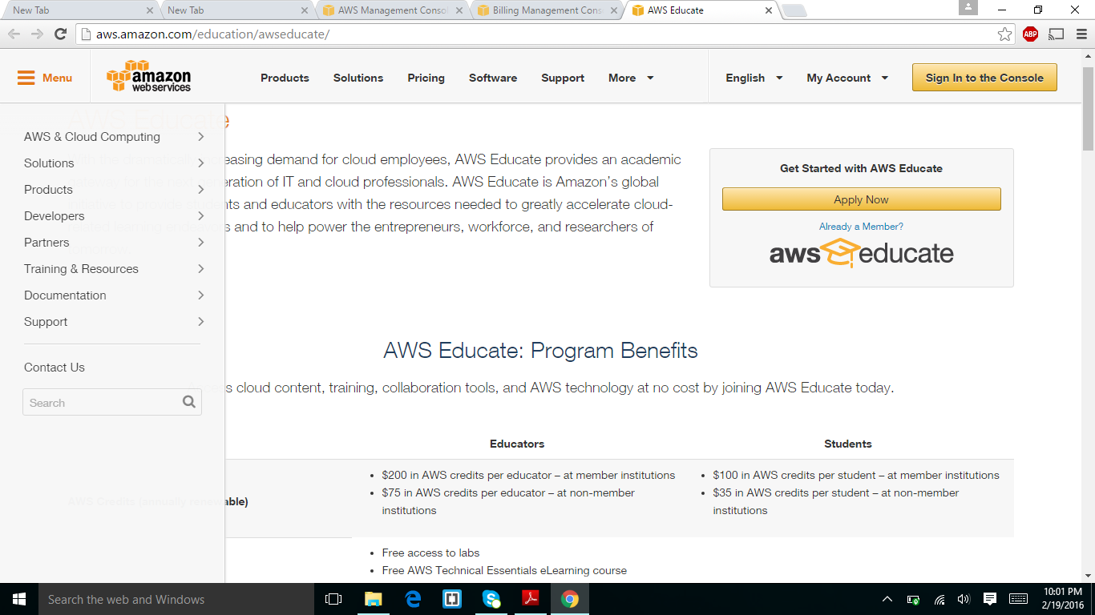

After I creating amazon web services account I have signed up AWS educate.

STEP8:

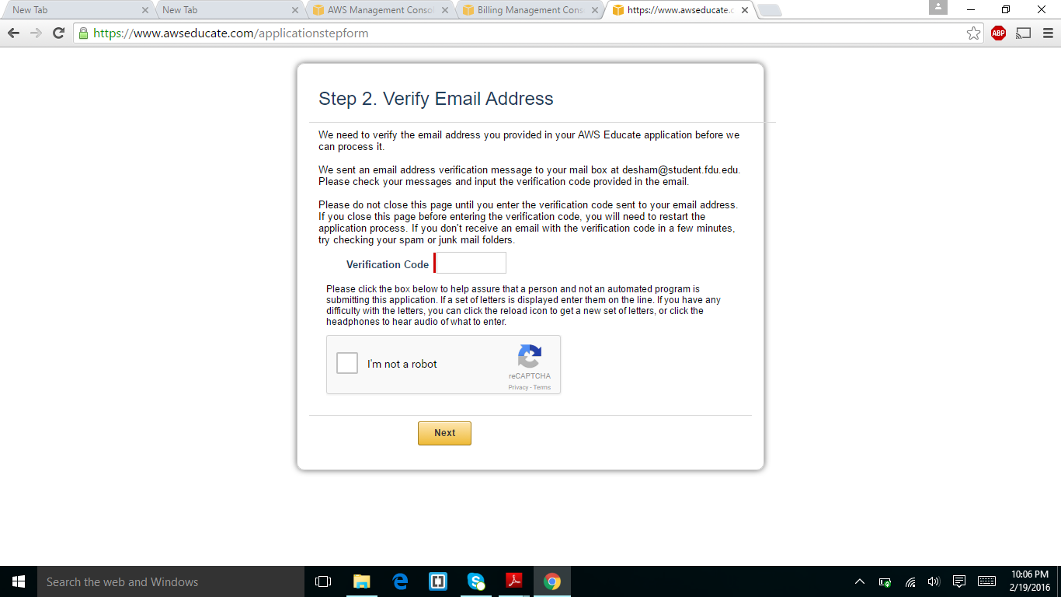

STEP9:

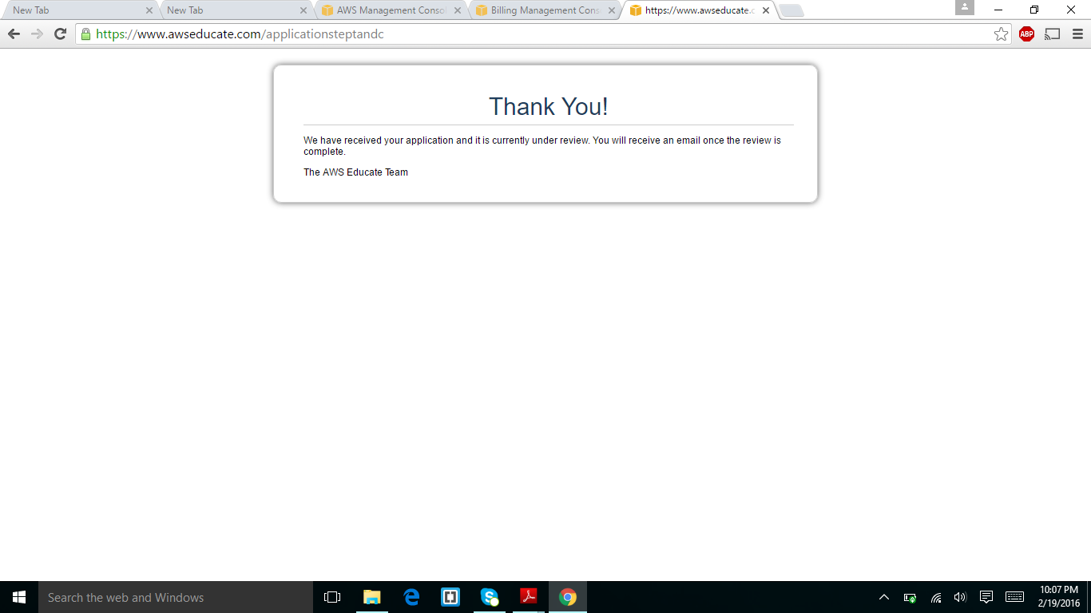

I completed registration of my account of AWS educate.