

GILDART HAASE SCHOOL OF COMPUTER SCIENCES AND ENGINEERING

University College: Arts – Sciences – Professional Studies

Fairleigh Dickinson University

__________________________________________________________

*Student’s Name: Professor:*

Desham,RajeshReddy (1682826) *Alex Rudniy,Ph.D* **LastName, First Name(Student I.D)**

**CSCI 6885_81**

**Big Data Analytics with Hadoop and R**

**SPRING 2016**

Assignment-6

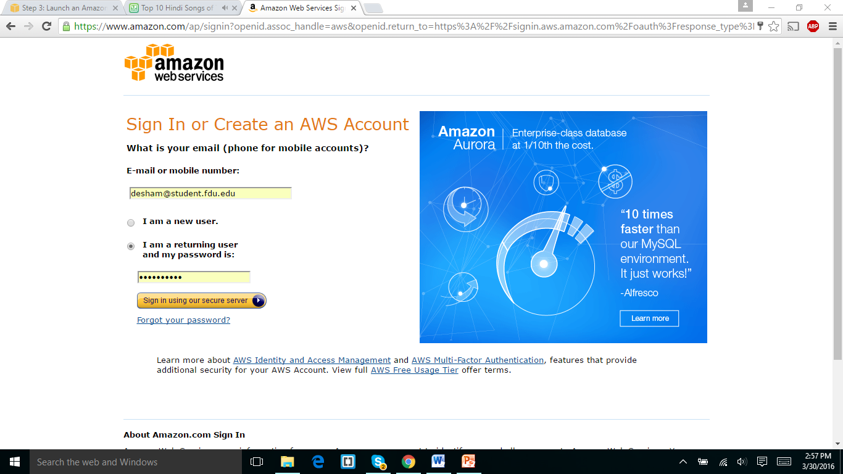

Sigining in to amazon web services.

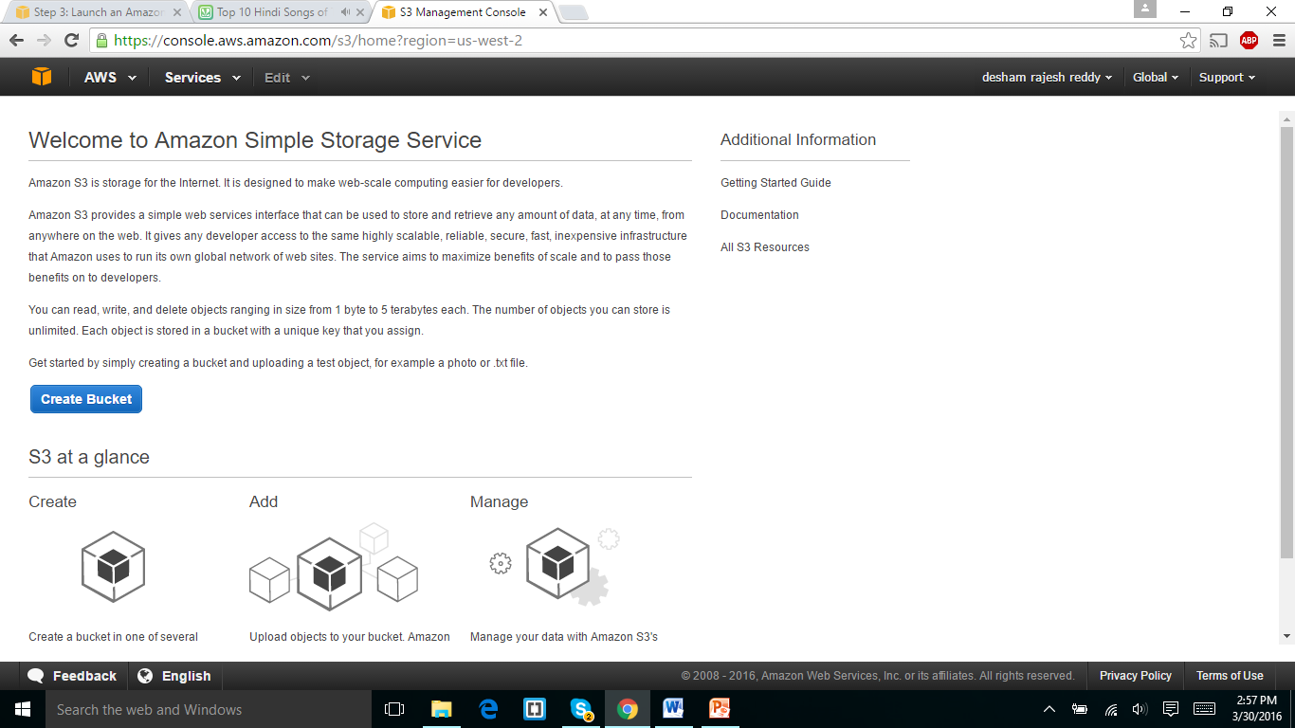

The above screenshot is the main page of amazon S3 services.

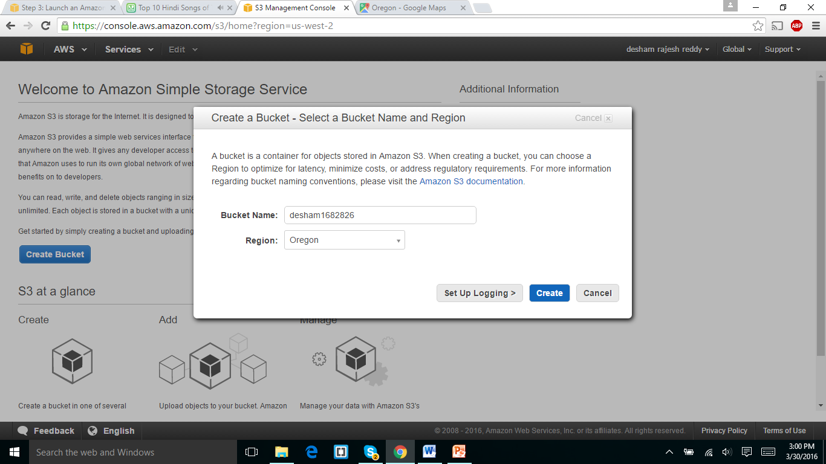

The above screen shot is taken in the process of creating the bucket.

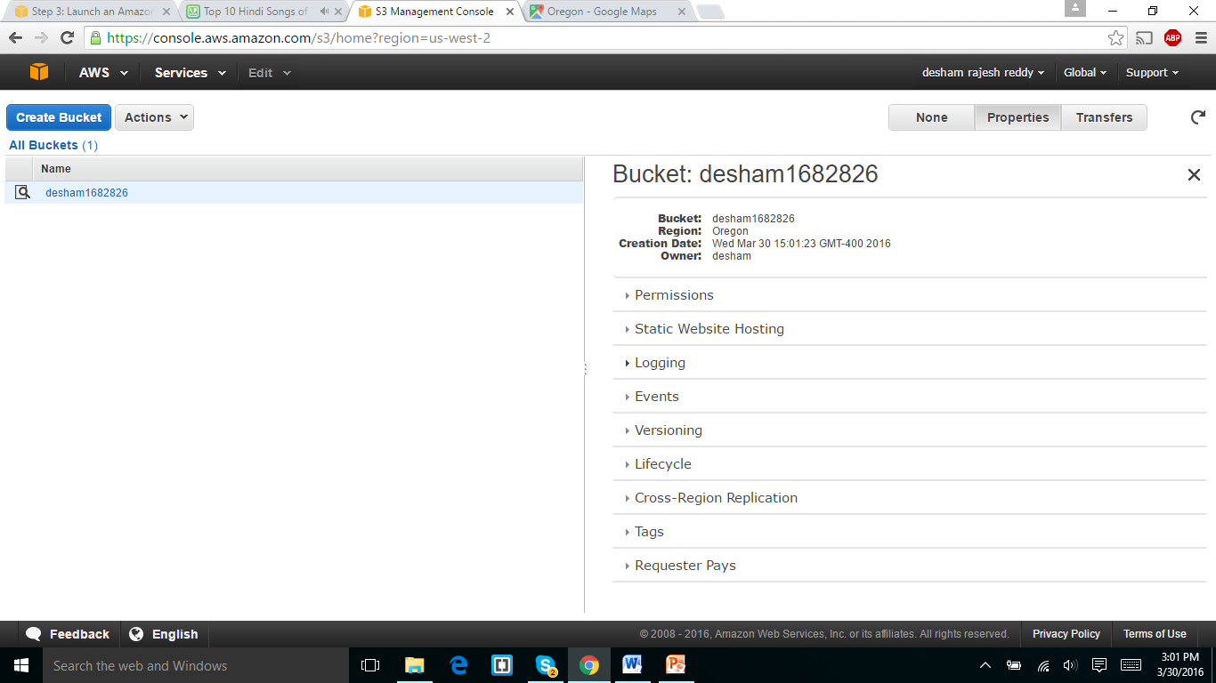

I selected the region as Oregon which is nearest service location and it is designated as us-west-2 location.

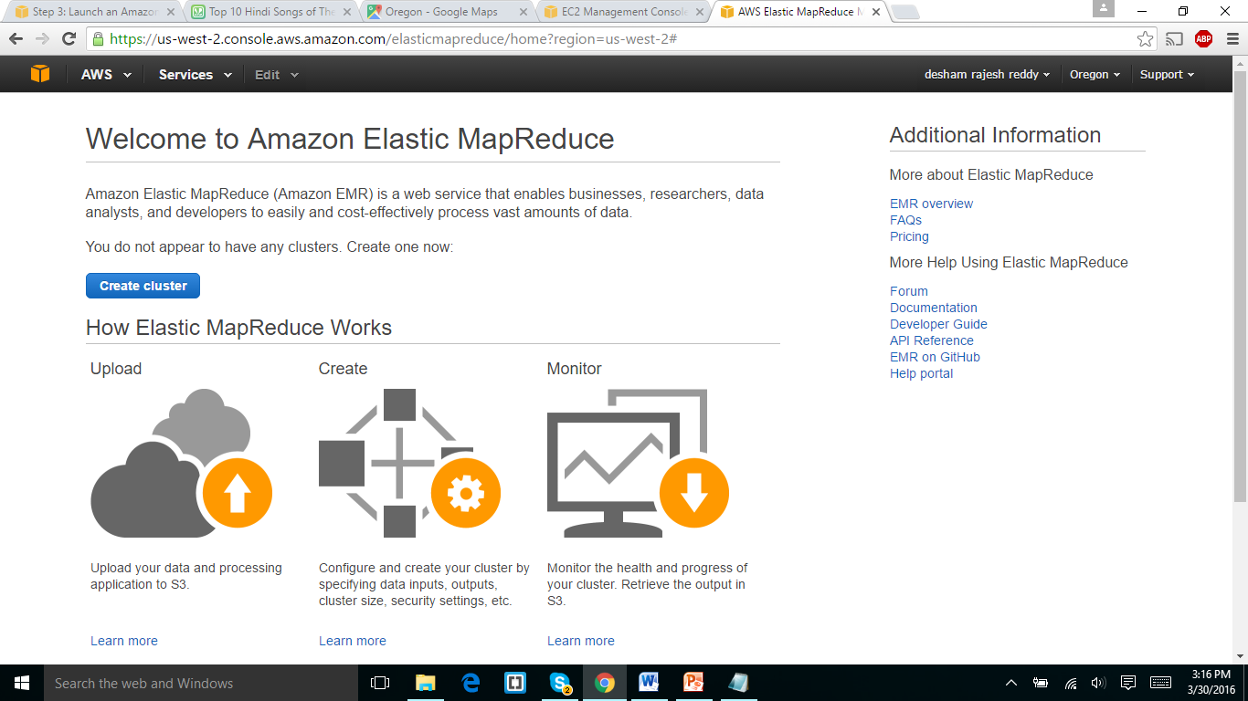

In the above screenshot It is the home page of EMR(Elastic map reduce ) of amazon.

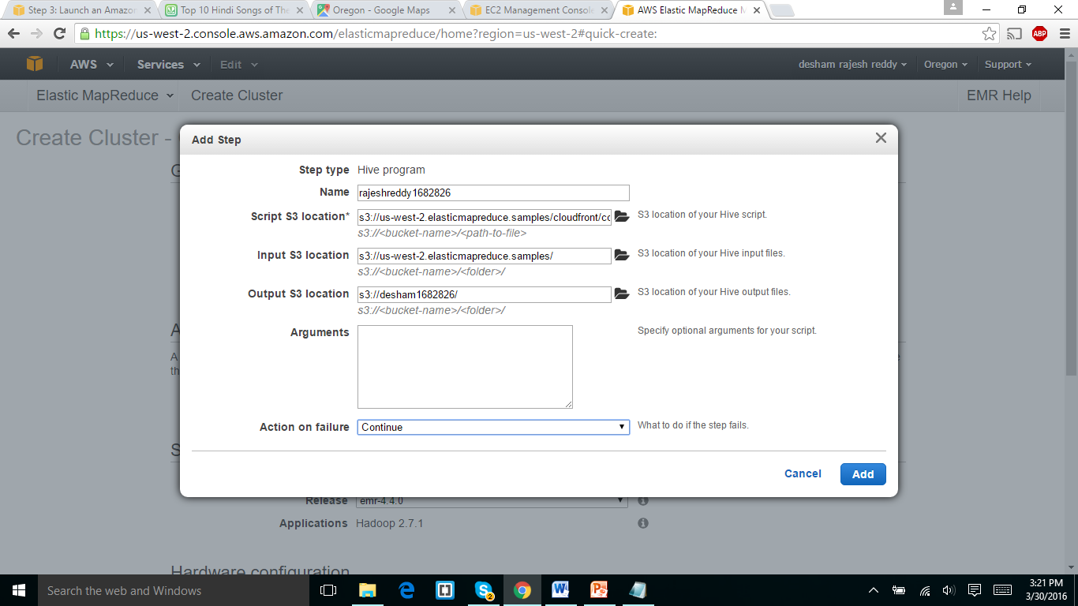

The above screen shot is the settings of the step type and input and output of s3 location.

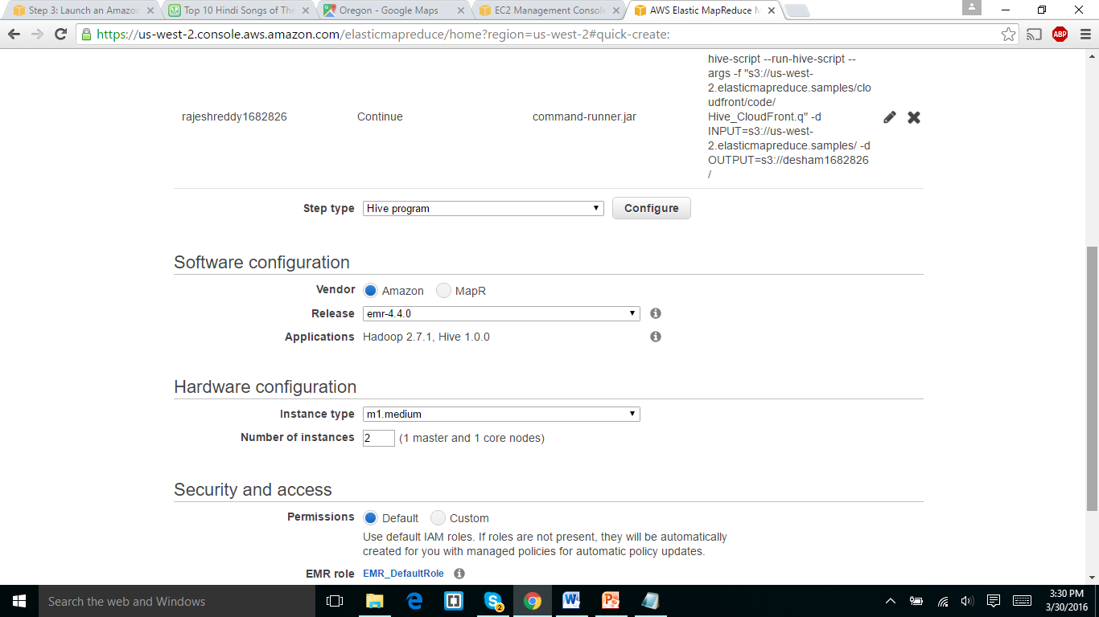

The above screen shot is the settings for software and hardware configuration and security access.

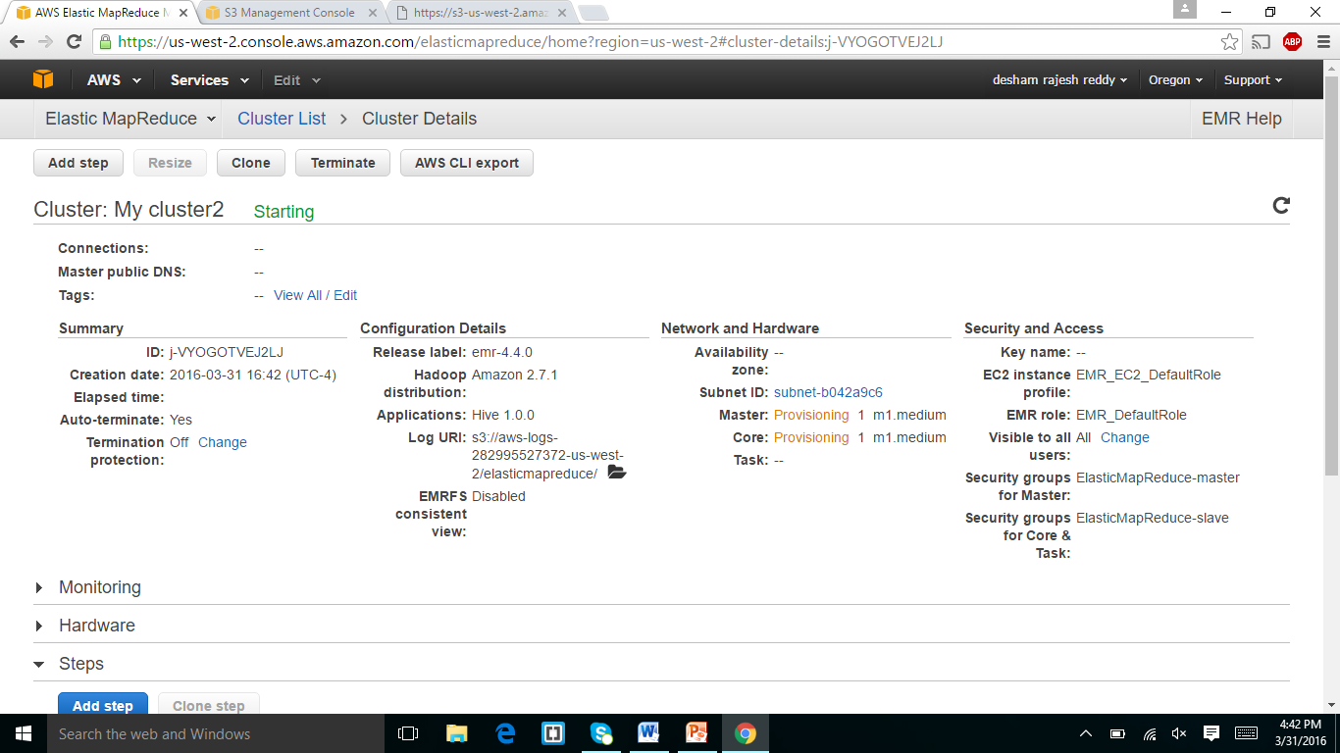

The above is the screen shot taken after the start of the cluster and it was terminated with the error.

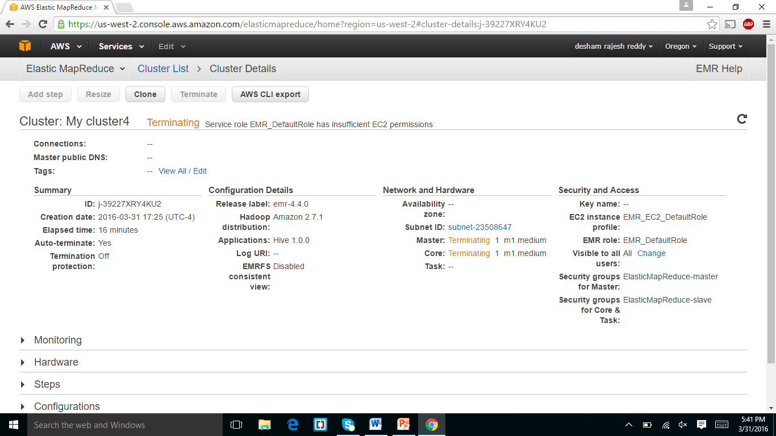

The error was shown in above screen shot was with the error and I tried restarting the cluster with four times. I was shown to the professor about the error. He said to submit the assignment with the error.