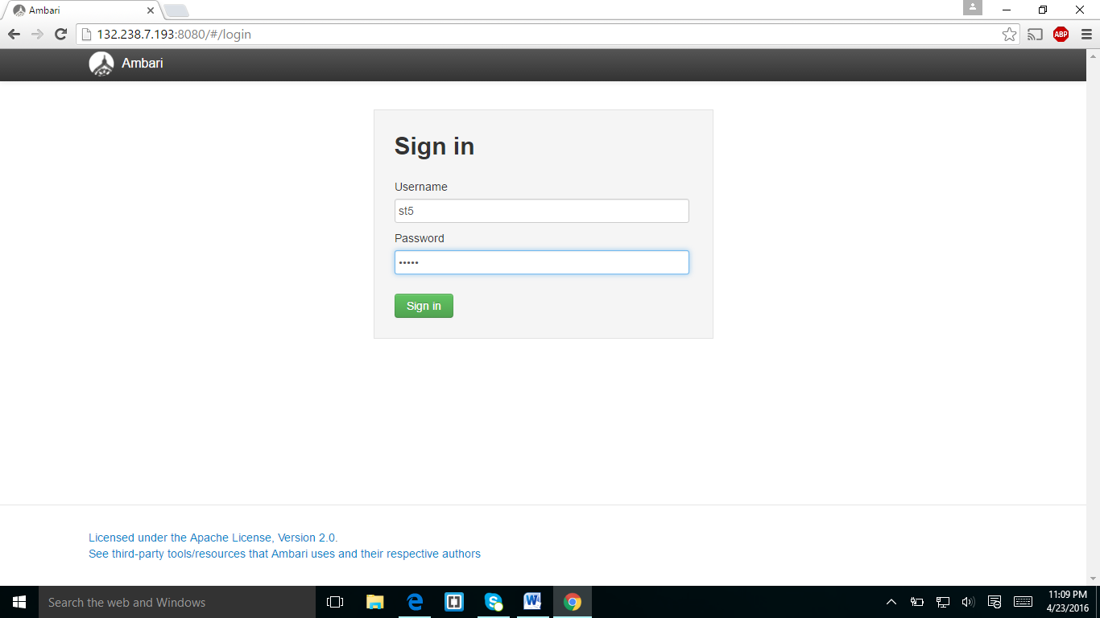

Logging into the ambari using my passwords

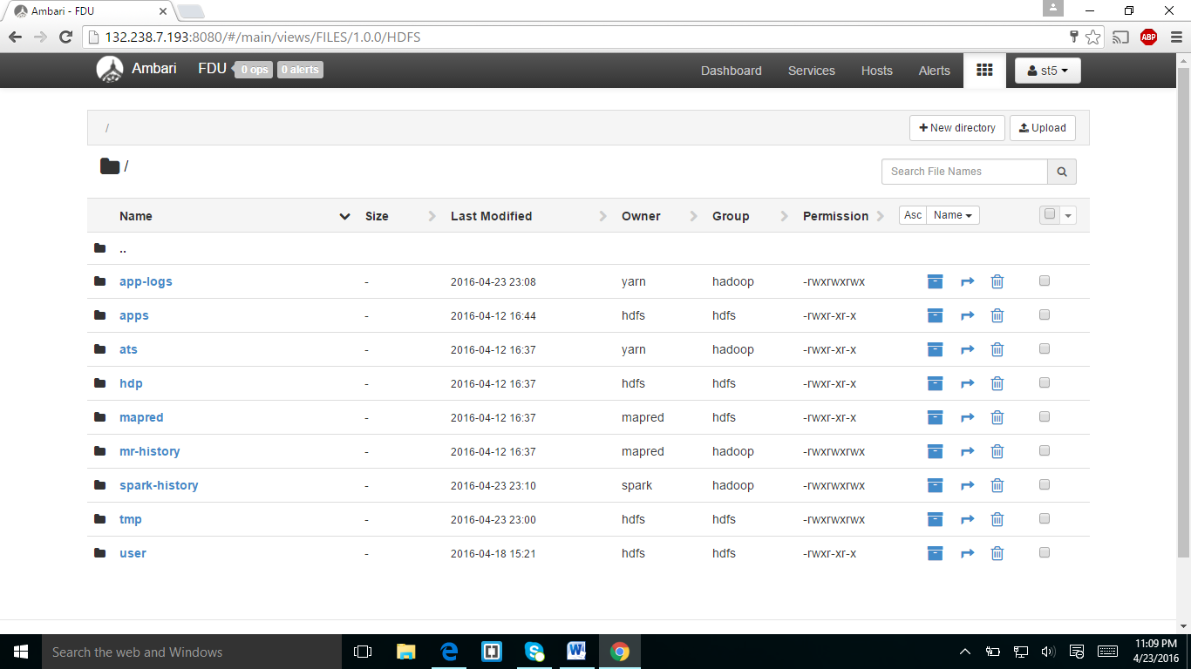

Navigating into my folder

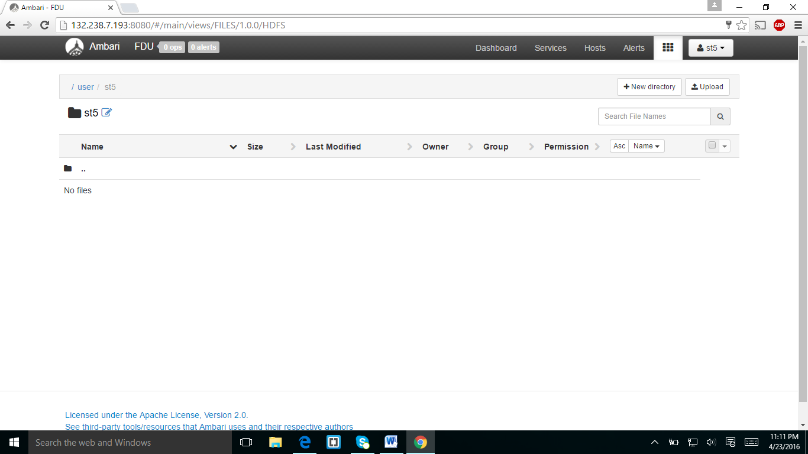

This is my folder and I downloaded the Batting.csv and master.csv.and showed in the below screenshot.

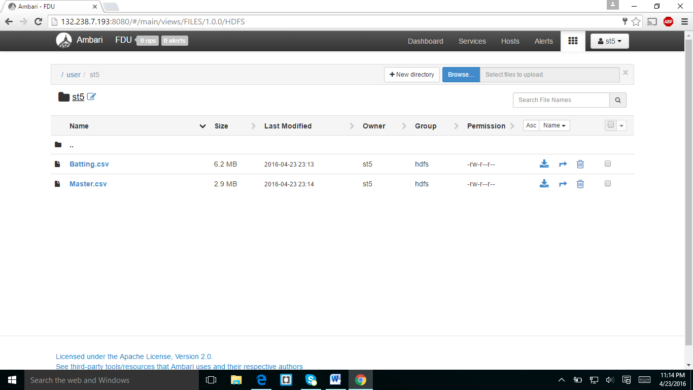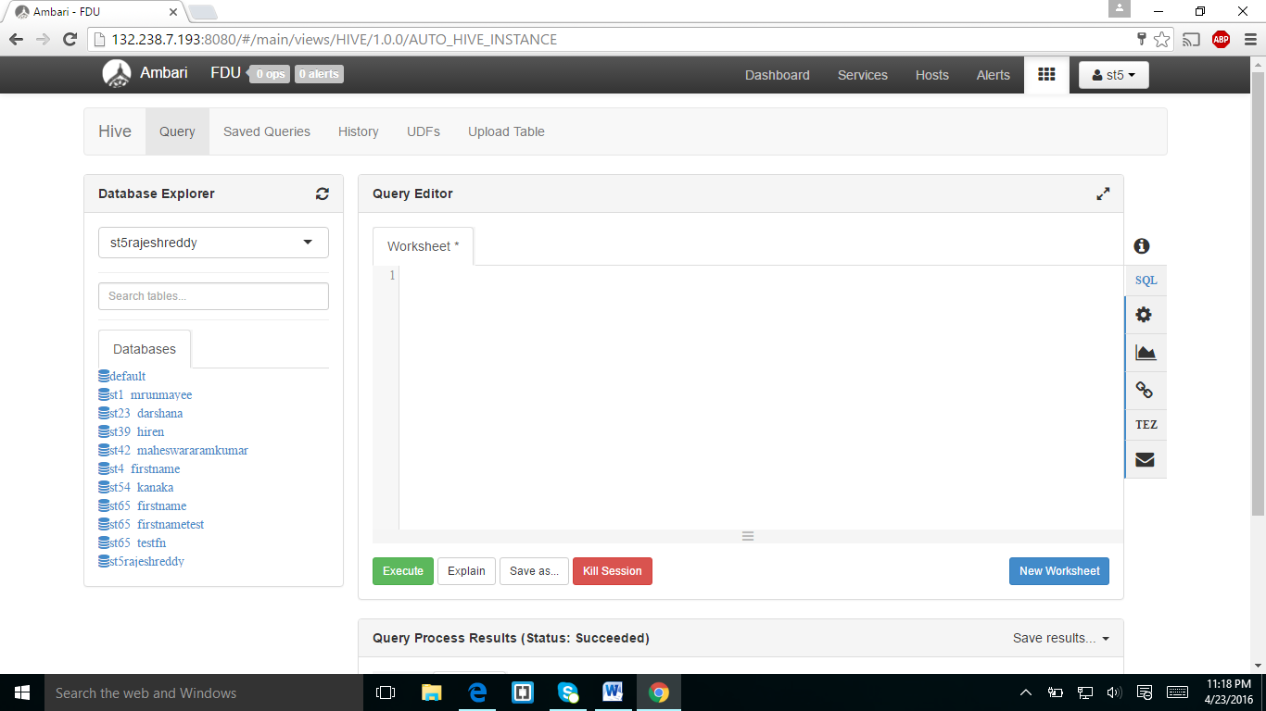

I created the database in my name and selected my database with my name.

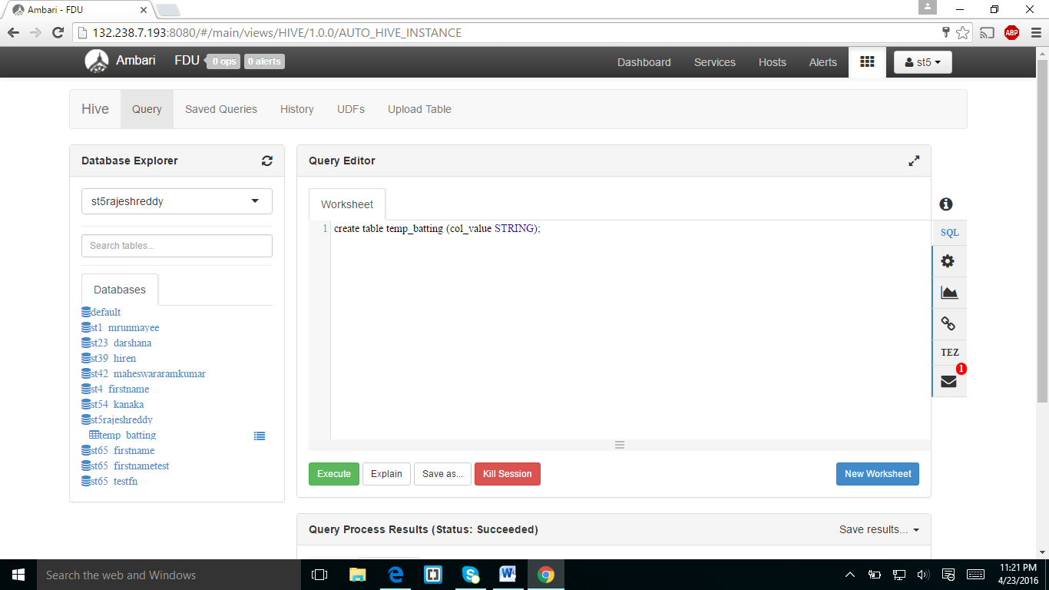

I created the table temp_batting with column (col_value).

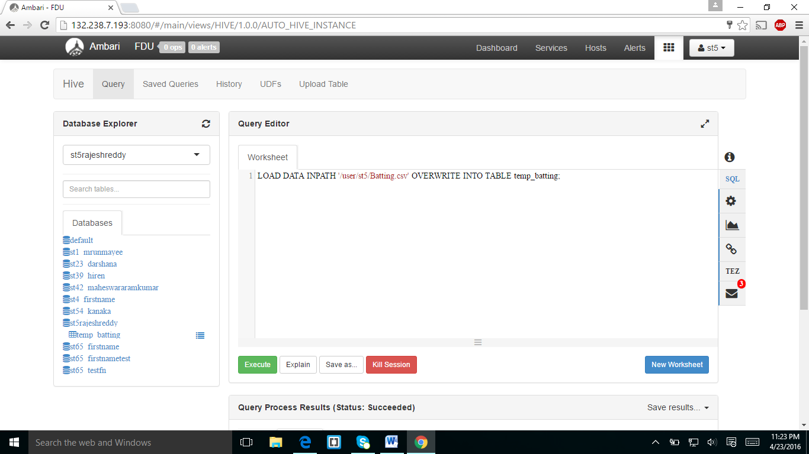

I loaded DATA from batting.csv into temp_batting.And I displayed the table in below screen shot.

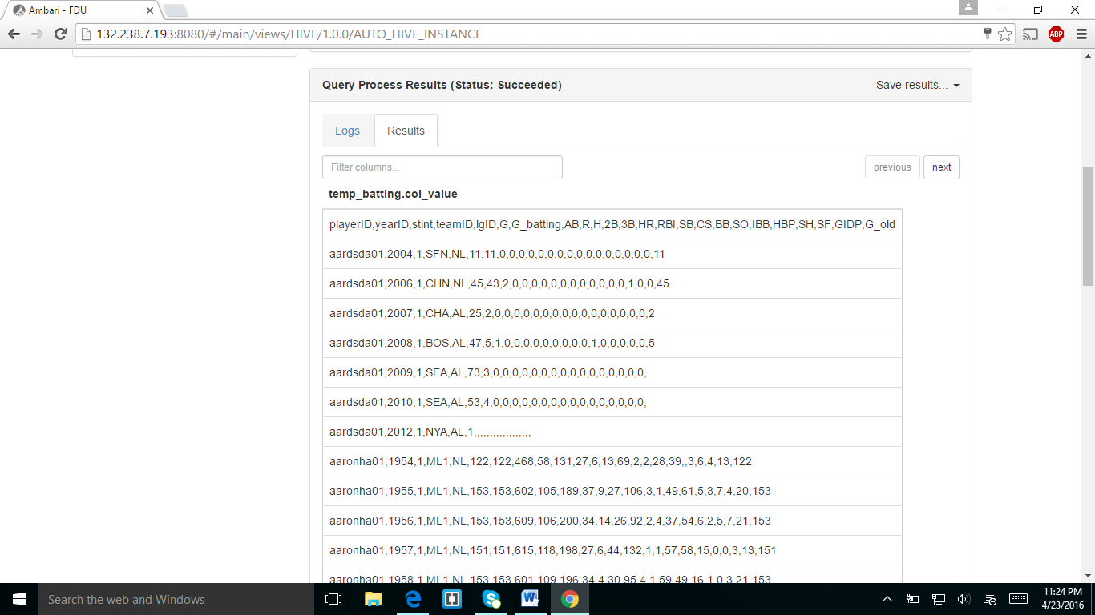

**16)ANSWER:** Only one column is in table temp_batting.

In the next screen shot I created the table batting with columns player_id ,year and runs

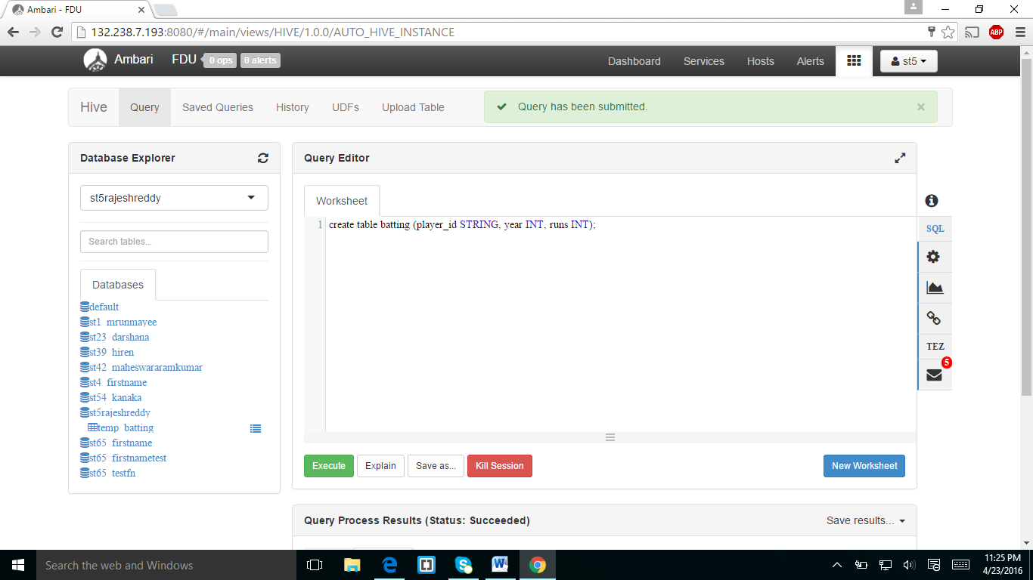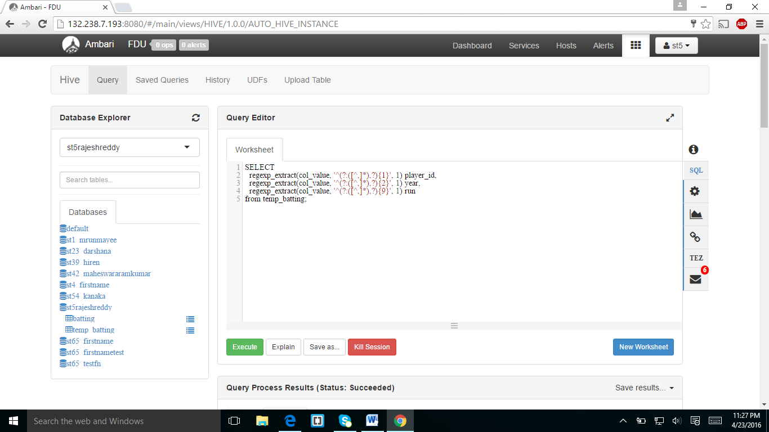

From table tempbatting I inserted data to other columns.and populated in down screenshot.

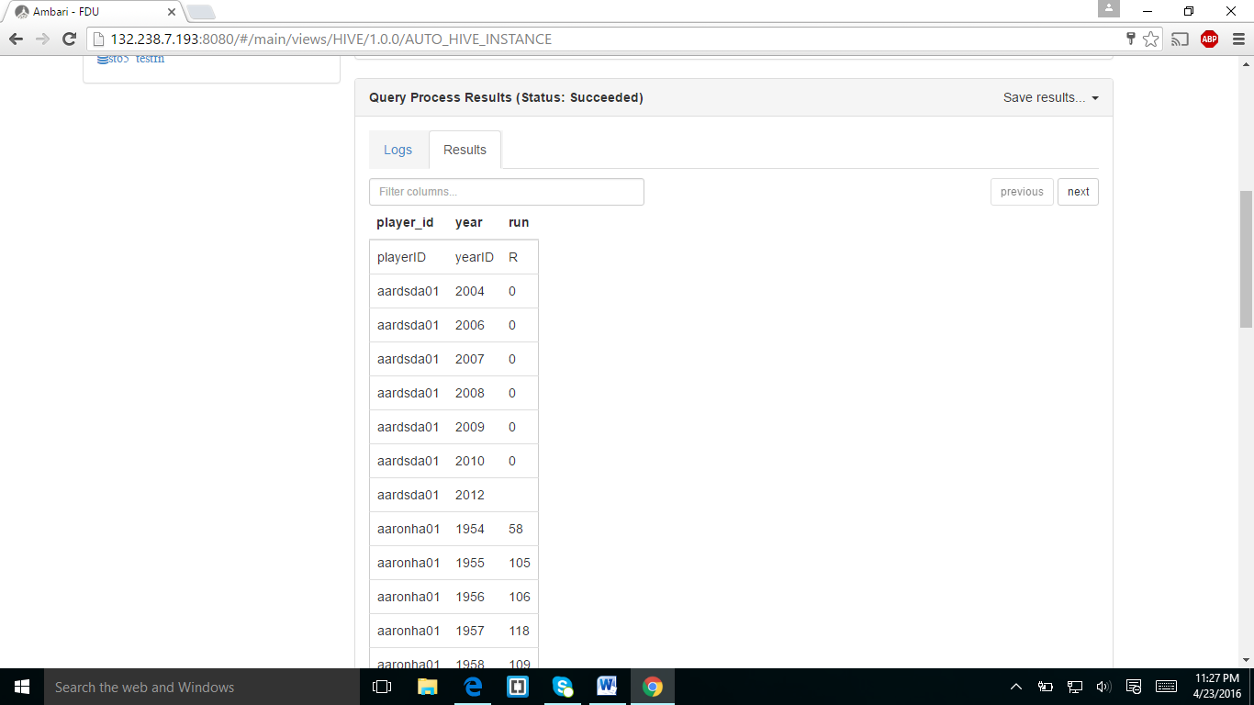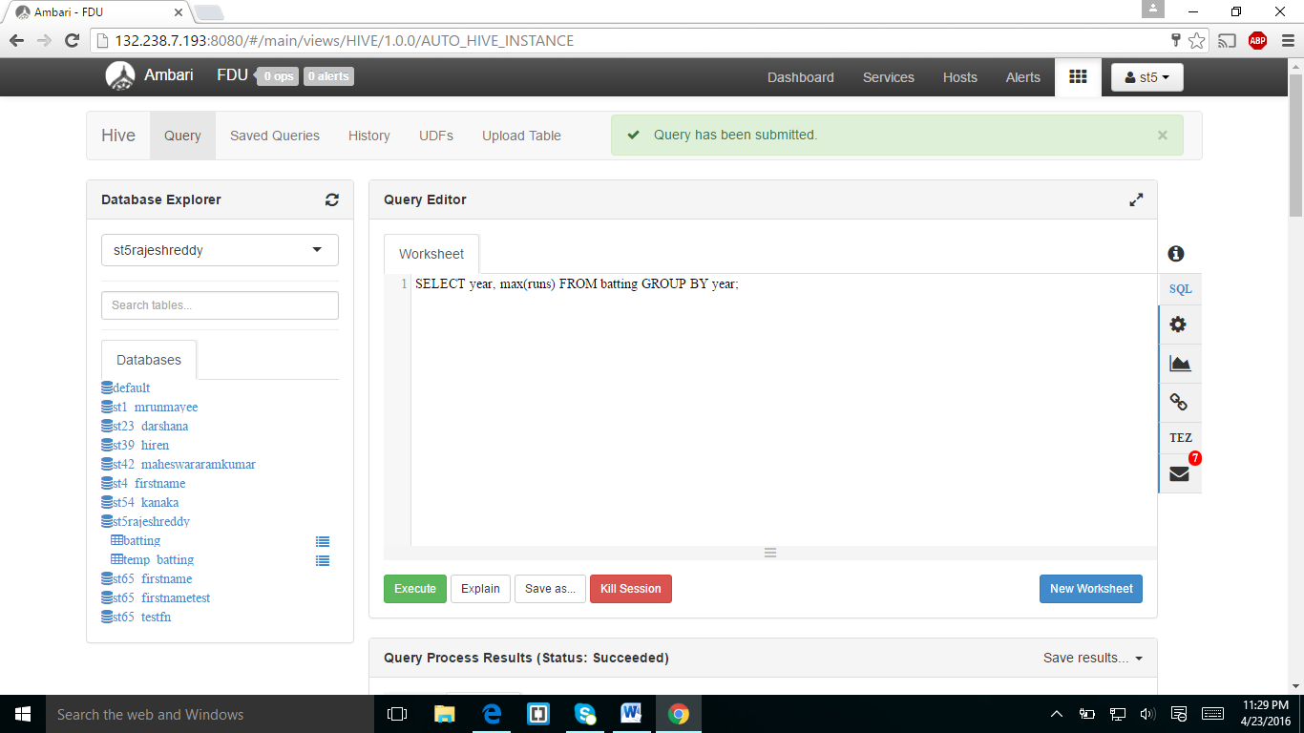

The above query is about maximum runs from batting group by year which was displayed in below screen shot.

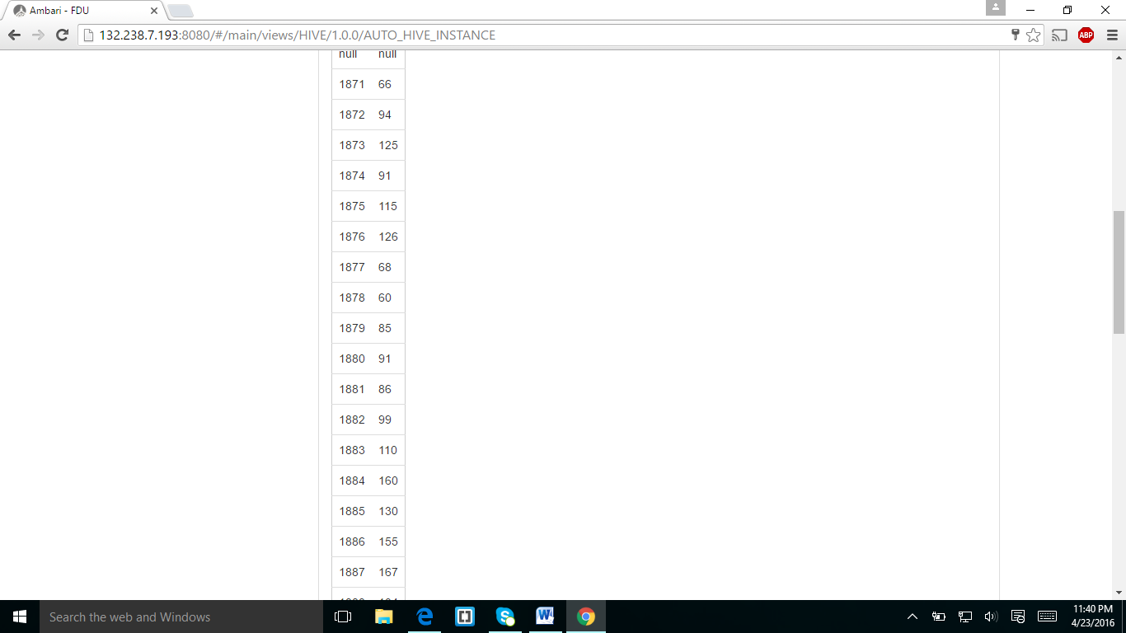

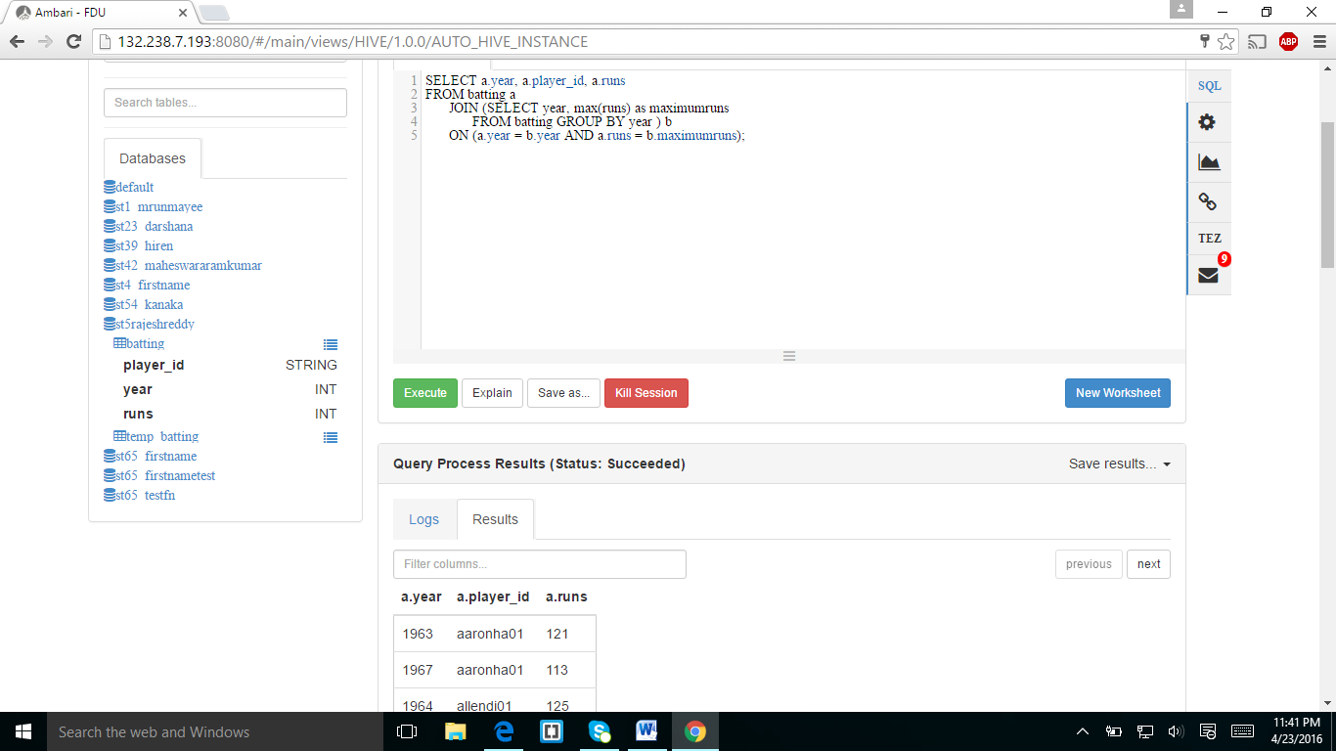

I created the join statement and results were displayed below.

**24 ANSWER:** 1963-aaronha01-121

**ASSIGNMENT2:**

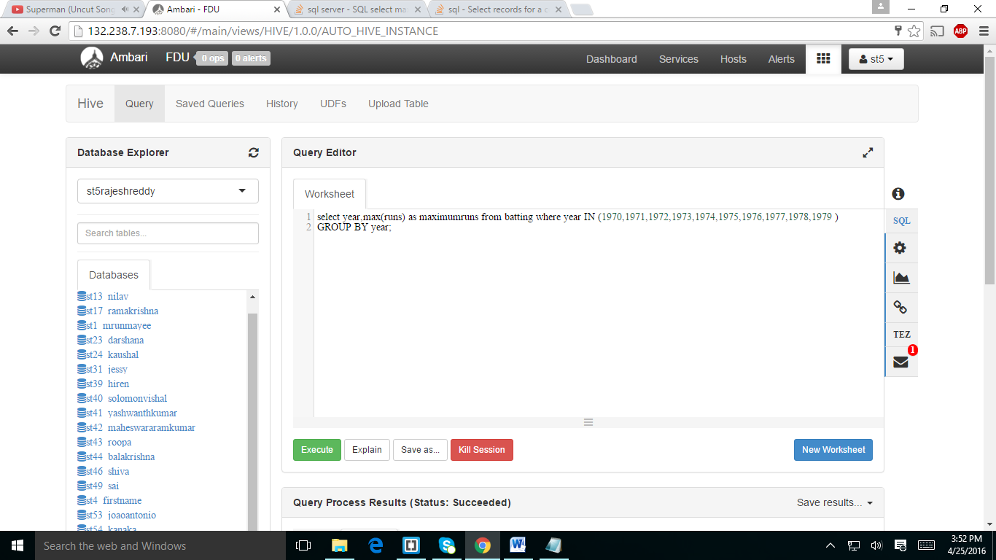

I displayed the maximum runs in the year 1970-1979 group by year.

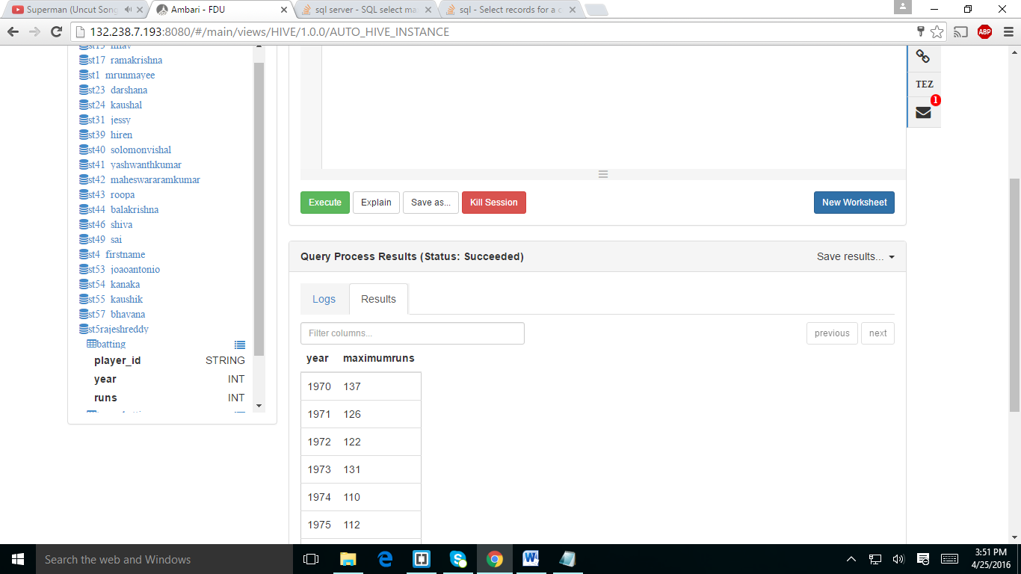

**ASSIGNMENT3:**

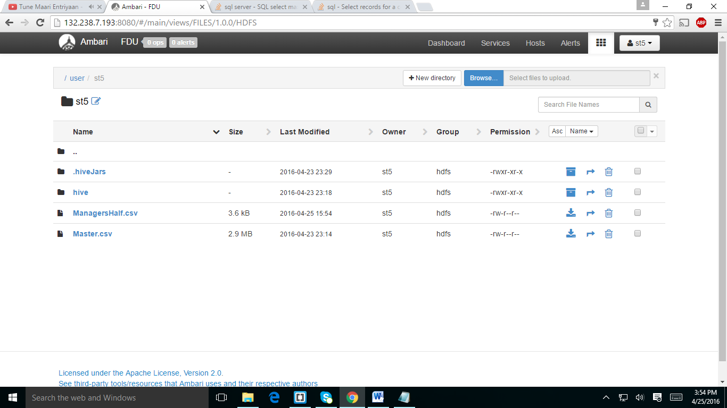

I downloadedManagershalf.csv file from webcampus and uploaded to my user folder.

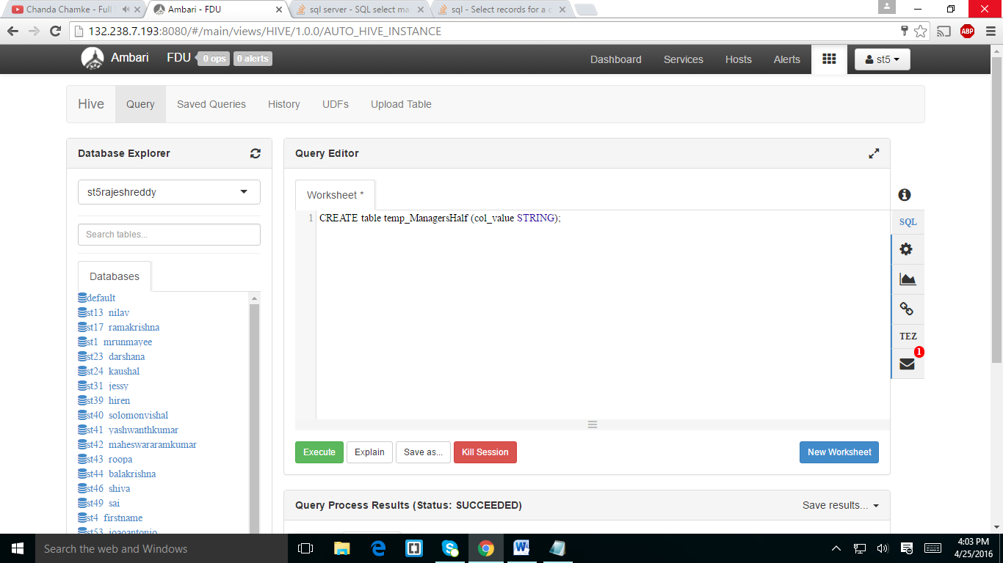

I created a table with single column.(table temp_managershalf)

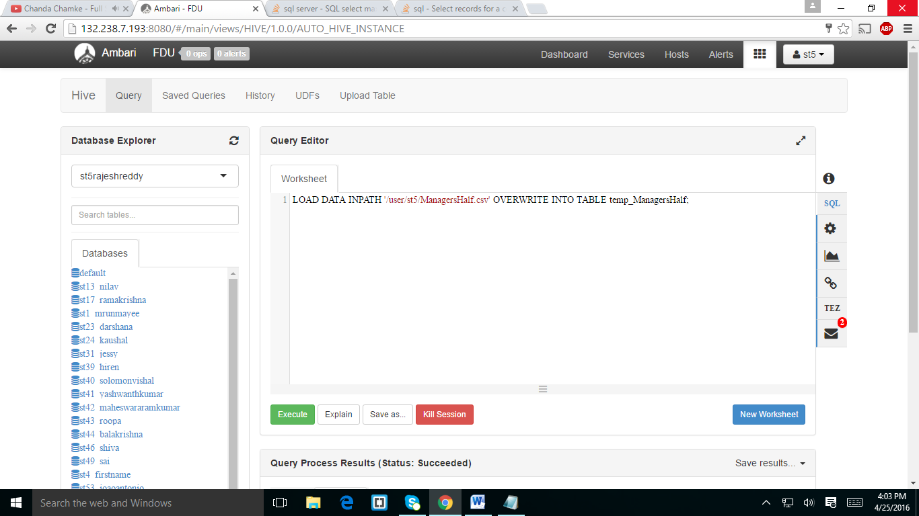

I loaded the data into the table temp_managershalf

In the below screen shot I created another table and loaded the data as columns

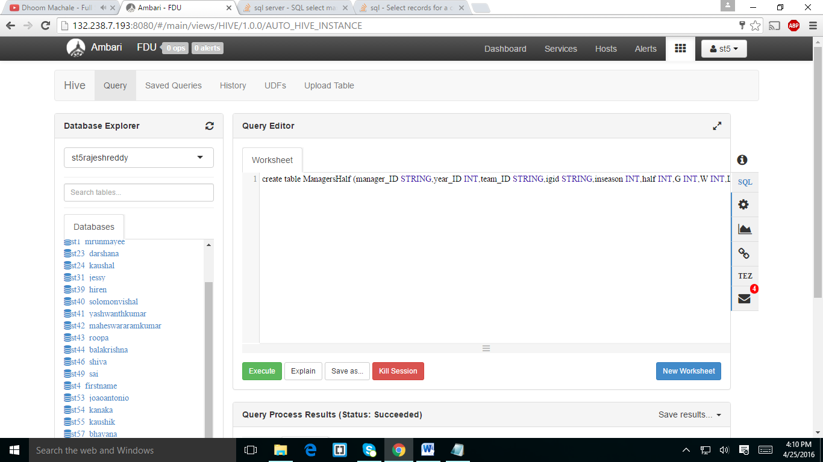

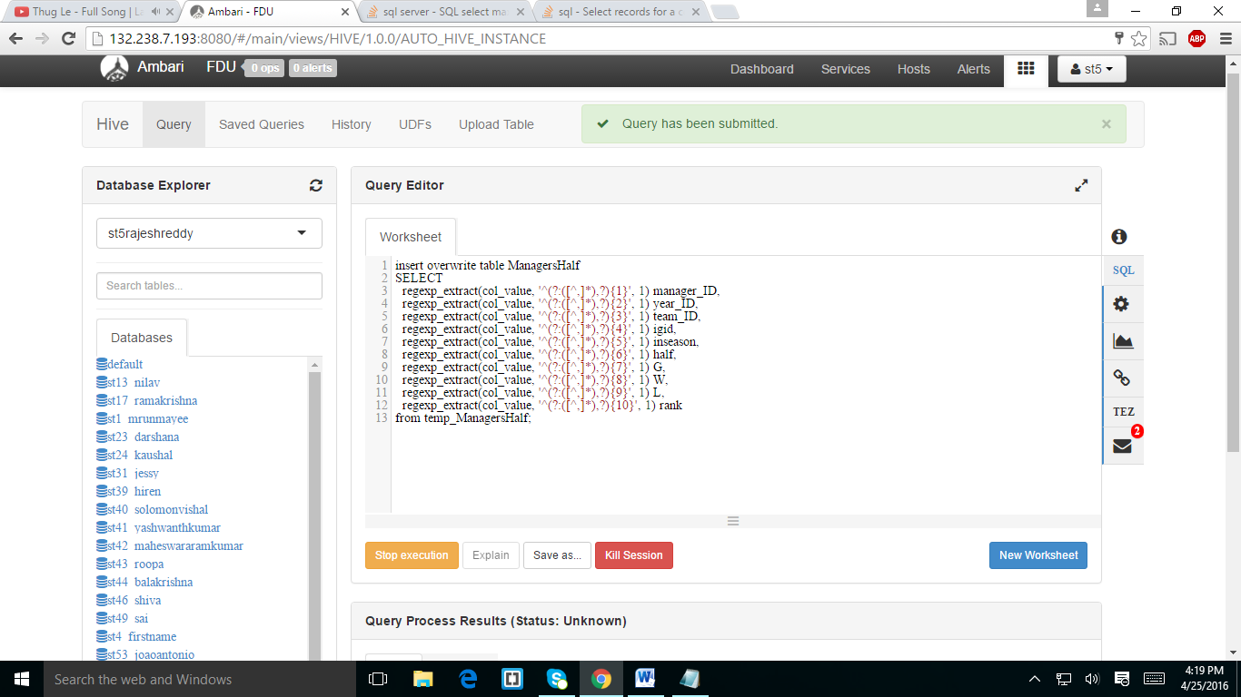

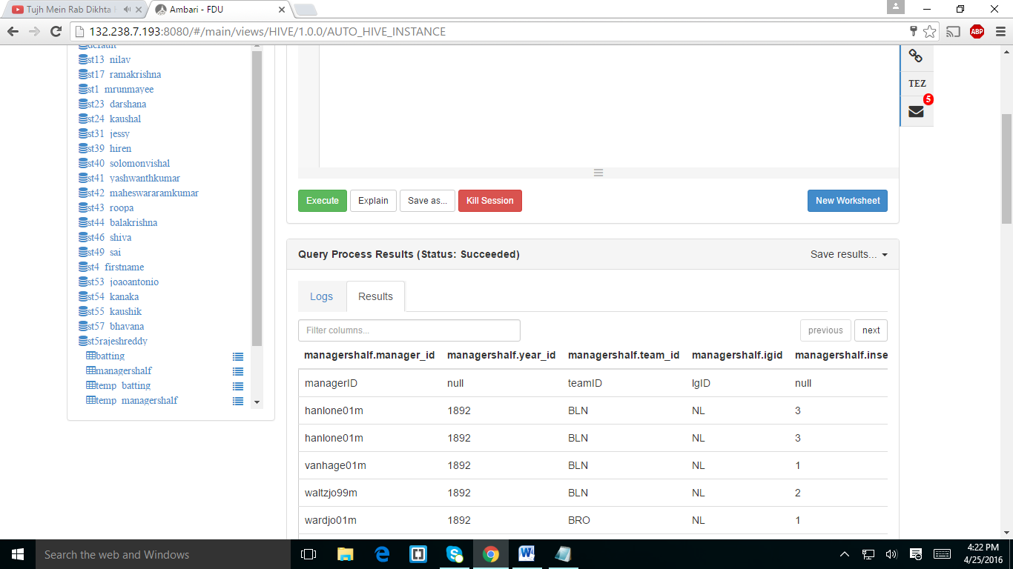

In the above screen shot I populate the table.

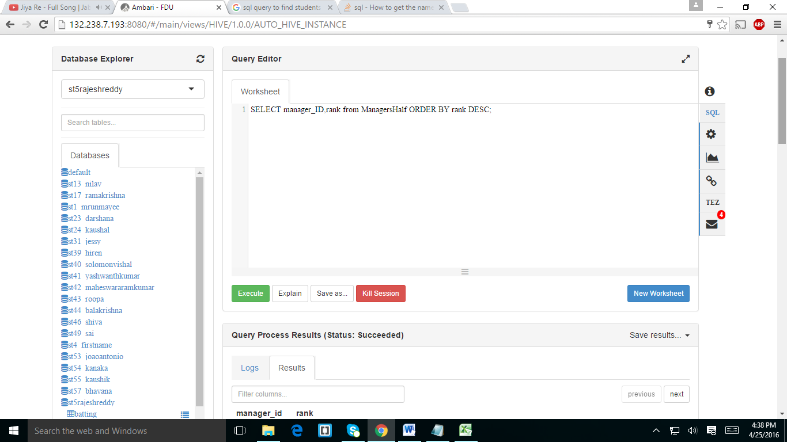

In the above screen shot I created statement for displaying the managers list with largest rank and the results displayed in below window.

