Program-Level Enrollment Structure Trends in U.S. Four-Year Institutions: An Applied IPEDS EF-CP Analysis for Higher Education Assessment Providers

Desha Matuska
Colorado State University Global
MIS581: Business Intelligence and Data Analytics
Dr. Orenthio Goodwin
May 3, 2026

Abstract
U.S. higher education faces sustained enrollment pressure driven by demographic shifts and uneven patterns of enrollment change across programs and student populations. This applied study examines program-level enrollment structure within U.S. four-year institutions using longitudinal Integrated Postsecondary Education Data System (IPEDS) EF-CP data. The analysis includes 216,259 program-level observations across five biennial reporting years (2016-2024) and evaluates differences in enrollment by academic program category, student level, and attendance status using descriptive statistics, trend analysis, and generalized linear modeling. Results indicate statistically significant differences in mean enrollment across program categories and student composition, as well as meaningful program-by-attendance-status interactions. However, program-specific differences in enrollment change over time were not statistically detectable. Findings demonstrate that enrollment disruption is structurally differentiated rather than uniform and should be interpreted as comparative signals rather than causal explanations. The study translates these results into decision-support insights for higher education assessment providers, emphasizing segmentation, contextualized benchmarking, and responsible interpretation to support accreditation, assessment, and continuous improvement efforts.
Keywords: Program-level enrollment, IPEDS EF-CP, higher education analytics, assessment providers, enrollment segmentation

Program-Level Enrollment Structure Trends in U.S. Four-Year Institutions: An Applied IPEDS EF-CP Analysis for Higher Education Assessment Providers
U.S. higher education is entering a sustained period of enrollment pressure in which institutions must respond to demographic shifts, intensified competition, and increasing demands to demonstrate value. In The Demographic Cliff Is Here, Paterson (2026) reports that a decline in new high school graduates is expected to begin now and cites projections indicating approximately 13% fewer high school graduates by 2041, with implications including more than 400,000 fewer students in the near term. These conditions heighten institutional urgency to adjust recruiting strategies, program offerings, and modality decisions rather than relying on the historical assumption that demand will rebound on its own (Paterson, 2026).
Empirical evidence further shows that enrollment changes are uneven rather than uniform. Fields and Brint (2023) describe the reversal of long-term expansion trends in the 2010s and show that total U.S. higher education enrollments declined by nearly seven percent between 2010 and 2019, with variation across tiers. Their work highlights the value of interpreting current conditions as “disruptions” that differ across institutional contexts rather than as a single system-wide decline (Fields & Brint, 2023). For higher education assessment providers, this unevenness matters because it shapes where institutions experience the greatest pressure to justify program effectiveness, maintain accreditation standing, and prioritize continuous improvement investments.
Leadership-focused scholarship reinforces that institutions must plan strategically and make programmatic decisions grounded in evidence. Strategic planning is paramount in response to the enrollment cliff, including conducting needs analyses, evaluating the net value of programs and services, and redesigning offerings to better align with the populations that institutions seek to serve (Campion, 2022). This framing aligns with assessment providers’ need to anticipate where institutions will require stronger documentation of outcomes, assessment support, and accreditation-related decision tools as enrollment pressures reshape institutional priorities.
At the program level, enrollment patterns can also be shaped by delivery modality, program structure, and student composition. One research article, using IPEDS-reported enrollment data, documents relationships between online enrollment and institutional diversity measures while also noting important IPEDS reporting constraints that require careful interpretation (Hoey, 2021). Another paper further demonstrates that academic programs vary substantially in how they adapt curricula to emerging skill demands, which is an important program “signal” that may plausibly intersect with student demand, even when not directly measured as an enrollment driver in administrative datasets (King, 2022).
Although enrollment disruption is widely discussed, higher education assessment providers often lack program-level, data-driven insight into where enrollment pressure is most concentrated and how enrollment composition is changing across programs and student segments. Without clear program-level signals, assessment providers may be forced to rely on generalized narratives about demographic decline rather than actionable segmentation and targeting aligned to accreditation and continuous improvement needs. This capstone project uses longitudinal IPEDS EF-CP (Fall Enrollment by Race/Ethnicity - Major Field of Study) data to identify program-level enrollment patterns within U.S. four-year institutions and translate those patterns into decision support for higher education assessment providers. Findings are intended to inform market segmentation, targeting, and innovation opportunities related to accreditation, assessment services, and continuous improvement offerings.
Objectives
The overall objective of this capstone is to examine program-level enrollment trends within U.S. four-year institutions using longitudinal IPEDS EF-CP data and to identify where enrollment disruption may be concentrated across academic programs and student segments. This objective aligns with the broader evidence that enrollment outcomes vary across contexts and require segmentation to support strategic decision-making (Fields & Brint, 2023; Campion, 2022).
The specific objectives of this study are to:
- Analyze longitudinal enrollment trends across selected program categories (major fields of study) in U.S. four-year institutions, recognizing that demographic pressures may affect program areas differently (Paterson, 2026).
- Test whether enrollment trends differ significantly across program categories, supporting a program-level understanding of disruption consistent with tier-based variation described in higher education enrollment research (Fields & Brint, 2023).
- Assess whether enrollment trends differ by student composition, including undergraduate vs. graduate and full-time vs. part-time, consistent with research showing that enrollment composition patterns can vary by level and attendance status (Hoey, 2021).
- Translate results into decision-support insights for assessment providers, aligning enrollment segmentation with the types of strategic responses institutions pursue in enrollment-decline environments (Phillips & Jones, 2025).
- Apply responsible interpretation practices, acknowledging limitations of administrative reporting and avoiding deficit-oriented conclusions, consistent with equity-focused guidance on careful terminology and interpretation in large-scale education datasets (Burmicky et al., 2022).
Overview of Study
This study is an applied, quantitative analysis of longitudinal program-level enrollment patterns within U.S. four-year institutions. The analysis uses IPEDS EF-CP data structured by institution, major field of study (CIP code), student level (undergraduate/graduate), attendance status (full-time/part-time), and reporting year. The study’s logic is grounded in the research consensus that enrollment change is not evenly distributed, and that decision-makers require more granular signals than institution-wide totals to understand where pressures are concentrated (Fields & Brint, 2023).
The study is explicitly oriented toward higher education assessment provider companies. From an applied perspective, program-level enrollment shifts can signal where institutions may face increased accountability scrutiny, heightened pressure to justify program value, and greater need for assessment evidence to support accreditation and continuous improvement initiatives (Campion, 2022). This aligns with the strategic and tactical responses described in the enrollment-cliff literature, which encourage institutions to rethink recruiting and positioning, cultivate new audiences, and use targeted strategies rather than generalized messaging (Phillips & Jones, 2025; Paterson, 2026).
Research Questions and Hypotheses
The capstone is guided by four research questions and corresponding null (H₀) and alternative (H₁) hypotheses:
- How do mean enrollment levels differ across the academic program categories examined within U.S. four-year institutions?
  - H₀₁: Mean enrollment trends do not differ significantly across the academic program categories examined within U.S. four-year institutions.
  - H₁₁: Mean enrollment trends differ significantly across the academic program categories examined within U.S. four-year institutions.
- Are there statistically significant differences in enrollment between undergraduate and graduate students across all included programs at U.S. four-year institutions?
  - H₀₂: There is no statistically significant difference in enrollment trends between undergraduate and graduate students across all included programs at U.S. four-year institutions.
  - H₁₂: There is a statistically significant difference in enrollment trends between undergraduate and graduate students across all included programs at U.S. four-year institutions.
- Within the program categories examined, are there statistically significant differences in enrollment trends between full-time and part-time students at U.S. four-year institutions?
  - H₀₃: Within the program categories examined, there is no statistically significant difference in enrollment trends between full-time and part-time students at U.S. four-year institutions.
  - H₁₃: Within the program categories examined, there is a statistically significant difference in enrollment trends between full-time and part-time students at U.S. four-year institutions.
- Within the academic program categories examined, are there statistically significant differences in enrollment trends over time across program categories at U.S. four-year institutions?
  - H₀₄: Enrollment trends over time do not differ significantly across program categories.
  - H₁₄: Enrollment trends over time differ significantly across program categories.
These questions reflect the broader research premise that enrollment disruption varies across contexts and that segmentation, either by program or composition, can improve strategic decision-making in constrained enrollment environments (Fields & Brint, 2023; Phillips & Jones, 2025).
Literature Review
Enrollment Pressure and the Demographic Cliff
The demographic cliff provides a strong contextual rationale for studying enrollment trends longitudinally. Paterson (2026) reports that a decline in new high school graduates is beginning now and emphasizes that institutions are already rethinking recruiting strategies, program offerings, and modality choices as the pipeline contracts. The article also highlights the importance of retention and serving students well as part of institutional resilience, which is an important contextual factor when interpreting changes in enrollment patterns (Paterson, 2026).
Campion (2022) complements this perspective by emphasizing proactive planning, including needs analysis, evaluation of current programs and services, and strategic redesign rather than reactive reductions. Together, these sources support the relevance of program-level analytics because enrollment pressure often translates into program evaluation decisions, which can create demand for assessment providers’ services tied to accreditation and continuous improvement.
Enrollment Disruption and Variation Across Contexts
Fields and Brint (2023) provide empirical support for the claim that enrollment change is uneven and tier dependent. They report that total enrollments declined by nearly seven percent between 2010 and 2019 and that the phrase “disruptions in enrollments” is preferable because trends varied by tier. Specifically, they describe a 25% drop in community college enrollments during the period and growth at public research universities, underscoring the unevenness of enrollment trajectories (Fields & Brint, 2023). While this capstone focuses on four-year institutions, the key implication is that “one-size-fits-all” narratives are insufficient for decision support. Granular segmentation is necessary to identify where pressures are concentrated and where stability exists.
Strategic Response, Segmentation, and Relevance to Assessment Providers
Marketing and strategic enrollment responses often depend on segmentation and targeting. Phillips and Jones (2025) identify strategies perceived as important for addressing predicted enrollment declines, including brand positioning, targeting specific student populations, cultivating new audiences, and using multiple marketing tools with testing for effectiveness. Although the capstone is not a marketing study, this research reinforces why program-level enrollment analytics can serve as a key input to institutional strategy: helping institutions (and supporting vendors) prioritize efforts where demand is shifting.
For assessment providers, these segmentation dynamics connect directly to market strategy. If enrollment declines concentrate in specific program areas or student segments, institutions may experience heightened scrutiny to demonstrate outcomes and program value, increasing demand for assessment tools, reporting support, and continuous improvement frameworks. This linkage aligns with the broader urgency in the demographic cliff discourse and leadership guidance to redesign offerings strategically (Paterson, 2026; Campion, 2022).
Program Structure, Curriculum Adaptation, and Enrollment Signals
Program-level enrollment patterns may plausibly intersect with program “signals,” such as curricular adaptation and public-facing descriptions of program relevance. King (2022) documents the extent to which AACSB-accredited accounting programs have incorporated data analytics into curricula and concludes that significant opportunities remain for innovation. The study notes that less than half of sampled programs have adequately adapted to workplace demands and that only a small percentage discuss analytics in course catalogs (King, 2022). Although the study does not directly measure enrollment outcomes, the evidence supports the broader argument that program-level differentiation and signaling vary across institutions, which makes a plausible contextual factor when interpreting shifts in demand across fields. For assessment providers, this supports the value of program-level analytics because curricular adaptation and program positioning can shape accreditation and assessment needs.
Modality and Enrollment Composition
Enrollment composition can vary by delivery modality and student level, with important implications for interpretation. Hoey (2021) uses IPEDS-reported enrollment data in an ex-post facto design and applies descriptive statistics and correlation analysis to examine relationships between online enrollment and minority enrollment in a specific institutional sector. The study reports that relationships vary by academic level and emphasizes limitations in how certain online enrollment demographics are reported, reinforcing the need for careful inference (Hoey, 2021). For this capstone, Hoey’s work supports segmenting by undergraduate/graduate and full-time/part-time because composition dynamics can differ across these groupings, and such segmentation can reveal patterns that institutional totals may mask.
Persistence, Financial Factors, and Complex Enrollment Systems
Enrollment outcomes are not only shaped by recruitment but also by persistence and retention dynamics. Gilstrap (2020) examines persistence among at-risk students using multiple linear regression and network analysis and highlights the complexity of enrollment-related systems, noting that variables often interact in nonlinear ways and that modeling choices can affect what patterns are detected. The study also reports financial dynamics related to persistence (e.g., relationships between aid and attrition/persistence), reinforcing that enrollment patterns can reflect multiple interacting mechanisms rather than a single cause (Gilstrap, 2020). For this capstone, Gilstrap’s work supports cautious interpretation: program-level changes in enrollment composition should be treated as signals for decision support rather than deterministic judgments about students or programs.
Ethical, Privacy, and Governance Considerations in Higher Education Analytics
Ethical considerations are central even when using aggregated or secondary data. Yang and Beil (2024) argue that AI/ML advancements have transformed higher education data management. Institutions must evaluate privacy policies and practices, including governance, transparency, and safeguards, especially when third-party vendors and expanded data collection are involved (Yang & Beil, 2024). Their discussion highlights FERPA as a key federal privacy law in higher education and distinguishes data privacy, security, and ethical use of data as interconnected but distinct concepts (Yang & Beil, 2024).
From an interpretation and research rigor standpoint, Pandey (2025) emphasizes that modern comparative education research increasingly uses data-intensive approaches, but that ethical concerns, data privacy issues, and contextual disparities remain persistent challenges requiring transparent methodological rigor. In addition, Burmicky et al. (2022) explicitly acknowledge limitations in large datasets for accurately capturing identities and emphasize careful terminology and inclusive framing. These studies are relevant for any enrollment analysis that might otherwise be misused as deficit labeling.
Collectively, the literature supports a program-level, longitudinal approach to understanding enrollment disruption. Yet a practical gap remains: assessment providers need actionable program-level signals to anticipate institutional needs and align services, rather than relying on broad narratives about enrollment decline. This capstone addresses that gap by applying structured analysis to IPEDS EF-CP program-level data and framing outputs as decision-support insights tailored to assessment providers.
Research Design
This capstone uses a quantitative, non-experimental, longitudinal design based on secondary administrative data. The rationale for a longitudinal design is consistent with evidence that enrollment disruption unfolds over time and varies across contexts (Fields & Brint, 2023). The study is non-experimental because it analyzes observed enrollment patterns rather than manipulating conditions. The design is also explicitly applied: its intent is to generate actionable segmentation insight for assessment providers rather than to make causal claims about why enrollments change. This decision-support orientation aligns with leadership guidance emphasizing strategic planning and evidence-based program decisions during enrollment pressure (Campion, 2022).
Methodology
The methodology is quantitative and uses secondary, aggregated administrative enrollment data. This aligns with the way multiple higher education studies use structured datasets to examine enrollment patterns and relationships across institutions and time (Fields & Brint, 2023). The unit of analysis is the program-level enrollment record (institution, major field of study, student segment, and year). Segment dimensions include student level and attendance status. This segmentation logic is consistent with empirical work showing that enrollment patterns and relationships can differ by level and status and that disaggregation may be necessary to detect meaningful patterns (Hoey, 2021).
Methods
Data will be organized into a longitudinal structure across multiple reporting years, with consistent program category and segment definitions applied across years. Data preparation will include checks for missingness and comparability across time to ensure that observed differences reflect reporting patterns rather than inconsistent data inclusion.
The planned analysis proceeds in three phases:
- Descriptive statistics to summarize enrollment totals and distributions by program category and segment across the selected years.
- Trend analysis to examine changes in enrollment over time by program category and segment (undergraduate/graduate; full-time/part-time).
- Inferential testing to evaluate whether differences across groups are statistically significant, aligned to the null hypotheses (H₀). In later findings, interpretation will follow standard hypothesis-testing logic (i.e., fail to reject or reject the null hypothesis).
Where appropriate, the study may use regression-style extensions to explore relationships among variables while acknowledging the complexity of enrollment systems and the limitations of linear modeling highlighted in persistence research (Gilstrap, 2020). The tools that will be utilized in the study are:
- SAS OnDemand for Academics: https://welcome.oda.sas.com/
- NCES IPEDS portal (data access): https://nces.ed.gov/ipeds/
Limitations
Several limitations must be acknowledged for responsible interpretation. First, administrative datasets constrain what can be concluded. Fields and Brint (2023) rely on state-level pooled data and explicitly emphasize that the analysis is contextual rather than causal, underscoring that enrollment trends reflect multiple interacting contexts. Similarly, this capstone treats results as comparative signals rather than causal explanations.
Second, IPEDS-based research can be limited by reporting scope and definitional constraints. Hoey (2021) notes limitations in the availability of certain modality-by-demographic details in IPEDS reporting, requiring careful inference and preventing overly specific claims about online enrollment composition.
Third, some plausible drivers of enrollment change are not directly measured in enrollment datasets. King (2022) demonstrates that programs vary in curricular adaptation and public-facing signaling, but those features are not directly linked within enrollment records, limiting causal interpretation.
Fourth, aggregated enrollment counts cannot capture student-level persistence mechanisms. Gilstrap (2020) shows that persistence is shaped by complex interactions among financial and academic variables and that modeling choices affect what is observed. Because this capstone does not use student-level persistence records, interpretations of enrollment composition changes must remain cautious and contextual.
Ethical Considerations
Ethical considerations remain central even when using aggregated, secondary data. There must be responsible interpretation and avoidance of deficit framing. Data-intensive approaches can support evidence-based policy but also raise ethical challenges, including risks of misinterpretation and the need for contextualization (Pandey, 2025). Large-scale datasets can fail to capture identities fully, and researchers should use careful terminology and inclusive framing to avoid harm (Burmicky et al, 2022). Consistent with these principles, this capstone will frame results as decision-support signals and avoid ranking or labeling programs or student groups as inherently successful or unsuccessful.
In addition, data privacy, data security, and ethical use of data are vital guidelines. AI/ML tools and third-party vendor relationships can heighten privacy risks and governance needs in higher education (Yang & Beil, 2024). Although IPEDS EF-CP is aggregated and not student-identifiable at the level used in this study, the project will still follow good governance practices, such as secure storage, controlled access, and avoidance of any re-identification attempt (Yang & Beil, 2024).
Finally, the project must address stakeholder impact and ethical use by an assessment-provider audience. Because the intended audience includes assessment providers that may use analytics for segmentation and targeting, ethical reporting must explicitly prevent misuse. Institutions are already under pressure to rethink strategies and emphasize what makes them distinctive (Paterson, 2026). Analytics framed as rankings could intensify harmful competition or deficit narratives. Accordingly, the capstone will present findings as contextualized patterns that can inform constructive planning, consistent with leadership-oriented guidance to redesign programs and services thoughtfully (Campion, 2022).
The literature and research framework presented in this study establishes a strong rationale for examining enrollment disruption at the program level. Demographic pressures, uneven enrollment trajectories across higher education, and strategic institutional responses all point to the need for more granular, evidence-based insight into how enrollment patterns are shifting across academic programs and student segments. By grounding the analysis in longitudinal IPEDS EF-CP data and emphasizing careful segmentation by program category, student level, and attendance status, this study positions enrollment trends as meaningful indicators of where institutions may experience heightened pressure to demonstrate program effectiveness and outcomes. These patterns are particularly relevant for higher education assessment providers, as they help identify where demand for accreditation support, assessment infrastructure, and continuous improvement services is most likely to intensify. The following findings build on this foundation by empirically examining enrollment trends across programs and student populations, translating descriptive and statistical results into decision-relevant insights that reflect the complex and differentiated nature of enrollment change in U.S. four-year institutions.
Findings
Across the four research questions, three null hypotheses (H₀₁-H₀₃) were rejected, indicating statistically significant differences by program category, attendance status, and student level. The null hypothesis for Research Question 4 (H₀₄) was not rejected, as program-specific differences in enrollment change over time were not statistically detectable. These outcomes frame the findings that follow and guide their analytical interpretation. All analyses assume consistency in IPEDS reporting definitions and treat enrollment totals as comparative structural indicators rather than causal measures. Accordingly, results are interpreted as analytical signals intended to inform segmentation and decision support, not to attribute enrollment change to specific institutional actions or student behaviors.
Findings are organized by research question, beginning with program-level differences (RQ1), followed by attendance-status differences within programs (RQ3), student-level differences across programs (RQ2), and trend differences over time by program category (RQ4). The analytic dataset used for this capstone contained 216,259 observations across five biennial IPEDS EF-CP reporting years (2016, 2018, 2020, 2022, 2024) and included the variables UNITID, CIPCODE, LSTUDY, SECTION, YEAR, and enrollment totals (EFTOTLT, EFTOTLM, EFTOTLW). Enrollment in this component is defined as for‑credit fall enrollment reported on the institution’s official reporting date or October 15, and EFTOTLT represents the grand total of men and women enrolled for credit.
Descriptive statistics showed that EFTOTLT was highly right‑skewed, with a mean of 443.31, a median of 107, a minimum of 1, and a maximum of 67,439 (SD = 1,318.89), indicating substantial dispersion and outliers. The distribution of observations across reporting years was relatively even: 2016 (45,357; 20.97%), 2018 (43,448; 20.09%), 2020 (42,263; 19.54%), 2022 (42,393; 19.60%), and 2024 (42,798; 19.79%). The analytic file included three program categories by CIPCODE: 52 (Business; 211,466; 97.78%), 22.0101 (Law; 3,029; 1.40%), and 51.1201 (Medicine; 1,764; 0.82%). These frequencies indicate that the analytic scope is program‑comparative but empirically imbalanced toward Business, which is important for interpreting practical significance alongside statistical significance.
For the program‑level comparison, mean enrollment differed across the included program categories: Law averaged 386.81, Business averaged 443.59, and Medicine averaged 507.18. A one‑way GLM/ANOVA comparing mean EFTOTLT across these program categories produced F(2, 216,256) = 4.85, p = .0078. At α = .05, the null hypothesis for the program‑level question was rejected, indicating that mean enrollments differed across Business, Law, and Medicine within the analytic dataset. Because enrollment distributions were highly dispersed, the variance assumption was evaluated; Levene’s test was statistically significant (p = .0047), indicating heterogeneity of variance across program categories and supporting cautious interpretation of mean differences in the presence of unequal variability.
Analytically, these results indicate that enrollment scale differs systematically by program context rather than reflecting random variation. This pattern reinforces the study’s central premise that enrollment disruption is structurally differentiated across academic fields, supporting the use of program-level segmentation as a more informative analytical lens than institution-wide enrollment totals. Although the differences in mean enrollment were statistically significant, the presence of heterogeneity of variance and high dispersion suggests that these differences should be interpreted qualitatively as comparative structural signals rather than precise magnitude effects.
Attendance status differences were also pronounced in descriptive results. Mean enrollments differed across SECTION values, with SECTION 1 averaging 471.02, SECTION 2 averaging 194.48, and SECTION 3 averaging 625.46. In the factorial GLM model reported in the analysis output, the Type III tests indicated a statistically significant SECTION effect (F = 185.03, p < .0001) and a statistically significant CIPCODE × SECTION interaction (F = 11.46, p < .0001). At α = .05, the null hypothesis regarding attendance status differences (and the absence of an interaction) was rejected, indicating that enrollments differed by attendance status and that attendance‑status differences varied across program categories within the analytic scope. The same output reported that the Type III main effect for CIPCODE in this factorial specification was not statistically significant (p = .0759), whereas the interaction remained significant, indicating that the program‑by‑attendance pattern was a key differentiator in this model.
From an analytical perspective, the significant program-by-attendance interaction indicates that attendance composition is not merely a descriptive characteristic, but a structural dimension that shapes enrollment patterns differently across programs. This finding supports incorporating attendance status explicitly into program level analytical frameworks when interpreting enrollment structure for assessment planning and implementation.
Student-level differences were evaluated using the student‑level model included in the analysis output, where LSTUDY was represented at two levels (values 2 and 12 in the model’s class-level information). The LSTUDY effect was statistically significant, F(1, 16,377) = 429.75, p < .0001, with R² = 0.02557. Analytically, the modest proportion of variance explained indicates that student-level differences represent one meaningful component of enrollment structure. These differences should be interpreted alongside other contextual factors rather than as a dominant driver of enrollment outcomes. At α = .05, the null hypothesis for the program‑agnostic student‑level comparison was rejected, indicating statistically significant mean differences by the LSTUDY categories evaluated in that model, while also showing that the model explains a modest proportion of variance in EFTOTLT. Although LSTUDY appears with multiple coded values in the broader file, the reported GLM specification evaluates student-level differences using the two LSTUDY categories represented in the model output (values 2 and 12).
Trend analysis was treated descriptively rather than predictively, consistent with the expectations for reporting results and the study’s decision‑support orientation. Descriptively, mean EFTOTLT increased from 423.21 in 2016 to 471.37 in 2024, with intermediate means of 439.60 (2018), 445.65 (2020), and 437.96 (2022). A model examining YEAR, CIPCODE, and YEAR×CIPCODE reported a non‑significant YEAR×CIPCODE interaction (p = .8536), supporting an interpretation that program‑specific differences in change over time were not statistically detectable through that interaction term in the reported specification. At α = .05, the null hypothesis for Research Question 4 (H₀₄) was not rejected, indicating that program‑specific differences in enrollment change over time were not statistically detectable through the YEAR × CIPCODE interaction.
Analytically, the absence of a statistically significant YEAR × CIPCODE interaction suggests that while enrollment levels differ by program category, the direction and shape of enrollment change over time are broadly similar across the program areas examined. This result indicates that program specific enrollment differences are primarily structural rather than temporal within the analytic scope of this study, reinforcing the value of segmentation while cautioning against overinterpreting short-term program-specific trend divergence.
Figure 1
Data set scope and sample size
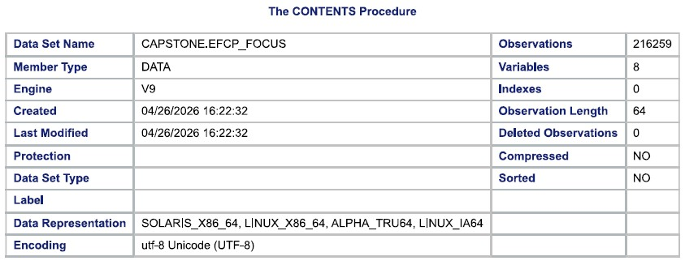
Figure 2
Data set variable list and attributes

Figure 3
Frequency procedure of the data set (YEAR, CIPCODE, SECTION)
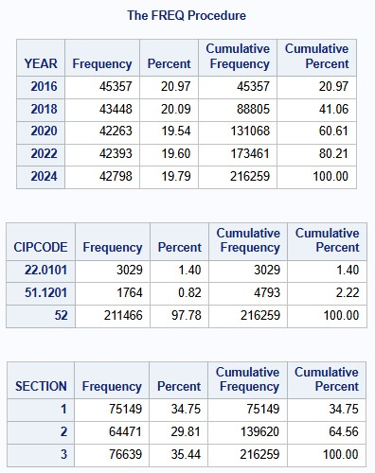

Figure 4
Frequency procedure of the data set (LSTUDY)
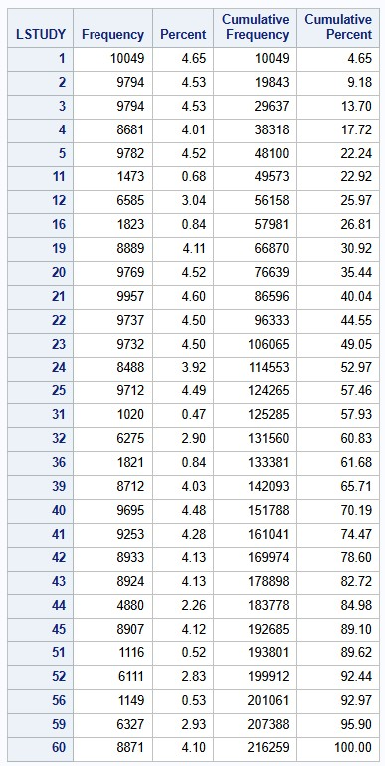

Figure 5
Means procedure with EFTOTLT as the analysis variable (YEAR, CIPCODE, SECTION)
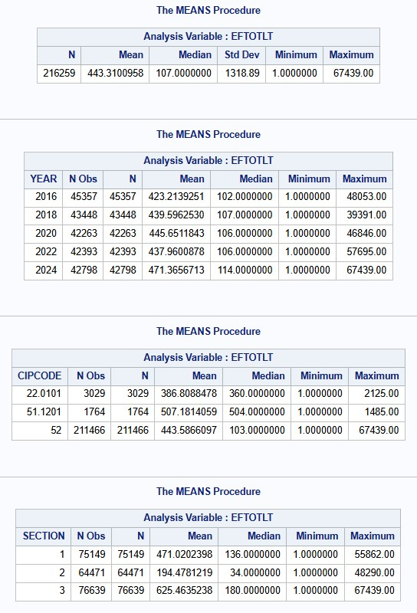

Figure 6
Means procedure with EFTOTLT as the analysis variable (LSTUDY)
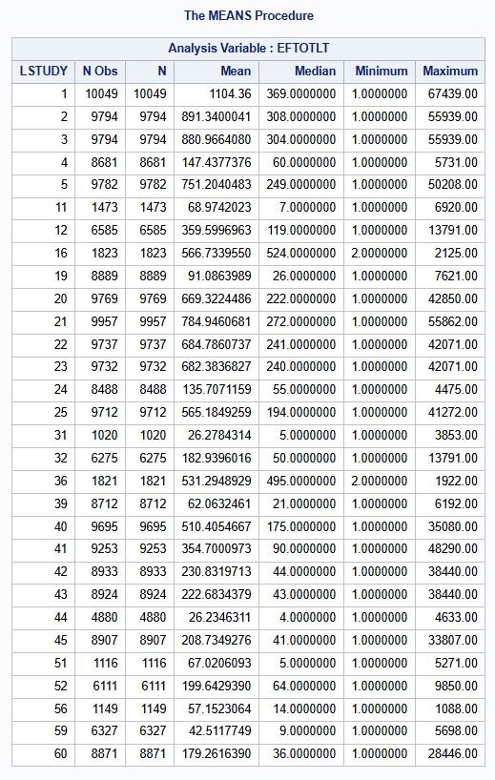

Figure 7
CIPCODE GLM procedure
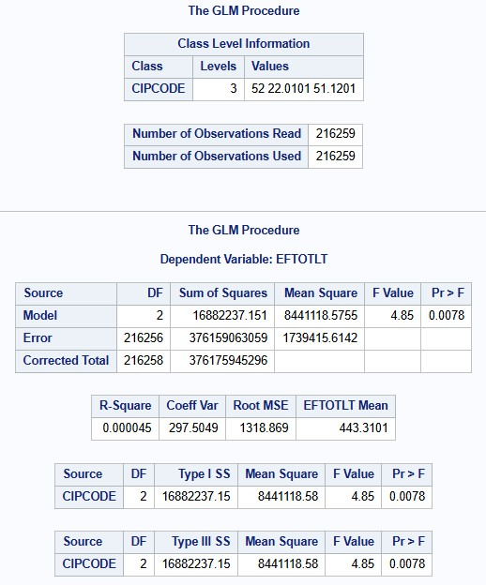
Figure 8
Levene’s Test of EFTOTLT for CIPCODE
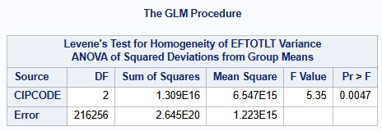

Figure 9
Distribution of EFTOTLT across CIPCODE
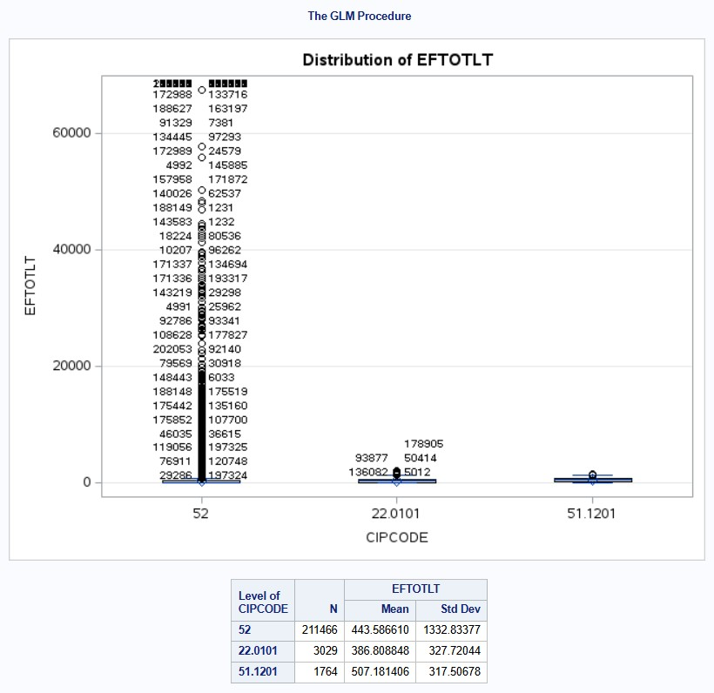

Figure 10
Mean Enrollment by Program Category and Attendance Status Type III SS table and chart
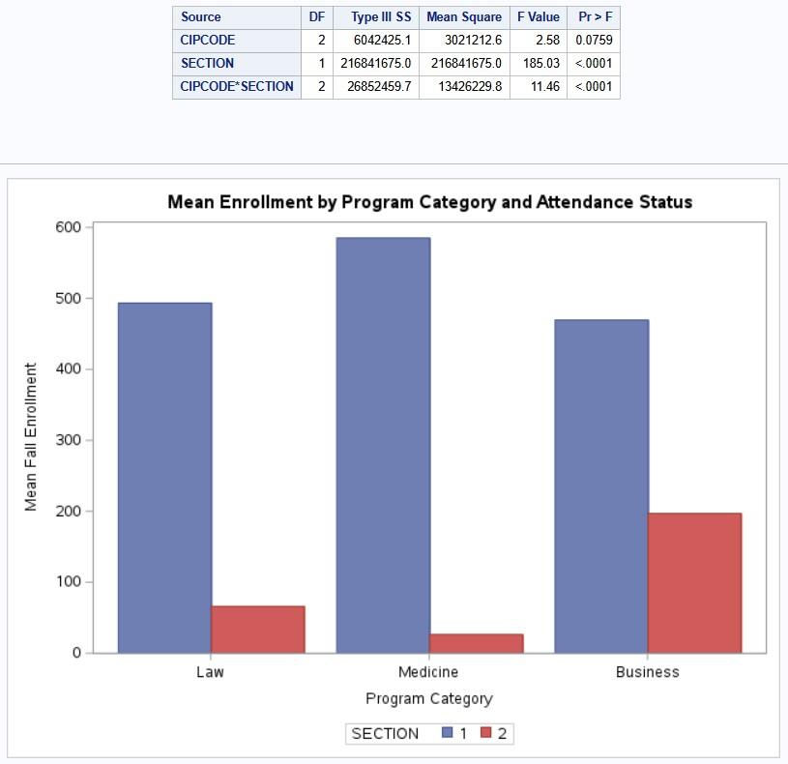

Figure 11
LSTUDY GLM procedure
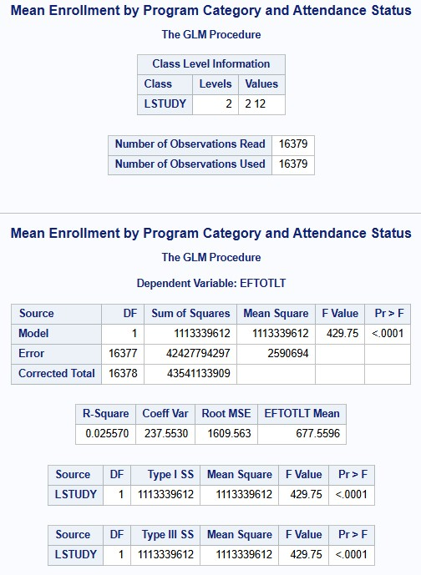

Figure 12
Mean Fall Enrollment by Student Level (All Programs) chart
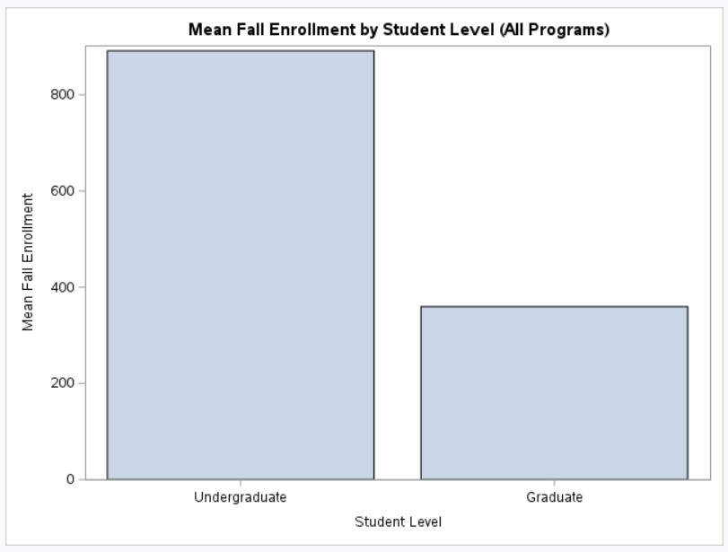

Figure 13
Overall Enrollment Trend Across Reporting Years chart
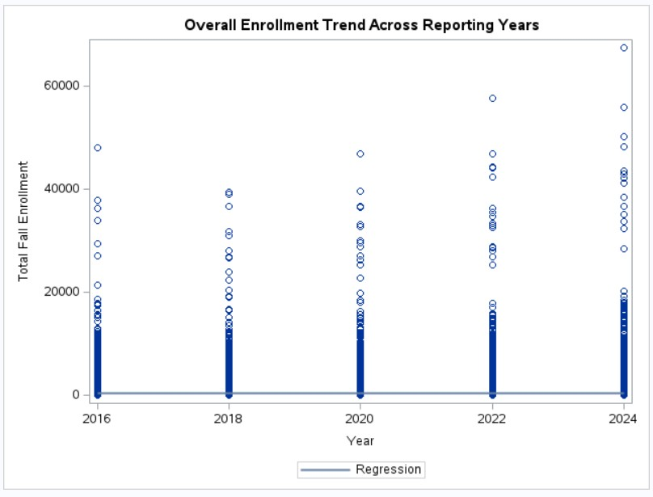

Figure 14
Enrollment Trends Over Time by Program Category Type III SS table and chart
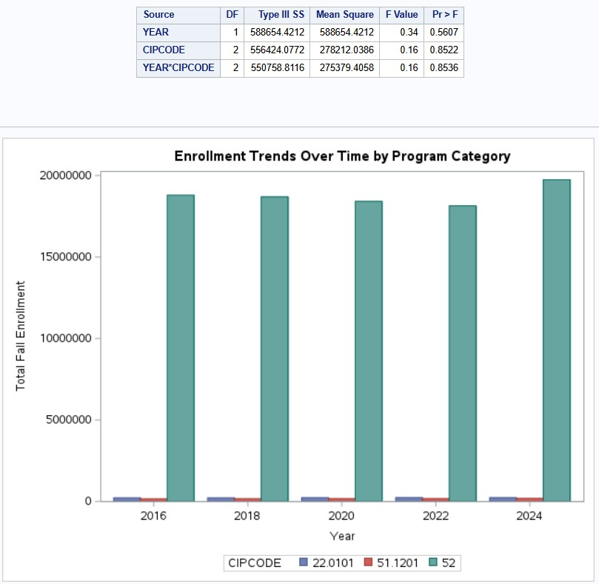
In summary, the inferential results across program category, attendance status, and student level reinforce the study’s central premise that enrollment disruption is structurally differentiated rather than uniform. At the same time, the non-significant YEAR × CIPCODE interaction suggests that program-specific differences in change over time were not statistically detectable within the reported specification. Collectively, these findings indicate that enrollment structure varies meaningfully across program and compositional dimensions, while time-based differences across the specific program categories included in this analytic scope were not statistically distinguishable.
Conclusion
This capstone used IPEDS EF‑CP longitudinal enrollment records to examine program‑level enrollment structure within U.S. four‑year institutions and to translate those patterns into decision‑support insight for higher education assessment providers. The analytic dataset included 216,259 records across five biennial reporting years and focused on three program categories present in the final prepared file: Business (CIPCODE 52), Law (22.0101), and Medicine (51.1201). Enrollment was measured using EFTOTLT, the IPEDS-defined total for‑credit fall enrollment, and findings were reported using hypothesis‑testing language centered on rejecting or failing to reject the null hypotheses.
Across the inferential tests conducted, three of the null hypotheses were rejected within the scope of the reported models, while H₀₄ was not rejected due to the non-significant YEAR × CIPCODE interaction (p = .8536). Mean enrollment differed across program categories (rejecting the program‑level null), enrollments differed by attendance status with a significant program‑by‑attendance interaction (rejecting the attendance-related null), and enrollments differed by the student‑level categories evaluated in the student‑level model (rejecting the student‑level null). At the same time, the descriptive and diagnostic outputs indicate that enrollment counts are highly dispersed and right‑skewed, with evidence of unequal variances across program categories, underscoring the importance of interpreting statistically significant differences as comparative signals rather than causal explanations. This conclusion is consistent with the study’s applied purpose and with the broader literature, which emphasizes that enrollment disruption is uneven across contexts and that decision makers require segmented signals rather than generalized narratives (Fields & Brint, 2023; Campion, 2022).
Recommendations
The findings from this analysis provide several actionable implications for higher education assessment providers seeking to align their services with the enrollment structures institutions manage. Because the inferential results demonstrate statistically significant differences across program categories, attendance status, and student-level composition, while also revealing substantial dispersion and unequal variances, recommendations should emphasize segmentation, contextualization, and flexible implementation rather than uniform benchmarking. Because the YEAR × CIPCODE interaction was not statistically significant, providers should treat time-based changes as broad patterns and prioritize program and compositional segmentation when tailoring benchmarking and implementation approaches.
First, the statistically significant differences in mean enrollment across Business, Law, and Medicine identified in the program-level GLM/ANOVA analysis support a program-segmented approach to assessment services. Rather than if institution-wide enrollment narratives apply uniformly across academic portfolios, assessment providers should differentiate benchmarking frameworks, reporting depth, and implementation cadence by program context. The observed differences in scale and variability across program categories suggest that programs operate under distinct enrollment structures, which can affect assessment capacity, reporting frequency, and expectations for evidence. Providers can leverage program-level enrollment scale and dispersion as practical indicators when advising institutions on assessment infrastructure, staffing models, and accreditation documentation strategies.
Second, the statistically significant attendance-status effect and the significant program-by-attendance interaction reported in the factorial GLM model indicate that attendance composition meaningfully shapes enrollment structure, and that its effects vary across program categories. This finding supports incorporating attendance status explicitly into assessment implementation models and client success playbooks. Programs with different full-time and part-time enrollment profiles may require distinct timelines, data-collection approaches, and engagement strategies. Assessment providers can add value by offering implementation guidance and tools that adapt to attendance-driven differences rather than applying a single, standardized assessment workflow across all programs.
Third, the statistically significant student-level differences identified in the student-level model (LSTUDY) reinforce the importance of composition-aware benchmarking and interpretation. Although the model explains a modest proportion of variance, the results indicate that enrollment structure differs systematically by student level. Assessment providers should therefore avoid cross-program or cross-institution comparisons that ignore structural differences in student composition. Instead, providers can position benchmarks and comparative reports as descriptive decision aids that explicitly account for student-level context. Framing outputs in this way supports responsible interpretation and reduces the risk of inappropriate rankings or deficit-oriented conclusions.
Finally, the diagnostic results, particularly the high dispersion, right-skewed enrollment distributions, and evidence of unequal variances across program categories, underscore the need for cautious interpretation of statistical significance. Assessment providers should emphasize that statistically significant differences reflect comparative structural patterns rather than causal explanations or inherent program quality. Reporting narratives should contextualize results within enrollment scale, variability, and institutional constraints. This approach strengthens provider credibility, aligns with ethical guidance on responsible analytics, and supports institutions in using data constructively for planning, accreditation, and continuous improvement rather than competitive labeling.
All in all, these recommendations align assessment services with the differentiated enrollment realities institutions face. By grounding segmentation, benchmarking, and implementation support in empirically observed program- and composition-level enrollment structures, assessment providers can better anticipate institutional needs, tailor solutions, and support evidence-based decision-making in an increasingly constrained enrollment environment.
References
Burmicky, J., Ryu, W., Palomín, L., & Sáenz, V. B. (2022). Leveraging Data for Policy Change: A Descriptive Analysis of Latino Men’s Postsecondary Enrollment and Degree Attainment Patterns in Texas. Education Policy Analysis Archives, 30(129).
Campion, L. L. (2022). Leading Through the Enrollment Cliff of 2026 (Part II). TechTrends: Linking Research & Practice to Improve Learning, 66(1), 112–113. https://doi-org.csuglobal.idm.oclc.org/10.1007/s11528-021-00688-4.
Fields, B., & Brint, S. (2023). The Disruption in U.S. Public Higher Education Enrollments, 2009-2019: Sources of Inter-State Variation by Tier. Journal of Higher Education, 94(2), 256–285. https://doi-org.csuglobal.idm.oclc.org/10.1080/00221546.2022.2082787.
Gilstrap, D. L. (2020). Understanding Persistence of At-Risk Students in Higher Education Enrollment Management Using Multiple Linear Regression and Network Analysis. Journal of Experimental Education, 88(3), 470–485. https://doi-org.csuglobal.idm.oclc.org/10.1080/00220973.2019.1659217.
Hoey, R. (2021). Diversity and Distance Learning: An Exploratory Study of the Relationships between Online and Minority Enrollment at Private Nonprofit Christian Colleges. Christian Higher Education, 20(3), 160–183. https://doi-org.csuglobal.idm.oclc.org/10.1080/15363759.2020.1756530.
King, A. Z. (2022). Data analytics in Association to Advance Collegiate Schools of Business–accredited U.S. university accounting programs: A quantitative research study. Journal of Education for Business, 97(5), 320–328. https://doi-org.csuglobal.idm.oclc.org/10.1080/08832323.2021.1953430.
Pandey, M. P. (2025). Innovative Research Methods in Comparative Education: Emerging Trends and Applications. Discover Education, 4. https://doi-org.csuglobal.idm.oclc.org/10.1007/s44217-025-00616-1.
Paterson, J. (2026). The Demographic Cliff Is Here. Journal of College Admission, 269, 24–29.
Phillips, C. H., & Jones, S. J. (2025). Strategic and Tactical Marketing Strategies for Regional Public Universities to Address the Enrollment Cliff. Journal of Higher Education, 96(4), 653–677. https://doi-org.csuglobal.idm.oclc.org/10.1080/00221546.2024.2378640.
Yang, E., & Beil, C. (2024). Ensuring data privacy in AI/ML implementation. New Directions for Higher Education, 2024(207), 63–78. https://doi-org.csuglobal.idm.oclc.org/10.1002/he.20509.
National Center for Education Statistics. (2026). Integrated Postsecondary Education Data System (IPEDS): Fall enrollment survey (EF-CP). U.S. Department of Education. https://nces.ed.gov/ipeds/.

