<div class="section">

<div class="slider">

<div class="container slidercontent">

<h1 class="hero">Wow.</h1>

<h2 class="hero">Wow.Wow.Wow</h2>

<div class="call"><span>Wow</span></div>

</div>

</div>

</div>



<div class="section">

<div class="container">

<div class="col four">

<h1 class="icon">[]</h1>

<h1 class="service">Wow</h1>

<p>Wow wow wow wow wow wow wow wow wow wow wow wow wow</p>

</div>

<div class="col four">

<h1 class="icon">[]</h1>

<h1 class="service">Wow</h1>

<p>Wow wow wow wow wow wow wow wow wow</p>

</div>

<div class="responsivegroup"></div>

<div class="col four">

<h1 class="icon">[]</h1>

<h1 class="service">Wow</h1>

<p>Wow wow wow wow wow wow wow wow wow wow wow</p>

</div>

<div class="col four">

<h1 class="icon">[]</h1>

<h1 class="service">Wow</h1>

<p>Wow wow wow wow wow wow wow</p>

</div>

<div class="group"></div>

</div>

</div>

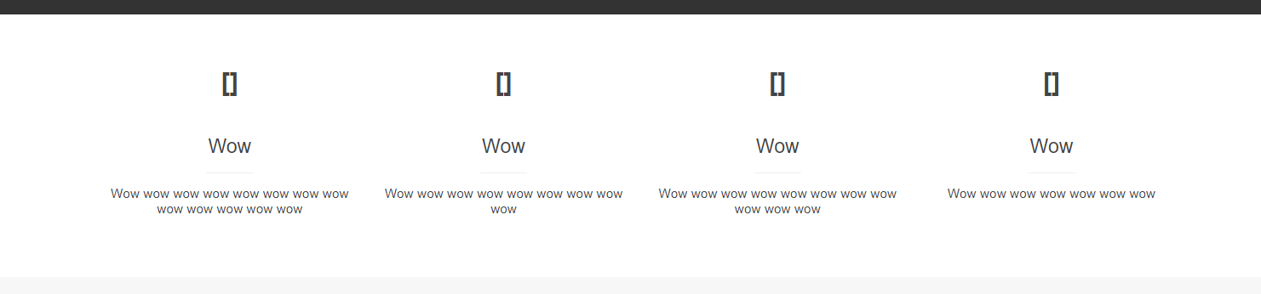

<div class="section bg">

<div class="container">

<h1>Wow wow</h1>

<h2>Wow wow wow!</h2>

<div class="col three bg nopad pointer">

<div class="imgholder"></div>

<h1 class="feature">Wow</h1>

<p>Wow wow</p>

</div>

<div class="col three bg nopad pointer">

<div class="imgholder"></div>

<h1 class="feature">Wow</h1>

<p>Wow wow wow</p>

</div>

<div class="col three bg nopad pointer">

<div class="imgholder"></div>

<h1 class="feature">Wow</h1>

<p>Wow wow wow</p>

</div>

<div class="group margin"></div>

<div class="col three bg nopad pointer">

<div class="imgholder"></div>

<h1 class="feature">Wow</h1>

<p>Wow wow</p>

</div>

<div class="col three bg nopad pointer">

<div class="imgholder"></div>

<h1 class="feature">Wow</h1>

<p>Wow wow wow</p>

</div>

<div class="col three bg nopad pointer">

<div class="imgholder"></div>

<h1 class="feature">Wow</h1>

<p>Wow wow wow</p>

</div>

<div class="group"></div>

</div>

</div>

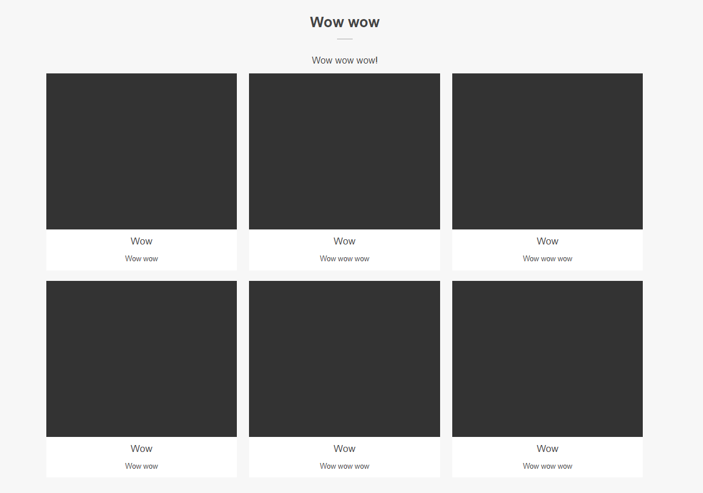

<div class="section">

<div class="container">

<h1>Wow? Wow wow wow wow!</h1>

<h2>Wow</h2>

<div class="col three">

<h1 class="icon side">[]</h1>

<h1 class="feature side">Wow</h1>

<p class="side">Wow wow wow wow wow wow wow wow wow wow wow wow wow</p>

</div>

<div class="col three">

<h1 class="icon side">[]</h1>

<h1 class="feature side">Wow</h1>

<p class="side">Wow wow wow wow wow wow wow wow</p>

</div>

<div class="col three">

<h1 class="icon side">[]</h1>

<h1 class="feature side">Wow</h1>

<p class="side">Wow wow wow wow wow wow wow wow wow wow wow</p>

</div>

<div class="group margin"></div>

<div class="col three">

<h1 class="icon side">[]</h1>

<h1 class="feature side">Wow</h1>

<p class="side">Wow wow wow wow wow wow wow</p>

</div>

<div class="col three">

<h1 class="icon side">[]</h1>

<h1 class="feature side">Wow</h1>

<p class="side">Wow wow wow wow wow wow wow wow</p>

</div>

<div class="col three">

<h1 class="icon side">[]</h1>

<h1 class="feature side">Wow</h1>

<p class="side">Wow wow wow wow wow wow wow wow</p>

</div>

<div class="group margin"></div>

</div>

</div>

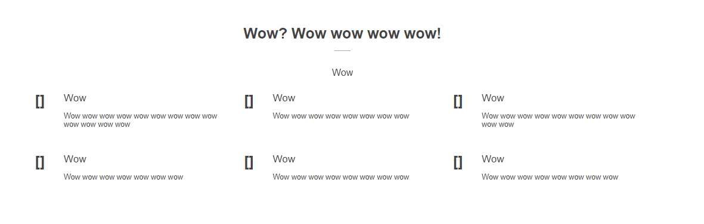

<div class="section bg">

<div class="container">

<h1>Wow</h1>

<h2>Wow wow wow wow</h2>

<div class="col two bg margin extrapad">

<h1 class="icon side">[]</h1>

<span class="feature side">Wow</span><span class="side"> - Wow wow wow</span>

<p class="side">Wow wow wow wow wow wow wow wow wow wow wow wow wow wow wow wow wow wow wow wow</p>

</div>

<div class="col two bg margin extrapad">

<h1 class="icon side">[]</h1>

<span class="feature side">Wow wow</span><span class="side"> - Wow wow</span>

<p class="side">Wow wow wow wow wow wow wow wow wow wow wow wow wow wow wow wow wow wow wow wow wow wow wow</p>

</div>

<div class="group margin"></div>

<div class="col two bg margin extrapad">

<h1 class="icon side">[]</h1>

<span class="feature side">Wow wow</span><span class="side"> - Wow</span>

<p class="side">Wow wow wow wow wow wow wow wow wow wow wow wow wow wow wow</p>

</div>

<div class="col two bg margin extrapad">

<h1 class="icon side">[]</h1>

<span class="feature side">Wow</span><span class="side"> - Wow wow</span>

<p class="side">Wow wow wow wow wow wow wow wow wow wow wow wow wow wow wow wow wow wow wow wow wow wow</p>

</div>

<div class="group"></div>

</div>

</div>

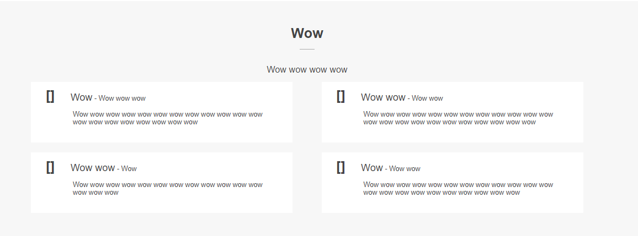

<div class="section">

<div class="container">

<div class="col two">

<h1 class="icon">[]</h1>

<h1 class="service">Wow</h1>

<p>Wow wow wow wow wow wow wow wow wow wow wow wow wow</p>

</div>

<div class="col two">

<h1 class="icon">[]</h1>

<h1 class="service">Wow</h1>

<p>Wow wow wow wow wow wow wow wow wow</p>

</div>

<div class="group"></div>

</div>

</div>

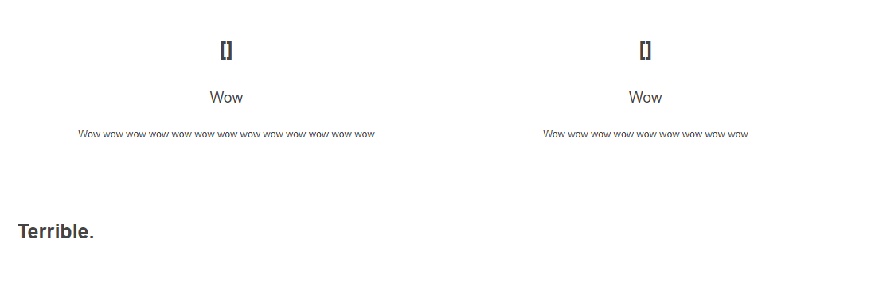

<div class="section">

<div class="container">

<h1 class="reset">Terrible.</h1>

</div>

</div>

