DIGITAL SIGNAL PROCESSING – EC5010 LABORATORY SESSION 1

DIGITAL SIGNAL PROCESSING THEORY AND APPLICATION

WIMALASOORIYA G.H.N.P.D.

2022/E/039

GROUP CG03

SEMESTER 05

28 APRIL 2025

PART1: SAMPLING, TIME DOMAIN & FREQUENCY DOMAIN REPRESENTATION

Generate the digital signal, x[n], obtained in your pre-lab.

y[n]=0.2+x(n) (1)

Plot y[n] scaling the x-axis to ms.

**PART 01**

1.)

**CODE**

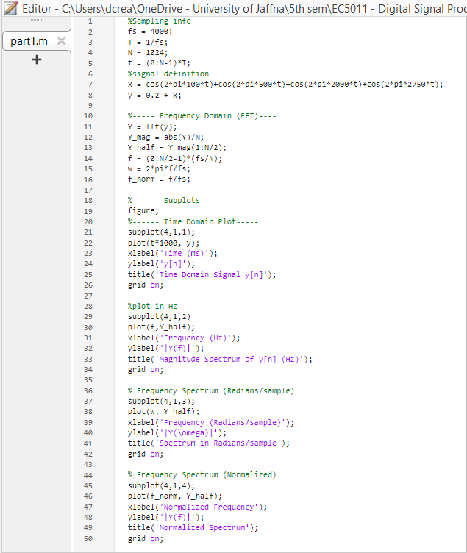

**OUTPUT**

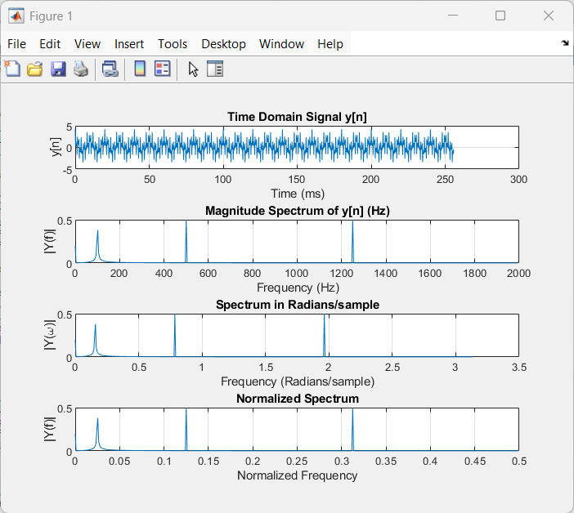

2.)

The DC value = 0.2

3.)

fa ​= ∣ f − k⋅fs ​∣ such that fa ​<fs​/2

fa =∣2750−4000∣=1250 Hz

* Aliased frequency component = 1250 Hz

4.)

**CODE**

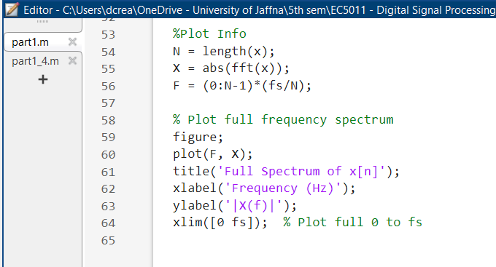

**OUTPUT**

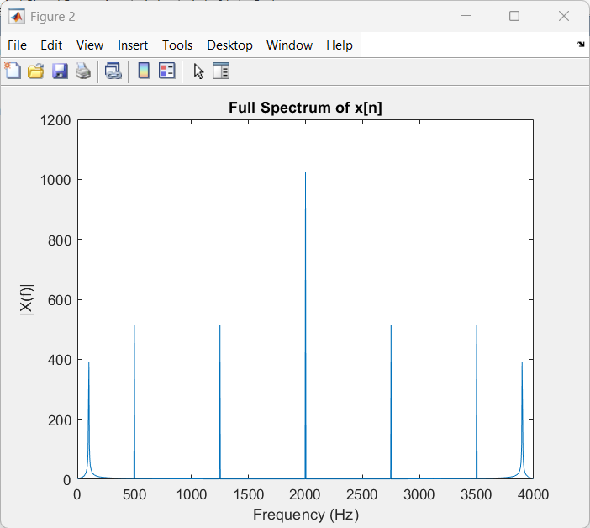

5.)

**CODE**

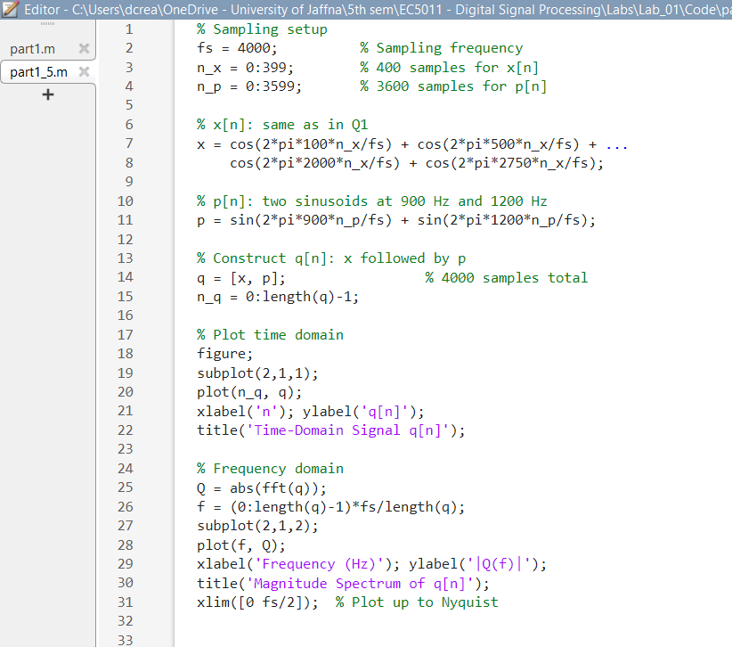

**OUTPUT**

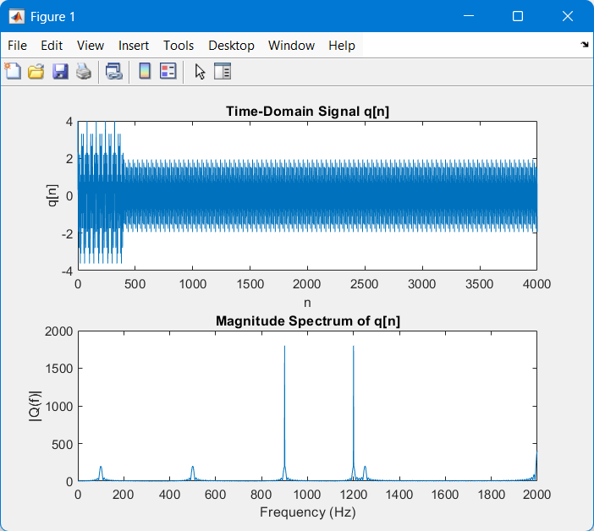

**PART 02**

**CODE**

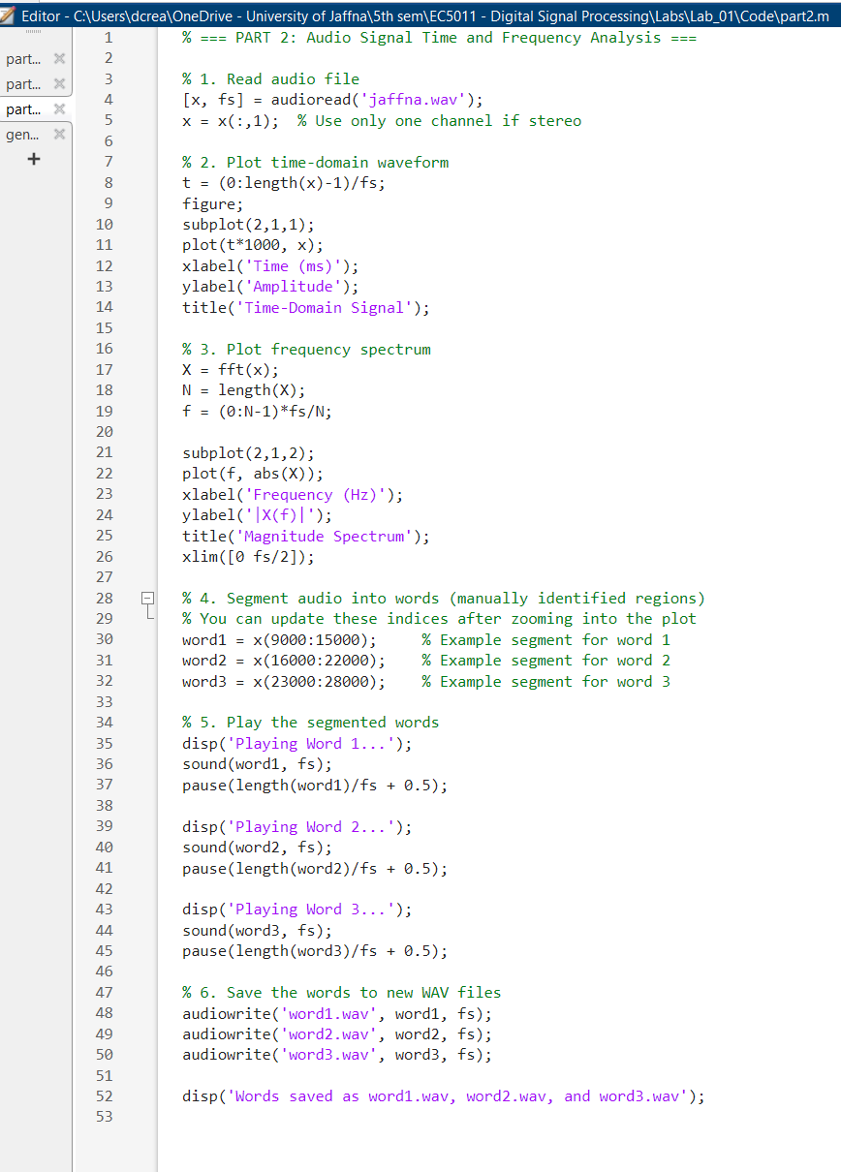

**OUTPUT**

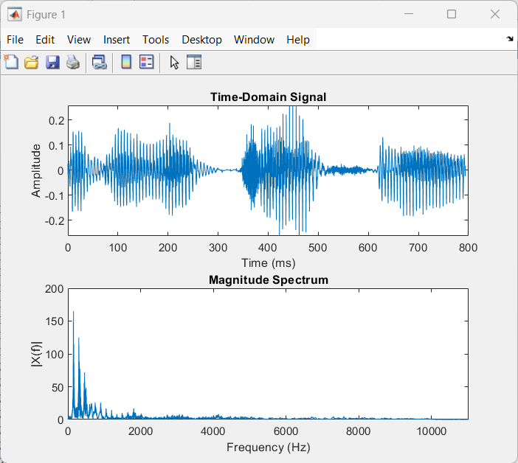

**PART 03**

**CODE**

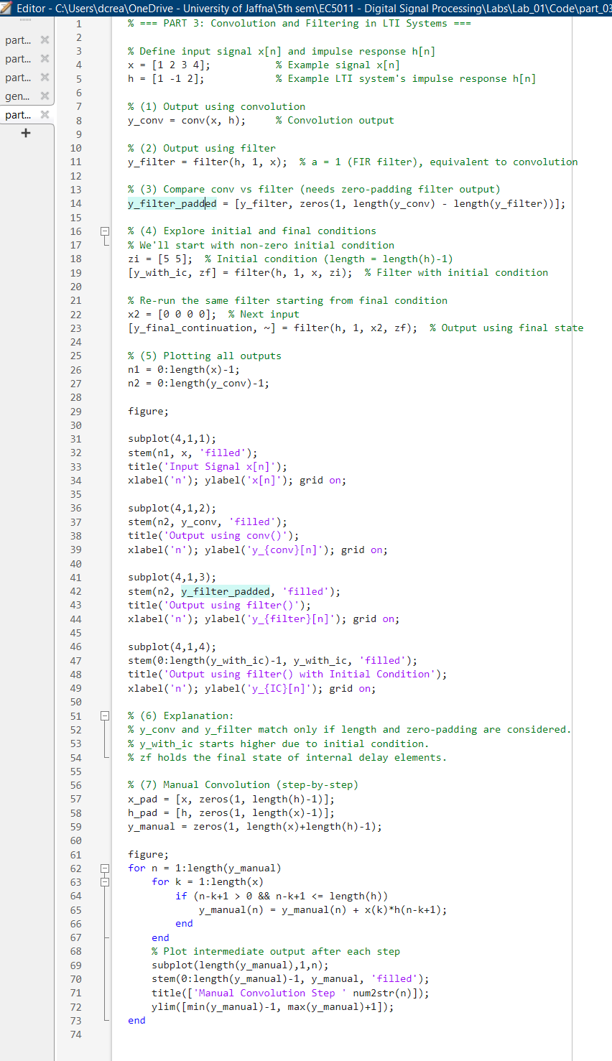

**OUTPUT**

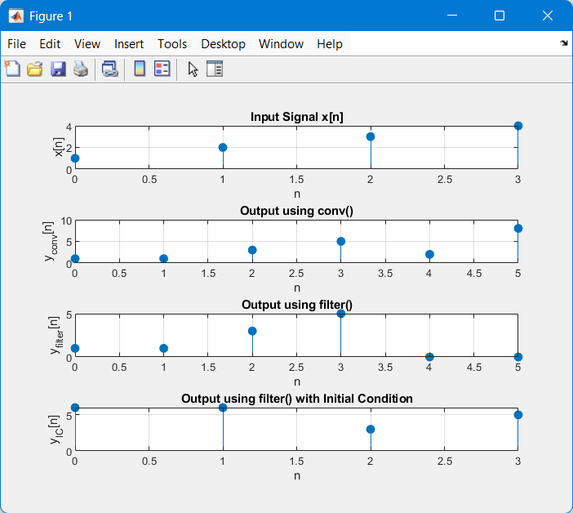

0.6 )

• Convolution output is longer (length = Lx + Lh −1) and shows full filter effect.

• Filter output is same size as x(n)x(n)x(n); assumes causal FIR system.

• Filter with final condition is used when processing a signal in chunks.

0.7 )

