DIGITAL SIGNAL PROCESSING – EC5011

LABORATORY SESSION 2

DIGITAL SIGNAL PROCESSING THEORY AND APPLICATION

WIMALASOORIYA G.H.N.P.D.

2022/E/039

GROUP CG03

SEMESTER 05

28 APRIL 2025

**PART 1: ANALYSIS OF A DIGITAL FILTER**

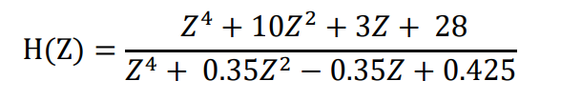

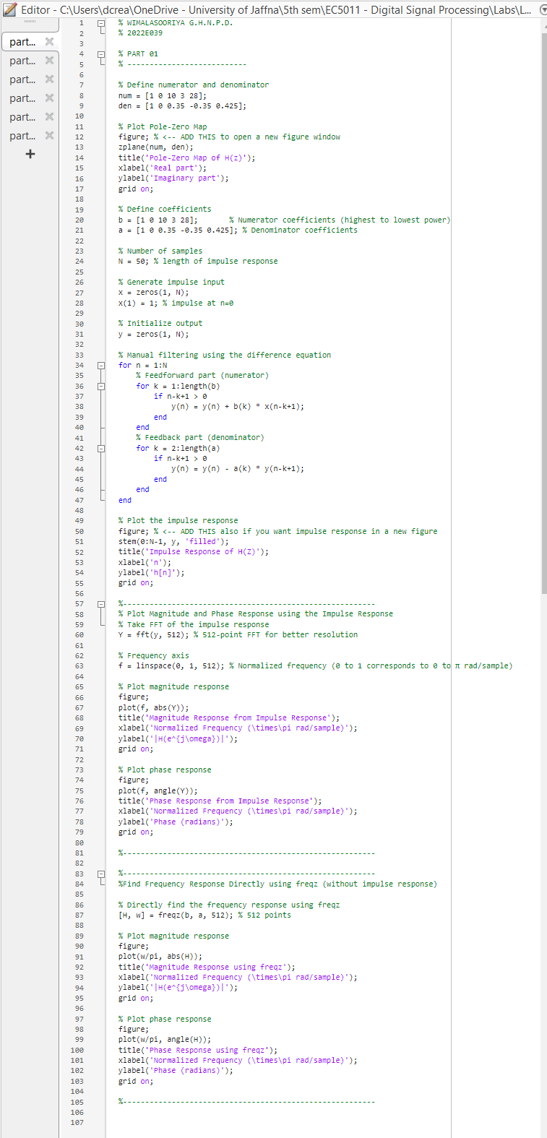

FIGURE 01: CODE

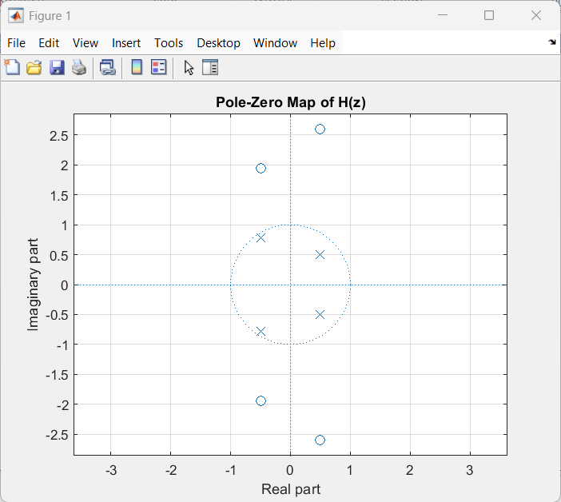

FIGURE 02: ZEROS & POLES

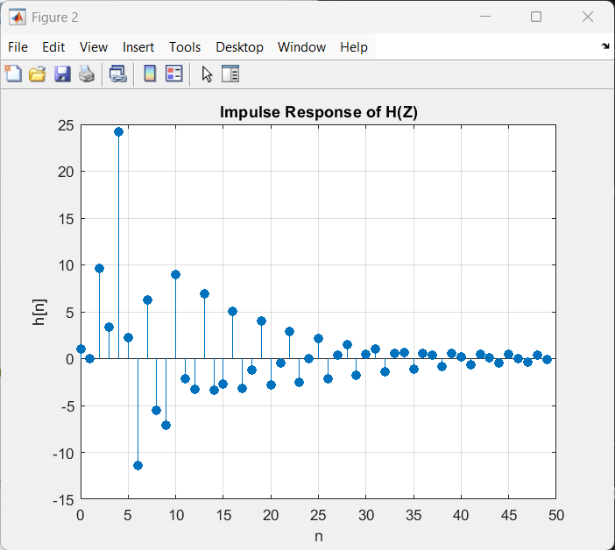

FIGURE 03: IMPULSE RESPONSE

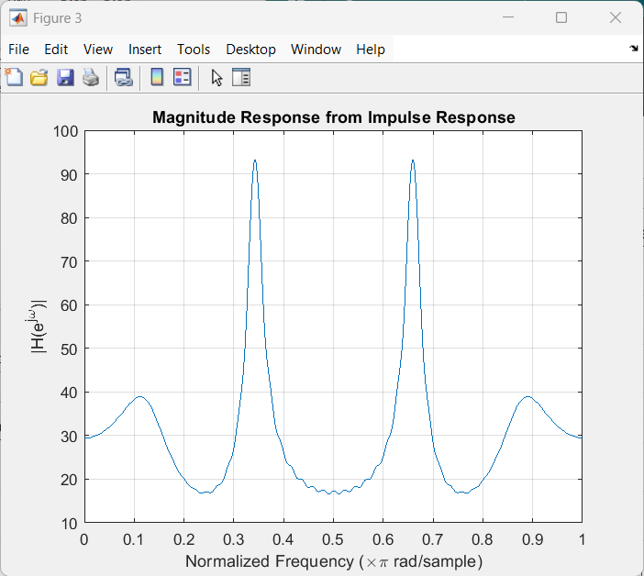

FIGURE 04: MAGNITUDE RESPONSE

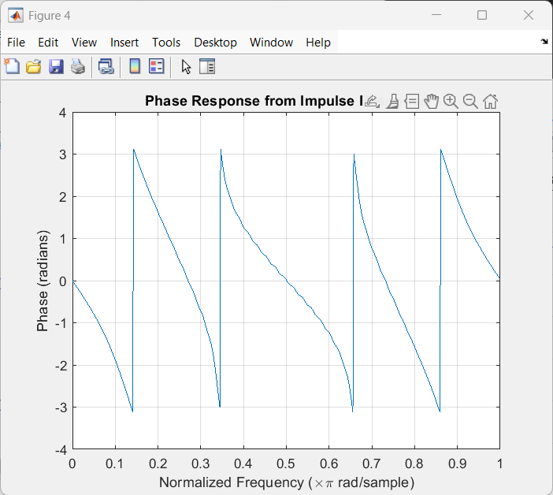

FIGURE 05: PHASE RESPONSE

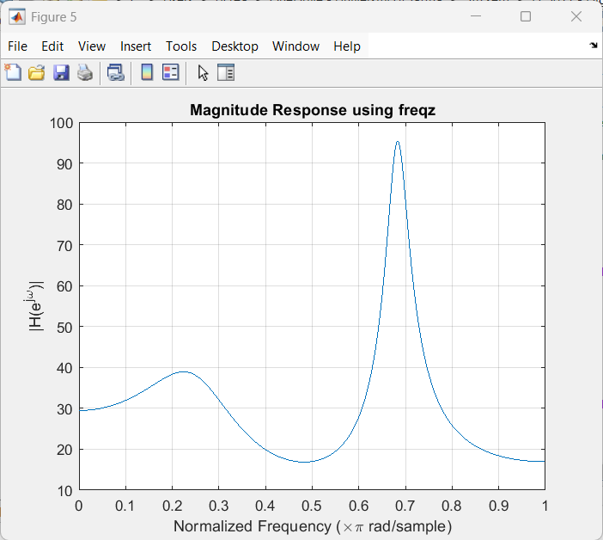

FIGURE 06: MAGNITUDE RESPONSE USING freqz

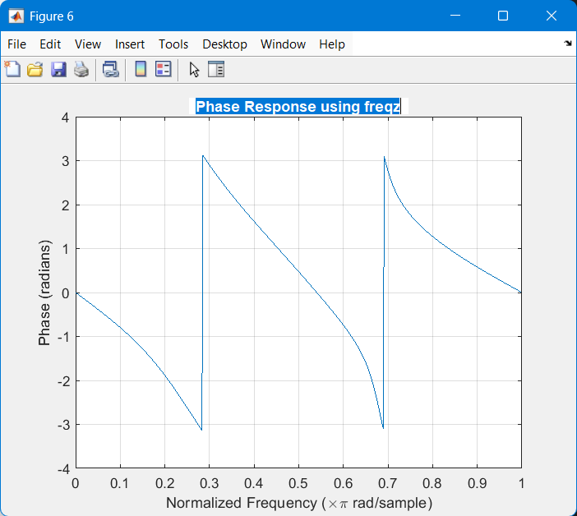

FIGURE 07: PHASE RESPONSE USING freqz

**PART2: DIGITAL FILTER DESIGN IN MATLAB**

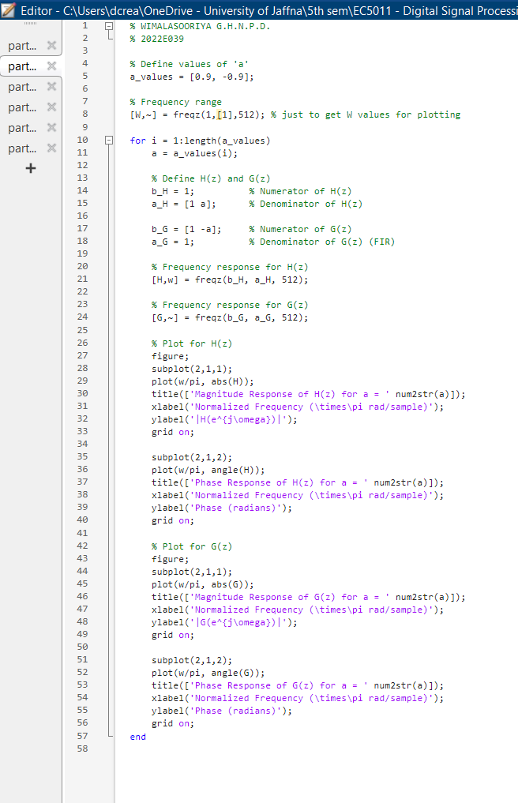

FIGURE 08: CODE

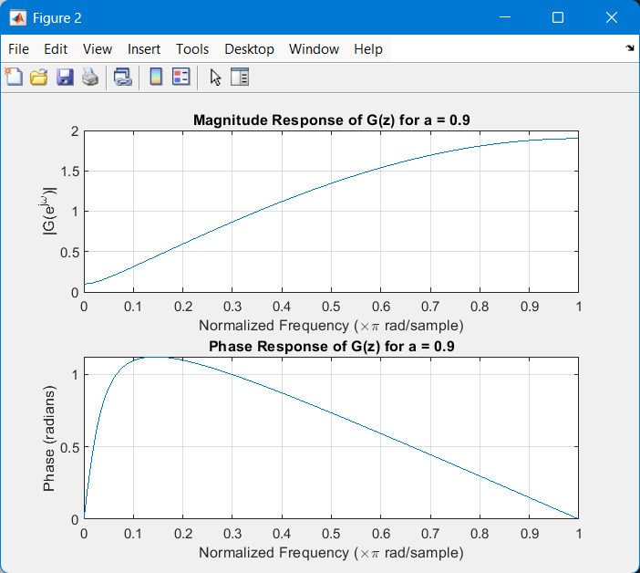

FIGURE 09: MAGNITUDE & PHASE RESPONSE OF G(Z) FOR A = 0.9

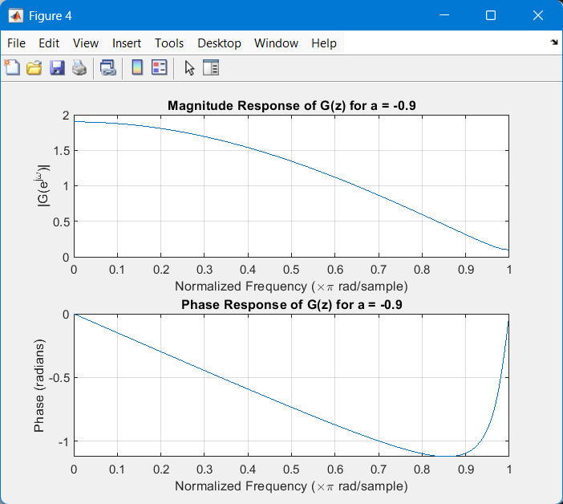

FIGURE 10: MAGNITUDE & PHASE RESPONSE OF G(Z) FOR A = -0.9

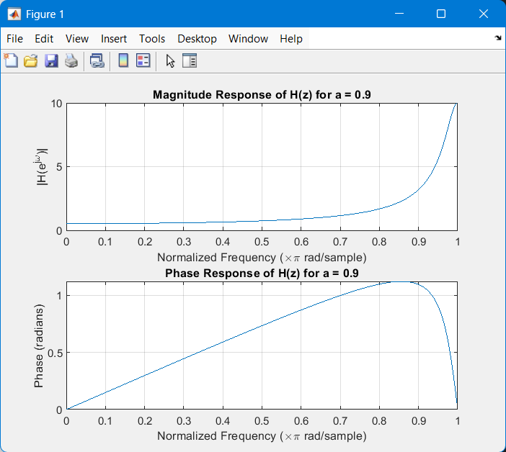

FIGURE 11: MAGNITUDE & PHASE RESPONSE OF H(Z) FOR A = 0.9

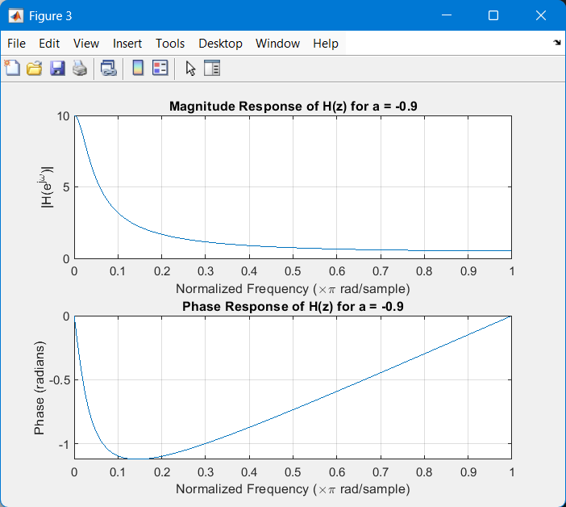

FIGURE 12: MAGNITUDE & PHASE RESPONSE OF H(Z) FOR A = -0.9

**PART3: ALLPASS FILTER**

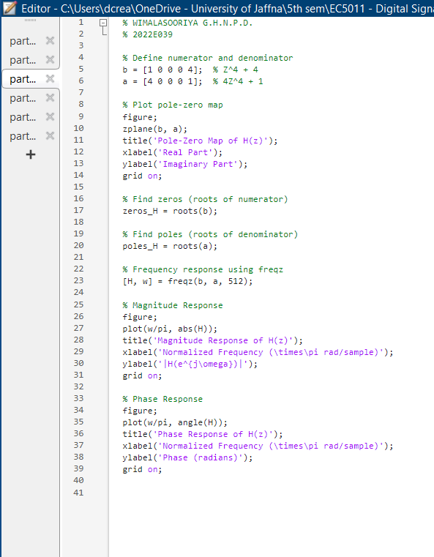

FIGURE 13: CODE

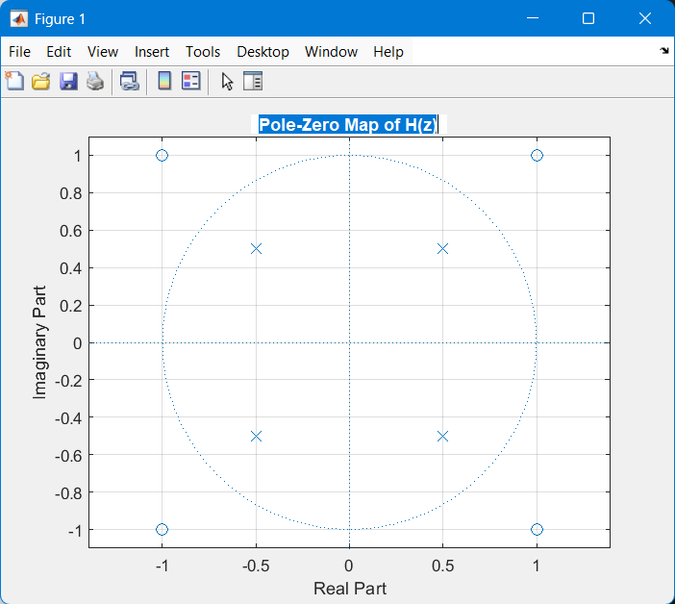

FIGURE 14: POLE-ZERO MAP OF H(Z)

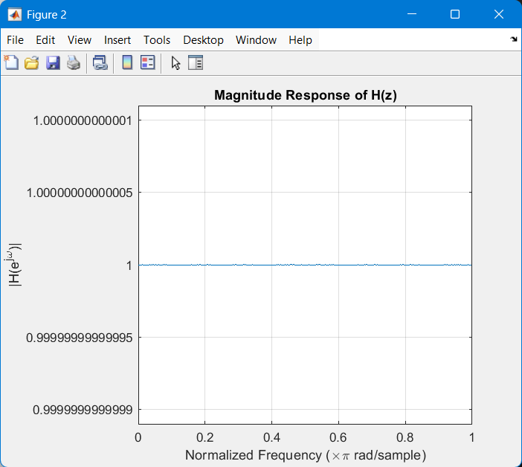

FIGURE 15: MAGNITUDE RESPONSE OF H(Z)

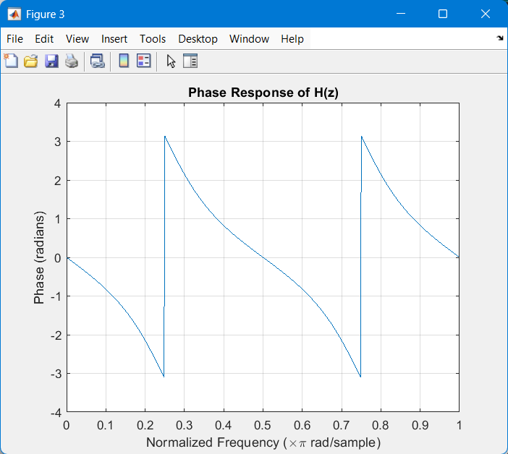

FIGURE 16: PHASE RESPONSE OF H(Z)

**PART4: MIN PHASE, MAX PHASE & MIXED PHASE**

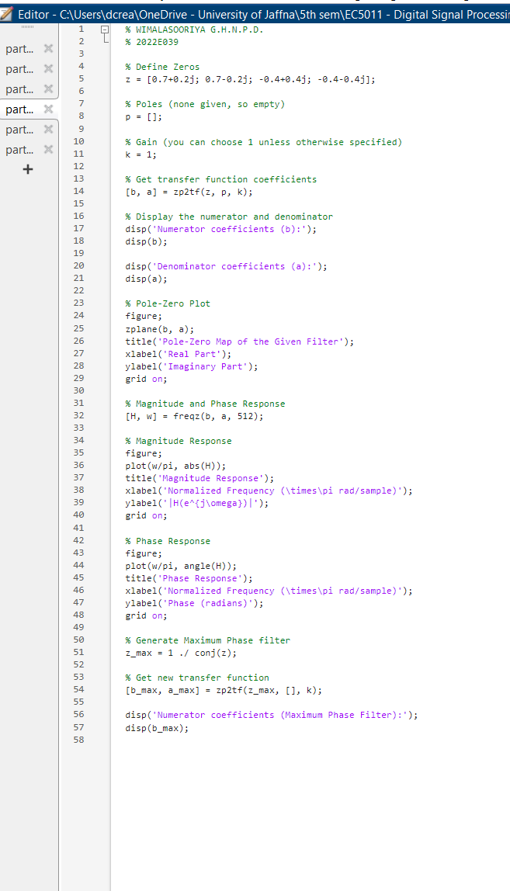

FIGURE 17: CODE

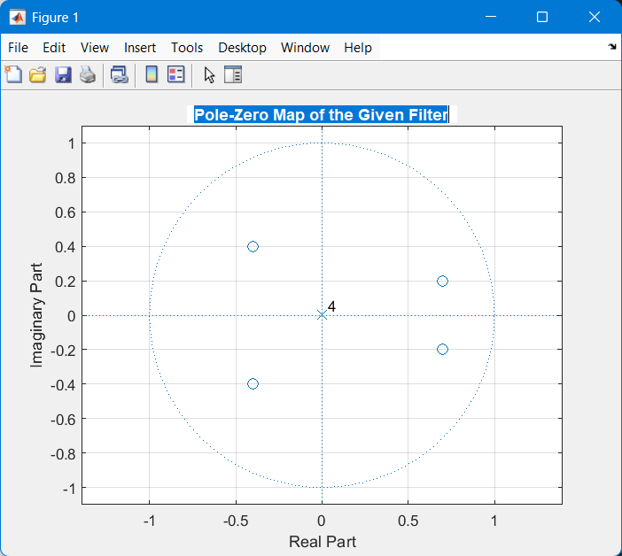

FIGURE 18: POLE-ZERO MAP

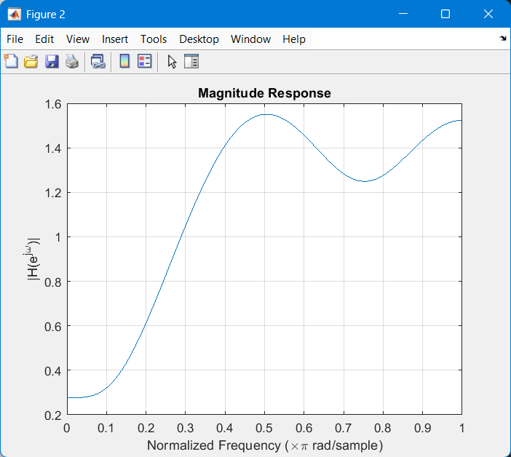

FIGURE 19: MAGNITUDE RESPONSE

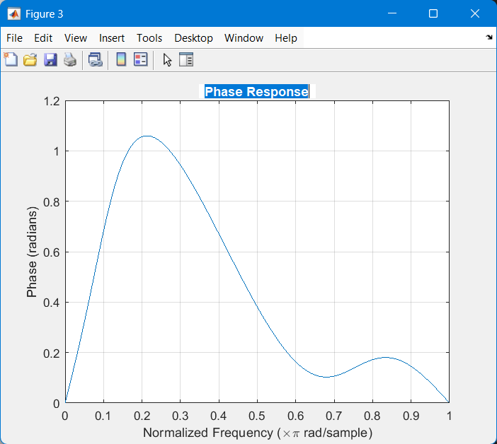

FIGURE 20: PHASE RESPONSE

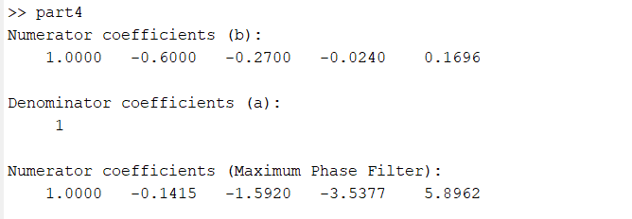

FIGURE 21: TERMINAL OUTPUT

**PART5: LINEAR PHASE FILTER**

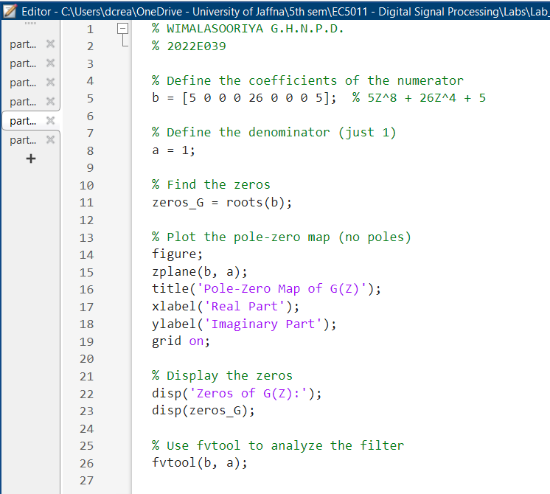

FIGURE 22: CODE

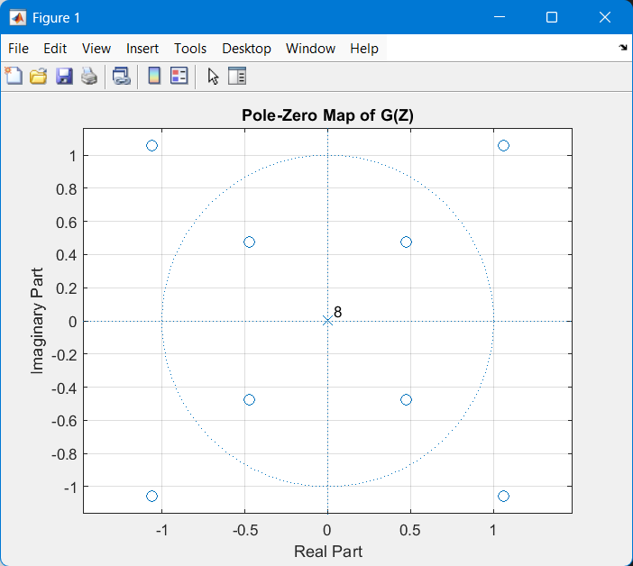

FIGURE 23: POLE-ZERO MAP

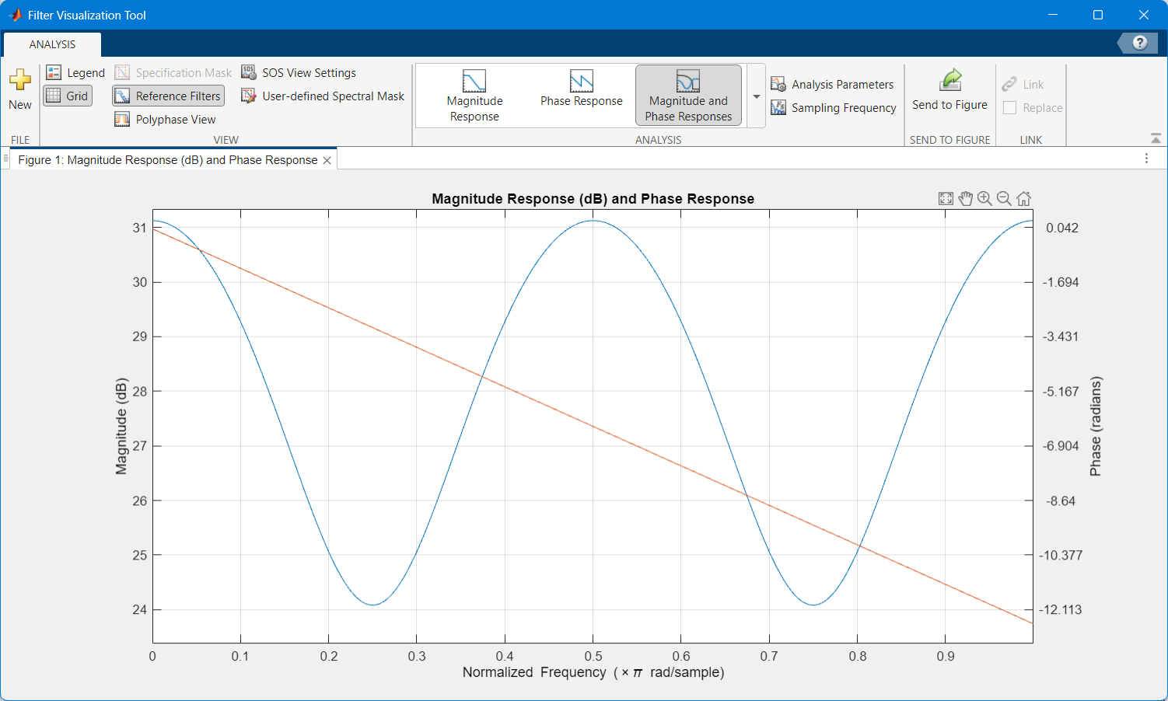

FIGURE 24: MAGNITUDE RESPONSE (dB) & PHASE RESPONSE

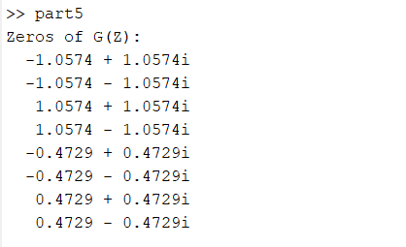

FIGURE 25: TERMINAL OUTPUT

**PART6 (OPTIONAL): FAST FOURIER TRANSFORM IMPLEMENTATION**

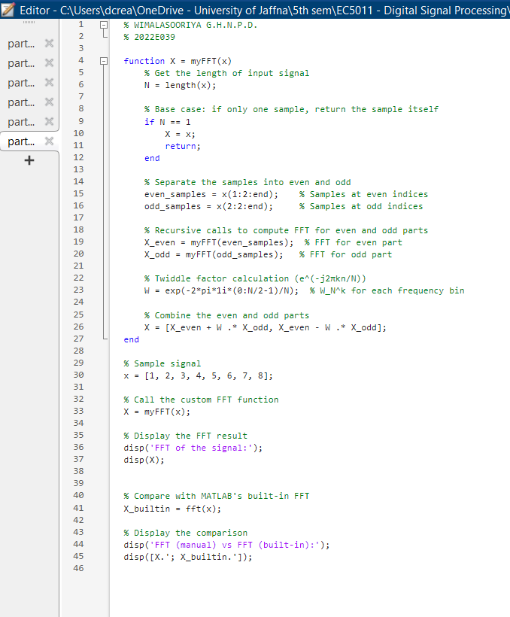

FIGURE 26: CODE

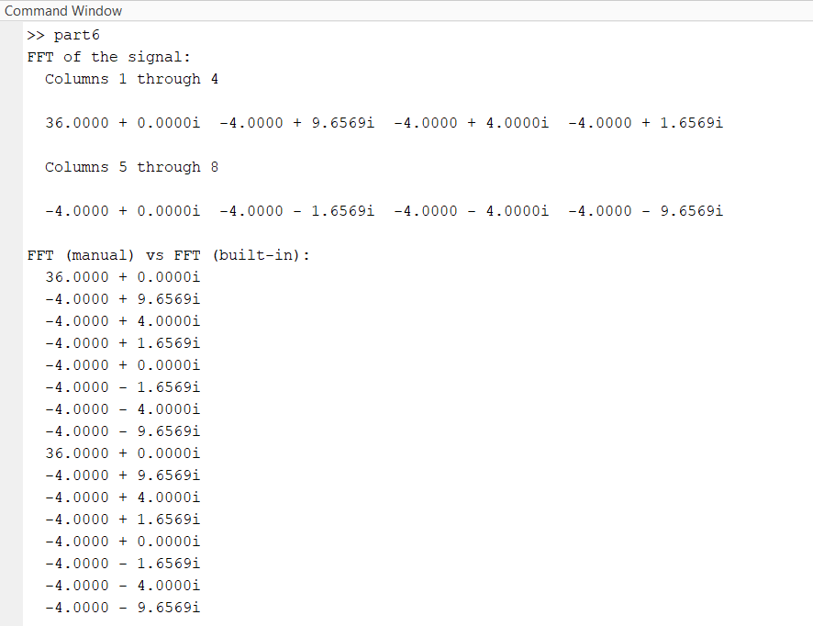

FIGURE 27: TERMINAL OUTPUT