Design and Development of Specialized Artificial Neural Networks for Industry-Specific Applications

Problem Formulation

Domain Application
Here we address the design, optimization and deployment of a lightweight Artificial Neural Network (ANN) based human segmentation on resource constrained mobile hardware. The system serves real world application addressing conference video call and prevent exposing sensitive domestic environment or intelelectual property.
Converence Video Call
Applications : Business meetings, telemedicine consulations conducted on mobile devices.
Methodology : ANN Process a live camera video frame and isolate human subject and render natural background blur or subsitute the background with a virtual office background.
Completed demonstration application have been developed here.

Operational Constraints
Unlike cloud based or asynchronous segmentation applciations video conferencing domain associates with following real time operational constraints.
Per Frame Synchronization
Inferencing is not a one time operation, it must continuously running for every single camera frame at the camera's native capture rate (24, 30 FPS).
Frame to Frame Consistancy (Temporal Coherence)
The frame inferencing should maintain descent fps rate. Any latency spike, dropped frame causes immediate jumping segementation mask. Camera capture and render fps is a constant and mask segmentation not maintaining similar fps would noticeable to human eye if it drops below 20fps.
Hardware
Memeory and CPU overheards are resource constraint specially at the inferening and rendering components in the pipeline.

Question 1 – Dataset and Exploratory Data Analysis
The project uses the Matting Human Dataset, a human portrait matting benchmark.

Dataset Overview

Data
Paired unstructured image data consisting of RGB human portrait images and ground truth alpha mattes(human contour segmented images based on alpha channel).

Dataset Volume
7700 image-matte pairs ~3.16 GB on disk space.

Data splitting
The dataset partitioning strategy was determined through trial and error approach while considering computational requirements.

Test : 500
500 images in testing allowed equitable benchmarking against the classical GrabCut [4] baseline. Because GrabCut is iterative graphcut algorithm running on the CPU which takes about 200 milliseconds per image. There is a significant performance gap between GrabCut (46.22% IoU) and UNet (98.12% IoU). Therefore 500 test set is statistically sound and keeps the margin of error at 0.15%(calcualation included in repo) under 0.5%.
Training: 6120 (85%)
Validation : 1080 (15%)
In first four models (v1.0 to v1.3) we used standard 70%, 30% split (5040 training images, 2160 validation images). Moving to an 85%, 15% split increased the training data set by 1080 images (+21.4%), providing the network with more data and varying human poses and backgrounds. This change showed a significant improvements in both Mean IOU (97.56%) and Dice Score (98.76%).
Final Ratio - 80% Training, 14% validation, 6% Training.

Reproducibility & Distribution
The dataset is hosted on Hugging Face under deshanc/unet-mobilenet-portrait-segmentation and can be retrieved via an script
sh ./config/hf_get_dataset.sh

Self Contained Samples
Since full dataset exceed 500MB added sample set with 140 paired images (100 training, 20, validation, 20 test) and packed it into the repository allows immediate training, validation, test, XAI and benchmarking.

EDA and Ground Truth Mask Comparison
To verify that the dataset splits are balanced, a mask comparison were conducted across all 7700 images. The table 1 below contains the result.
Matric | Training Dataset  N = 6120) | Validation Dataset  (N = 1080) | Test Dataset  (N = 500)
Foreground Ratio | 51.78% | 57.44% | 49.49%
Background Ratio | 48.22% | 42.56% | 50.51%
Train vs. Test Foreground  Difference | Baseline | N/A | -2.29%
Native Image Resolution | 600 x 800 (100%) | 600 x 800 (100%) | 216 x 288 (100%)
Aspect Ratio | 3:4 | 3:4 | 3:4

Table 1: Ground Truth Mask & Spatial Distribution Analysis

As depicted in table 1 all 6120 training images human portrait occupy an average of 51.78% of total pixels while background occupy averag of 48.22%. 50/50 balance ensures gradient update during neural network training not affect by dominated background or foreground pixels.
Foreground person coverage in test set (49.49%) differs from training(51.78%) by only 2.29%. This shows that test set shares same framing and body scale distributed as the training set.
Validation set has slightly closer portrait framing because it has 57.44% foreground which can effectively handle camera zoom and prevents overfitting to a single body scale.

Errors and Qualitative and Operational consequences
False Positive – Background Falsely classified as Person
Confidential physical backgrounds (family members walking in background, whiteboards with company passwords) are not blurred and goes into the video conference feed.
Severity – Privacy Breach, The system should minimize false positive cases.
False Negative – Person Falsely classified as Background
Part of the user (hands, shoulders, etc…) are erroneously classified as background and blurred out.
Severity – Erosions in the Telepresence, Lower professional credibility.

Metrics and Justifications
The accuracy is not considers as primary matric in CNN usecases due to class imbalance problem.
$$Accuracy= \frac{TP+TN}{TP+TN+FP+FN}$$
For an example if an image with 1M pixels where the human portrait occupy only 1K pixels a model could predict all black background mask which could acive 99% accuracy.
TP – Predicted Positive and Actual Positive = 0
FP – Predicted Positive but actually Negative = 0
TN – Predicted Negative and Actually Negative = 990000
FN – Predicted Negative but actually Positive = 10000
$Accuracy= \frac{0+990000}{0+990000+0+10000}$ = 99%
Here we sould use DICE Scrore which indicates how well the ground truth and predicted mask overlap, here its 0%. Here it completely ignores True Negative background pixels, completely focuss on object only.
We would use Intersection Over Union (IOU/Jaccard Index) and DICE Score(F1-Score) as the [rimary metrics.
IOU Supporting Factors
A = Ground Truth
B = Predicted Mask
$$IOU \left(A, B\right)=\frac{| A ∩ B |}{| A ∪ B |}= \frac{TP}{TP + FP + FN}$$
IOU penalizes over segmentation (privacy leak/ by FP ↑) and under segmentation (Erossions/ by TP ↓ and FN ↑).

$DICE\left(A, B\right)= \frac{2 x Overlap}{Actual Size + Predicted Size }= \frac{2 x | A ∩ B |}{\left|A\right| + |B|}= \frac{2 x TP}{\left(TP+FN\right)+(TP+FP)}$

According to the DICE formula above it does not contain TN which is the background segment. And also it normalize the overlap agianst the size( Actual Size + Predicted Size), not the size of the image. Hence image is larger or smaller it does not care only the size of the person it matters.

ANN Architecture

Modelling Constraints Considered
- Multi Level Feature Reuse
Hair silhouettes and finger boundaries occupy only tiny areas of the pixels soup. High level bottle neck features alone cannot reconstruct the human contour accurately. Model architecture must incoperate higher level spatial feature maps in the decoder stages. This is exactly what comes in the skip connection in U-NET.

- High computational power
Standard convolution associates with higher parameter count and makes larger models. Larger the model the inferencing time would be larger and directly affecting FPS rate in video conferencing. So we would consider depthwise seperable convolution which bring down parameter count drastically and creates small model size. Here we woud use MobileNet which is a Depthwise Seperable Convolution as the encoding part of the U-Net for feature extraction.

- Loss Function to address overlaps and pixel level cross entrophy
For the overlaps we would use DICE score above explained. But pixel level cross entrophy is need to tell how bad our model is predicting the mask. This would help the optimizer to figure out how to make the model params to make the model accurate. Since this is binary classifier(Forground/Background) we would use Binary Cross Entrophy.
$$Loss=Loss DICE+Loss BCE$$

To address above constraint the chosen architecture is a custom U-NET
- Encoder- MobilenetV1 as the feature encoder
- Decoder - Symettric mutiple stage upsampling with Skip connection
- The loss function would be combined DICE and BCE
Binary Cross Entrophy, refer figure 1 below
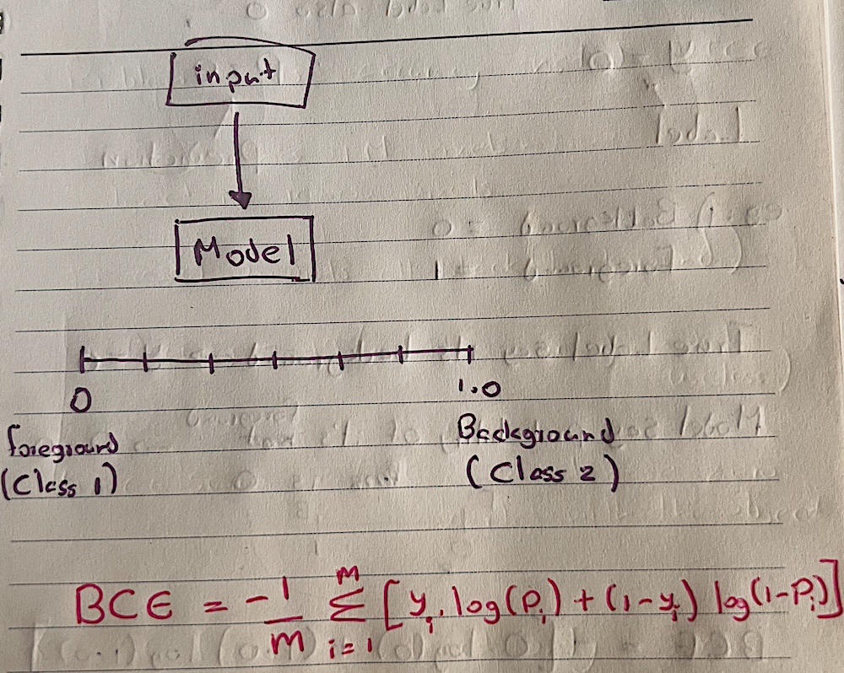 | 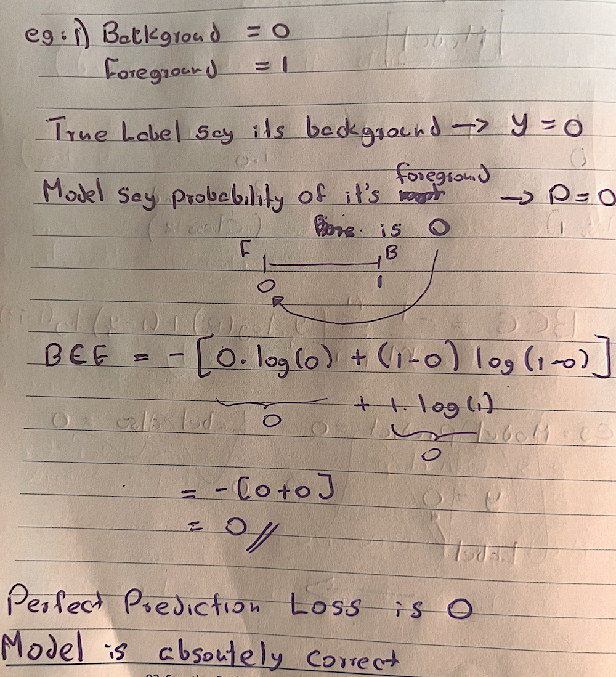

Figure 0: Binary Cross Entrophy and sample usage in binary classifier (Background/Foreground)

MobilenetV1
This is a lightweight architecture with descent accuracy. This was proposed by Google in 2017 [1]. The breakthrough innovation here is the depthwise seperable convolution. This distribute the standard convolution operation into two separate steps.
- Depthwise Convolution
- Pointwise Convolution

Depthwise Convolution, Figure 1
- Applies single filter to each input channel seperately.
- So it outputs same number of output channels
- Each feature in separate channel learn seperately
- Feature in different channels not getting mixed, depth feature kept intact
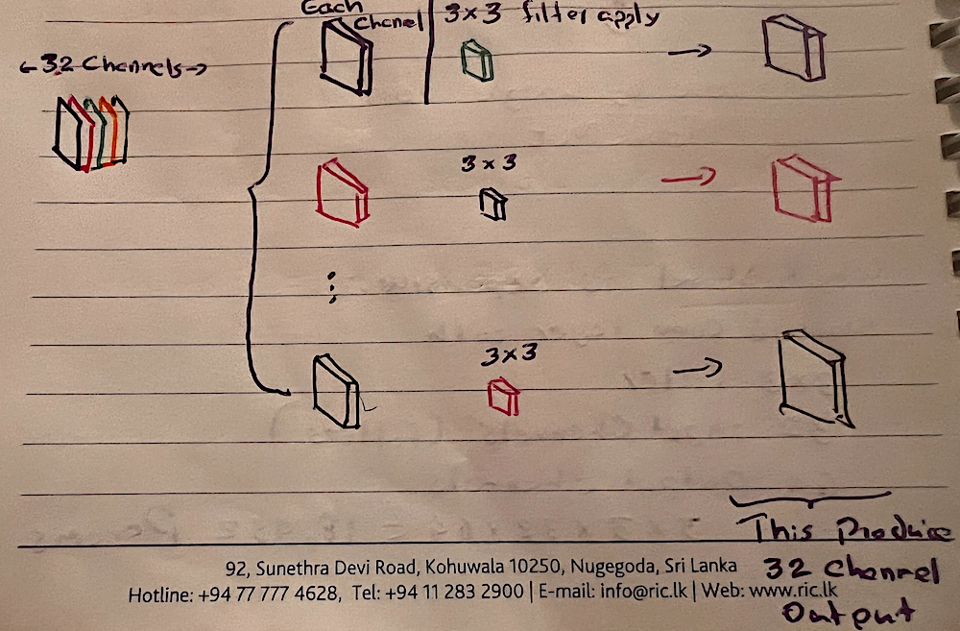
Figurer 1: Depthwise Convolution

Pointwise Convolution, Figure 2
- 1 x 1 filter throughout the all channel amd condenses down to single output map
- Different 1 x 1 filters do the same operation to get the number of output channels
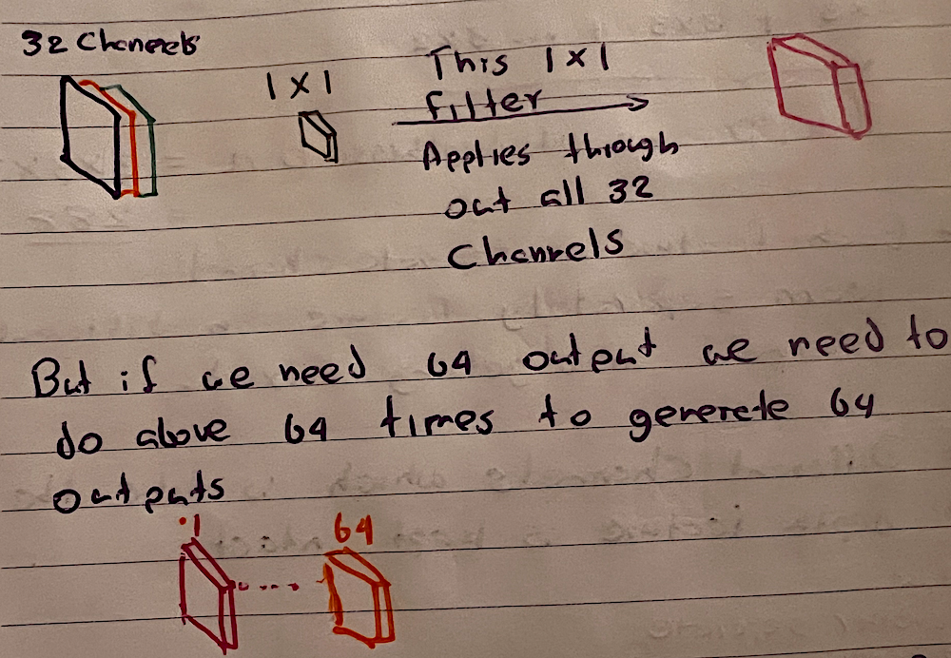
Figurer 2: Pointwise Convolution
The reason the term Seperable
- First it handles spatial filtering independenctly per channel in depthwise
- Second channel mixing independencly per pixel in pointwise
Figure 3 depicts how does the depthwise and pointwise connects each other.
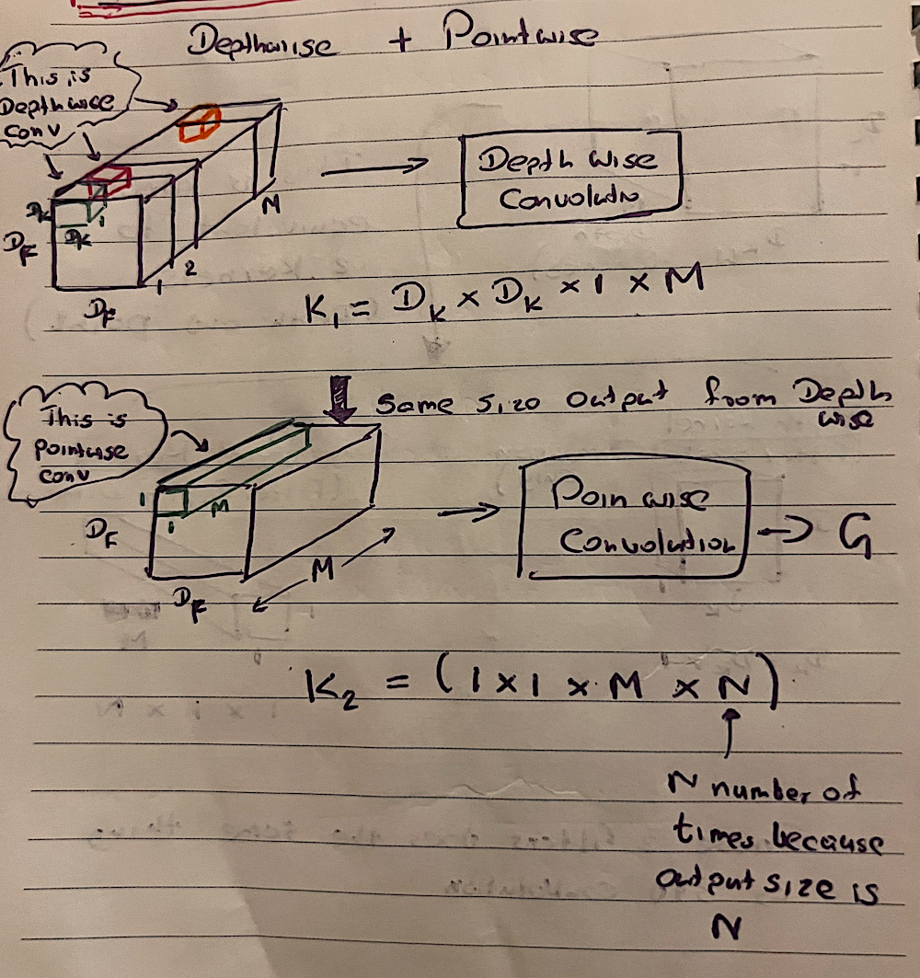
Figurer 3: Depthwise + Pointwise

Cost calcualtion between Standard Convolution and Depthwise Seperable Convolution

$$COST= \begin{matrix}Number of Elements Per Kernel \\ * \\ Number of Kernels \\ * \\ Number of Positions Taken Per Kernel\end{matrix}$$

D_{f} = Input Dimenstion (Width or Hieght)
D_{k} = Kernel Dimension (Width or Height)
M = Number of Channels
N = Output Size

Cost of Standard Convolution (X₁)
$$X_{1}=D_{f}* D_{f}* D_{k}* D_{k}*M*N$$

Cost of Depthwise Seperable Convolution (X₂)
$$X_{2}=Depthwise Cost+Pointwise Cost$$

$$Depthwise Cost=D_{k}* D_{k}*1* M*N* D_{f}* D_{f}$$

$$Pointwise Cost=1* 1* M*N* D_{f}* D_{f}$$

$$X_{2}=({D_{k}}^{2}*M* {D_{f}}^{2})+(M* {{N* D}_{f}}^{2})$$

$Cost Ratio= \frac{X_{2}}{X_{1}}= \frac{1}{N}+ \frac{1}{{D_{k}}^{2}}$

If we take an example of outputs(N) is 64, Kernels 32, and Kernel dimension (D_{k}) is 3.
Cost Ratio = 12.67%, Cost Reduction is 87.33%
Param Count Comparison and Model Size
Standard Convolution = 3 x 3 x 32 x 64 = 18432
Depthwise Seperable = (3 x 3 x 32) + (1 x 1 x 32 x 64) = 2336
Depthwise seperable has less params hence smaller size models.

Depth Wise Seperable(DSC) Block
Figure 4 and 5, depicts the DSC blcok we have in the implementation
Input | → | Depthwise Convolution | → | RELU | → | Pointwise Convolution | → | BN | → | RELU

Figure 4: DSC Block
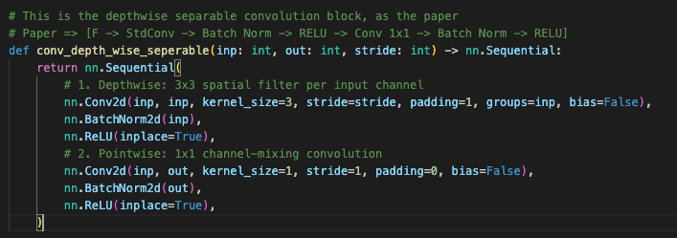
Figure 5: DSC Block implementation
MobilenetV1 we used for encoder stage in UNET as decribed above and Table 1 below demonstrate the blcoks progression while figure 6 below depicts implementation configuration.
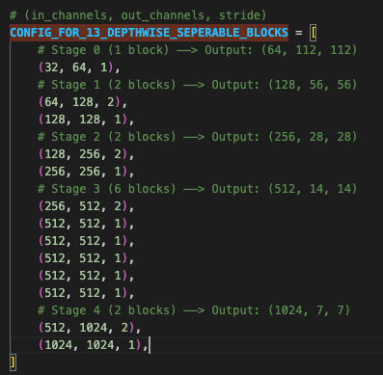
Figure 6: DSC block configuration
Stage | Block Index | Configuration (in/out/stride) | Input Tensor | Stride & Size Change | Output Tensor | Feature Map Generated
Inital |  | conv_standard(3, 32, 2) | (3, 224, 224) | Stride 2 (halves) | (32, 112, 112
Stage 0 | 0 | (32, 64, 1) | (32, 112, 112) | Stride 1 (Same) | (64, 112, 112) | (64, 112, 112)  Skip Con
Stage 1 | 1 | (64, 128, 2) | (64, 112, 112) | Stride 2 (halves) | (128, 56, 56)
Stage 1 | 2 | (128, 128, 1) | (128, 56, 56) | Stride 1 (keeps) | (128, 56, 56) | (128, 56, 56)  Skip Con
Stage 2 | 3 | (128, 256, 2) | (128, 56, 56) | Stride 2 (halves) | (256, 28, 28)
Stage 2 | 4 | (256, 256, 1) | (256, 28, 28) | Stride 1 (Same) | (256, 28, 28) | (256, 28, 28)  Skip Con
Stage 3 | 5 | (256, 512, 2) | (256, 28, 28) | Stride 2 (halves) | (512, 14, 14)
Stage 3 | 6 | (512, 512, 1) | (512, 14, 14) | Stride 1 (Same) | (512, 14, 14)
Stage 3 | 7 | (512, 512, 1) | (512, 14, 14) | Stride 1 (Same) | (512, 14, 14)
Stage 3 | 8 | (512, 512, 1) | (512, 14, 14) | Stride 1 (Same) | (512, 14, 14)
Stage 3 | 9 | (512, 512, 1) | (512, 14, 14) | Stride 1 (Same) | (512, 14, 14)
Stage 3 | 10 | (512, 512, 1) | (512, 14, 14) | Stride 1 (Same) | (512, 14, 14) | (512, 14, 14)  Skip Con
Stage 4 | 11 | (512, 1025, 2) | 1024 | Stride 2 (halves) | (1024, 7, 7)
Stage 4 | 12 | (10241 1024, 1) | 1024 | Stride 1 (Same) | (1024, 7, 7) | (1024, 7, 7)  Bottleneck

Table 2 : Blocks Progression

Every encoder geenrated feature map marked as a skip connection in Table 1 concatenated with the corresponding U-Net decoder upsampled feature map. Mainreason for this is recover dropped spatial representations during downsampling, such as hair silhouettes, finger boundaries, etc…
We do not have pooling here, polling is for downsampling the spatial dimesntion. When we go deep in the network number of channels increase and saptial dimension decrease as above table 2 depicted. To decrease spatial dimension we have used stride = 2 and depthwise convolution instead polling.
Shrinking Hyperparameters
To make the model even fastler/smaller there are two hyperparameters discussed in Mobilenetv1 paper[1].
- Width Multiplier - $α$
- Resolution Multiplier - ρ

Width Multiplier $α$
This reduces the number of Kernels, hence reduce the depth of the output and model size as depicted in figure 7 below.
$$α ∈[0, 1]$$
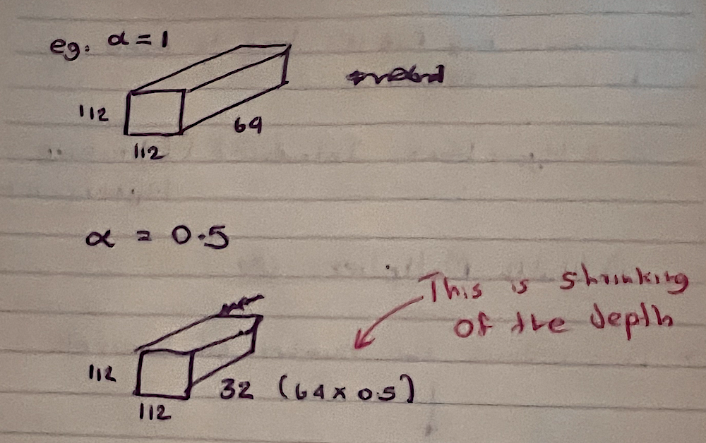
Figure 7: Width Multiplier
When $α=1$, No Shrinking. We refer to this as Baseline model in MobilenetV1. During out model developmenet also we used $α$ with 0. 5 and 0.75.
Cost Computation with Width Multiplier
Depthwise Seperable ConvolutionCost Computation, X
$$X=({D_{k}}^{2}*M* {D_{f}}^{2})+(M* {{N* D}_{f}}^{2})$$
When Consider Alpha We need to consider parameters representing number of kernels
- M = Depthwise Kernels
- N = Pointwise Kernels

$$X_{α}=({D_{k}}^{2}*αM * {D_{f}}^{2})+(αM* {{αN* D}_{f}}^{2})$$

Here the reduction is approximately equals to $α$², the calcualtion depicted in figure 8 below.
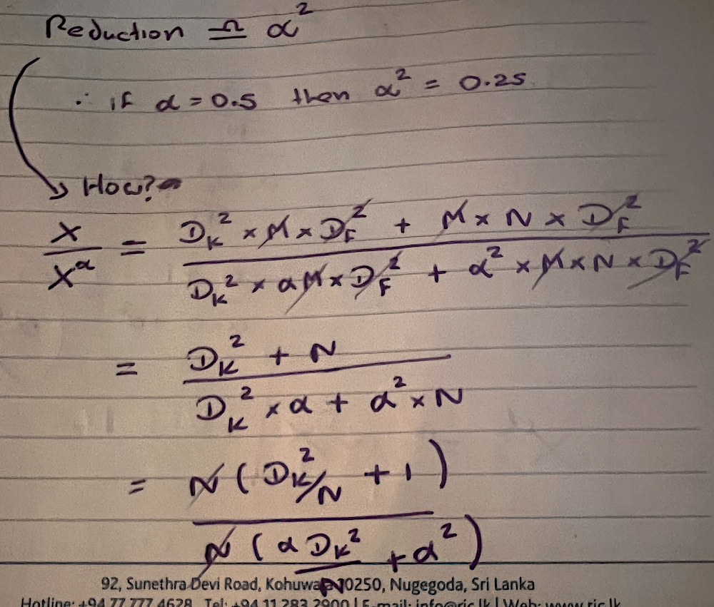 | 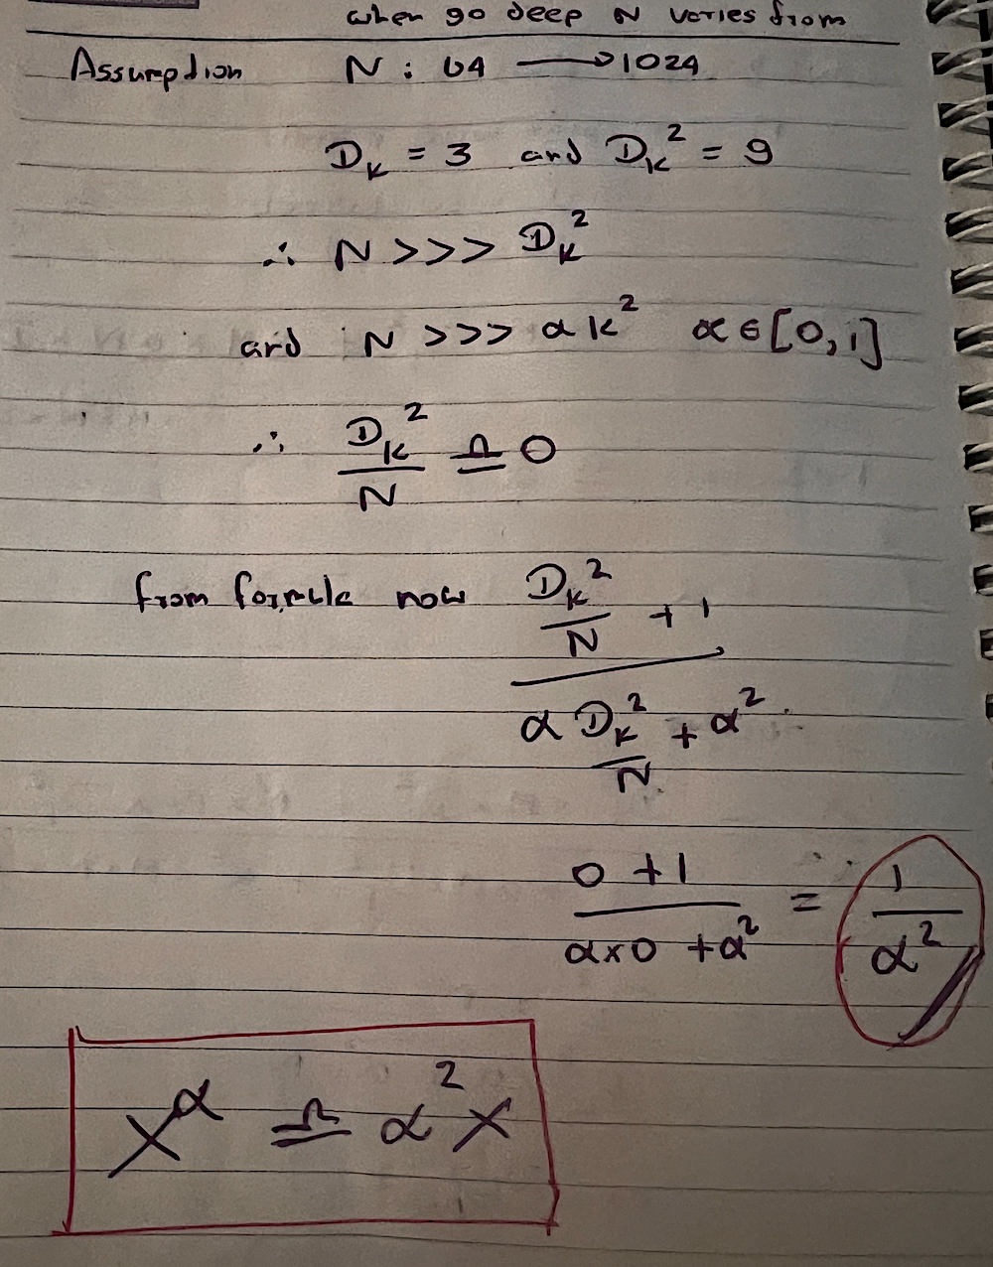

Figure 8: Width multiplier Cost Redcution calculation

Resolution Multiplier ρ
The resolution we refer here is the input dimension ($D_{f})$. So we multiply all $D_{f}$ by ρ. And as similar to width multiplier cost is reduced by ρ². Resolution multiplier makes the feature maps spatially smaller.
MobilenetV1 paper also discussed about reducing the number of layers and make shallowe models. But in comparison thinner models better than shallowe models by 3%[1]. So we only used width multiplier when creating out model.

U-Net [2]
U-Net is a symettrical “U” shape encoder-decoder convolution neural network designed for pixel level predictions. We used U-Net here for segmentation of foreground and background from human portrait images.
U-Net Components
- Encoder
- Bottleneck
- Decoder/Upsampling
- Skip Connection

Encoder
As discussed above the encoder part which is for efeature extraction we used mobilenet.

Bottleneck
The bottom part of the U-Net connecting encoder and the decoder. It has the most compressed featurer set with highest channel count.

Decoder/Upsampling
This steps recovers the spatial resolution which was downgraded by encoding above. There are few upsampling methods
- Nearest Neighbour
- Transpose convolution
Unlike nearest neighbour this has another 5 thainable weights to fine tune during the training as depicted in figure 9 below.
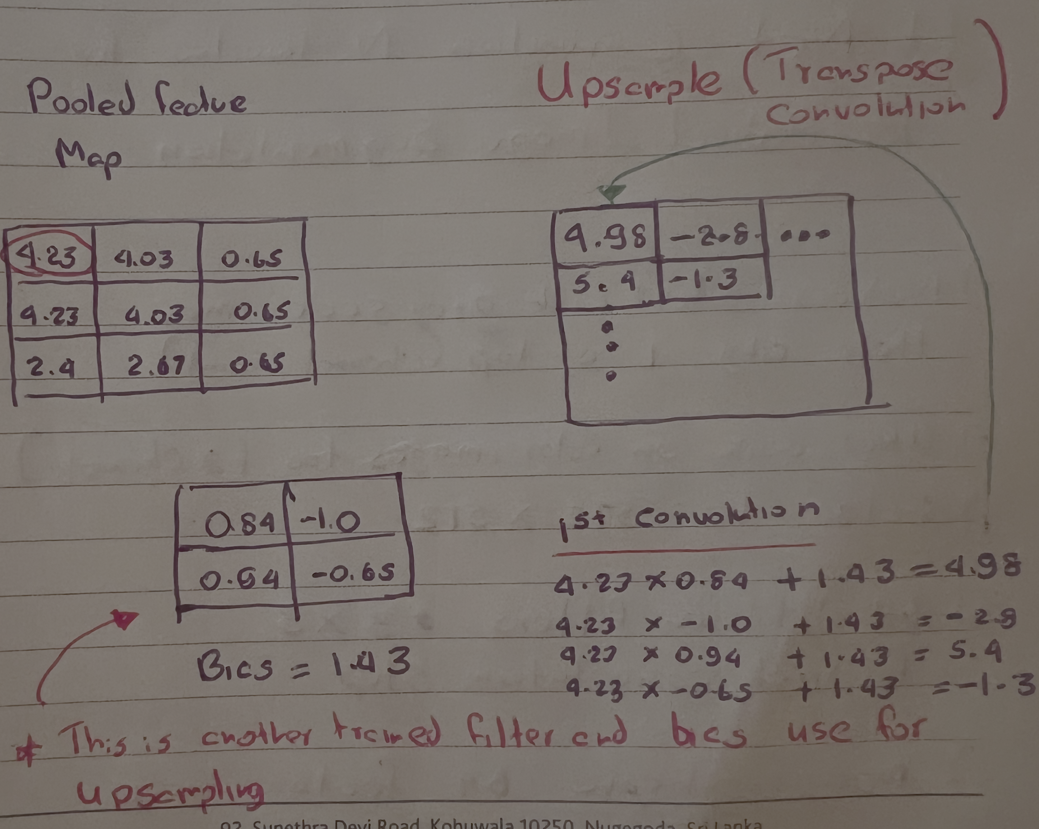
Figure 9: Transpose convolution upsampling
- Bilenear Interpolation
This is the linear interpolation(weight based) considering both x and y axises. In our model we would use this instead tranapose convolution due to associated grid-like or checkerboard artifacts[3].

SKIP Connection
The upsampled feature map is concatenated along the U axis with the corresponding feature map extracted from the encoder. Concatanating encoder feature map we have highlighted in the table 2 above. First it we need to do a final convlution with a kernel (1 x 1 x 2) and concat as depicted in figure 10 below.
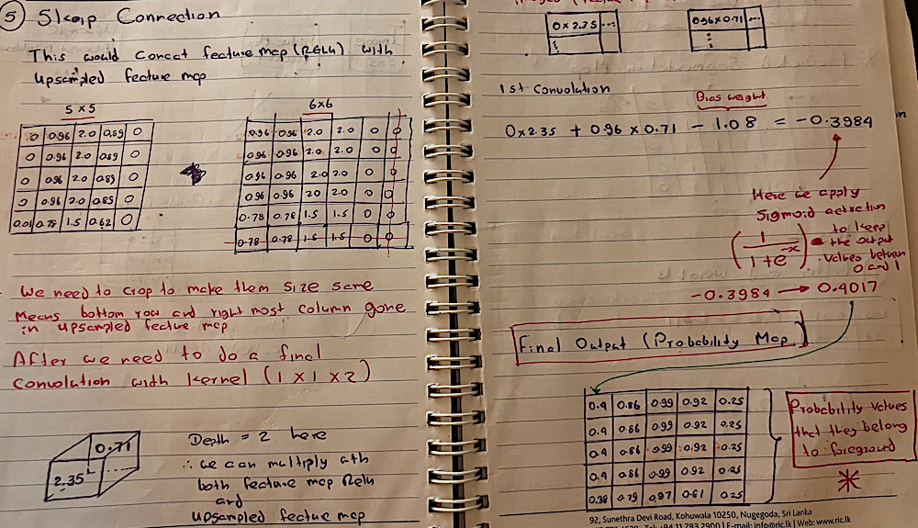
Figure 10: U-Net Skip connection

Alternative Approaches
Table 1.3 below shows possible alternative approaches with different CNN/Classical architectures and the reson why they were rejected on our conference call usecase.
Architecture | Parameters | Rejection
Classical GrabCut | None | Incompatible for video 30fps
DeepLabv3-ResNet | 58.6M | Unnesssary heavy
DeepLabv3-MobileNetV3 | 11M | Lack of skip connection to fine tune hair edges, fingers, etc..
MobileNetV1 + Unet (Our approach) | 8.3M (W = 1.0)  3.9M (W=0.5) | FPS still low without backing up from apple neural engine when inferencing
MobileNetV3 + Unet (Our approach) | 0.98M | Selected due to higher fps without apple neural engine backing up
Table 3: Alternative CNN/Classical approaches
Following benchmarking MobilenetV1 against other architectures highlighted in MobilenetV1 Paper[1]
- Baseline MobileNet (W = 1.0) is 32x smaller and requires 27x less computation than VGG-16 while achieving +1.0% higher accuracy
- Baseline MobileNet is more accurate than GoogLeNet while consuming 2.5x less computations
- Scaled thinner MobileNets (W = 0.5) outperform SqueezeNet and AlexNet in both speed and accuracy

Model Development

Evolutionary Development Milestones
- Milestone 1– v1.0
MobileNetV1 (W = 1.0) Trained from scratch
- 5040 training and 2160 validation images
- Adam Optimizer
- BCE + DICE Loss
- Learning Rate 0.001
- 3 Epochs
- Milestone 2 – v1.1 (Baseline)
Same like v1.0 but 15 Epochs
- Milestone 3 – v1.2
Transfer Learning with pretrained MobileNetV3 backbone integrated into the U-Net decoder with same like baseline but 15 Epochs
- Milestone 4 – v1.3
V1.1 with width multiplier ($α$ =0.5) with the intention of thinning the model.
- Milestone 5 – v1.4
MobilenetV3 backbone in v1.3 above retrained with new training/validation imageset partition(85:15 - 6120 training, 1080 validation)
Model Creation Execution
As shown in the configuration files in figure11.a below the .env.gloabl needs to update with image data set path and target model version configuration depicted in figure 11.b below. Here it’s model v1.4 above.
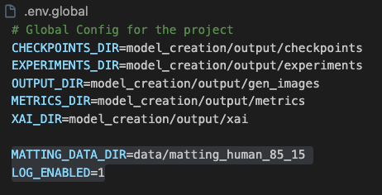 | 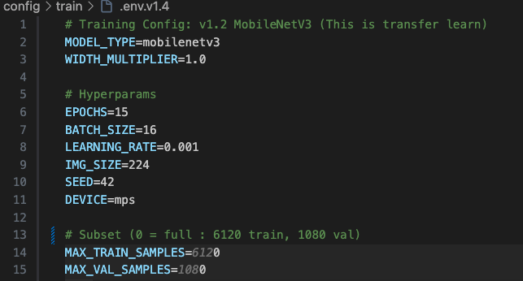
Figure 11.a : Global Config | Figure 11.b : Model v1.4 configuration

Once configured below command could run on the root directory to create the model. For each model a separate configuration file is added under config/train direcotry.
python model_creation/main.py --env config/train/.env.v1.4 --task train

Model Deployment and Versioning
For model versioning initially started with DVC and later move to hugging face. All models deployed under public hugging face model repo.
Execute below to get all trained models from hugging face to respective directories.
sh ./config/hf_get_all.sh

Model Evaluation against 500 test image set
Same as training a configuration files are added for evaluation of each model created as shown in figure 12 below.
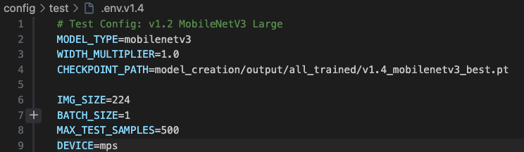
Figure 12 : Model Testing configuration (v.1.4)

The model evaluation result depicted in table 4 below compares Mean IOU and DICE Score of each model when tested against 500 images. The original, ground truth and predicted mask also included on best and worst cases with corresponding IOU/DICE values. The reason why the model picked different worst and best image for each time it ran is they has different architectures, hyper params which fundamentally changes where they fail/success.
Model | Mean IOU | Mean  DICE | Best/Worst Sample
Model | Mean IOU | Mean  DICE
  Original | Ground Truth | Predicted
V1.0 | 87.59% | 93.14% |  |  |   IOU: 0.9843  DICE: 0.9921
V1.0 | 87.59% | 93.14% | 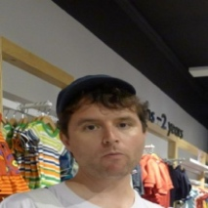 | 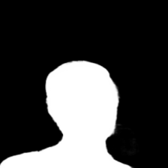 |   IOU: 0.5433  DICE: 0.7040
V1.1 | 96.78% | 98.33% |  |  |   IOU: 0.9917  DICE: 0.9958
V1.1 | 96.78% | 98.33% | 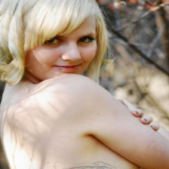 | 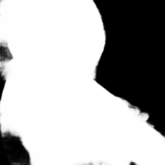 | 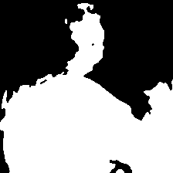  IOU: 0.6118  DICE: 0.7591
V1.2 | 97.38% | 98.66% | 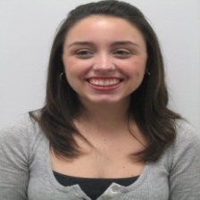 |  |   IOU: 0.9916  DICE: 0.9957
V1.2 | 97.38% | 98.66% |  | 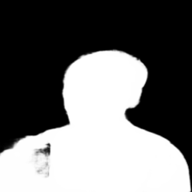 |   IOU: 0.8501  DICE: 0.9189
V1.3 | 95.51% | 97.65% | 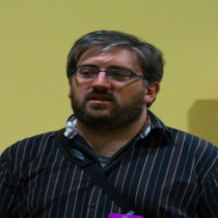 | 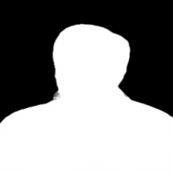 |   IOU: 0. 9907  DICE: 0.9953
 |  |  | 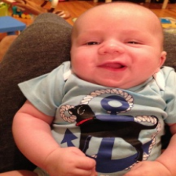 | 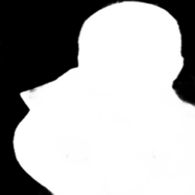 | 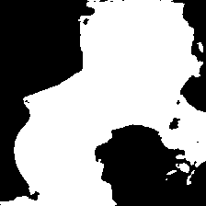  IOU: 0.7351  DICE: 0.8473
V1.4 | 97.56% | 98.76% | 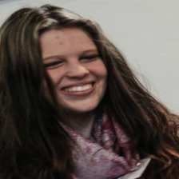 | 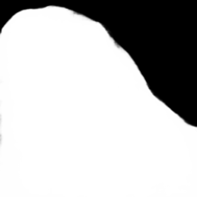 |   IOU: 0.9916  DICE: 0.9958

IOU: 0.8340
DICE: 0.9095

Table 4: Trained 5 models IOU/DICE comparison and Best/Worst IOU images

 | Model Family | Train/Validation  Split | Width Multiplier ($α$) | Epochs | Params | Mean IOU | Mean DICE
V1.0 | MobileNetV1 | 70:30 | 1.0 | 3 | 8.31M | 87.59% | 93.14%
V1.1 | MobileNetV1 | 70:30 | 1.0 | 15 | 8.31M | 96.78% | 98.33%
V1.2 | MobileNetV3 | 70:30 | 1.0 | 15 | 0.98M | 97.38% | 98.66%
V1.3 | MobileNetV1 | 70:30 | 0.5 | 15 | 3.96M | 95.51% | 97.65%
V1.4 | MobileNetV3 | 85:15 | 1.0 | 15 | 0.98M | 97.56% | 98.76%
Table 5: Model comparative evaluation
Quantitave Analysis based on Table 5 model comparative evaluation
- Pretrained MobilenetV4 (v1.4) has the highest predictive accuracy with 97.56% Mean IOU and 98.76% DICE Score. Its +0.78% IOU over MobilenetV1 baseline(v1.1) and 8x fewer parameters count, which v1.4 would give very good performance in our video conferencing usecase.
- $α$ = 0.5 (v1.3) reduced the paramer count by 52% when compare with $α$ = 1.0 (v1.1), but it has reduced the IOU/DICE value signifiantly when compare with MobilenetV3(v1.4 and v1.2).
GrabCut[4] Benchmark
Here we have benchmarked the v1.4 model against Grabcut classical baseline on 500 test data set. And table 6 below depicts the results.
Method | Mean IOU | Mean DICE
GrabCut | 46.22% | 61.3%
Model V1.4 | 98.14% | 99.05%

Table 6: Grabcut vs CNN model v1.4
Version 1.4 outperforms the Grabcut by +51.92% IOU. Its noticeable that Mean IOU/DICE of model v1.4 on table 5 and table 6 are different on same 500 test image data set. The reason is on benchmark result which is on table 6 above IOU/DICE compare against binarized groud truth image. Hence Grabcut only outputs binary mask, model generated mask also converter to binary with a threshold. At boundy pixels where 0.7 like fraction alpha becomes full 1.0 value. This is called Soft IOU and Binary IOU.
Figure 13 below illustrates a Grabcut and CNN Model v1.4 visual comparison.
Original | Ground Truth | GrabCut | CNN v1.4
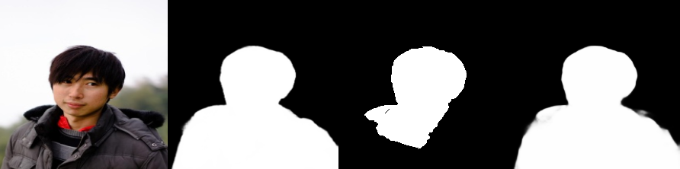
Figure 13: Grabcut vs CNN v1.4
This can be executed from the root directory by running below command
python model_creation/main.py --env config/benchmark/.env.v1.4 --task benchmark

Application Implementation
Production grade Native iOS application written with ObjectiveC/C++ with hardware accelerated inferencing and processing. The architecture is illustrated in figure 14 below.
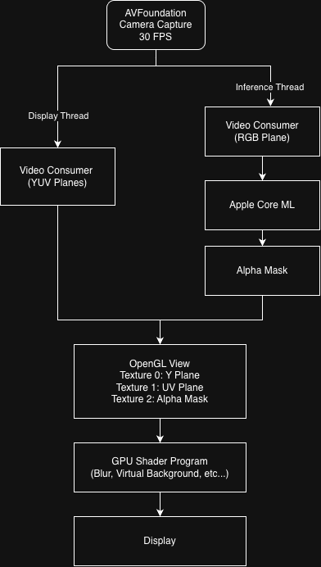
Figure 14: App architecture
- Local/Network Video Pipelines
RTP/UDP based video pipeline with fully network streaming compatible. Local camera frame or network streaming video supported.
- Asynchronous Inferencing
Frame capturing and inferencing run on completely independent threads synchronized via thread safe mutext. The intention was to individually capture framerates of rendering and inferencing for benchmarking purposes.
- Hardware accelerated Model
Pytorch model exported to Apple Core ML enabling execution on the dedicated Apple Neural Engine
- GPU Processing
After generating the mask the alpha pixel isolated and processed via a fragmetn sahder program which runs on GPU. Rendeing is not a burden to CPU
CPU usage Profiling
iPhone 13 with Apple Neural Engine (Figure 15)
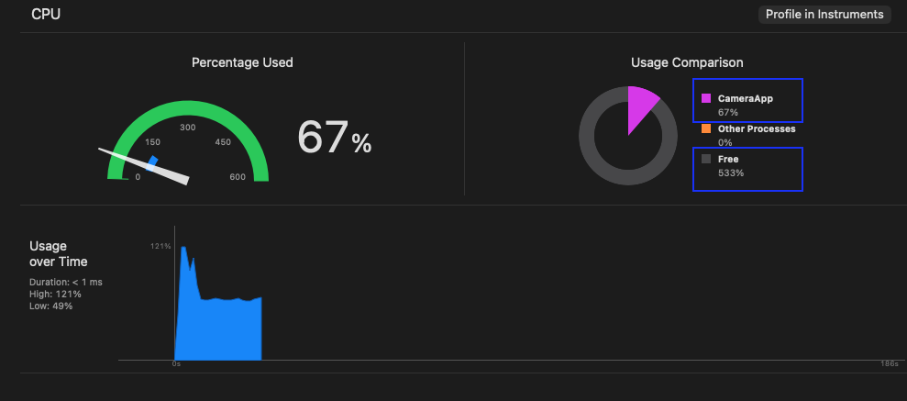
Figure 15: CPU Profiling on iPhone 13
Apple A15 Chip has 6 Core CPU = total capacity 600%
App using 67%, while 533% is free.
$$Total CPU Load= \frac{67\%}{600\%} ≃11\%$$

iPad Pro 10.5 No neural Engine (Figure 16)
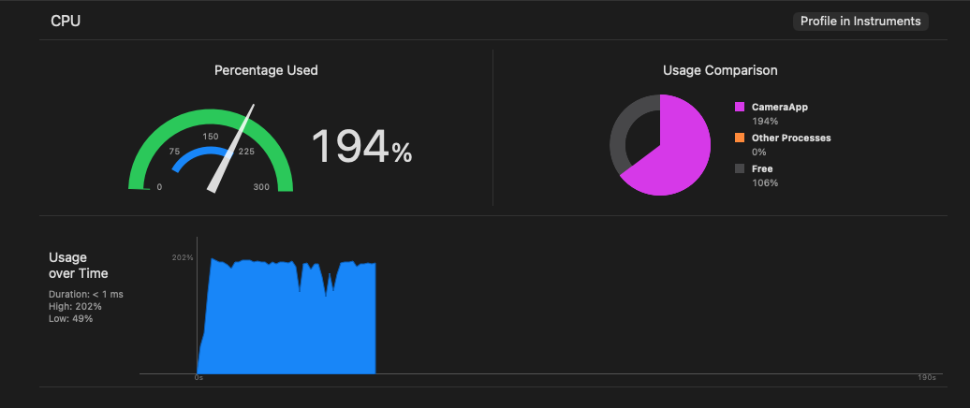
Figure 16: CPU Profiling on iPad Pro 10.5
$$Total CPU Load= \frac{194\%}{400\%} ≃48\%$$

Device | Chip | Cores | Neural Engine | Procssing GPU | Camera FPS | CPU Load | FPS
  Render | Inference
iPhone 13 | A15 | 6 | Yes | Yes | 60 | 10% | 60 | 60
iPad Pro 10.5 | A10X | 4 | No | Yes | 60 | 48% | 60 | 40
Table 7: Performance Matrix

Quantitative analysis based on performance matrix in table 7
- Neural engine backed hardware highly affects the inference performance which has almost no delay in iPhone 13.
- Even without neural engine backing still the light weight model(v1.4) able to maintain 40 fps on > 10 years old hardware.

Explaainable AI (XAI)
Unlike Linear Regression which is self explanatory Neural networks are less self explanatory due to they have millions of parameters. In our model also it has 0.98 Million parameters. Therefore even it has 97.56% IOU we have no idea why it has succeeded.
Questions in our human segmentation model
- Did it actually learn human features
- Was it cheating by using a shortcut
Here we can use XAI to prove that the model is making decisions based on actural human features that it learnt, not by coindidences.
IOU = How Well Model Performed
XAI = Why it Performed well or why failed
We picked Grad-Cam method for XAI and following explans the reason
- Latency
SHAP/LIME uses super pixel method to minimize the number of combinations. Our inout image size size 224 x 224 (50176), 2⁵⁰¹⁷⁶ combination is impossible calcualtion and lets assume it segment the image into 50 super pixel segment.
Still 2⁵⁰ is a huge number for calculation.
Even it uses Kernel Level Shap still it could associate with many combinations and calcualtions.
Grad-Cam uses only one backword pass and one forward pass which is super fast and less calcualtion.

- When LIME/SHAP create super pixels it destroys fine boundaries. Therefore Hair/Shoulders pixel level precision gone.
- Grad-Cam offers architectural insights
It can goes to the mobilenet encoder stages and explain what convolution feature map actually learned.
In our model Grad-Cam would be use to explain what part of the image used to make the segmentation by highlighting pixel regions of the image that important for segmentation by drawing HeatMap(Class Activation Map/Cams)

[1] A. G. Howard et al., “MobileNets: Efficient convolutional neural networks for mobile vision applications,” arXiv preprint arXiv:1704.04861, 2017.
[2] O. Ronneberger, P. Fischer, and T. Brox, "U-Net: Convolutional Networks for Biomedical Image Segmentation," in Medical Image Computing and Computer-Assisted Intervention (MICCAI), Munich, Germany, 2015, pp. 234–241. doi: 10.1007/978-3-319-24574-4_28.
[3] A. Odena, V. Dumoulin, and C. Olah, “Deconvolution and checkerboard artifacts,” Distill, vol. 1, no. 10, Art. no. e3, 2016, doi: 10.23915/distill.00003.
[4] C. Rother, V. Kolmogorov, and A. Blake, "GrabCut: Interactive foreground extraction using iterated graph cuts," ACM Transactions on Graphics (TOG), vol. 23, no. 3, pp. 309–314, Aug. 2004

