MSc Data Science
Big Data Analytics Technologies Coursework
Chamika Deshan
COMScDS251P-015

Setup
The source code for all tasks can be found in git repositoy below.
https://github.com/deshancha/bigdata_cw
Adjusting the paramter below in .env file can Disable/Enable Logs, Default is enabled.
LOG_ENABLED=1

Task 1: Distributed Time-Series Data Management using InfluxDB

Step 1.1 Containerized Environment Provisioning
Figure 1.1 below ilustrates .env configurations and figure 1.2 below depicts the docker compose file
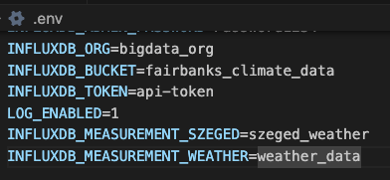
Figure 1.1: .env file
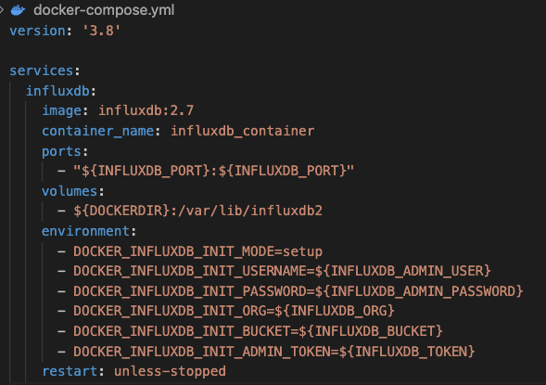
Figure 1.2: Docekr Compose File

Step 1.2: Database Schema & Ingestion Scripting
This is a Python program written with clean architecture with dependency injection. Below are the usecases
- Load Data
- Crate Bucket
- Drop Bucket
- Open Connection
- Close Connection
- Load CSV
- Write Records – Writing to Database
- Writing Records
We write both szeged_weather and weather_data to same bucket. We destingushed them by measurement as depicted in the code segment in figure 1.3 below.
Figure 1.3: Measurements to distiguish Points

Program Execution
python3 src/main.py <PARAM>
PARAM | Description
-1 | Drop Bucket configured in .env INFLUXDB_BUCKET
0 | Crete Bucket
1 | Write weatherHistory.csv as 1000 batches
2 | Write Project 1 - Weather Dataset.csv as 1000 batches
Table 1.1 : Program execution
Maintain the Historical TimeStamp
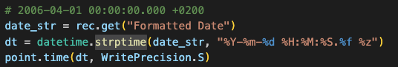
Figure 1.4: Keep Historial Timestamp

Step 1.3: Flux Time-Series Analytical Querying
Window Aggregation to compute sliding hourly averages across an extended observation span.
Here we group all data points into 1 hour windows and computes the mean temperature for each window. And we get a time series of hourly temperatures for Szeged from 2016 January to December. Figure 1.5 below depictes the related InFlux query.
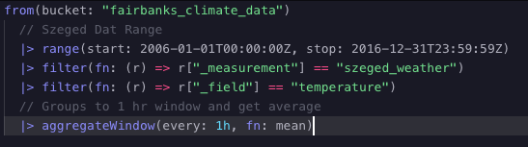
Figure 1.5: Flux time-series query
Anomaly Isolation filters to capture observations exceeding two standard deviations from the dataset mean. Figure 1.6 below depicts the related Influx Query.
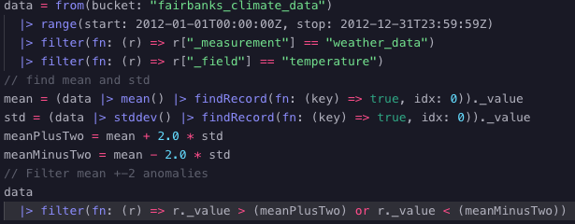
Figure 1.6: Influx query for anomaly isolation
Finally We put visualize in the dashbaord as shown in figure 1.7 below
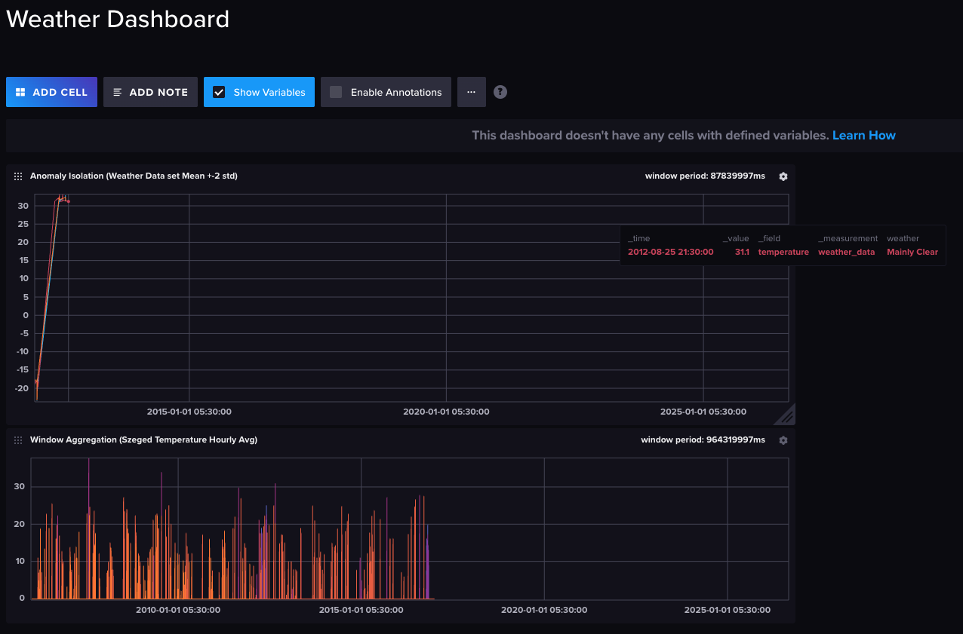
Figure 1.7: Dashboard Visualization
Downsampling tasks that continuously summarize historical data into an auxiliary bucket governed by an explicit 30-day retention rule
Figure 1.8 depicts the downsamplig task runs everyday 1hour after midnight and get daily average data and write to separate bucket named “weather_data_downsampled”, the bucket has 30 day retention policy as shown in figure 1.9 (>30 days automatically get deleted).
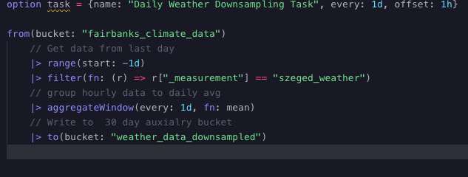
Figure 1.8: Sheduled Task
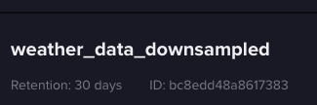
Figure 1.9: Retention period 30 days

Task 2: Real-Time Stream Ingestion & Processing with Apache Kafka and Apache Flink
Components
- Live Telemetey Data Producer
- Flink Processing and Sink to InfluxDB
- Influx Time Series Traffic Data Visualize
Implmentation with Python and Kotlin on containerlized environment with clean architecture with proper dependency injection for scalability.

Step 2.1: Multi-Container Orchestration Setup
Figure 2.1 below ilustrates .env configurations and figure 2.2 below is the docker container.
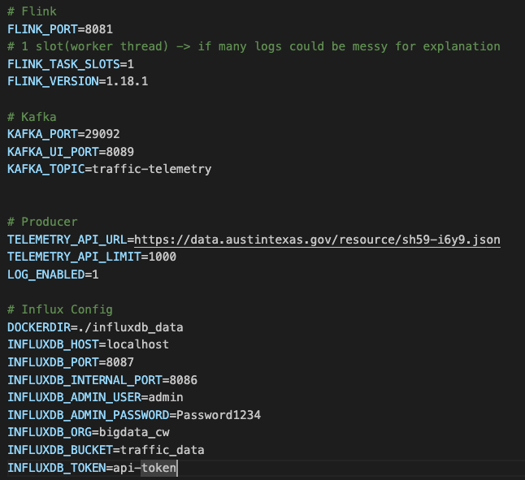
Figure 2.1: .env config for docker and programs
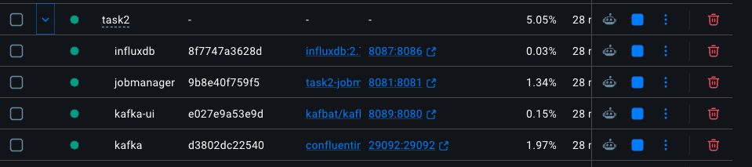
Figure 2.2: Docker Container

Step 2.2: Kafka Topic Architecture & Live Simulation
This is python implementation for retrive traffic telemetry data from camera traffic api and send to kafka topic “traffic-telemetry” every 2 second.
Usecases
- Fetch Telemetry – Fetch Records
- Parse Telemetry – Api Data to Json
- Connect Producer – Connect to Kafka broker
- Send Telemetry – Send Json to Kafka topic
- Close Producer – Closes and Release resources
Above are seperately distributed to respective usecases with usecase names as depicted in figure 2.3 below
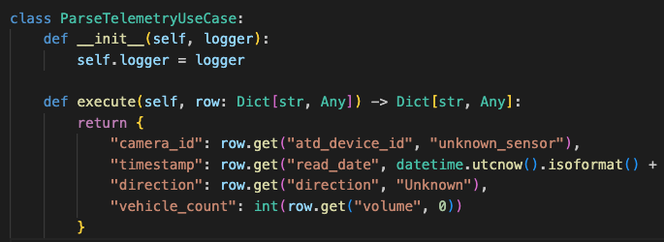
Figure 2.3: Parsing Telemetry api data

Step 2.3: Stateful Flink Processing & Out-of-Order Handling
This is a kotlin Flink stream processing implementation that source is consume from Kafka Topic “traffic-telemetry” and aggregate traffic data in 10 minutes window frames and sink the result to InfluxDB.

Watermark Strategy and Timing
We measure the progress of time at stream level not at the source level, therfore the kafka source is initialized with No Watermark Strategy.
After we receive the Json payload we assign timestamp and watermark strategy allowing 10 seconds delay (leaving space for netwrok delays). Finally stream key assigned with camera id and they grouped into 10 minutes window for summing up the vehicle count as shown in figure 2.4 below.
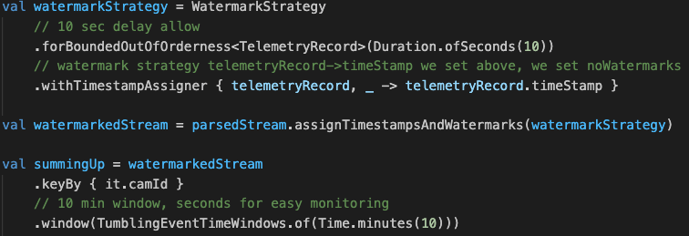
Figure 2.4: Watermark strategy and Windowing

Deploying to Flink
We have created a kotlin helper Task to build jar and deploy to Job Manager as shown in figure 2.5 below. We can just execute “gradle deployToDocker” and jars would be build, copy to job manager and execute.
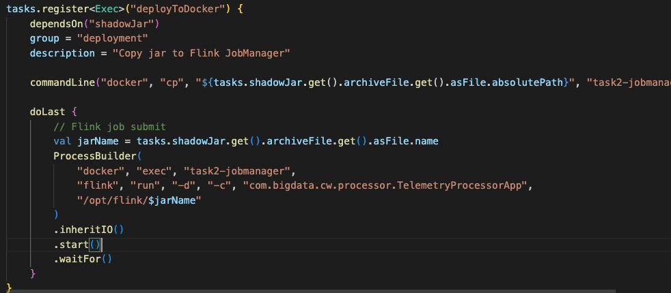
Figure 2.5: Gradle Task for execute Flink Processing with Job Manager
For the sink of the stream we added a InfluxDB sink and write the data to InfluxDB as shown in figure 2.6 below.
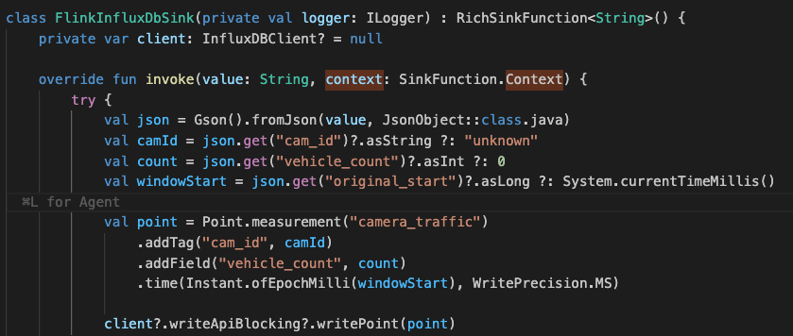
Figure 2.6: InfluxDBSink
Finally we could visualize the traffic data time series using a Influx query as shown in Traffic Dashboard figure 2.7 below.
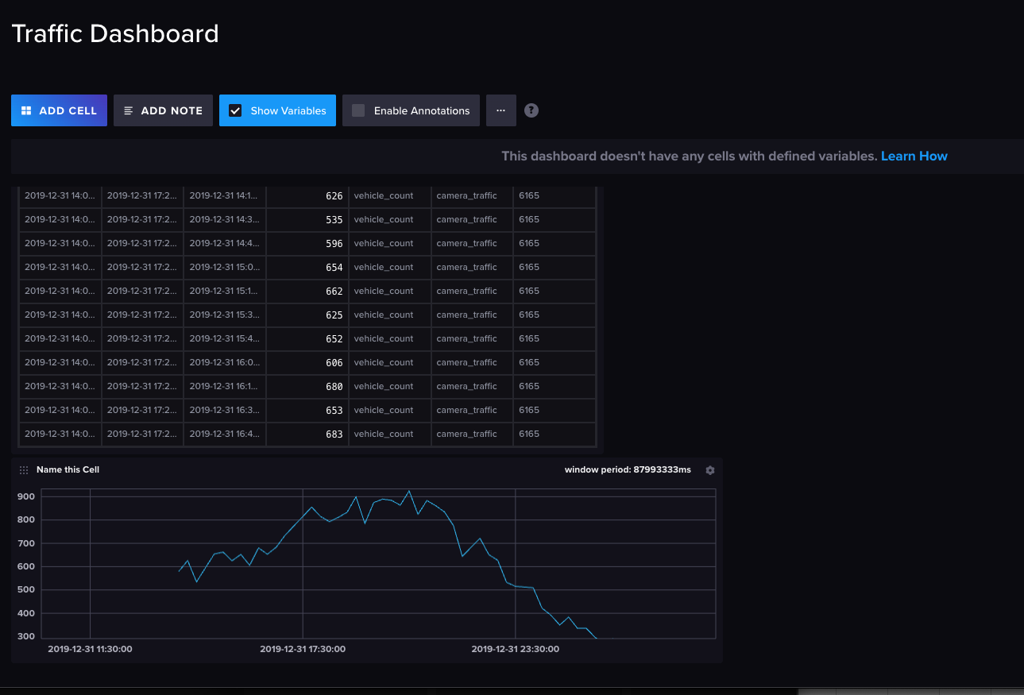
Figure 2.7: Traffic Dashboard

Task 3: Scalable Data Analytics with Apache Spark
Here we have a dataset which maps the hyperlinks pointing between web pages of Berkley and Stanford university domains.

Step 3.1: Spark Container Environment Setup
Figure 3.1 depicts .env for docker configurations which denotes resource limits for workers and other configurations for spark master and worker services.

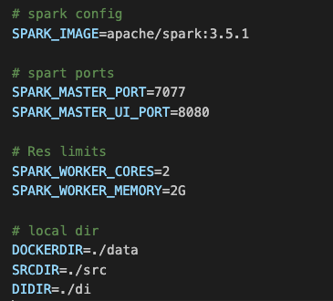
Figure 3.1: .env file for docker config

Step 3.2: PySpark Distributed Job Implementation
Here our main usecase is compute network matrices and we start with parse the text file into a Spark Dataframe while striping out metadata headers as depicted in figure 3.2 below.
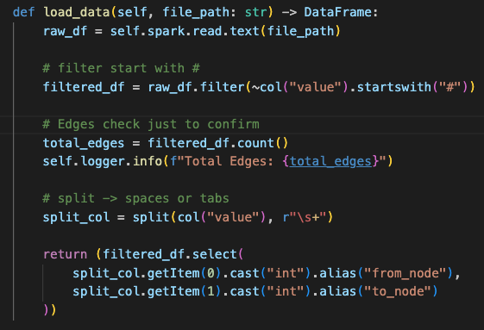
Figure 3.2: parse to spark data frame
Next we have implementation of in-degree distribution calculation as depeicted in figure 3.3 below. Here we group the dataset by ‘to_node’ vertex and count the incoming links pointing to each which is 617094. Here we explicitely say spark to store the computed dataframe in memeory which can be reuse on subequent opertions.
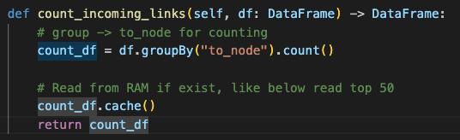
Figure 3.3: Count incoming links
Finally we find top 50 destination nodes as depicted in the figure 3.4 below.
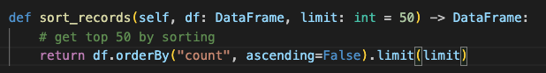
Figure 3.4: Get top 50 records

Step 3.3: Execution Metrics Capture
We excute the job inside running docker container on a spark cluster.
docker exec -it spark-master /opt/spark/bin/spark-submit --master spark://spark-master:7077 /opt/spark/work-dir/src/main.py
Top 5 most linked pages
- 438238 with 84208 links
- 401873 with 48205 links
- 184094 with 44290 links
- 768 with 44101 links
- 927 with 77067 links
Total time : 9.49 seconds

Dat Skew across worker group : Minimum Skew
As depicted in figure 3.5 in console log stage tasks completion time mostly falling between 12 ms and 35ms. No tasks took long duration so we can say work was split uniformly.
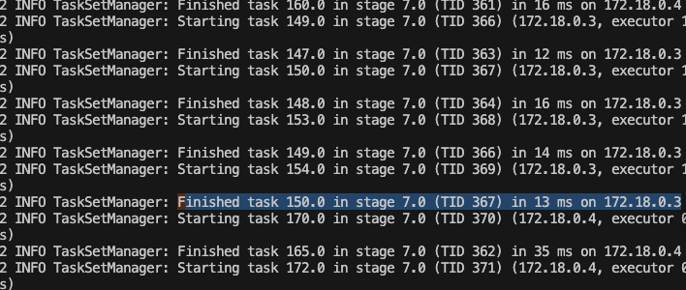

Task 4: Graph Database Engineering using Neo4j

Step 4.1: Neo4j Docker Provisioning
Figure 4.1 below ilustrates .env configurations and figure 4.2 below is the docker compsoe file.
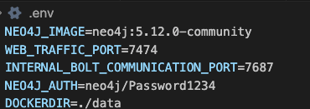
Figure 4.1: .env

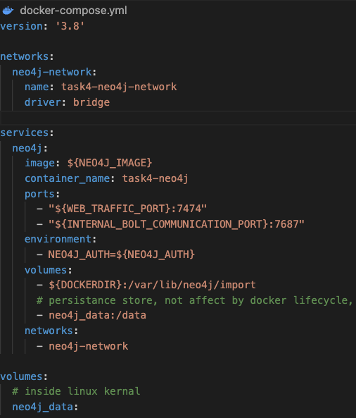
Figure 4.2: Docker Compose File

Step 4.2: Cypher Graph Ingestion

Data Extraction
Figure 4.3 illustrates the python implementation of subsetting of downloaded patent text structure, number of records(5000) to be extrated would be input by cmd line param.
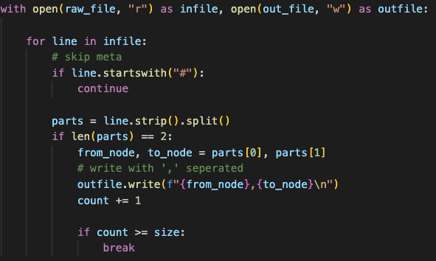
Fifure 4.3: Data Extraction

Import Logics
Here we used LOAD CSV procedures to convert raw textual records to structured graph node set with directed relationships.

Create Nodes
Figure 4.5 below illustrates the cypher script to create the patent nodes as depicted in figure 4.4
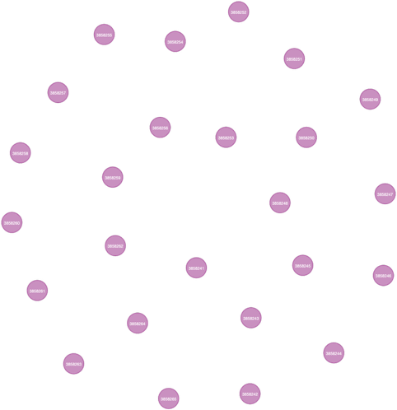
Figure 4.4: Patent Nodes
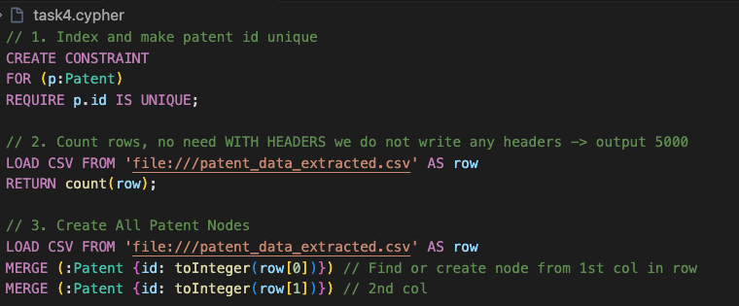
Figure 4.5: Cypher Text for creating the nodes

Create Links
Figure 4.6 illustrates the patent reference relationships which is drawn by the cypher script illustrated in figure 4.7
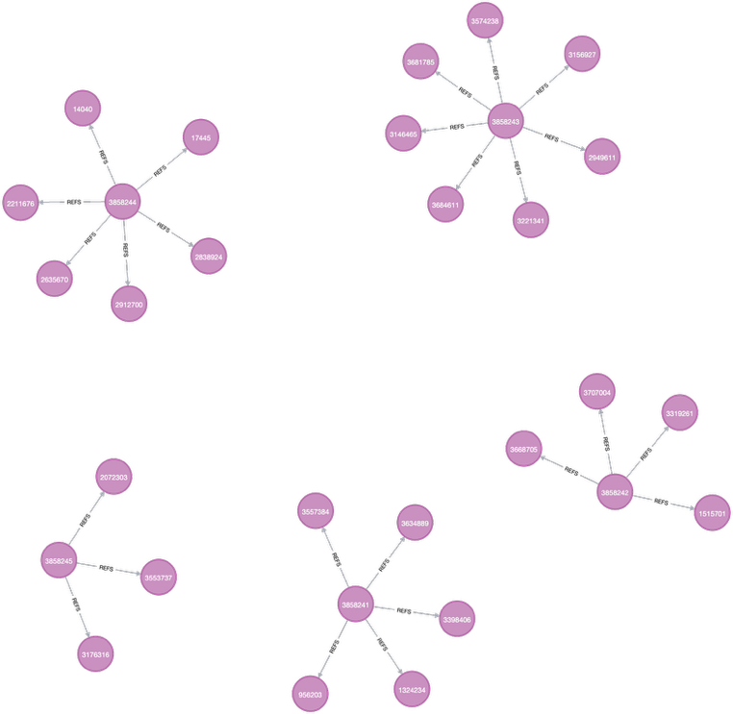
Figure 4.6: Patent Reference drawing
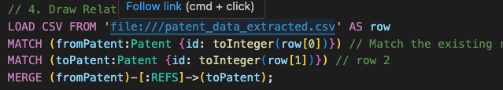
Figure 4.7: Cypher script for creating the patent node links

Step 4.3: Graph Querying and Network Analytics
Identify connected nodes of a target patent
Figure 4.8 depicts the cypher script to identify direct neighbours of patent id 3858243 and figure 4.9 depicts the results.
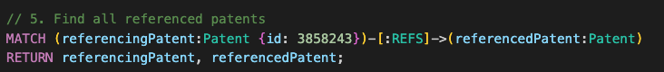
Figure 4.8: Cypher scripts to find all referenced patents
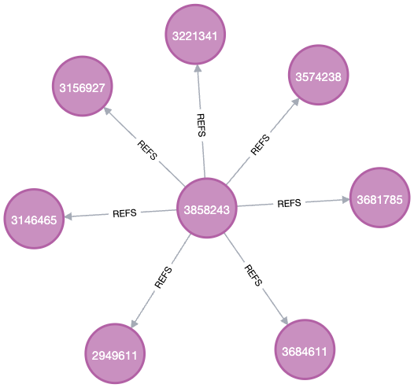
Figure 4.9: Find all referenced parents

Top-tier patent records
Figure 4.10 below depicts the cypher text to find top 5 patent. All top 5 referenced patents has more than 3 citations as shown in figure 4.11 below.
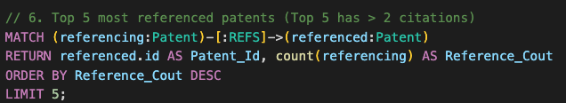
Figure 4.10: Cypher script to find top 5 referenced patents
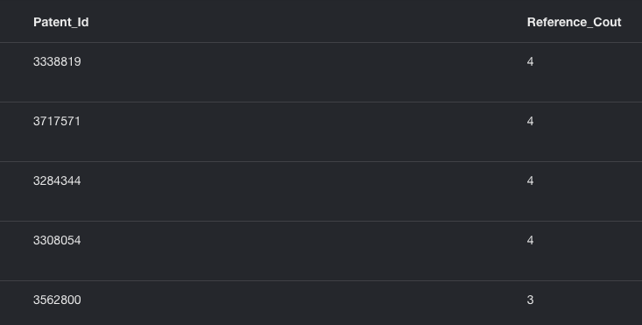
Figure 4.11: Top 5 cited patents

Figure 4.12 depicts the cypher script to find hidden relatioships. It searching upto 3 hops (4 patent nodes) and return with maxium hop count length. As the result depicted in the figure 4.13 Patent 2807431 and 3176316 are seperated by 4 nodes. The direct search wont return anything which leaves theire relatioship hidden.
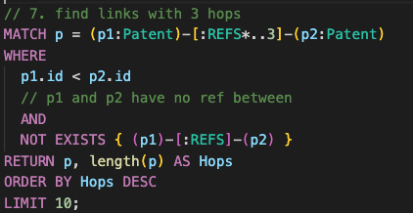
Figure 4.12: Find links with 3 hops
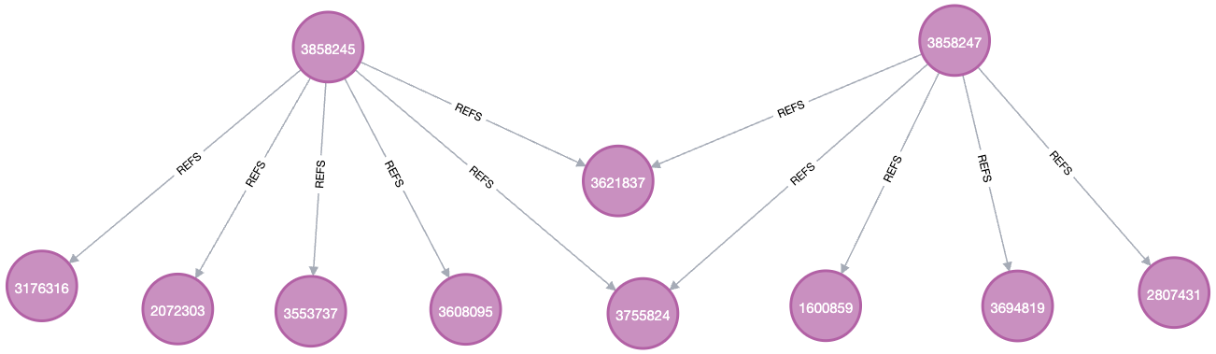
Figure 4.13: Patents links upto 3 hops
Shortest Path diplay Between nodes 2807431 and 3176316 searching upto depth of 5 hops.
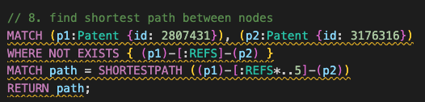
Figure 4.14: Find shortest paths between 2 nodes
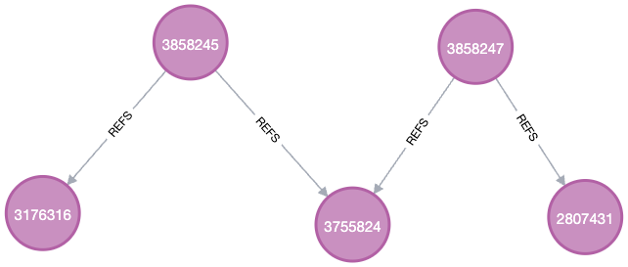
Figure 4.15: Node Graph of shortest path drawn

Task 5: Theoretical Foundations & Future Engineering Trends

Part 5.1: Enterprise Data Governance Frameworks

Introduction
Modern data governance shifting from strict set of rules to more flexible and risk focused strategies backed by technology advancements. Here it more focuss on managing the data accross entire lifecycle rather than individual level. To find, evaualte, address and track potential data threats following four step risk cycle is used.
- Continous Finding
- Assessment
- Management
- Minitoring
The data protection need to be incoperated from grounds up instead of adding it later.

Centralized vs. Distributed Architectural Patterns
Table 5.1 compares and contrasts the functional limitations of centralized and distributed architectural patterns.
 | Centralized( Traditional) | Distributed (Modern)
Movement | Copy data into to a central storage | Zero copying
Frsheness | Batch updates and delayed | Real time access to latest data
Cost | High cost with duplciation | Low cost with no redundant data
Maintainance | Pipeline are fragile | Fewer moving parts and agile
Security | Apply separate across each storage | Apply centrally across all resources

Govern the lifecycle of big data pipelines

GDPR - General Data Protection Regulation
GDPR imposes strict obligations on handling EU citizens data. Compliance requires adherence to principles like lawfulness, purpose limitation, data minimization, accuracy, storage limitation, integrity, and accountability.

The OperationalRole of Metadata Catalog Systems
Metadata systems and data mapping tools are used for identifying where the sensitive data get stored and finding potential risks. Automated Data Lineage & Access Controls [1] allows governance and authorization verified automatically in real time when someone quiries data.

Part 5.2: Emerging Frontiers – Quantum Computing & LLM-Driven Loop Engineering

Quantum Big Data Paradigms

Quantum Machine Learning (QML) and Quantum Computing
Quantum computing opertes with principles like superposition and entanglement [2], which allows quantum algorithms to perform complex calculations in parallel, and much faster than classical computers.

Challenge standard constraints on NP-hard processing problems
Quantum computing provides superior processing power which is required for high dimensional calcualtions and speed up the training of complex models.

Cryptographic signatures
Cuantum computing can create unbreakable quantum encryption methods[3] which could makes a significant threat to existing classical cryptographic algorithms.

LLM Loop Engineering

Automated Code-Generation Agents in CI/CD & Transformation

Syntax-Constrained Generation: Instead of unconstrained string output the code generation agents use Context Free Grammar (CFG) decoding to enforce strict syntax constraints.
Closed Evaluation Loops : Ontermediate outputs from code generation agents are checked using deterministic assertion engines. They would feed errors, stack traces back to agents in case they occur before prsesent to the users.

Open Synthesis
when integrating nondeterministic LLM outputs with strict, deterministic distributed runtime engines we can address following problems.
- Non-Determinism[4]: Different Answer Every Time
When Spark or Flink crashes they ca nrestart and we would get same result which is deterministic.
When we inout LLM exact same data twice it may give slightly different answer.

- Traffic Jam: Runs on different speed
Flink or Spark can process millions of records per second, where as LLM could takes significantly higher time just to generate one answer. Therefore sending stream of records to LLm would make a massive bottleneck.

- The Strict Rule Problem
General frameworks/compilers operates with strict rules[5], even with simple missing paranthesis they would trigger compile/runtime errors. LLMs may output incorrect formats, non exisitng key works which would instantly rejects by compilers. So once they integrated they may trigger erros ins tead of executing the work.

References
- Wider, A., Verma, S., & Akhtar, A. (2023). "Decentralized Data Governance as Part of a Data Mesh Platform: Concepts and Approaches," 2023 IEEE International Conference on Web Services (ICWS).
- (2025). "Quantum Machine Learning: A Comprehensive Review of Integrating AI with Quantum Computing for Computational Advancements," PMC.
- (2025). "Quantum Machine Learning Models for Enhancing Big Data Analytics," 2025 International Conference on Future Technologies.
- Bomma, H. P. (2025). "Integrating Large Language Models into Data Engineering Workflows," Scholars Journal of Engineering and Technology.
- Ding, B., et al. (2024). "Large Language Models as Pretrained Data Engineers: Techniques and Opportunities," Proceedings of the VLDB Endowment.

