Task 4: Graph Database Engineering using Neo4j
Step 4.1: Neo4j Docker Provisioning
.env File
Figure 4.1 below ilustrates .env configurations and figure 4.2 below is the docker compsoe file
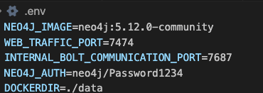
Figure 4.1: .env
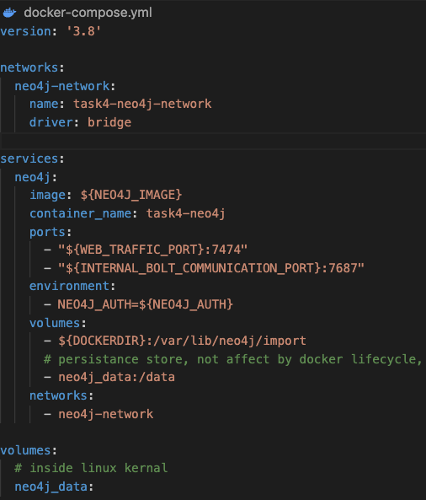
Figure 4.2: Docker Compose File
Step 4.2: Cypher Graph Ingestion
Data Extraction
Figure 4.3 illustrates the python implementation of subsetting of downloaded patent text structure, number of records(5000) to be extrated would be input by cmd line param.
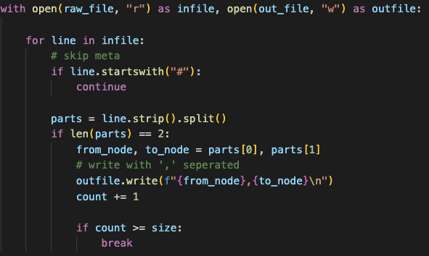
Fifure 4.3: Data Extraction
Import Logics
Here we used LOAD CSV procedures to convert raw textual records to structured graph node set with directed relationships.
Create Nodes
Figure 4.5 below illustrates the cypher script to create the patent nodes as depicted in figure 4.4
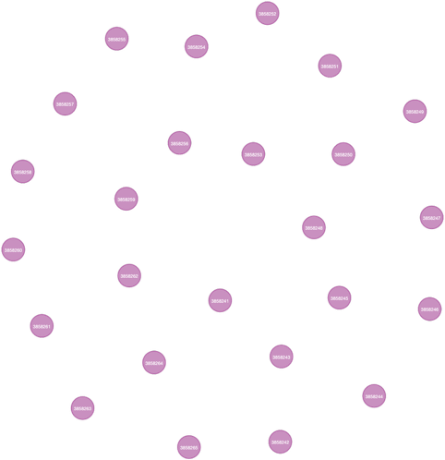
Figure 4.4: Patent Nodes
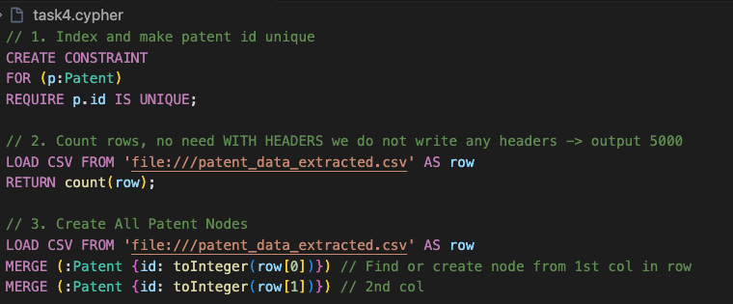
Figure 4.5: Cypher Text for creating the nodes
Create Links
Figure 4.6 illustrates the patent reference relationships which is drawn by the cypher script illustrated in figure 4.7
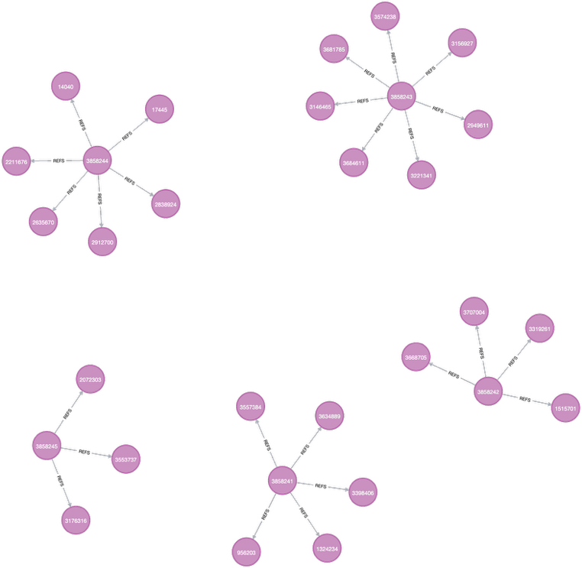
Figure 4.6: Patent Reference drawing
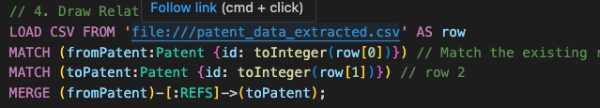
Figure 4.7: Cypher script for creating the patent node links

Step 4.3: Graph Querying and Network Analytics
Identify connected nodes of a target patent
Figure 4.8 depicts the cypher script to identify direct neighbours of patent id 3858243 and figure 4.9 depicts the results.
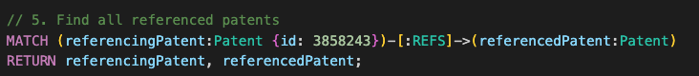
Figure 4.8: Cypher scripts to find all referenced patents
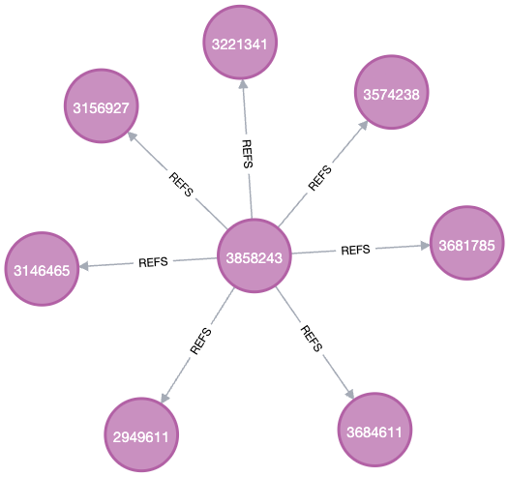
Figure 4.9: Find all referenced parents

top-tier patent records
Figure 4.10 below depicts the cypher text to find top 5 patent. All top 5 referenced patents has more than 3 citations as shown in figure 4.11 below.
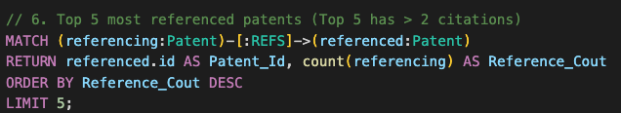
Figure 4.10: Cypher script to find top 5 referenced patents
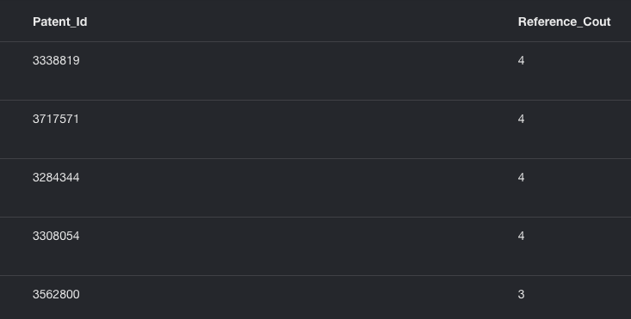
Figure 4.11: Top 5 cited patents

Figure 4.12 depicts the cypher script to find hidden relatioships. It searching upto 3 hops (4 patent nodes) and return with maxium hop count length. As the result depicted in the figure 4.13 Patent 2807431 and 3176316 are seperated by 4 nodes. The direct search wont return anything which leaves theire relatioship hidden.
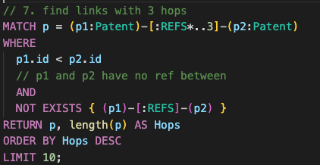
Figure 4.12: Find links with 3 hops
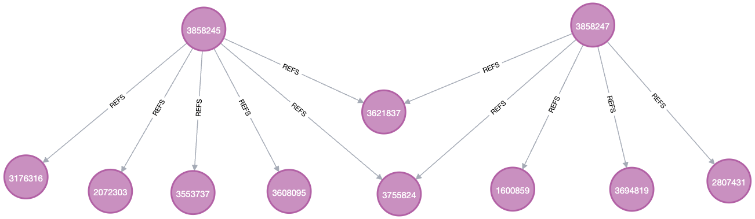
Figure 4.13: Patents links upto 3 hops
Shortest Path diplay Between nodes 2807431 and 3176316 searching upto depth of 5 hops.
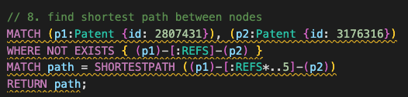
Figure 4.14: Find shortest paths between 2 nodes
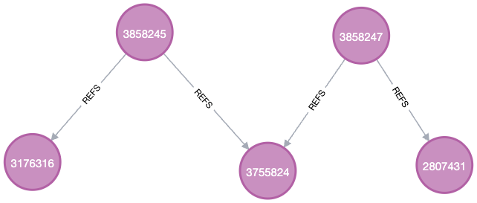
Figure 4.15: Node Graph of shortest path drawn

